**MaxCDN:**

|  |
| --- |
| <!-- Latest compiled and minified CSS --> <link href="https://cdn.jsdelivr.net/npm/bootstrap@5.1.3/dist/css/bootstrap.min.css" rel="stylesheet">  <!-- Latest compiled JavaScript --> <script src="https://cdn.jsdelivr.net/npm/bootstrap@5.1.3/dist/js/bootstrap.bundle.min.js"></script> |

**Containers**

Bootstrap 5 also requires a containing element to wrap site contents.

There are two container classes to choose from:

1. The .container class provides a responsive **fixed width container**
2. The .container-fluid class provides a **full width container**, spanning the entire width of the viewport

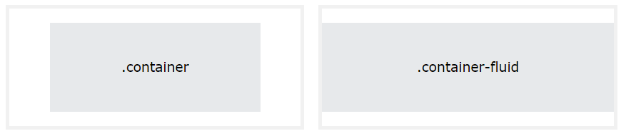

**Container padding**

spacing

Where *property* is one of:

* m - for classes that set margin
* p - for classes that set padding

Where *sides* is one of:

* t - for classes that set margin-top or padding-top
* b - for classes that set margin-bottom or padding-bottom
* l - for classes that set margin-left or padding-left
* r - for classes that set margin-right or padding-right
* x - for classes that set both *-left and *-right
* y - for classes that set both *-top and *-bottom
* blank - for classes that set a margin or padding on all 4 sides of the element

Where *size* is one of:

* 0 - for classes that eliminate the margin or padding by setting it to 0
* 1 - (by default) for classes that set the margin or padding to $spacer * .25
* 2 - (by default) for classes that set the margin or padding to $spacer * .5
* 3 - (by default) for classes that set the margin or padding to $spacer
* 4 - (by default) for classes that set the margin or padding to $spacer * 1.5
* 5 - (by default) for classes that set the margin or padding to $spacer * 3
* auto - for classes that set the margin to auto

Respontive Container

* You can also use the .container-sm|md|lg|xl classes to determine when the container should be responsive.
* The max-width of the container will change on different screen sizes/viewports:

|  |  |  |  |  |  |  |
| --- | --- | --- | --- | --- | --- | --- |
| **Class** | **Extra small <576px** | **Small ≥576px** | **Medium ≥768px** | **Large ≥992px** | **Extra large ≥1200px** | **XXL ≥1400px** |
| .container-sm | 100% | 540px | 720px | 960px | 1140px | 1320px |
| .container-md | 100% | 100% | 720px | 960px | 1140px | 1320px |
| .container-lg | 100% | 100% | 100% | 960px | 1140px | 1320px |
| .container-xl | 100% | 100% | 100% | 100% | 1140px | 1320px |
| .container-xxl | 100% | 100% | 100% | 100% | 100% | 1320px |