

**<<Quizlet>>**

**Software Requirement Specification**

– Hanoi, February 2023 –

Record of changeS

|  |  |  |  |
| --- | --- | --- | --- |
| Date | A* M, D | In charge | Change Description |
| 13/Feb | A | PhuongNV | * Create UI of folder page * Create new folder and add to database |
| 13/Feb | A | AnhTHV | * Create UI screen home page before login page * Create database |
| 13/Feb | A | GiangNH | * Create UI of footer * Search by user name and study set name |
| 13/Feb | M, A | VuBL | * Create login, register * CRUD study sets |
| 13/Feb | M, A | HungBM | * Modified a verify, login and register * Modified filter |

*A - Added M - Modified D - Deleted

**Table of Contents**

I. Overview 4

1. Introduction 4

2. System Functions 5

3. Entity Relationship Diagram 6

II. Functional Requirements 7

1. <<Feature Name 1>> 7

a. <<Function Name 1>> 7

b. <<Function Name 2>> 7

2. <<Feature Name 2>> 7

# I. Overview

## 1. Introduction

* The Quizlet Online Learning is a new software system that supports storage and management of courses. At the same time, you can refer to and study other people's folders and courses if you have permission from the owner. The system is expected to evolve over several releases, ultimately connecting to the Internet ordering services for several local schools to test and improve.

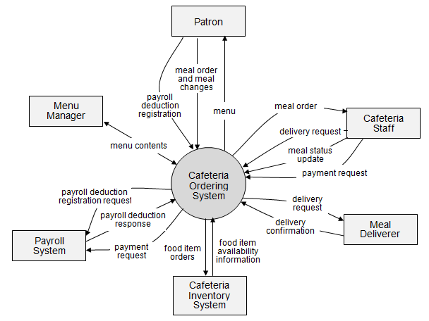>>

## 2. System Functions

#### a. Screen Flow

*[This part shows the system screens and the relationship among screens. You can draw the Screens Flow for the system in the form of diagram as below]*

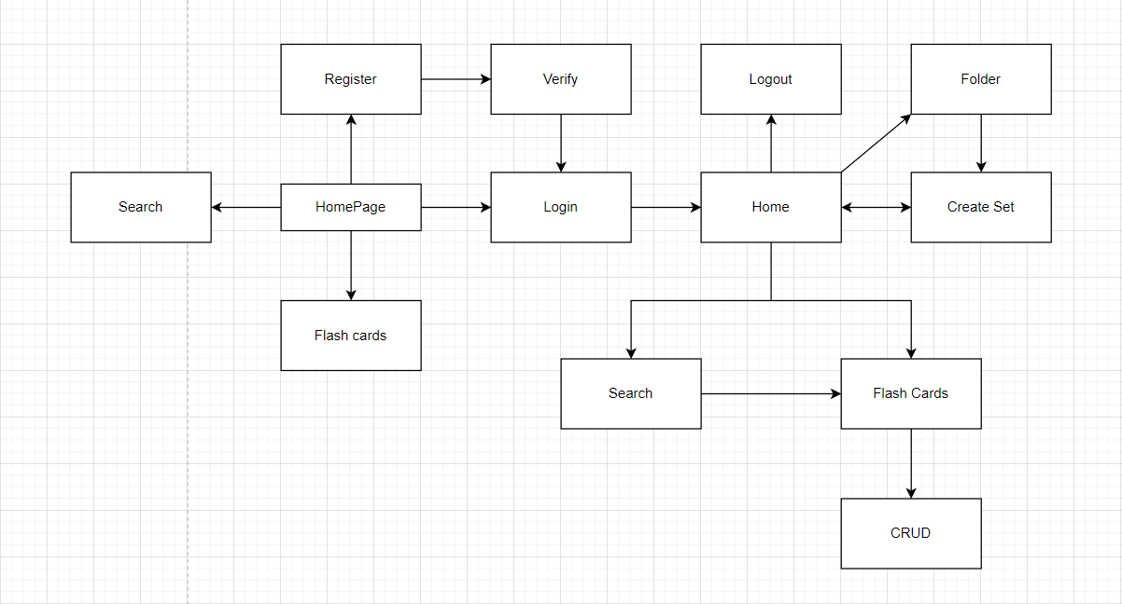

#### b. Screen Details

*[Provide the descriptions for the screens in the Screens Flow above]*

|  |  |  |  |
| --- | --- | --- | --- |
| **#** | **Feature** | **Screen** | **Description** |
| 1 | Login/ Register | Login/ Register | Create a form to login and register, user can register and login after verify email. |
| 2 | Study sets info | Study set | Show all info and all card in study sets |
| 3 | CRUD study set | Study set | Add, update, delete study set but study set must have 2 or more cards. |
| 4 | Search study set | Header | Search study sets by study set name or user name |
| 5 | Folder info | Folder | Show folder info and create a new folder and save it to database |
| 6 | Card info | Flash Cart | Show cards info |
| 7 | CRUD cards | Flash Cart | Add, Update, Delete cards |

#### c. User Authorization

*[Provide the system roles authorization to the system features (down to screens, and event to the screen activities if applicable) in the table form as below – replace Role1, Role2,… with the specific system user role names]*

|  |  |  |
| --- | --- | --- |
| **Screen** | **User** | **Guest** |
| HomePage | X | X |
| Home | X |  |
| Login | X | X |
| Register | X | X |
| FlashCard | X | X |
| Search | X | X |
| Create Set | X |  |
| Verify | X |  |
| Folder | X |  |
| Update Set | X |  |

In which:

* User role: do all function of page
* Guest role: only access to homepage, login/register, view cards and search study sets.

#### d. Non-Screen Functions

*[Provide the descriptions for the non-screen system functions, i.e batch/cron job, service, API, etc.]*

|  |  |  |  |
| --- | --- | --- | --- |
| **#** | **Feature** | **System Function** | **Description** |
| 1 | <<Feature Name>> | <<Function Name1>> | <<Function Name1 Description>> |
| 2 | … |  |  |

## 3. Entity Relationship Diagram

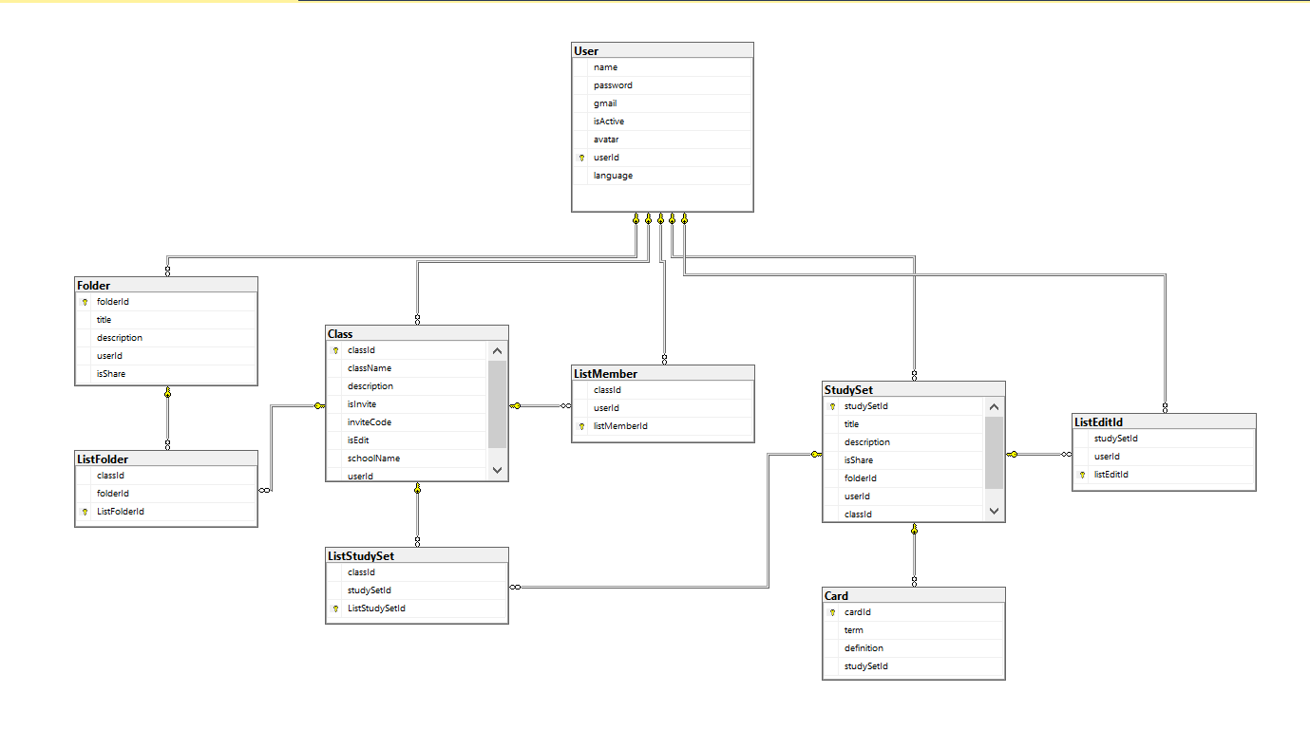

**Entities Description**

|  |  |  |
| --- | --- | --- |
| **#** | **Entity** | **Description** |
| 1 | User | All information of users |
| 2 | Card | All information of list cards |
| 3 | Study Set | All information of list study sets |
| 4 | Class | All information of list class |
| 5 | Folder | All information of list folder |
| 6 | List Folder | A class contain folders |
| 7 | List study set | A class contain study sets |
| 8 | List member | A class contain user |
| 9 | List edit id | A user has many study set |

# II. Functional Requirements

## 1. <<Homepage>>

### a. <<Screen>>



*This is home page before user login or register. Everybody can access this page.*

### b. <<Search>>

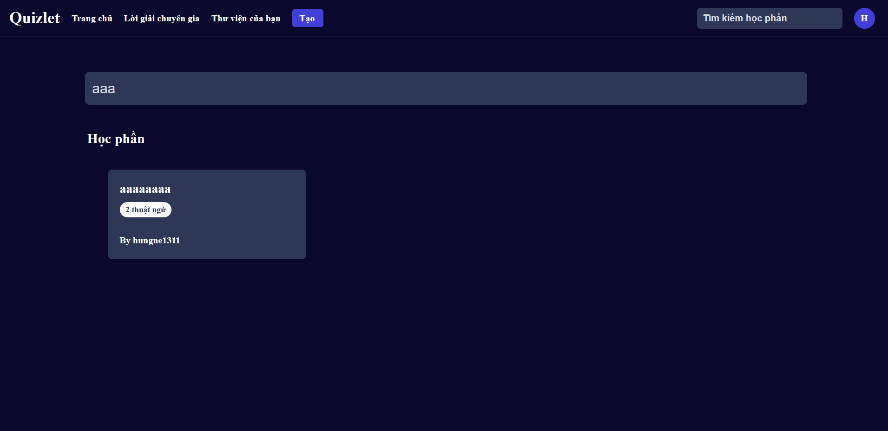

Everybody can search study set by name study set or user name.

### c. <<View study set>>

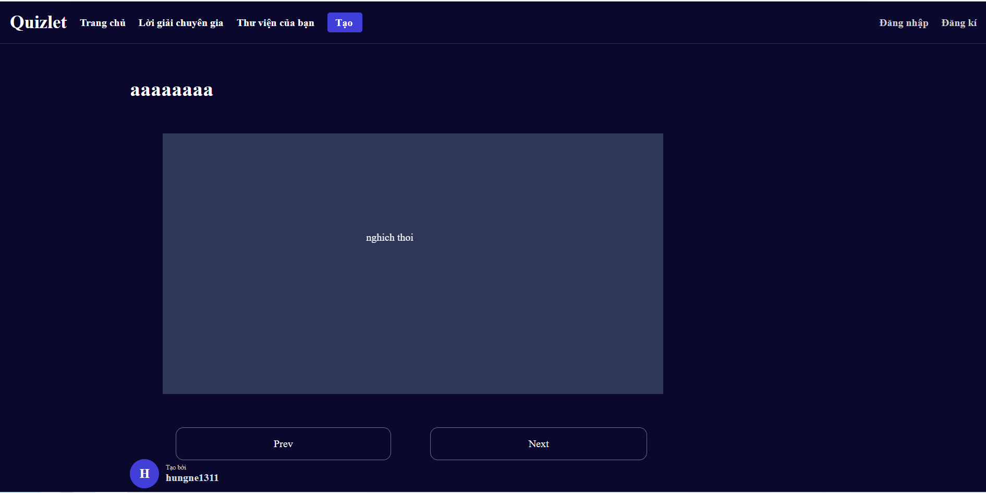

Everybody only can view study set and cards.

## 2. <<Login>>

### <<Screen>>

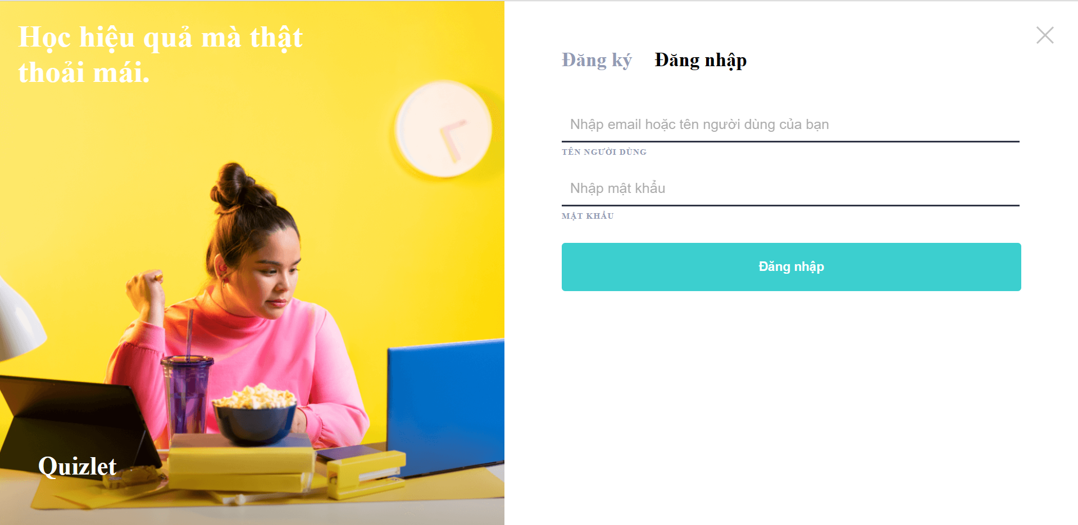

Everybody can login in this page.

## 3. <<Register>>

### <<Screen>>

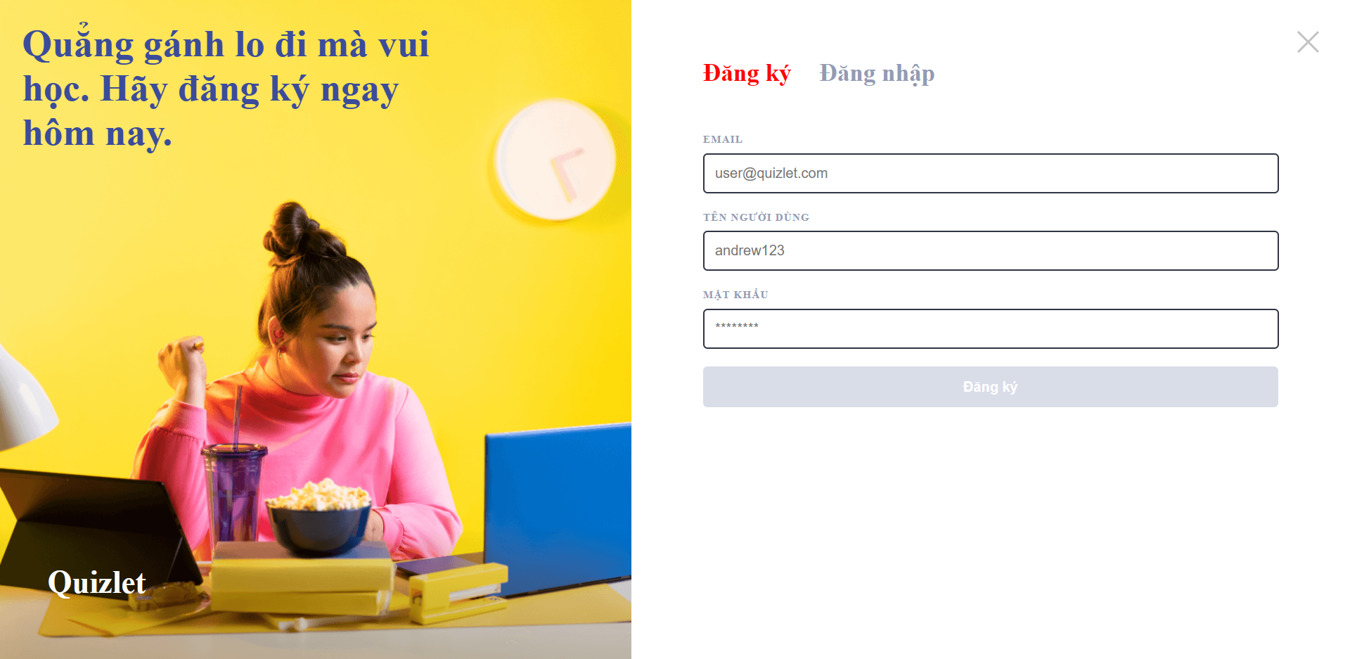

## 4. <<Home>>

a. Screen

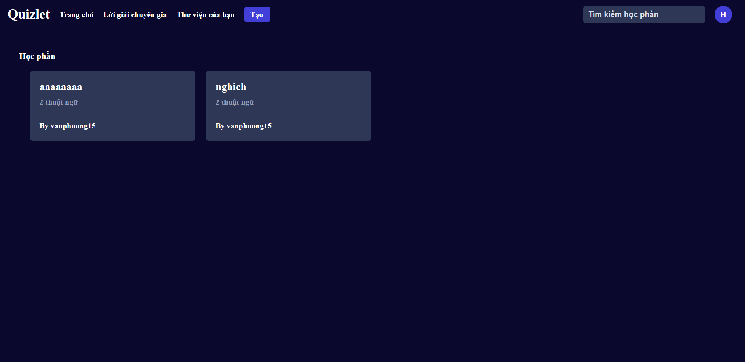

After login, user can access to this page.

b. View Study set

## 5. <<FlashCard>>

a. Screen

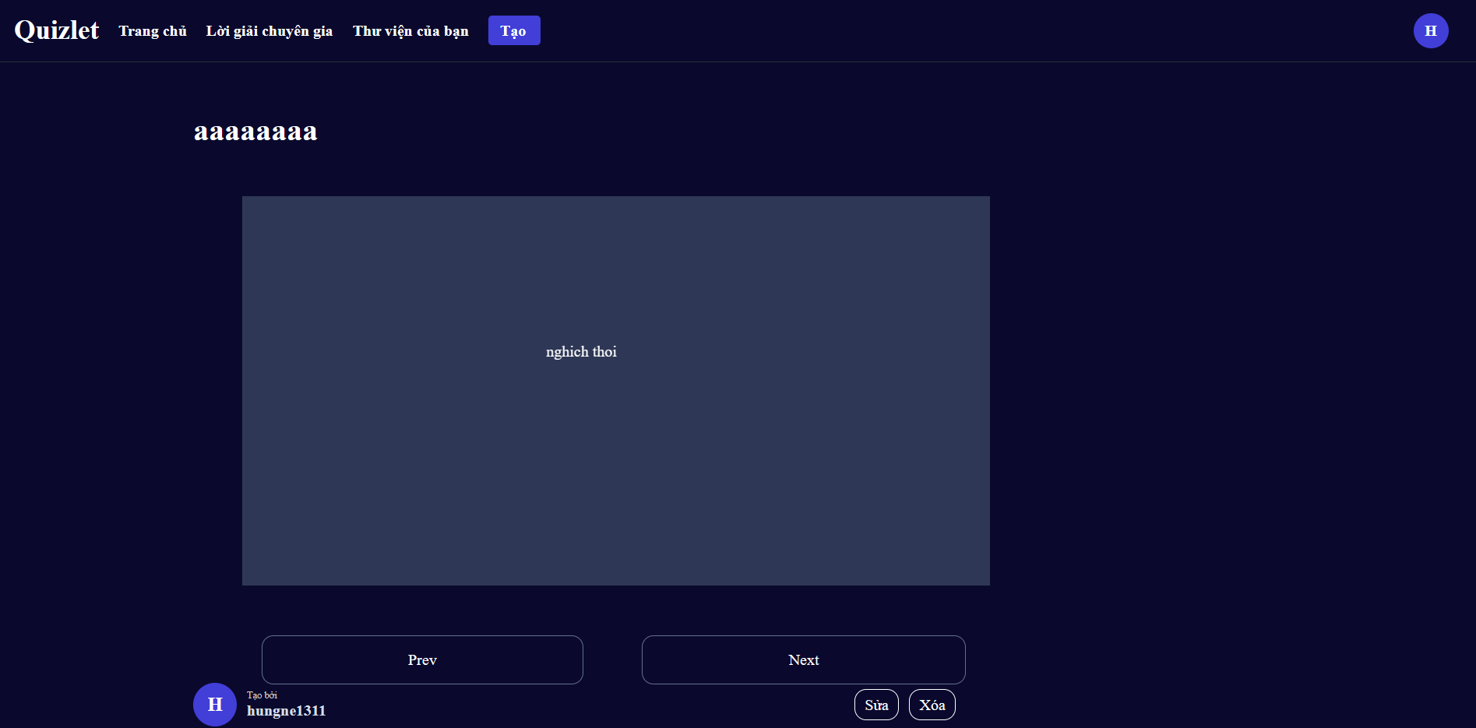

View all information of study sets

b. CRUD study sets

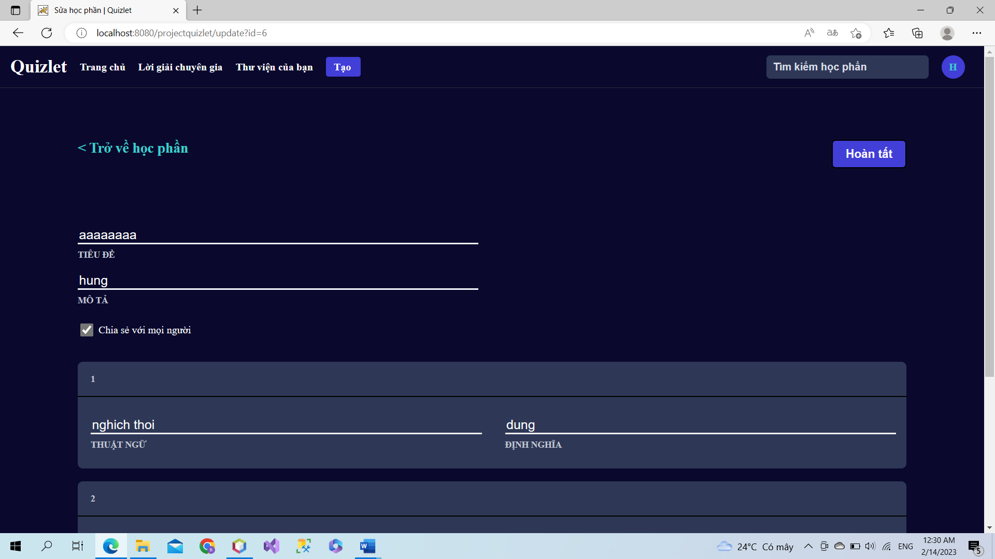

## 6. <<Folder>>

a. Screen

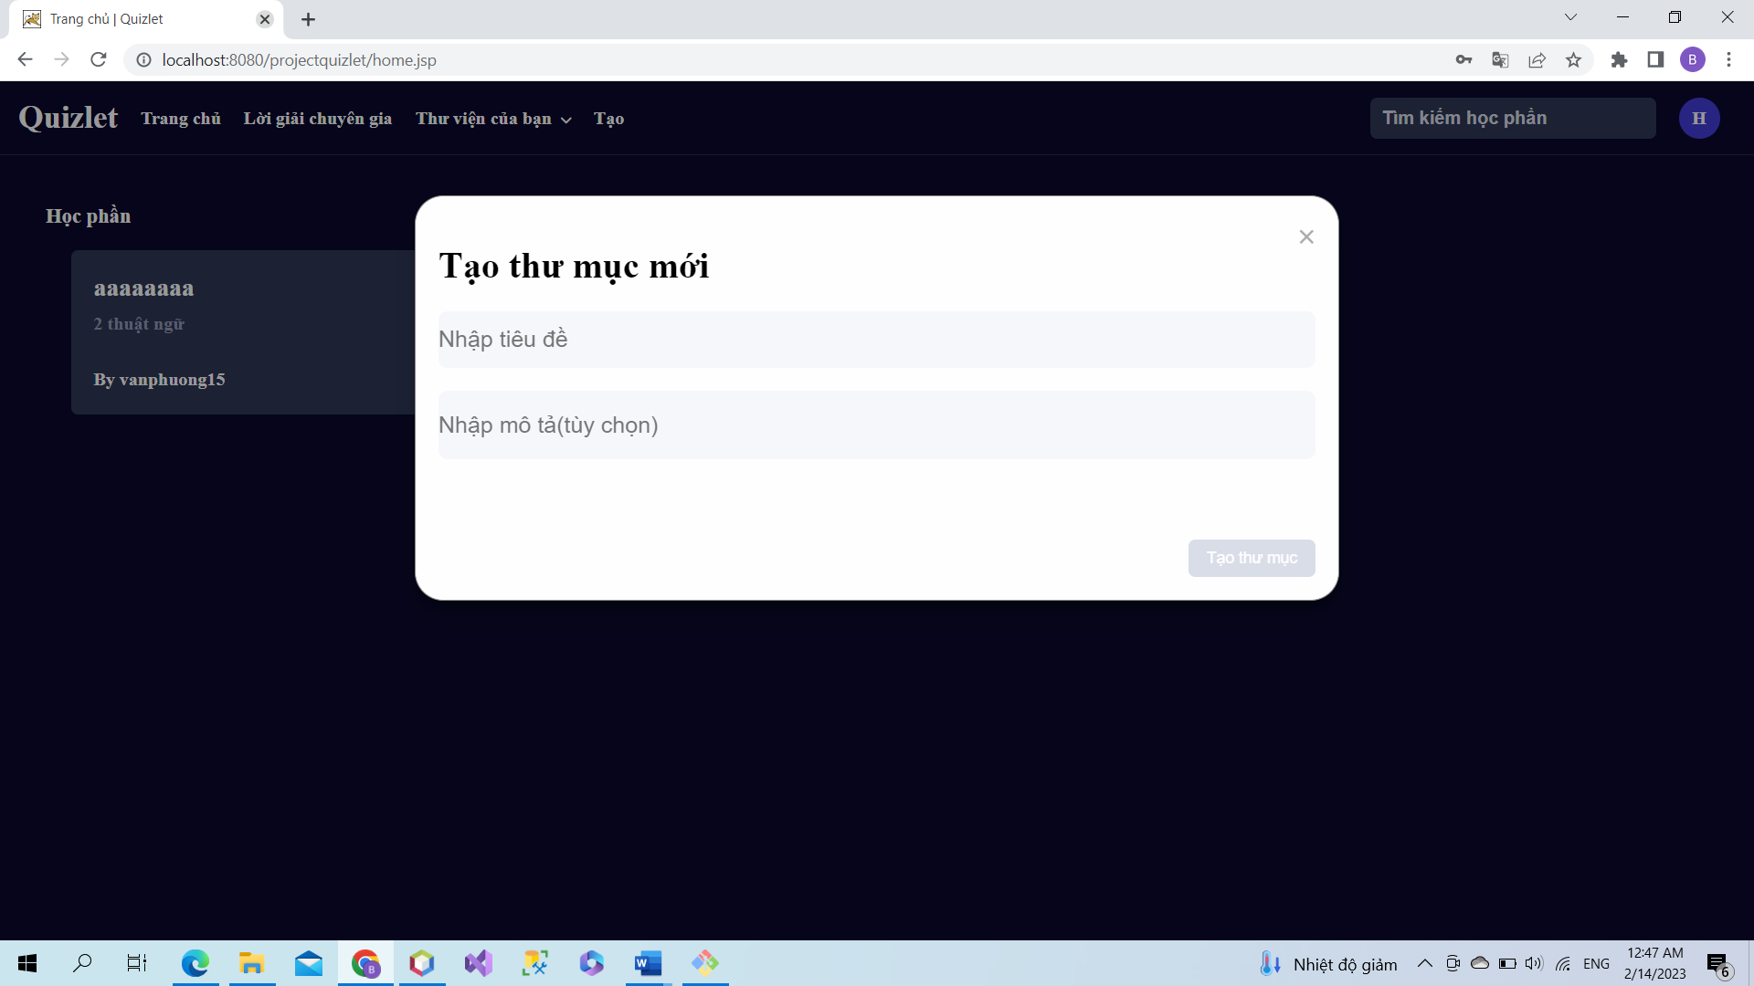

**User can add a new folder.**

b. View list folder

