**Các bước liên kết appsflyer với firebase**

1. FireBase:

Project settings > Cloud Messaging > Manage Service Accounts

1. Google cloud

* Roles > CREATE ROLE
* IAM > GRANT ACCESS

1. AppsFlyer

* Tạo dự án
* Uninstall measurement (Project ID form FireBase)

1 FireBase

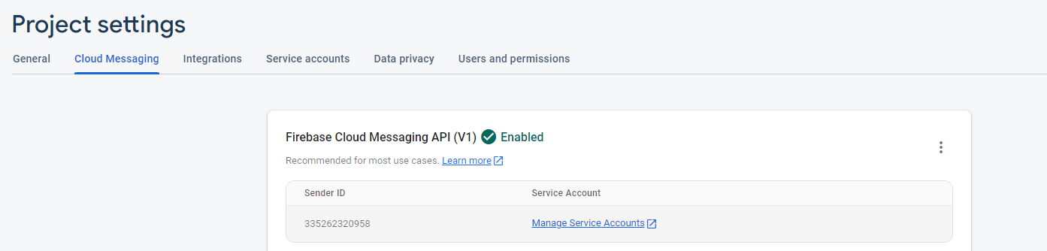

2 Google Cloud  
Hướng dẫn: <https://support.appsflyer.com/hc/en-us/articles/4408933557137-Uninstall-measurement?utm_source=hq1&utm_medium=ui&utm_campaign=appsettings#http-v1>

Create Role

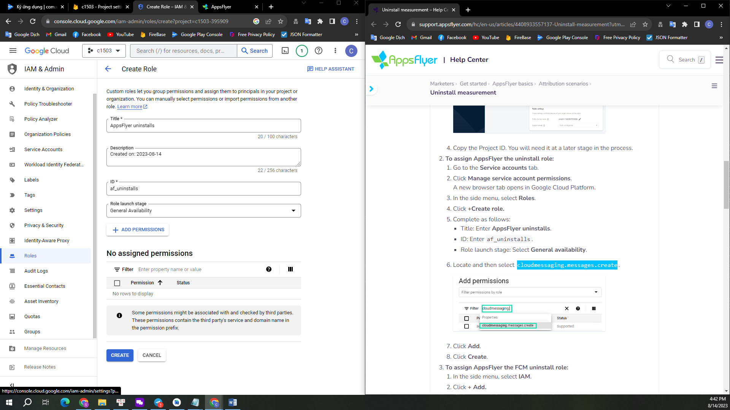

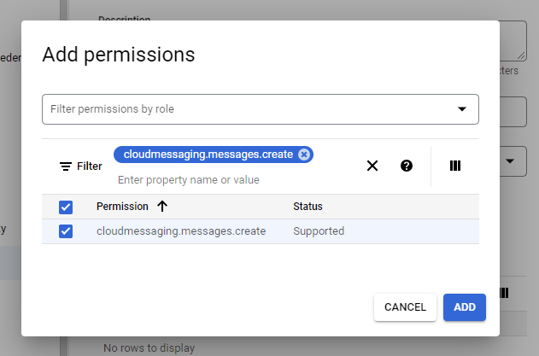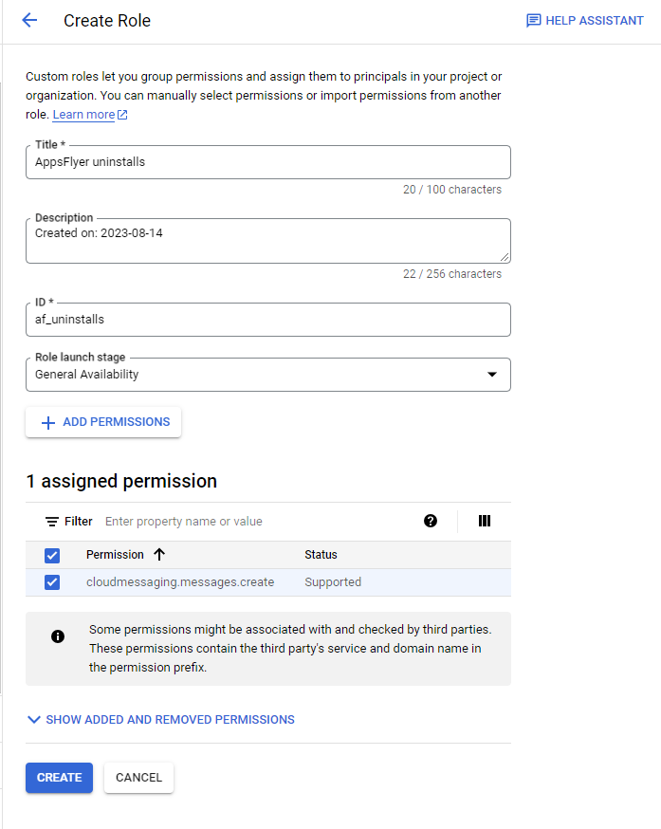

Create Grant Access

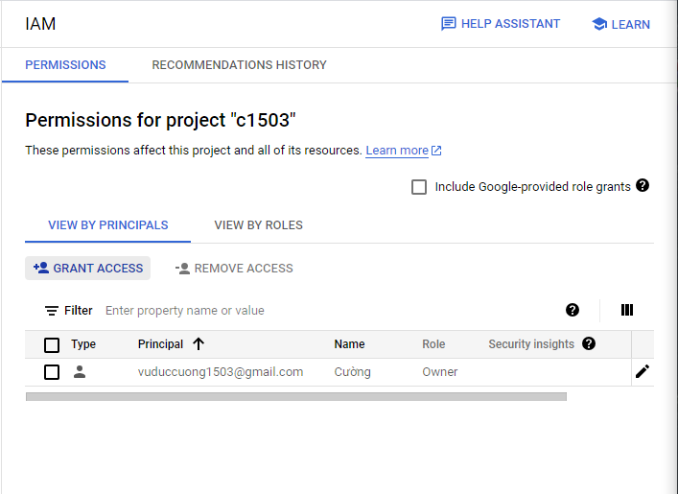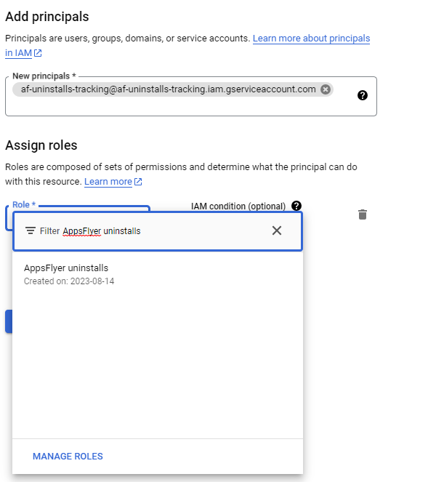

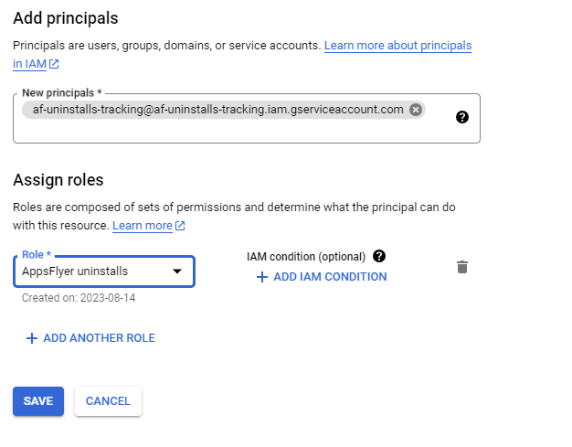

3 AppsFlyer

Create Project New

