BÁO CÁO THỰC HÀNH LAB 1  
LẬP TRÌNH HƯỚNG ĐỐI TƯỢNG

**Table of Contents**

**Part I. The Very First Java Programs** 3

2.2.1Write, compile the first Java application: 3

2.2.2 Write, compile the first dialog Java program 4

2.2.3 Write, compile the first input dialog Java application 4

2.2.4 Write, compile, and run the following example: 6

2.2.5 Write a program to calculate sum, difference, product, and quotient of 2 double numbers which are entered by users. 8

2.2.6. Write a program to solve: 9

**Part II: 6. Exercises:** 11

6.1. Write, compile, and run the Choosing Option program: 11

6.2. Write a program for input/output from keyboard 13

6.3. Write a program to display a triangle with a height of n stars (*), n is entered by users. .........................................................................................................................................13

6.4. Write a program to display the number of days of a month, which is entered by users (both month and year). If it is an invalid month/year, ask the user to enter again...........................................................................................................................................14

6.5. Write a Java program to sort a numeric array and calculate the sum and average value of array elements. 15

6.6. Write a Java program to add two matrices of the same size. 16

**Table of Figures**

Figure 1: Chương trình đầu tiên HelloWorld 3

Figure 2: First dialog Java program 4

Figure 3: First input dialog Java application 5

Figure 4: Show Two Numbers 7

Figure 5: Caculate 2 numbers program 8

Figure 6: The first-degree equation with one variable 9

Figure 7: The system of first-degree equations with two variables 10

Figure 8: The second-degree equation with one variable 10

Figure 9: Choosing Option program_ver1.0 11

Figure 10: Choosing Option program_ver2.0 12

Figure 11: Program for input/output from keyboard 13

Figure 12: Program to display a triangle 14

Figure 13: Program to display the number of days of a month 15

Figure 14: Program to sort an array and calculate the sum and average value 15

Figure 15: Java program to add two matrices of same size 16

# **Part I. The Very First Java Programs**

## 2.2.1Write, compile the first Java application:

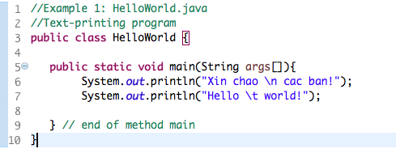

*Kết quả:*

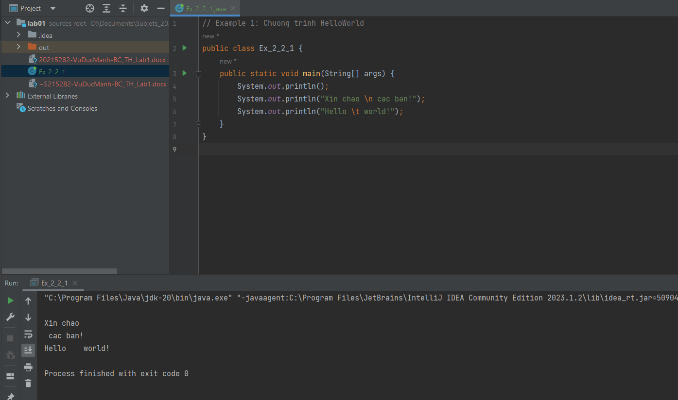

Figure 1: Chương trình đầu tiên HelloWorld

## Screen Shot 2019-02-12 at 122.2.2 Write, compile the first dialog Java program

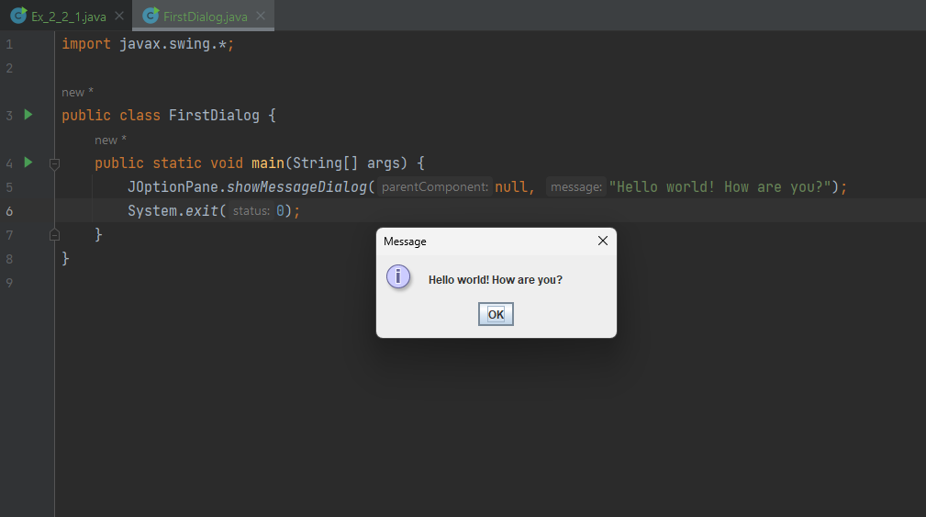

Figure 2: First dialog Java program

## 2.2.3 Write, compile the first input dialog Java application

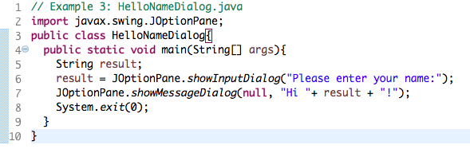

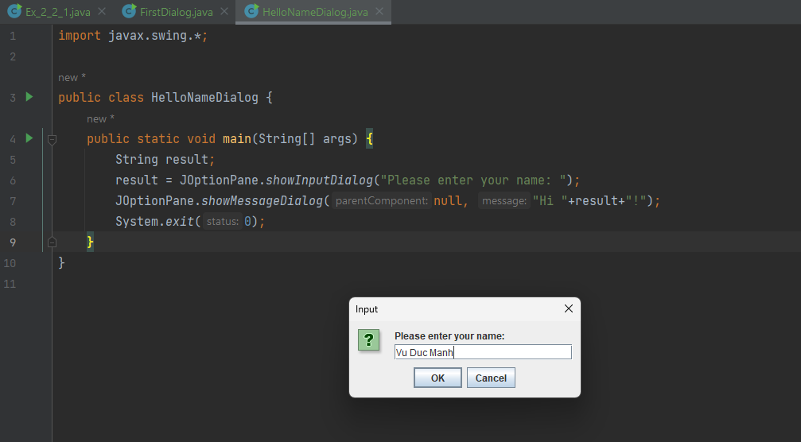

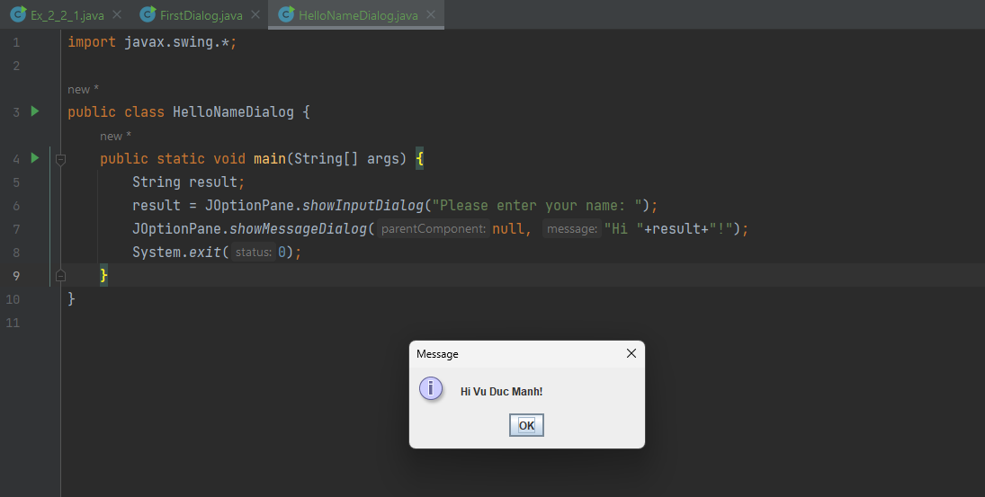

Figure 3: First input dialog Java application

## 2.2.4 Write, compile, and run the following example:

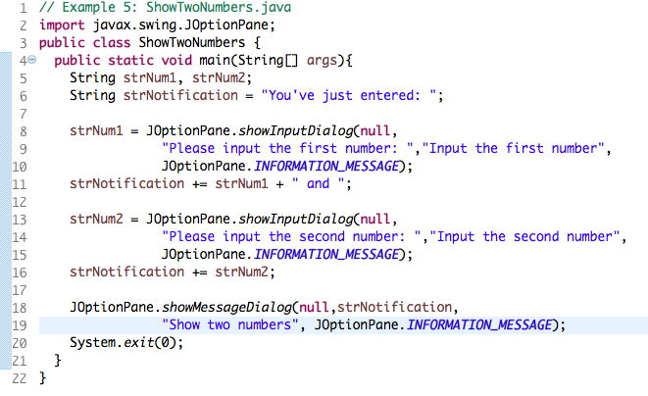

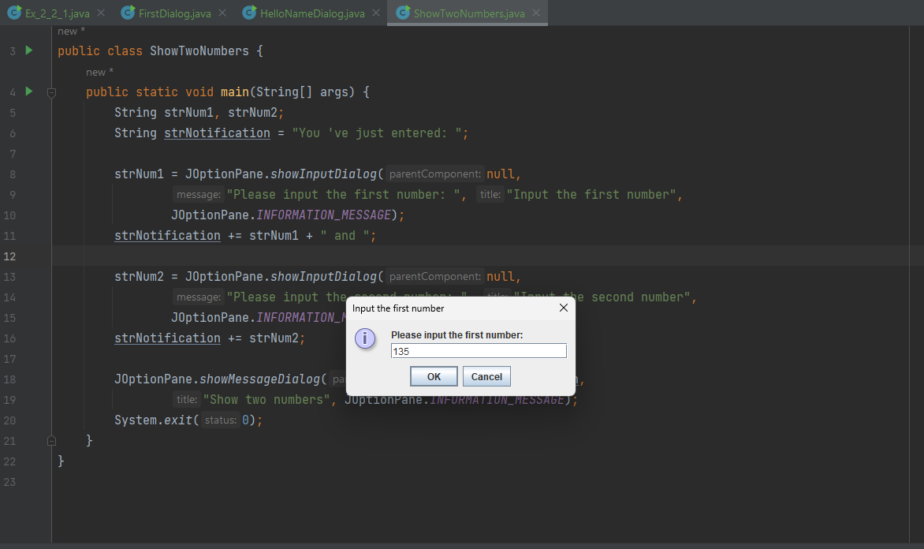

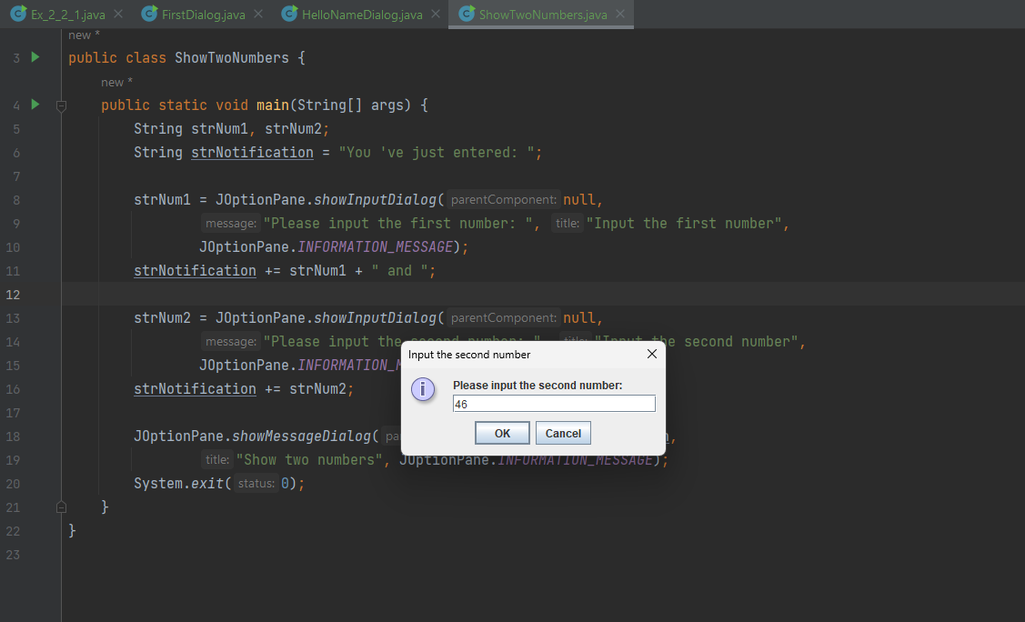

Figure 4: Show Two Numbers

## 2.2.5 Write a program to calculate sum, difference, product, and quotient of 2 double numbers which are entered by users.

**Notes**

* To convert from String to double, you can use

**double num1 = Double.parseDouble(strNum1)**

* Check the divisor of the division

Figure 5: Caculate 2 numbers program

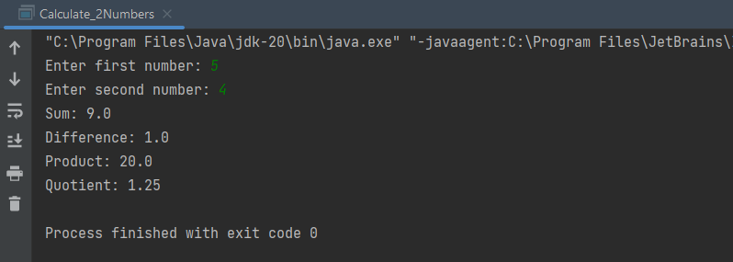

## 2.2.6. Write a program to solve:

* The first-degree equation (linear equation) with one variable
* The system of first-degree equations (linear system) with two variables
* The second-degree equation with one variable

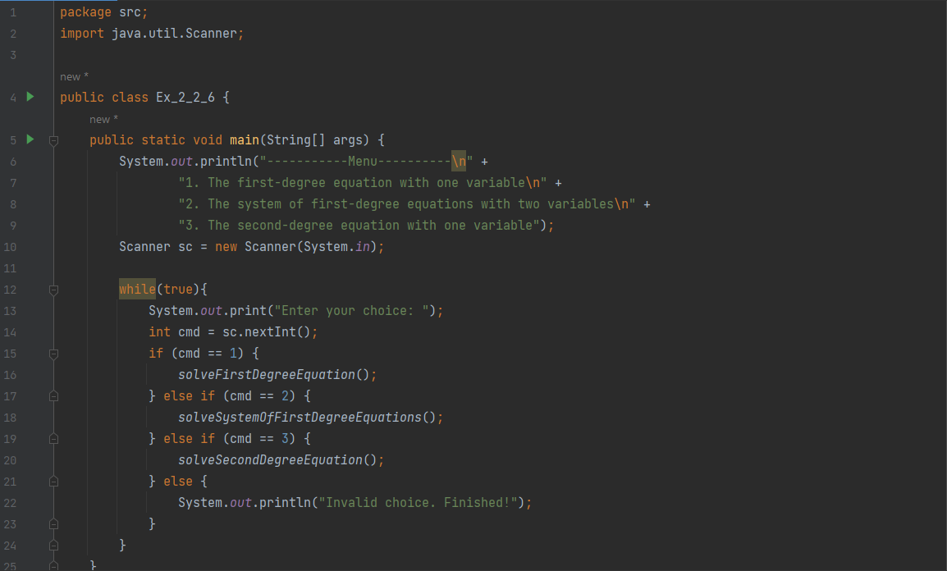

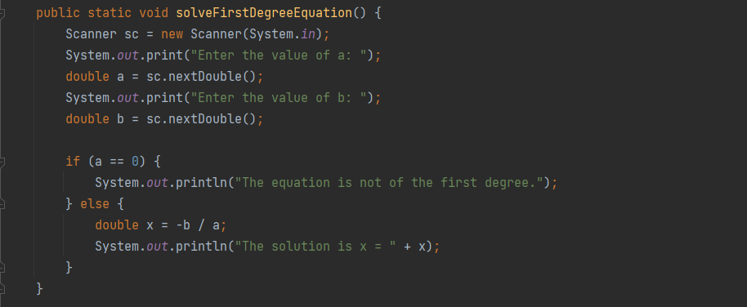

Figure 6: The first-degree equation with one variable

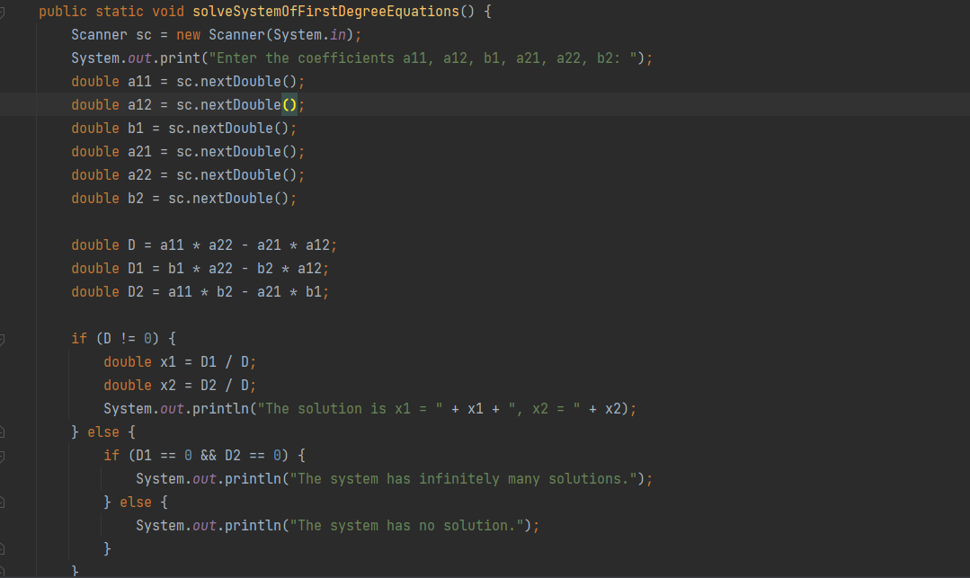

Figure 7: The system of first-degree equations with two variables

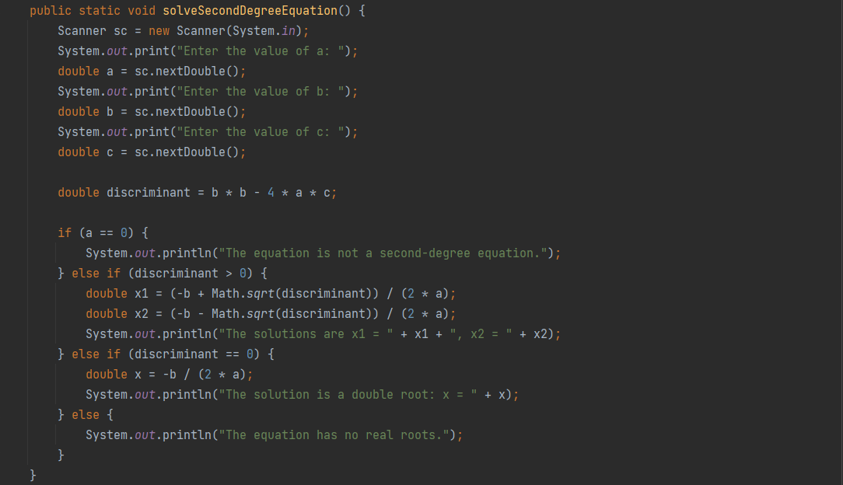

Figure 8: The second-degree equation with one variable

# **Part II: 6. Exercises:**

## Write, compile, and run the Choosing Option program:

Figure 9: Choosing Option program_ver1.0

* Nếu người dùng chọn "Cancel”, thì biến **option** sẽ nhận giá trị **JOptionPane.CANCEL_OPTION**. Sau đó, thông điệp "You've chosen: No" sẽ được hiển thị
* Sửa với 4 options: “Yes”, “No”, “I do”, “I don’t”.

Figure 10: Choosing Option program_ver2.0

## Write a program for input/output from keyboard

Figure 11: Program for input/output from keyboard

## Write a program to display a triangle with a height of n stars (*), n is entered by users.

Figure 12: Program to display a triangle

## Write a program to display the number of days of a month, which is entered by users (both month and year). If it is an invalid month/year, ask the user to enter again.

Figure 13: Program to display the number of days of a month

## Write a Java program to sort a numeric array and calculate the sum and average value of array elements.

Figure 14: Program to sort an array and calculate the sum and average value

## Write a Java program to add two matrices of the same size.

**Note**: You must create a new Java project for this exercise.

* The matrices can be entered by the user or constants.

Figure 15: Java program to add two matrices of same size