BÁO CÁO THỰC HÀNH LAB 2  
LẬP TRÌNH HƯỚNG ĐỐI TƯỢNG

**Table of Contents**

**1. Các nhánh trong github** 3

**2. Working with method overloading** 3

2.1. Overloading by differing types of parameters 3

2.2. Overloading by differing the number of parameters. 3

**3. Passing parameter** 3

**4. Use debug run** 3

**5. Classifier Member and Instance Member** 3

**6. Open the Cart class** 3

**7. Implement the Store class** 3

**8. Re-organize your projects** 3

**9. String, StringBuilder and StringBuffer** 3

**10. Release flow demonstration** 3

**Table of figures**

Figure 1: Method to add a list DVD to cart. 3

Figure 2: Check method to add a list DVD. 3

Figure 3: Method to add 2 DVDs to cart. 4

Figure 4: Check method to add 2 DVDs. 4

# **1. Các nhánh trong github**

# **2. Working with method overloading**

## 2.1. Overloading by differing types of parameters

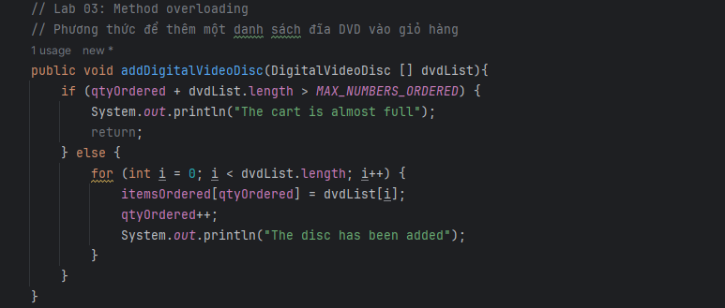

Figure 1: Method to add a list DVD to cart.

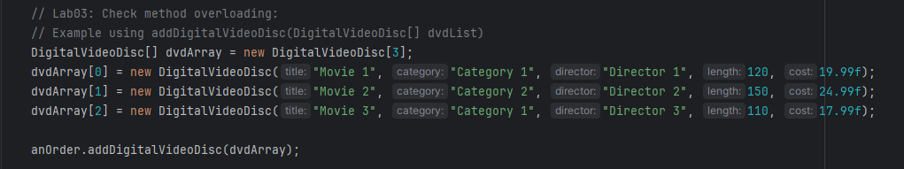

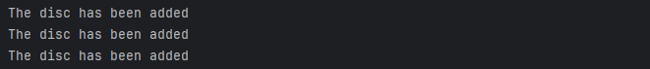

Figure 2: Check method to add a list DVD.

## 2.2. Overloading by differing the number of parameters.

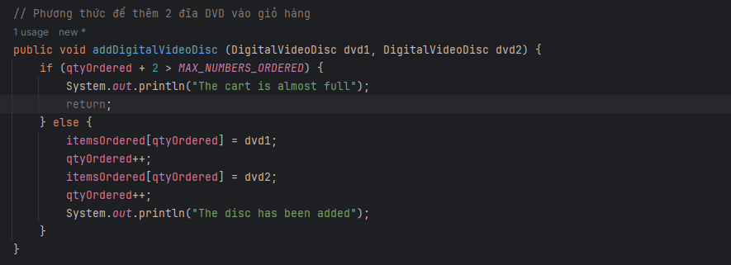

Figure 3: Method to add 2 DVDs to cart.

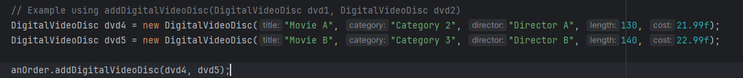

Figure 4: Check method to add 2 DVDs.



# **3. Passing parameter**

# **4. Use debug run**

# **5. Classifier Member and Instance Member**

# **6. Open the Cart class**

# **7. Implement the Store class**

# **8. Re-organize your projects**

# **9. String, StringBuilder and StringBuffer**

# **10. Release flow demonstration**