BÁO CÁO THỰC HÀNH LAP 1  
LẬP TRÌNH HƯỚNG ĐỐI TƯỢNG

# **Part I. The Very First Java Programs**

## 2.2.1Write, compile the first Java application:

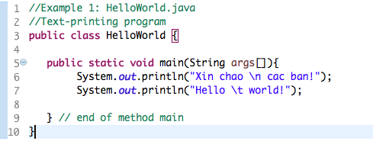

*Kết quả*

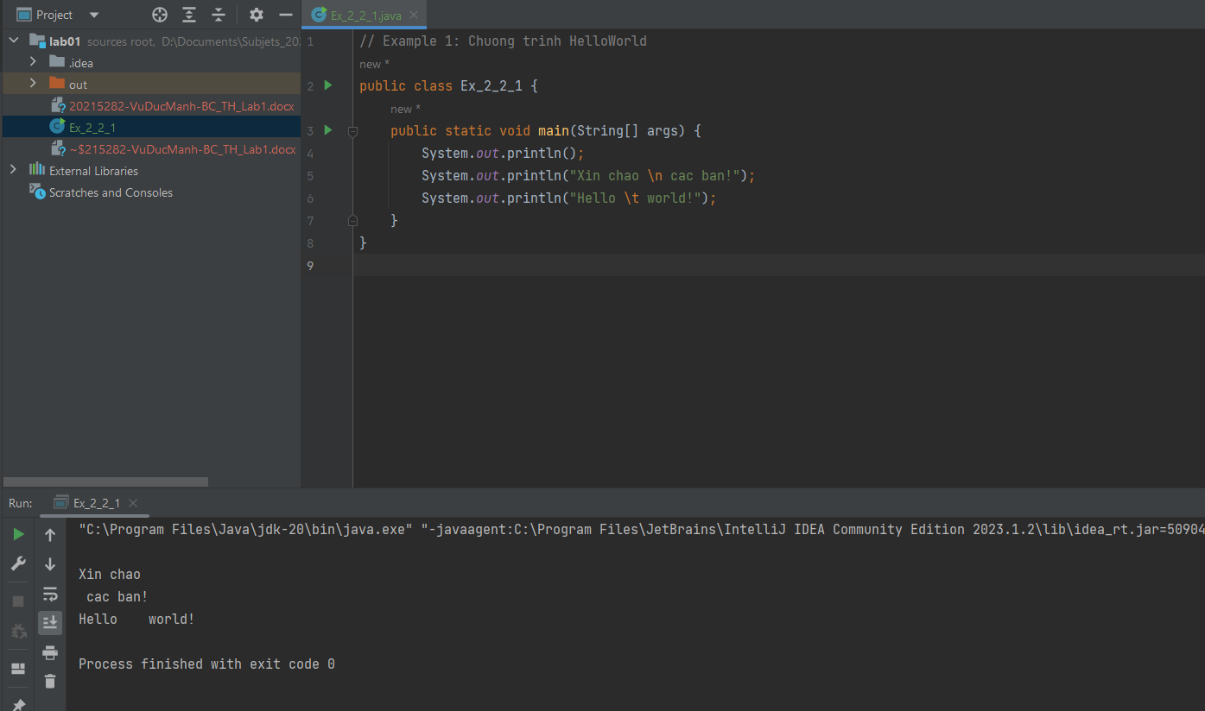

## Screen Shot 2019-02-12 at 122.2.2 Write, compile the first dialog Java program

### 

## 2.2.3 Write, compile the first input dialog Java application

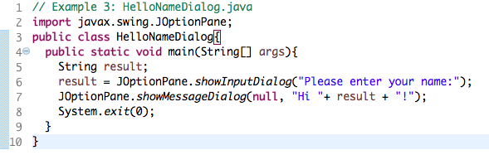

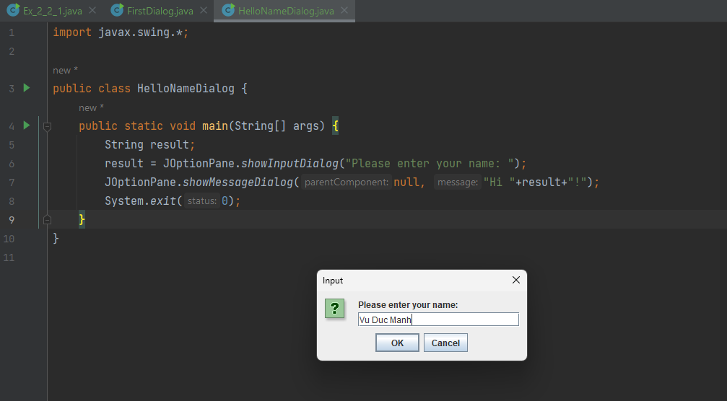

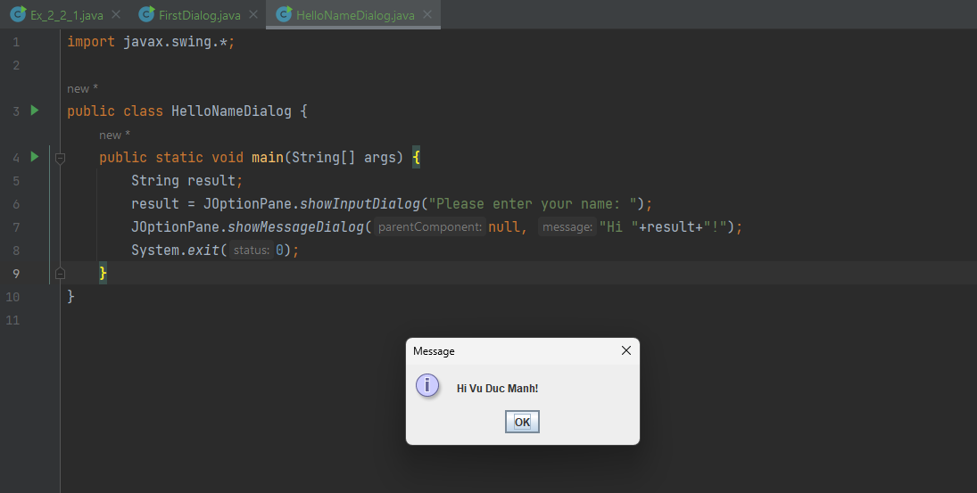

## 2.2.4 Write, compile, and run the following example:

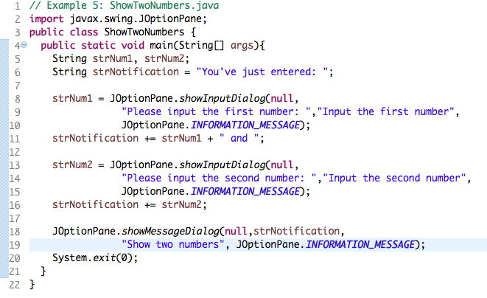

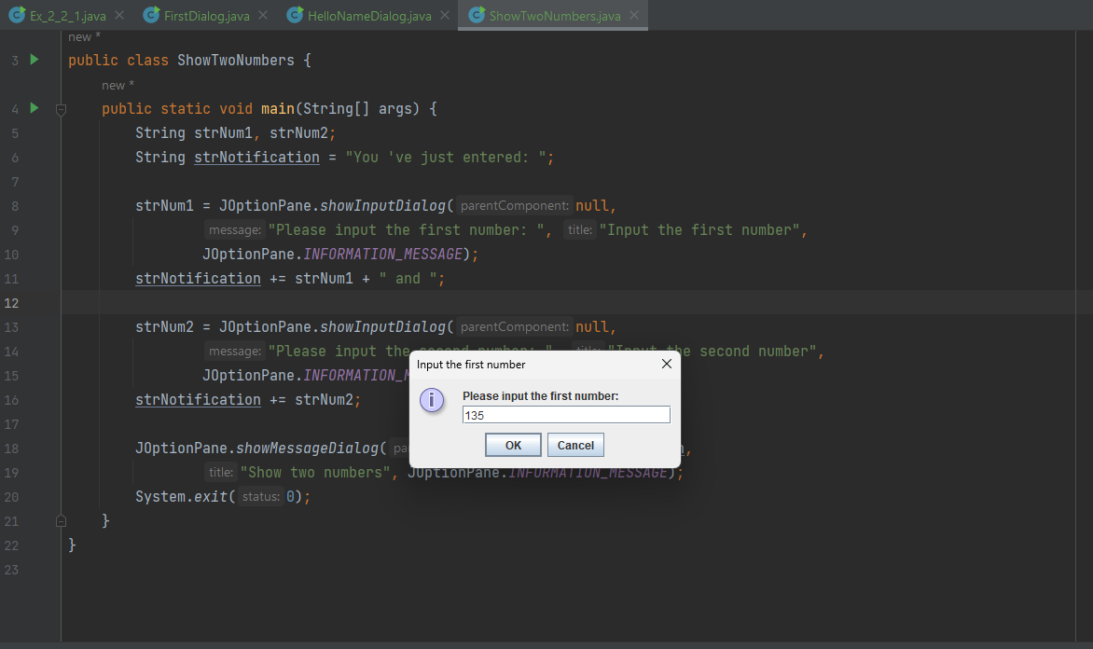

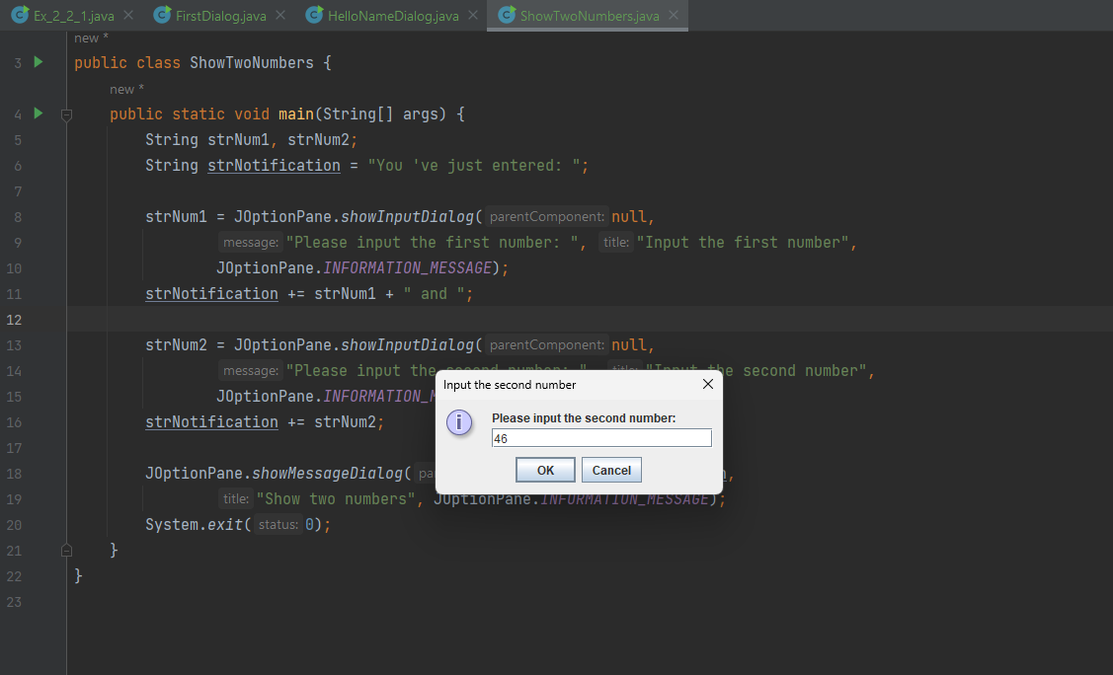

## 2.2.5 Write a program to calculate sum, difference, product, and quotient of 2 double numbers which are entered by users.

**Notes**

* To convert from String to double, you can use

**double num1 = Double.parseDouble(strNum1)**

* Check the divisor of the division

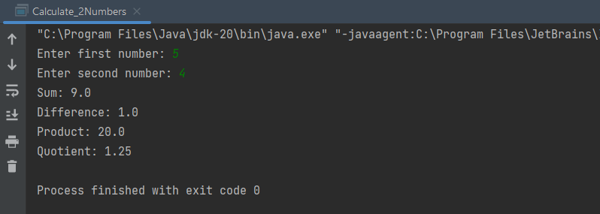

## 2.2.6. Write a program to solve:

* The first-degree equation (linear equation) with one variable
* The system of first-degree equations (linear system) with two variables
* The second-degree equation with one variable

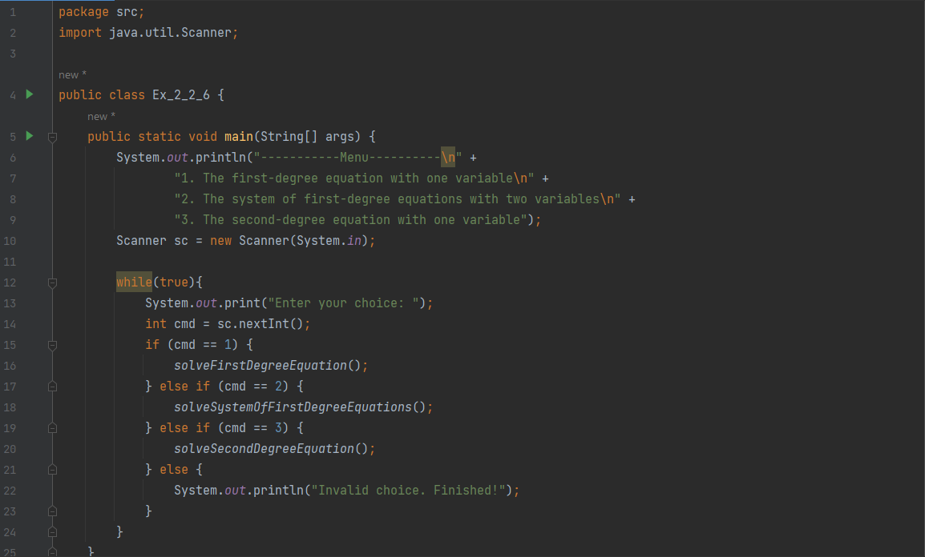

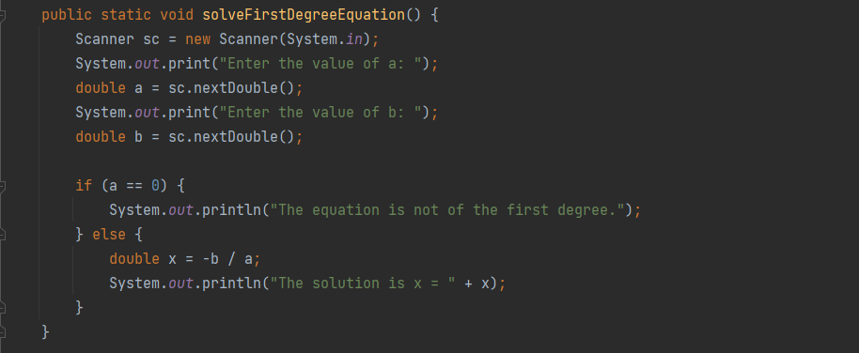

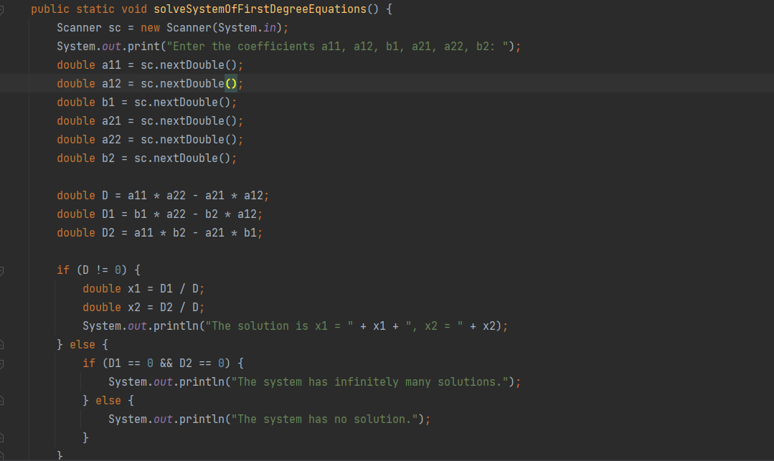

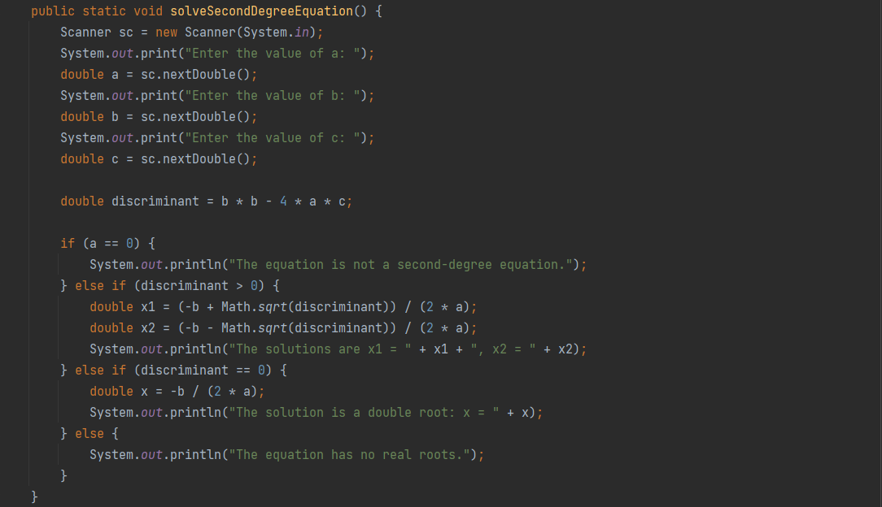

# **Part II: 6. Exercises:**

## Write, compile, and run the Choosing Option program:

* Nếu người dùng chọn "Cancel”, thì biến **option** sẽ nhận giá trị **JOptionPane.CANCEL_OPTION**. Sau đó, thông điệp "You've chosen: No" sẽ được hiển thị
* Sửa với 4 options: “Yes”, “No”, “I do”, “I don’t”.

## Write a program for input/output from keyboard

## Write a program to display a triangle with a height of n stars (*), n is entered by users.

## Write a program to display the number of days of a month, which is entered by users (both month and year). If it is an invalid month/year, ask the user to enter again.

## Write a Java program to sort a numeric array and calculate the sum and average value of array elements.

## Write a Java program to add two matrices of the same size.