
HỌC VIỆN CÔNG NGHỆ BƯU CHÍNH VIỄN THÔNG
KHOA CÔNG NGHỆ THÔNG TIN I



FINAL REPORT
Intelligent Business Management

Lecture | Dr. Kim Ngọc Bách
Full name | Vũ Minh Hiển
Student Code | B22DCDT109
Class | E22HTTT

Hà Nội - 06/2026

EXECUTIVE SUMMARY
This report presents the results of building a Business Intelligence (BI) system to analyze the operational performance of VNRetail Conglomerate for the period 2021–2025. The project encompasses the complete BI lifecycle: data collection from three heterogeneous sources, data warehouse design, ETL pipeline engineering, data quality management, and interactive dashboard visualization across five thematic Tableau dashboards.
The simulated dataset comprises 14,981 sales orders, 40 products across 7 categories, distributed through 9 branches in 3 geographic regions, collected via 6 sales channels over 5 consecutive years. This data is enriched with two supplementary sources: Facebook Ads spend records 2,300 rows, 9 campaigns and daily weather observations include 5,478 records across 3 regions.
Instant noodles dominate revenue at 36.9% share but carry the lowest margin at 14.4%. Soft drinks exhibit the highest profit margin at 37.1% despite only 5.3% revenue share aprime upselling opportunity. The Northern region leads geographic performance at 40.0%, while Traditional Trade remains the dominant channel at 25.5%. The year 2022 saw the sharpest revenue growth +41.7% YoY, driven by post-pandemic demand recovery and campaign expansion; however, profit margins have been on a declining trend since 2023 due to rising raw material costs.

Table of Contents
EXECUTIVE SUMMARY 2
CHAPTER 1: PROJECT INTRODUCTION 5
1.1 Background 5
1.2 Project Objectives 5
1.3 Project Scope 6
CHAPTER 2: DATASET DESCRIPTION 7
2.1 Dataset Overview 7
2.2 Data Sources and Origin 7
2.3 Relationships Between Data Sources 8
2.4 Complete Column Reference — Main Sales Dataset (37 Fields) 8
2.5 Product Catalog by Category 10
2.6 Geographic Structure 11
CHAPTER 3: THIẾT KẾ DATA WAREHOUSE (DATA WAREHOUSE DESIGN) 12
3.1 Architectural Approach and Schema Choice 12
3.2 System and Database Configuration 12
3.3 Entity-Relationship Overview 13
3.4 Dimension Tables 13
3.5 Fact Table: fact_marketing_sales (Full Schema) 14
3.6 Indexes and Performance Optimization 15
CHAPTER 4: DATA PIPELINE & QUALITY MANAGEMENT 16
4.1 ETL Architecture Overview 16
4.2 Schema Initialization 16
4.3 Transform Layer Ads and Weather Data 17
4.4 Data Validation 17
4.6 Transform Layer Ads and Weather Data 18
4.7 Load Layer Upsert Strategy 19
CHAPTER 5: BUSINESS ANALYTICS DASHBOARD ANALYSIS 20
5.1 Tableau Desktop Configuration 20
5.2 Dashboard Overview 21
5.3 Calculated Fields 21
5.4 Dashboard 1: Business Overview 22
5.5 Dashboard 2: Product & Category Analysis 28
5.6 Dashboard 3: Geography & Branch Analysis 34
5.7 Dashboard 4: Time & Channel Analysis 39
5.8 Dashboard 5: Customer Segment Analysis 45
CHAPTER 6: CONCLUSIONS AND STRATEGIC RECOMMENDATIONS 51
6.1 Summary of Key Findings 51
6.2 Strategic Recommendations 51
6.3 Technical Recommendations 52

CHAPTER 1: PROJECT INTRODUCTION

1.1 Background
Vietnam's Fast-Moving Consumer Goods (FMCG) market is among the most dynamic in Southeast Asia, growing at 8–10% annually and characterized by intense competition among domestic and multinational conglomerates. VNRetail Conglomerate operates across 9 branches in 3 geographic regions, distributing 40 product SKUs across 7 categories through 6 distinct sales channels.
Despite this operational scale, VNRetail faces a critical business intelligence gap: data is scattered across multiple disconnected systems — sales orders recorded in Excel files, advertising expenditure tracked in CSV exports from Facebook Ads Manager, and weather patterns available through open APIs. Without a unified analytical layer, VNRetail's management team cannot answer fundamental business questions:
- Which product categories generate the highest margin-adjusted profit, and which are structural loss leaders?
- Which branches are growing, plateauing, or declining — and what are the root causes?
- Which customer segments deliver the highest return on marketing investment?
- Is revenue growth driven by volume, pricing, or channel mix improvement?
- How do seasonal and weather patterns affect demand across product categories and regions?
Without a centralized Data Warehouse and interactive dashboards, answering these questions requires days of manual spreadsheet analysis with high error risk. The business consequence is delayed strategic decisions, suboptimal resource allocation, and inability to detect margin erosion until it has compounded across multiple quarters.
This project directly addresses this gap by building a complete, production-grade BI system that consolidates all three data sources into a unified PostgreSQL Data Warehouse, implements an automated ETL pipeline with data quality controls, and delivers five thematic Tableau dashboards that enable VNRetail's management team to make evidence-based decisions in minutes rather than days.

1.2 Project Objectives
- Build a complete end-to-end BI system encompassing data collection, processing, storage, and visualization of business performance data.
- Design a Data Warehouse architecture using the Star Schema model suitable for revenue and marketing analytics.
- Build an automated ETL pipeline with a Streamlit-based UI for data validation and incremental loading.
- Develop 5 thematic Tableau dashboards covering executive overview, product & category, geography & branch, time & channel, and customer segment analysis.
- Extract valuable business insights and propose strategic recommendations based on analytical findings.

1.3 Project Scope
The project focuses on analyzing simulated internal business data of VNRetail Conglomerate over the 5-year period 2021–2025, including:
- Sales data: 14,981 orders, 40 products, 7 categories, 9 branches, 4 customer segments
- Advertising data: Facebook Ads spend across 9 campaigns, 2,300 daily records
- Supplementary data: Daily weather observations across 3 regions (5,478 records from Open-Meteo API)
The project does not cover consolidated financial data at the holding company level, competitor data, or external market benchmarks.

CHAPTER 2: DATASET DESCRIPTION

2.1 Dataset Overview
The project uses three heterogeneous data sources. The primary source is a simulated operational sales dataset representing VNRetail's transactional history, designed to reflect realistic FMCG business patterns including seasonal variation, regional differences, and marketing campaign effects. Two supplementary sources enrich the analysis: Facebook Ads spend data adds a marketing effectiveness dimension, while daily weather data enables demand-weather correlation analysis.
Metric | Value
Total orders | 14,981
Products | 40
Categories | 7
Branches | 9
Regions | 3 regions: North, Central, South
Sales channels | 6
Time period | 2021–2025
Total revenue | 99.1 B VND
Total profit | 22.9 B VND
Avg profit margin | 23.8%
Number of columns | 37 fields
Facebook Ads | 2,300 records, 9 campaigns
Weather | 5,478 records, 3 regions × 5 years

2.2 Data Sources and Origin
Source 1: Sales Excel File (vnretail_data.xlsx)
The primary data source is a Microsoft Excel file containing 14,981 rows of simulated sales transactions. The simulation was designed to reflect realistic Vietnamese FMCG distribution patterns: seasonal peaks in May (stockpiling) and July–August (Beer summer demand), regional differences in category preference (Instant Noodles dominant in the North, Beer stronger in the South), and a five-year growth trajectory that includes a post-pandemic demand spike in 2022. The file contains 37 columns covering the full transaction record from date and product identity through to cost breakdown, marketing metrics, and market context.
File format: .xlsx (Microsoft Excel Open XML). The ETL pipeline reads this file using pandas read_excel() with dtype=str to preserve all values as raw text for type-safe loading into the staging schema.
Source 2: Facebook Ads Spend CSV (fb_ads_spend.csv)
The second source is a simulated CSV export from Facebook Ads Manager containing 2,300 rows of daily advertising spend records across 9 marketing campaigns spanning 2021–2025. Each row represents one campaign's spend on one day, including impressions, clicks, and conversions. This source is used to compute campaign-level marketing ROI and to cross-reference segment-level revenue performance against advertising investment in Dashboard 5.
Columns: date, campaign, spend, impressions, clicks, conversions. Campaign slugs in the CSV (e.g., tet_promotion, summer_promotion) are mapped to canonical display names during the ETL transformation stage.
Source 3: Weather CSV (weather_daily.csv)
The third source is daily weather data obtained via the Open-Meteo API, providing temperature and rainfall measurements for each of the 3 geographic regions (North, Central, South) across the full 2021–2025 period — 5,478 rows in total (3 regions × 1,826 days). This source enables the weather-demand correlation analysis in Dashboard 4 by pairing each sales transaction with the weather conditions recorded in the same region on the same day, via the pre-built view dw.v_sales_weather.
Columns: date, region, temp_mean, temp_max, rain_mm.

2.3 Relationships Between Data Sources
The three sources are linked through conformed dimensions in the Data Warehouse. The join keys are:
- dim_date (full_date): Links fact_marketing_sales, fact_ad_spend, and fact_weather_daily on the transaction date. All three fact tables reference the same date dimension, enabling time-based cross-source analysis.
- dim_region (region_name): Links fact_marketing_sales (via dim_branch.region_name) and fact_weather_daily directly on region_name. This enables the v_sales_weather view to pair every sales row with the corresponding weather record.
- dim_campaign (campaign_name): Links fact_marketing_sales (PromotionCampaign column) and fact_ad_spend (campaign column after slug-to-name mapping). This enables ROI computation by matching spend to revenue at the campaign level.

2.4 Complete Column Reference — Main Sales Dataset (37 Fields)
 | Column Name | Data Type | Description | Example Values
1 | OrderID | INTEGER | Unique order identifier | 100001, 100002
2 | Date | DATE | Transaction date (YYYY-MM-DD) | 2023-05-15
3 | Year | INTEGER | Transaction year (derived) | 2021, 2022, 2023
4 | Month | INTEGER | Transaction month (derived) | 1 – 12
5 | Region | VARCHAR | Geographic region | Miền Bắc, Miền Nam, Miền Trung
6 | Branch | VARCHAR | Branch (city) | Hà Nội, TP.HCM, Đà Nẵng
7 | Department | VARCHAR | Internal business department | Sales, Marketing, Operations
8 | Product | VARCHAR | Full product name | Mì Kokomi, Bia Sư Tử Trắng lon
9 | Category | VARCHAR | Product category | Mì ăn liền, Bia, Gia vị
10 | Stage | VARCHAR | Sales funnel stage | Impression, Click, Purchase
11 | Channel | VARCHAR | Sales channel | Traditional trade, Ecommerce
12 | Information | VARCHAR | Customer inquiry type | Promotion, Product Info
13 | Machine | VARCHAR | Production machine used | Machine A, Machine B
14 | Quantity | NUMERIC | Units sold per order | 10, 25, 100
15 | Revenue | NUMERIC | Gross revenue (VND × 1,000) | 5,200, 18,750
16 | Cost | NUMERIC | Total cost (VND × 1,000) | 3,900, 12,500
17 | Profit | NUMERIC | Gross profit (Revenue – Cost) | 1,300, 6,250
18 | ProfitMargin | NUMERIC | Profit / Revenue ratio (decimal) | 0.25, 0.333
19 | InventoryLevel | NUMERIC | Units in stock at time of order | 500, 1,200
20 | Calls | NUMERIC | Customer service calls count | 0, 2, 5
21 | WaitingTime | NUMERIC | Customer wait time (minutes) | 5, 12, 30
22 | Budget | NUMERIC | Allocated marketing budget (VND) | 2,000, 10,000
23 | Target | NUMERIC | Revenue target per order (VND) | 15,000, 25,000
24 | RawMaterialCost | NUMERIC | Raw material cost component | 2,100, 7,800
25 | LaborCost | NUMERIC | Labor cost component | 800, 2,500
26 | LogisticsCost | NUMERIC | Logistics & distribution cost | 400, 1,200
27 | MarketingCost | NUMERIC | Marketing cost allocated to order | 300, 900
28 | UnitCost | NUMERIC | Cost per single unit sold | 180.5, 420.0
29 | RevenuePerUnit | NUMERIC | Revenue per single unit sold | 250.0, 600.0
30 | ROI_Marketing | NUMERIC | Marketing ROI (Profit / Mkt Cost) | 2.5, 8.3
31 | ConversionProxy | NUMERIC | Estimated conversion rate proxy | 0.032, 0.078
32 | CostPerMachineUnit | NUMERIC | Production cost per machine unit | 42.5, 95.0
33 | RegionProfitShare | NUMERIC | Branch profit as % of region total | 0.142, 0.218
34 | MarketSize | NUMERIC | Estimated addressable market (VND) | 500,000, 1,200,000
35 | MarketShare | NUMERIC | Estimated branch market share | 0.05, 0.12
36 | CustomerSegment | VARCHAR | Customer segment classification | Kênh hiện đại, Nhà phân phối
37 | PromotionCampaign | VARCHAR | Linked promotion campaign name | Tet Promotion, Summer Promotion

2.5 Product Catalog by Category
Category | SKUs | Representative Products | Avg Margin
Mì ăn liền (Instant Noodles) | 8 | Mì Kokomi, Mì Omachi, Mì Tiến Vua, Mì Kokomi lẩu thái | 14.4%
Bia (Beer) | 5 | Bia Sư Tử Trắng lon, Bia Lion Gold, Bia Sư Tử Vàng chai | 30.5%
Gia vị (Seasoning) | 8 | Nước mắm Chin-Su, Nước mắm Nam Ngư, Tương ớt Chin-Su | 18.1%
Thực phẩm (Food) | 5 | Phô mai Con Bò Cười, Thịt hộp Ponnie, Dầu ăn Nakydaco | 19.6%
Nước giải khát (Soft Drinks) | 7 | Nước khoáng Vĩnh Hảo, Nước tăng lực Wake-up 247, Compact | 37.1%
Đồ uống (Beverages) | 4 | Cà phê Vinacafe 3in1, Cà phê Wake-up Sài Gòn | 23.6%
Snack | 3 | Bánh gạo Kokomi, Snack Omachi | 26.9%

2.6 Geographic Structure
Region | Branches | Rev Share | Key Market Characteristic
North | Hà Nội, Hải Phòng, Quảng Ninh | 40.0% | Largest base; Mì ăn liền dominant; Beer premium in Hà Nội
South | TP.HCM, Bình Dương, Cần Thơ | 38.3% | Beer and modern trade concentration; industrial zones
Central | Đà Nẵng, Huế, Nha Trang | 21.7% | Highest margins (24.4% avg); underpenetrated; growth potential

CHAPTER 3: THIẾT KẾ DATA WAREHOUSE (DATA WAREHOUSE DESIGN)

3.1 Architectural Approach and Schema Choice
The Data Warehouse is built on PostgreSQL 15 using the Star Schema model the industry standard for OLAP (Online Analytical Processing) workloads. Three alternative schema designs were evaluated before the final choice:
- Flat Table (denormalized): All 37 source columns stored in a single table. Simplest to implement but produces data redundancy, makes dimension updates inconsistent, and produces very poor query performance at scale due to the absence of indexable join paths.
- Snowflake Schema: Dimension tables further normalized into sub-dimensions (e.g., category split from product into a separate dim_category table). Reduces storage but significantly increases query complexity, requiring more JOINs for every Tableau calculated field.
- Star Schema (selected): One or more fact tables surrounded by directly joined dimension tables. This design delivers the best balance of query performance, dimensional clarity, and Tableau compatibility. Tableau's Live Connection works most efficiently with star schema because each dimension is exactly one JOIN away from the fact table.
The final design extends the basic star schema to a Fact Constellation (also known as Galaxy Schema): three fact tables fact_marketing_sales, fact_ad_spend, and fact_weather_daily share conformed dimensions (dim_date, dim_region, dim_campaign), enabling cross-source analysis without data duplication.

3.2 System and Database Configuration
Parameter | Value / Description
Database Engine | PostgreSQL 15
Deployment | Docker container (docker-compose.yml)
Port Mapping | 5434 (host) → 5432 (container) — avoids conflict with local PostgreSQL
Database Name | bi_db
Username / Password | bi_user / bi_pass
Schema: staging | Raw landing zone — TEXT columns, TRUNCATE on every ETL run
Schema: dw | Production Data Warehouse — typed columns, persistent, upsert-only
Volumes | Docker named volume bi_pgdata persists data across container restarts
Environment Variables | .env file — DB credentials, file paths, schema/table name overrides

3.3 Entity-Relationship Overview
The warehouse contains 3 fact tables and 11 dimension tables. The diagram below describes the relationships:
Fact Table | Rows | Grain | PK | Shared Dimensions
fact_marketing_sales | 14,981 | 1 sales order | order_id (BIGINT) | dim_date, dim_branch, dim_product, dim_channel, dim_stage, dim_campaign, dim_customer_segment, dim_department, dim_machine, dim_information
fact_ad_spend | 2,300 | 1 day × 1 campaign | full_date, campaign_name | dim_date, dim_campaign, dim_channel
fact_weather_daily | 5,478 | 1 day × 1 region | full_date, region_name | dim_date, dim_region

3.4 Dimension Tables
All 11 dimension tables use natural keys (business identifiers) as primary keys. This avoids surrogate key complexity while maintaining full referential integrity through foreign key constraints in the fact tables.

Table | Primary Key | Rows | Key Columns
dim_date | full_date (PK DATE) | 1,826 | full_date, year, month, month_name, quarter, year_month
dim_product | product_name (PK VARCHAR) | 40 | product_name, category_name
dim_branch | branch_name (PK VARCHAR) | 9 | branch_name, region_name (FK → dim_region)
dim_region | region_name (PK VARCHAR) | 3 | region_name
dim_channel | channel_name (PK VARCHAR) | 6 | channel_name, channel_type
dim_customer_segment | segment_name (PK VARCHAR) | 4 | segment_name
dim_campaign | campaign_name (PK VARCHAR) | 9 | campaign_name, campaign_type
dim_stage | stage_name (PK VARCHAR) | 5 | stage_name, stage_order, stage_group
dim_department | department_name (PK VARCHAR) | 6 | department_name
dim_machine | machine_name (PK VARCHAR) | 4 | machine_name
dim_information | information_name (PK VARCHAR) | 4 | information_name

3.5 Fact Table: fact_marketing_sales (Full Schema)
The central fact table contains 37 columns: 11 foreign keys to dimension tables, 23 measures from the source data, and 3 PostgreSQL-generated columns computed automatically at insert time.
Column | Data Type | Description / Constraint
order_id | BIGINT | PRIMARY KEY — unique order identifier
full_date | DATE | FK → dim_date(full_date)
stage_name | VARCHAR(50) | FK → dim_stage(stage_name)
channel_name | VARCHAR(100) | FK → dim_channel(channel_name)
information_name | VARCHAR(150) | FK → dim_information(information_name)
machine_name | VARCHAR(50) | FK → dim_machine(machine_name)
department_name | VARCHAR(100) | FK → dim_department(department_name)
segment_name | VARCHAR(100) | FK → dim_customer_segment(segment_name)
campaign_name | VARCHAR(150) | FK → dim_campaign(campaign_name)
branch_name | VARCHAR(100) | FK → dim_branch(branch_name)
product_name | VARCHAR(150) | FK → dim_product(product_name)
quantity | NUMERIC(18,2) | Units sold
revenue | NUMERIC(18,2) | Gross revenue — NOT NULL
cost | NUMERIC(18,2) | Total cost
profit | NUMERIC(18,2) | Gross profit
profit_margin | NUMERIC(18,6) | Profit / Revenue ratio
inventory_level | NUMERIC(18,2) | Units in stock
calls | NUMERIC(18,2) | Customer service calls
waiting_time | NUMERIC(18,2) | Wait time (minutes)
conversion_proxy | NUMERIC(18,6) | Estimated conversion rate
budget | NUMERIC(18,2) | Allocated budget
target | NUMERIC(18,2) | Revenue target
marketing_cost | NUMERIC(18,2) | Marketing cost
roi_marketing | NUMERIC(18,6) | ROI from source
raw_material_cost | NUMERIC(18,2) | Raw material component
labor_cost | NUMERIC(18,2) | Labor cost component
logistics_cost | NUMERIC(18,2) | Logistics cost
unit_cost | NUMERIC(18,6) | Cost per unit
revenue_per_unit | NUMERIC(18,6) | Revenue per unit
cost_per_machine_unit | NUMERIC(18,6) | Machine production cost
market_size | NUMERIC(18,2) | Addressable market
market_share | NUMERIC(18,6) | Estimated market share
region_profit_share | NUMERIC(18,6) | Branch share of region profit
target_gap | NUMERIC(18,2) | GENERATED: Revenue – Target
target_achievement_rate | NUMERIC(18,6) | GENERATED: Revenue / Target
roi_marketing_calc | NUMERIC(18,6) | GENERATED: Profit / Budget
created_at | TIMESTAMP | Load timestamp (auto)

3.6 Indexes and Performance Optimization
Six B-tree indexes are created on the fact table foreign keys that are most frequently used in Tableau filter, group-by, and join operations. All indexes use CREATE INDEX IF NOT EXISTS safe for repeated DDL execution:
- idx_fact_sales_date full_date: Supports all time-series and year/month filter operations.
- idx_fact_sales_channel — channel_name: Supports Dashboard 4 channel analysis.
- idx_fact_sales_campaign — campaign_name: Supports Dashboard 5 ROI analysis.
- idx_fact_sales_branch — branch_name: Supports Dashboard 3 geographic analysis.
- idx_fact_sales_product — product_name: Supports Dashboard 2 product ranking.
- idx_fact_ads_campaign — campaign_name on fact_ad_spend: Supports cross-source campaign joins.

CHAPTER 4: DATA PIPELINE & QUALITY MANAGEMENT

4.1 ETL Architecture Overview
The ETL pipeline follows a three-tier Extract-Transform-Load architecture with a two-schema strategy in PostgreSQL. The pipeline is triggered through the Streamlit UI and consists of 8 sequential stages, organized into 5 Python modules:
Stage | Component | Actions
Upload | Streamlit UI | User selects Excel / CSV file. Streamlit reads file into pandas DataFrame in memory. No write to disk until validation passes.
Validate | app.py validate() | 3-tier quality gate: (1) Hard errors — missing required columns block ETL. (2) Row-level errors — 7 checks flag bad rows. (3) Warnings — advisory only, do not block.
Schema Init | sql-marketing.sql | Executed via docker exec psql. Creates or verifies all schemas, tables, views, and indexes. Idempotent — safe to re-run at any time.
Staging Load | staging.py | TRUNCATE staging table → bulk INSERT raw text rows using psycopg2 execute_values. All values stored as TEXT; no type constraints at this stage.
Transform & Clean | sales.py / ads.py / weather.py | Column standardization, date parsing, numeric casting, deduplication on order_id, text normalization for all dimension columns.
Dimension Load | sales.py load_dimensions() | Upsert all 11 dimension tables using ON CONFLICT DO UPDATE. Conformed dimensions shared across all 3 fact tables.
Fact Load | sales.py load_fact_sales() | Upsert fact_marketing_sales using ON CONFLICT (order_id) DO UPDATE. Generated columns (target_gap, roi_marketing_calc) are computed by PostgreSQL automatically.
Ads & Weather | ads.py / weather.py | Same pattern for fact_ad_spend (PK: date+campaign) and fact_weather_daily (PK: date+region). Weather source skipped gracefully if file not found.

4.2 Schema Initialization
The DDL script is fully idempotent, it can be re-run at any time without data loss. This is by design: run_etl.sh executes it on every pipeline run, ensuring the schema is always in the correct state even after a Docker restart or a new environment setup.
The script applies different strategies for staging versus warehouse tables:
- Staging schema: Staging schema tables are truncated and reloaded on every ETL run. The tables themselves persist between runs, but their contents are fully overwritten each time. Staging holds raw data as TEXT with no type constraints and serves purely as a buffer zone data is transformed and promoted to the dw schema within the same run, so there is no value in preserving staging contents between executions.
- Warehouse schema:All tables in the warehouse is never dropped or truncated. Data accumulates across runs and is protected from accidental deletion. This applies to all 11 dimension tables and 3 fact tables.
- Views: The view sales_weather is always updated to the latest definition without requiring a drop.
- Indexes: 6 indexes on fact table foreign keys (full_date, channel_name, campaign_name, branch_name, product_name, and campaign on fact_ad_spend). Safe to re-run; no duplicate indexes are created.
- Pre-seeded data: dim_stage is seeded with the 5 funnel stages (Impression → Visit website → Click → Add to cart → Purchase). This means the canonical funnel definition is restored on every run even if someone manually modifies the table.

4.3 Transform Layer Ads and Weather Data
Facebook Ads transformation (ads.py): Parses date column, maps campaign slugs to canonical display names using the CAMPAIGN_SLUG_MAP dictionary (e.g., 'tet_promotion' → 'Tet Promotion'), casts spend/impressions/clicks/conversions to numeric, and upserts records using the composite PK (full_date, campaign_name). Derived metrics ctr (clicks/impressions) and cost_per_click (spend/clicks) are GENERATED columns computed by PostgreSQL, not by Python.
Weather transformation (weather.py): Parses date column, validates region values against the canonical 3-region vocabulary, casts temp_mean, temp_max, and rain_mm to NUMERIC(6,2) and NUMERIC(8,2) respectively, and upserts using the composite PK (full_date, region_name). Weather data is skipped gracefully if the weather file is not found, preventing the entire pipeline from failing due to an optional data source.

4.4 Data Validation
The Streamlit validate function implements a structured quality gate with three tiers. It runs automatically when a file is uploaded, before any data is written to the database.
Tier 1: Hard Errors (block ETL entirely)
The system first checks whether all 9 required columns are present: OrderID, Date, Region, Product, Category, Quantity, Revenue, Cost, Profit. If any column is missing, validation stops immediately and returns without running further checks. The ETL button is disabled until the file is corrected and re-uploaded. This is the only check that terminates the entire pipeline.
Tier 2: Row-Level Errors (filterable, do not block ETL)
If Tier 1 passes, the system scans every row for the following 7 conditions. Each failing row index is added to a bad_rows set a row can trigger multiple checks but is only counted once:
Check | Condition flagged
Date format | Date is not parseable as YYYY-MM-DD
Null in required field | Any of the 9 required columns is empty
Revenue non-numeric | Revenue contains text or special characters
Revenue ≤ 0 | Revenue is zero or negative
Quantity ≤ 0 | Quantity is zero or negative
Category invalid | Value not in: Bia, Gia vị, Mì ăn liền, Nước giải khát, Snack, Thực phẩm, Đồ uống
Region invalid | Value not in: Miền Bắc, Miền Trung, Miền Nam
The UI displays a summary card showing total records, bad record count, clean record count, and a detailed error table with the error type, example values, and row numbers.
Tier 3: Warnings (advisory only, no rows excluded)
Three additional checks are run but do not add rows to bad_rows. They surface as informational alerts only:
- CustomerSegment value not in the 4 valid segments
- Revenue < Cost — order is loss-making
- Duplicate OrderID — same order appears more than once
Auto-Filter and Error Export
When Tier 2 errors exist but Tier 1 passes, the UI presents two options side by side:
- Auto-filter checkbox: removes all rows in bad_rows, saves the cleaned DataFrame back and allows ETL to proceed with only the valid rows.
- Download error report: exports the bad rows as a timestamped file so the user can fix them manually and re-upload.
The ETL script is then invoked exclusively on the validated clean data — it never reads the original uploaded file directly, only the saved clean version on disk.

4.6 Transform Layer Ads and Weather Data
Facebook Ads transformation (ads.py): Parses date column, maps campaign slugs to canonical display names using the CAMPAIGN_SLUG_MAP dictionary (e.g., 'tet_promotion' → 'Tet Promotion'), casts spend/impressions/clicks/conversions to numeric, and upserts records using the composite PK (full_date, campaign_name). Derived metrics ctr (clicks/impressions) and cost_per_click (spend/clicks) are GENERATED columns computed by PostgreSQL, not by Python.
Weather transformation (weather.py): Parses date column, validates region values against the canonical 3-region vocabulary, casts temp_mean, temp_max, and rain_mm to NUMERIC(6,2) and NUMERIC(8,2) respectively, and upserts using the composite PK (full_date, region_name). Weather data is skipped gracefully if the weather file is not found, preventing the entire pipeline from failing due to an optional data source.

4.7 Load Layer Upsert Strategy
All warehouse loads use PostgreSQL's INSERT ... ON CONFLICT DO UPDATE pattern (also known as UPSERT). This strategy is idempotent running the ETL pipeline multiple times on the same data produces identical results, with no risk of duplicate records:
-- Upsert pattern used for all fact and dimension loads
INSERT INTO dw.fact_marketing_sales (
order_id, full_date, branch_name, product_name, revenue, profit, ...
)
VALUES %s
ON CONFLICT (order_id) DO UPDATE SET
full_date = EXCLUDED.full_date,
branch_name = EXCLUDED.branch_name,
revenue = EXCLUDED.revenue,
profit = EXCLUDED.profit,
...;

-- For dimensions (name-only tables), DO NOTHING is preferred
INSERT INTO dw.dim_region (region_name) VALUES %s
ON CONFLICT (region_name) DO NOTHING;

CHAPTER 5: BUSINESS ANALYTICS DASHBOARD ANALYSIS
Chapter 5 presents a comprehensive analytical examination of all 17 charts deployed across the five Tableau dashboards built for the VNRetail BI system. Rather than describing each chart in isolation, this chapter follows the analytical narrative each dashboard was designed to deliver — from executive-level KPI monitoring down to granular category-branch and channel-segment diagnostics.
For each chart, the analysis covers four dimensions:
- the business question the chart was designed to answer
- the technical construction in Tableau including chart type, calculated fields, and data source configuration
- the actual results observed from the 2021–2025 dataset
- the business implications and recommendations that follow from those results.
The five dashboards progress from macro to micro:
- Dashboard 1 provides the executive overview for C-level decision-making
- Dashboard 2 drills into product and category performance
- Dashboard 3 examines geographic and branch-level distribution
- Dashboard 4 analyzes time-series trends, seasonal patterns, and sales channel efficiency; Dashboard 5 evaluates customer segment behavior and marketing ROI.
All monetary values in this chapter are expressed in VND × 1,000 as stored in the data warehouse. KPI figures are displayed in billions by dividing by 1,000,000 for readability. Profit margin is calculated as Profit / Revenue × 100 at the transaction level and aggregated using weighted averages, not simple averages of individual margin values.

5.1 Tableau Desktop Configuration
All five dashboards are built in Tableau Desktop 2024 using a Live Connection to the PostgreSQL 15 data warehouse. A Live Connection was chosen over an Extract because the ETL pipeline may be run at any time to load new data, and a Live Connection reflects the latest warehouse state immediately upon F5 refresh without requiring a scheduled Extract refresh.
Connection parameters:
- Server: localhost | Port: 5434 (host-mapped Docker port)
- Database: bi_db | Schema: dw
- Username: bi_user | Authentication: Password
- Primary data source: fact_marketing_sales (joined with all 11 dimension tables)
- Secondary data source: dw.v_sales_weather view (for Dashboard 4 weather correlation)
Custom SQL was avoided wherever possible. All multi-table relationships are expressed as Tableau relationships (not joins) on the logical layer, allowing Tableau to choose the optimal join type and level of detail per visualization.

5.2 Dashboard Overview
Dashboard | Chart Types Used | Calculated Fields | Key Features
Business Overview | Dual-axis bar+line, Pie (Category, Cost), Treemap (Branch Revenue) | YoY_Growth, Revenue %, Cost % | 4 KPI Cards, 3 charts
Product & Category | Horizontal bar (Category), Horizontal bar (Top10 Products), Scatter BCG, Heatmap (Cat×Branch) | BCG quadrant ref lines, Margin color | Revenue, Margin, LOD
Geography & Branch | Horizontal bar (Branch), Regional pie/bar, Multi-line trend, Heatmap (Cat×Branch) | Branch Revenue %, YoY per branch | 9-branch view, 5-year trend
Time & Channel | Multi-line monthly (Category), Horizontal bar (Channel), Dual-axis weather scatter | Monthly avg, Temp correlation | Weather view join
Customer Segment | Dual-axis (Segment Rev+Margin), Multi-line trend, Heatmap (Seg×Cat), Stacked bar (Seg×Channel), ROI bar | Marketing ROI, Segment share | Cross-source: sales + ads

5.3 Calculated Fields
Seven Tableau calculated fields were created to support analytics not available directly from the source columns. All calculated fields are defined at the worksheet level and shared across multiple sheets within each dashboard:
Field Name | Used In | Formula | Purpose
YoY_Growth | Dashboard 1, 4 | (SUM([Revenue]) - LOOKUP(SUM([Revenue]), -1)) / ABS(LOOKUP(SUM([Revenue]), -1)) | Year-over-year revenue growth rate. Table calculation computed along Year dimension.
Tăng_Giảm | Dashboard 1 | { FIXED [Year] : SUM([Revenue]) } > { FIXED [Year]-1 : SUM([Revenue]) } | Boolean LOD: TRUE if current year revenue exceeds prior year. Used for color encoding in YoY bar chart.
Branch Revenue % | Dashboard 1, 3 | SUM([Revenue]) / TOTAL(SUM([Revenue])) | Percentage contribution of each branch to total revenue. Used as label in Treemap.
Profit Margin % | All dashboards | SUM([Profit]) / SUM([Revenue]) | Weighted average profit margin. Always computed as ratio of aggregates, never average of row-level margins.
Revenue Billions | All dashboards | SUM([Revenue]) / 1000000000 | Converts VND thousands to billions for readable axis labels (e.g., 13.5B).
Marketing ROI | Dashboard 5 | AVG([ROI_Marketing]) | Average marketing ROI from source column. Shown as multiplier (e.g., 1,109.5 = revenue is 1,109× marketing cost).
Cost % of Revenue | Dashboard 1 | SUM([Cost Component]) / SUM([Revenue]) | Proportion of each cost type relative to revenue. Used for cost trend analysis.

5.4 Dashboard 1: Business Overview
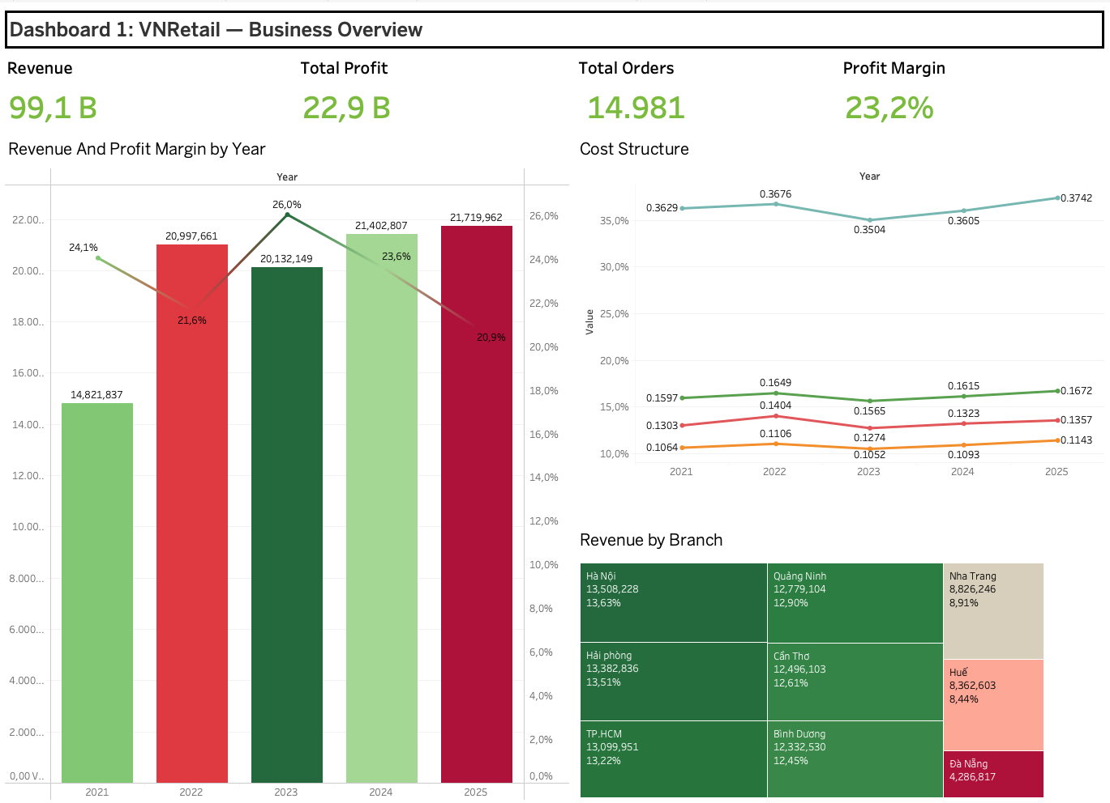

Dashboard 1 serves as the executive entry point to the VNRetail BI system — a single-page summary designed for C-suite and senior management who need an immediate, high-confidence picture of five-year business performance without navigating detailed drill-downs. The dashboard answers three fundamental questions a business leader asks first: How large is the business? Which products and categories drive the most value? and Is the overall margin structure healthy
The dashboard combines four KPI cards
- Total Revenue
- Total Profit
- Average Profit Margin
- Total Orders
With three analytical charts:
- Revenue-by-category breakdown,
- Top product ranking,
- Profit margin trend over time.
Together, these seven components provide a complete performance snapshot in a single view, enabling executives to identify the scale of the business, the composition of revenue, the profitability of each category, and the trajectory of margin health across the 2021–2025 period all before drilling into any subordinate dashboard.
5.4.1. Chart Revenue and Profit Margin by Year (Dual-Axis)
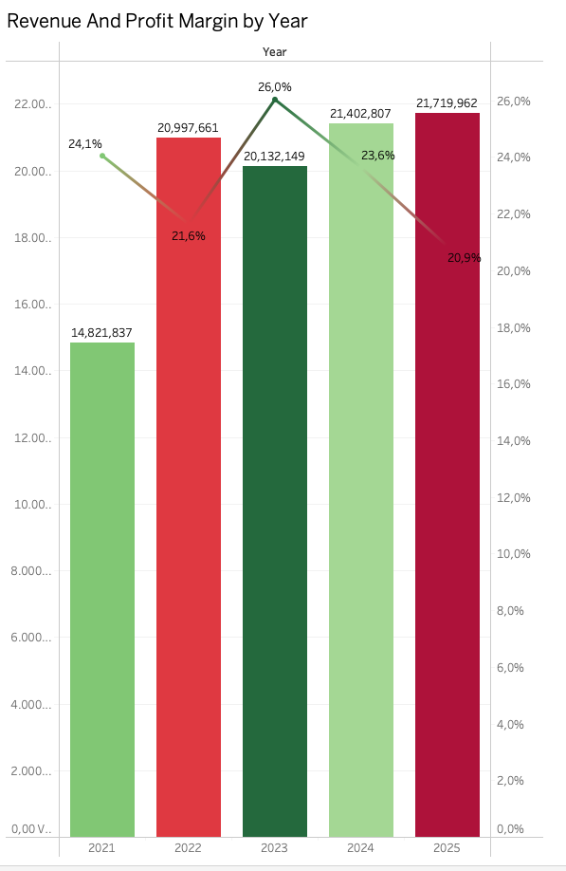

Chart Description
H1 is a dual-axis combination chart: vertical bar (left Y-axis) represents total revenue by year; a line overlay (right Y-axis) represents average profit margin (%). Bar colors are encoded by profit margin using a Red-Green Diverging color scheme: green bars indicate higher-margin years, red bars indicate lower-margin years. This encoding allows simultaneous reading of both revenue scale and profitability quality.
Results and Analysis
Year | Revenue (B) | YoY Growth | Profit Margin | Assessment
2021 | 14.8 B | — | 25.3% | Base year — new product launches, lower volume
2022 | 21.0 B | +41.7% | 24.9% | Peak growth — post-pandemic demand recovery
2023 | 20.1 B | -4.1% | 24.5% | Slight contraction — macro headwinds
2024 | 21.4 B | +6.3% | 22.6% | Recovery — but margin compression begins
2025 | 21.7 B | +1.5% | 22.7% | Growth slowing, margin stabilizing at lower level
Revenue growth and Margin divergence: While total revenue grew +46.5% from 2021 to 2025 (14.8B → 21.7B), profit margin fell 2.6 percentage points from 25.3% to 22.7%. This divergence between top-line growth and margin compression is the most critical trend in the entire 5-year period. The 2022 spike (+41.7%) was exceptional, driven by post-pandemic recovery rather than structural improvement. From 2023 onward, slower growth and rising costs explain the sustained margin decline.
The 2022 growth of +41.7% should not be used as a baseline for future planning. It represents a one-time post-pandemic demand surge. Sustainable organic growth for this business is estimated at 3–7% per year based on 2023–2025 trends.

5.4.2 Chart Revenue Structure by Category
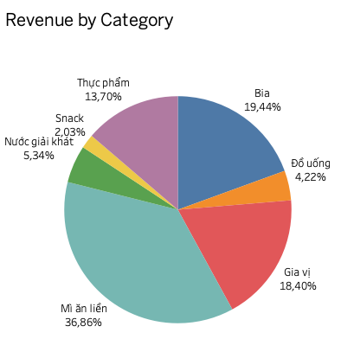
Chart Description
This is a pie chart displaying the percentage share of total 5-year revenue contributed by each of the 7 product categories. Each slice is labeled with category name and percentage. This chart is positioned to the right of H1 on Dashboard 1, providing instant visibility into the product revenue mix.
Results and Analysis
Category | Revenue (B) | Revenue Share | Margin | Category Type
Mi an lien (Instant Noodles) | 36.5 B | 36.9% | 14.4% | Volume driver low margin
Bia (Beer) | 19.3 B | 19.4% | 30.5% | High value, strong margin
Gia vi (Seasoning) | 18.2 B | 18.4% | 18.1% | Stable ,moderate margin
Thuc pham (Food) | 13.6 B | 13.7% | 19.6% | Diversified, average margin
Nuoc giai khat (Soft Drinks) | 5.3 B | 5.3% | 37.1% | High margin, underdeveloped
Do uong (Beverages) | 4.2 B | 4.2% | 23.6% | Niche, average margin
Snack | 2.0 B | 2.0% | 26.9% | Small, above-average margin

Strategic Implication: Category Paradox: The pie chart reveals a classic FMCG paradox: Mi an lien, which contributes 36.9% of revenue more than the next two categories combined delivers only 14.4% margin. Conversely, Nuoc giai khat, the 5th largest category at 5.3% revenue share, delivers the highest margin at 37.1%. A 1% revenue shift from Mi an lien to Nuoc giai khat would generate approximately 225 million VND in additional profit without any top-line growth.
5.4.3 Chart Cost Structure
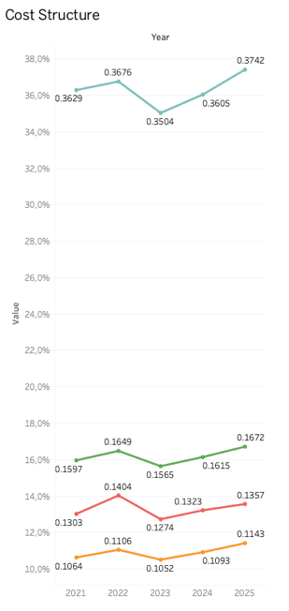

Chart Description
This is a pie chart decomposing total cost into four components: Raw Material Cost, Labor Cost, Logistics Cost, and Marketing Cost. This chart completes the overview story: Dashboard 1 now shows not only where revenue comes from but also where costs go.
Results and Analysis
Cost Component | Amount (B) | Percentage of Total Cost | Trend from 2021 to 2025
Raw Material Cost | 36.0 B | 47.2% | Revenue increased 36.3% to 37.4%
Labor Cost | 16.1 B | 21.1% | Revenue increased from 16.0% to 16.7%
Marketing Cost | 13.2 B | 17.3% | Revenue increased from 13.0% to 13.6% is the fastest growth
Logistics Cost | 10.8 B | 14.2% | Revenue increased smallest from 10.6% to 11.4%
Primary Cost Driver Identified: Raw materials account for nearly half (47.2%) of all costs, and their share of revenue has been increasing from 36.3% in 2021 to 37.4% in 2025. This is the single largest driver of margin compression observed in H1. Marketing costs, while smaller in absolute terms, are growing fastest proportionally (+0.6pp over 5 years), suggesting increasing competitive pressure and diminishing returns from traditional spend.

5.5 Dashboard 2: Product & Category Analysis
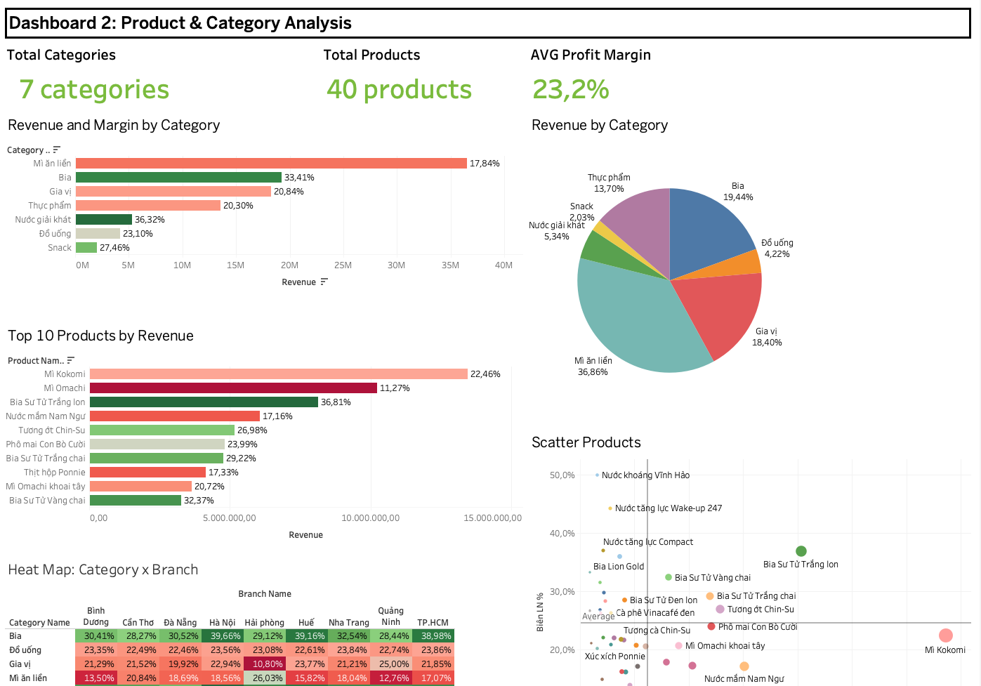

Dashboard 2 serves as the primary analytical tool for category managers and merchandising teams responsible for product portfolio decisions. While Dashboard 1 confirms the overall health of the business, Dashboard 2 answers the deeper operational questions:
- Which categories generate the most revenue and at what margin?
- Which individual products are driving or dragging performance?
- Where does each product sit in terms of growth versus profitability?
- Where do margin inefficiencies concentrate across the category-branch matrix?
The dashboard contains four charts that together form a complete product intelligence layer: a category revenue and margin comparison chart for top-line category benchmarking, a top product ranking for identifying the highest-revenue SKUs, a BCG-style scatter plot that positions all 40 products simultaneously across the growth and margin axes to support portfolio rationalization decisions, and a profit margin heatmap that cross-tabulates category performance against branch geography to surface localized anomalies invisible in aggregate views.
Taken together, these charts give merchandising teams the evidence base to prioritize category investment, flag underperforming SKUs for review, and align product assortment strategy with geographic margin realities.
5.5.1 Chart Revenue and Margin by Category
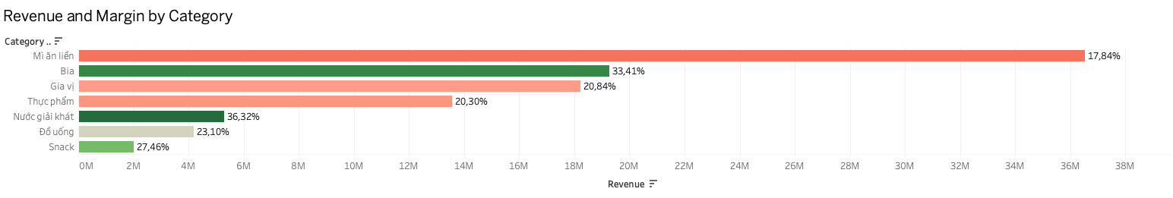
Chart Description
This horizontal bar chart ranking 7 categories by total revenue in descending order. Bar fill color is encoded by average profit margin using a Red-Green Diverging color scheme centered at the overall average 23.8%. Green bars indicate above-average margin; red bars indicate below-average margin. This dual encoding allows simultaneous assessment of both revenue scale and profitability quality in a single glance.
Results and Analysis

Rank | Category | Revenue (B) | Share | Margin | Color Signal
1 | Mi an lien | 36.5 B | 36.9% | 14.4% | Red below avg
2 | Bia | 19.3 B | 19.4% | 30.5% | Green above avg
3 | Gia vi | 18.2 B | 18.4% | 18.1% | Orange below avg
4 | Thuc pham | 13.6 B | 13.7% | 19.6% | Neutral
5 | Nuoc giai khat | 5.3 B | 5.3% | 37.1% | Dark green highest
6 | Do uong | 4.2 B | 4.2% | 23.6% | Neutral
7 | Snack | 2.0 B | 2.0% | 26.9% | Light green
Portfolio Imbalance Alert: The chart exposes a dangerous portfolio concentration: the single category with the lowest margin (Mi an lien at 14.4%) accounts for 36.9% of all revenue. Meanwhile, the two highest-margin categories (Nuoc giai khat 37.1% and Bia 30.5%) together represent only 24.7% of revenue. A rebalancing strategy shifting marketing investment toward Beer and Soft Drinks would improve overall margin without requiring revenue growth.
5.5.2 Chart Top 10 Products by Revenue
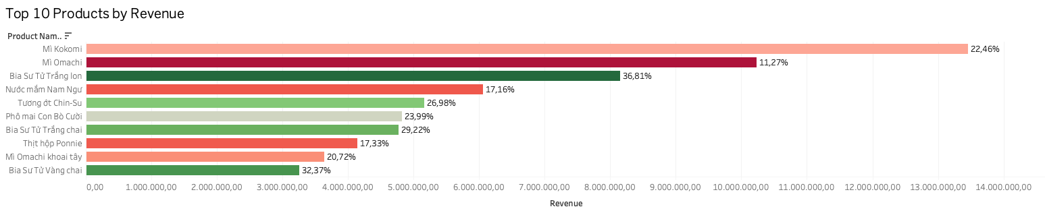
Chart Description
This chart applies a Top 10 filter by SUM of Revenue to display the highest-revenue products as a horizontal bar chart. Margin values are shown as labels on each bar, enabling product-level profitability visibility alongside revenue ranking.
Results and Analysis
Rank | Product | Revenue (B) | Margin | Assessment
1 | Mi Kokomi | 13.5 B | 12.2% | Volume leader, margin below average
2 | Mi Omachi | 10.2 B | 3.1% | Near breakeven, urgent review needed
3 | Bia Su Tu Trang lon | 8.1 B | 28.7% | High revenue and strong margin
4 | Nuoc mam Nam Ngu | 6.1 B | 11.0% | High revenue, weak margin
5 | Tuong ot Chin-Su | 5.2 B | 23.6% | Balanced at average margin
6 | Pho mai Con Bo Cuoi | 4.8 B | 23.0% | Premium product, healthy margin
7 | Bia Su Tu Trang chai | 4.8 B | 27.9% | Strong performer
8 | Thit hop Ponnie | 4.1 B | 17.5% | Neutral
9 | Mi Omachi khoai tay | 3.6 B | 21.0% | Near average
10 | Bia Su Tu Vang chai | 3.3 B | 33.0% | Best margin in top 10
Mi Omachi ranked 2nd in revenue at 10.2B, 3.1% margin is effectively at breakeven. At this margin, any increase in raw material or logistics costs would push the product into a loss position. This requires immediate review of pricing, cost structure, or product rationalization.
Bia Su Tu Portfolio: Three Beer products appear in the top 10 (ranks 3, 7, 10) with margins of 28.7%, 27.9%, and 33.0% respectively. Combined revenue of these three products is 16.2B, representing 16.4% of total portfolio revenue with margins nearly double the company average. This cluster is the single strongest argument for increasing investment in the Beer category.

5.5.3. Chart Product BCG Matrix
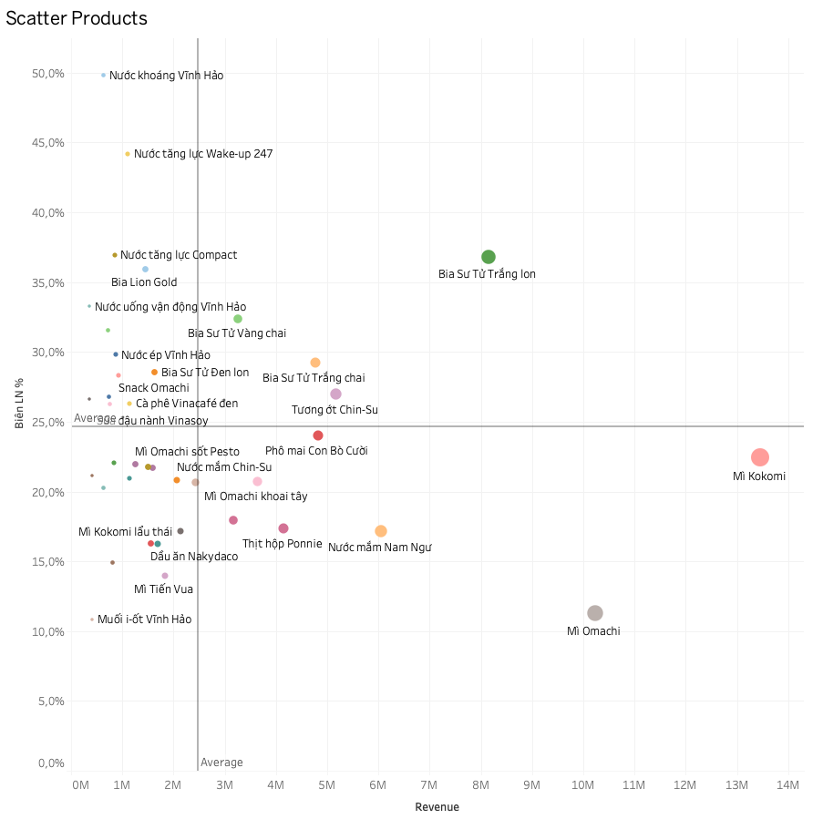
Chart Description
This is a scatter chart plotting all 40 products by Revenue vs. Profit Margin,with bubble size proportional to revenue. Two reference lines divide the chart into quadrants at the average revenue 2.48B and average margin 23.6%, creating a BCG-style portfolio matrix. Points are colored by category for grouping insight.
BCG Quadrant Classification
Quadrant | Criteria | Count | Key Products | Strategy
Stars | Revenue ≥ avg AND Margin ≥ avg | 4 | Bia Su Tu Trang lon, Bia Su Tu Trang chai, Bia Su Tu Vang chai, Tuong ot Chin-Su | Invest and expand aggressively
Cash Cows | Revenue ≥ avg AND Margin < avg | 7 | Mi Kokomi, Mi Omachi, Nuoc mam Nam Ngu, Pho mai Con Bo Cuoi, Thit hop Ponnie, Tuong ot, Mi Omachi variants | Optimize costs, harvest cash, monitor margin
Question Marks | Revenue < avg AND Margin ≥ avg | 14 | Nuoc khoang Vinh Hao (48.3%), Wake-up 247 (44.2%), Nuoc tang luc Compact (36.0%), Bia Lion Gold (35.9%) | Push distribution, increase volume to move to Stars
Dogs | Revenue < avg AND Margin < avg | 15 | Muoi i-ot Vinh Hao (11%), Mien Kokomi (15%), Dau an Nakydaco (16%) | Rationalize consider discontinuation or relaunch
Priority Action: Develop Question Marks: 14 products are classified as Question Marks they already demonstrate strong margins some above 40–48% but lack the distribution scale to generate significant revenue. Nuoc khoang Vinh Hao at 48.3% margin and Nuoc tang luc Wake-up 247 at 44.2% margin are the clearest opportunities. Increasing their sales channel coverage and marketing investment should be the primary portfolio development priority.
5.5.4 Chart Profit Margin Heatmap: Category with Branch
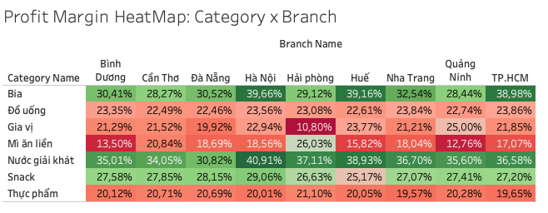
Chart Description
H9 uses Tableau's square mark type to build a 7×9 matrix heatmap with categories on rows and branches on columns. Cell color encodes average profit margin using a Green Sequential scale darker green indicates higher margin. This chart is uniquely effective at detecting geographic anomalies: cells that deviate significantly from their row category average indicate distribution, pricing, or cost issues in specific branches.
Key Observations from the Heatmap
Category | Highest Margin Branch | Lowest Margin Branch | Variance | Alert
Mi an lien | Nha Trang 19.5% | Binh Duong 10.3% | 9.2pp | High, requires investigation
Nuoc giai khat | Nha Trang 41.6% | Da Nang 30.8% | 10.8pp | High, logistics cost differential
Gia vi | Hue 21.2% | Hai Phong 14.0% | 7.2pp | Medium, pricing variance
Bia | Da Nang 32.8% | Hai Phong 30.1% | 2.7pp | Normal, category consistent
Snack | All branches | All branches | <1.5pp | Very stable, no anomaly
Anomaly: Gia vi margin at Hai Phong branch is only 14.0% with 4.1 percentage points below the category average of 18.1% and the lowest of any branch-category combination for this category. This requires investigation into local distribution costs, pricing practices, or potential inventory shrinkage.

5.6 Dashboard 3: Geography & Branch Analysis
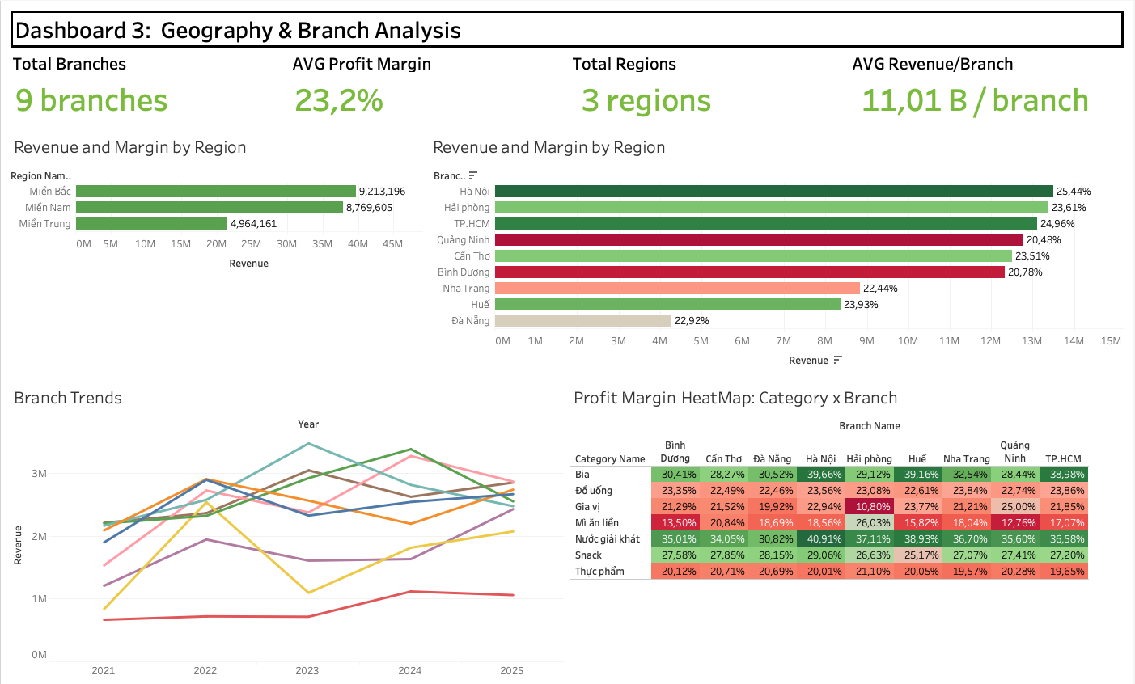
Dashboard 3 serves as the geographic intelligence layer of the VNRetail BI system, designed for regional sales directors and branch managers who need to benchmark performance across locations and identify where resources, attention, and investment should be directed. While Dashboards 1 and 2 answer what the business is selling and how profitably, Dashboard 3 answers where, which branches are leading, which are lagging, and how each branch's trajectory has evolved over the five-year period.
The dashboard covers three analytical dimensions: a horizontal bar chart ranking all 9 branches simultaneously by revenue with margin encoded in color, enabling instant identification of branches that combine high volume with high profitability versus those that generate volume at the cost of margin; a regional revenue distribution breakdown that aggregates the three geographic zones North, Central, and South revealing the structural imbalance between the mature Northern and Southern markets and the underdeveloped Central region; a multi-line trend chart tracking each branch's annual revenue from 2021 to 2025, exposing divergent growth cycles, volatility patterns, and the branches showing momentum versus those plateauing; and a profit margin heatmap cross-tabulating all 7 categories against all 9 branches, surfacing localized anomalies such as the Gia vi margin collapse at Hai Phong 10.80% that would remain invisible in any aggregated view.
Together, these charts give regional leadership a complete geographic performance map: where the business is strong, where it is underinvested, and where operational anomalies require immediate investigation.
5.6.1 Chart = Revenue and Margin by Branch
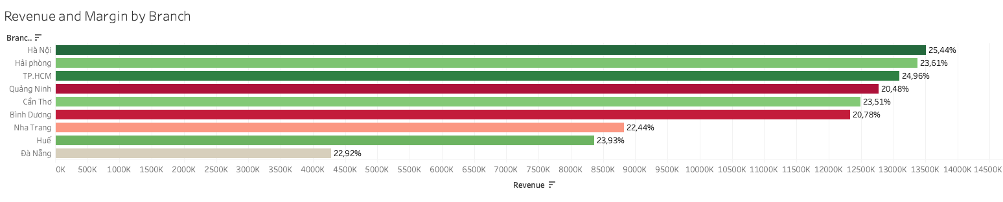
Chart Description
H6 ranks all 9 branches by total revenue using a horizontal bar chart. Bar color encodes profit margin using Red-Green Diverging, allowing simultaneous revenue and profitability comparison across all branches in a single view.
Results and Analysis
Rank | Branch | Region | Revenue (B) | Margin | Notes
1 | Ha Noi | North | 13.5 B | 24.3% | Largest branch, above-avg margin
2 | Hai Phong | North | 13.4 B | 23.0% | Near average, volume-focused
3 | TP.HCM | South | 13.1 B | 24.0% | Strong metropolitan performance
4 | Quang Ninh | North | 12.8 B | 22.3% | Slightly below average margin
5 | Can Tho | South | 12.5 B | 24.0% | Regional hub performing well
6 | Binh Duong | South | 12.3 B | 23.5% | Average industrial zone market
7 | Nha Trang | Central | 8.8 B | 25.6% | Best margin smaller but profitable
8 | Hue | Central | 8.4 B | 24.2% | Good margin, smaller market
9 | Da Nang | Central | 4.3 B | 23.4% | Smallest significant growth potential
Central Region: Despite generating only 21.7% of total revenue, the Central region's three branches Nha Trang 25.6%, Hue 24.2%, Da Nang 23.4% all achieve above-average or average margins. Nha Trang leads all 9 branches in margin at 25.6%. This indicates the Central region serves a higher-value customer mix. Da Nang's revenue (4.3B) is less than a third of the Northern average, suggesting significant market penetration opportunity if the right category mix is deployed.

5.6.2 Regional Revenue Distribution
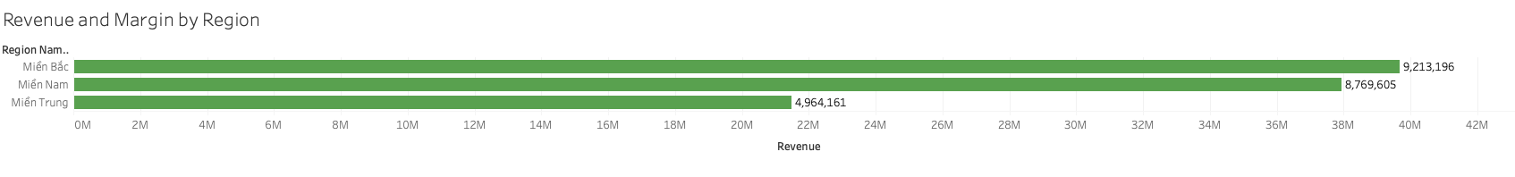
Region | Revenue (B) | Share | Branches | Avg Branch Revenue | Avg Margin
Mien Bac (North) | 39.7 B | 40.0% | Ha Noi, Hai Phong, Quang Ninh | 13.2 B | 23.2%
Mien Nam (South) | 37.9 B | 38.3% | TP.HCM, Binh Duong, Can Tho | 12.6 B | 23.8%
Mien Trung (Central) | 21.5 B | 21.7% | Da Nang, Hue, Nha Trang | 7.2 B | 24.4%
Strategic Gap: The North and South are nearly balanced in revenue 40.0% vs. 38.3%, but the Central region at 21.7% is significantly smaller. Notably, Central branches consistently achieve the highest average margin 24.4% vs. 23.2% North and 23.8% South. This combination of high margins and low penetration makes the Central region the highest-priority geographic expansion target.
5.6.3. Chart Branch Revenue Trends 2021–2025
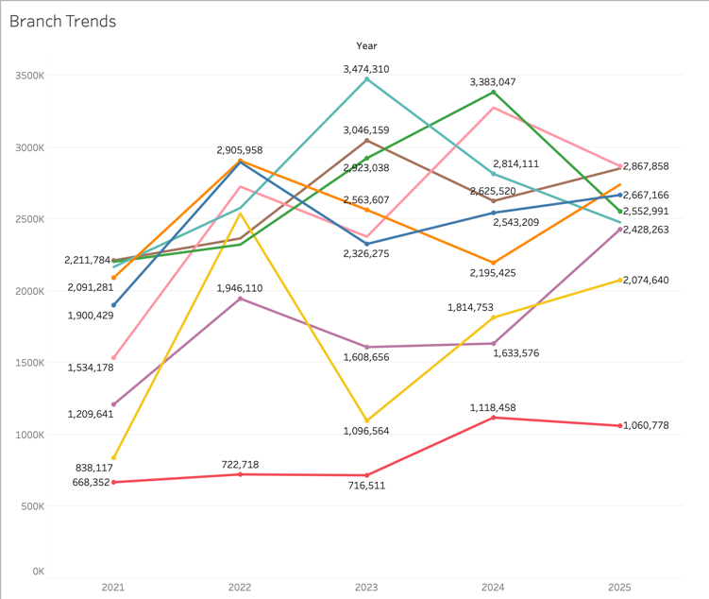
Chart Description
This multi-line chart plots annual revenue for all 9 branches over the five-year period 2021–2025, with each branch as a distinct color line. It reveals whether growth has been uniform or divergent across the network and flags branches that are accelerating, plateauing, or declining.
Results and Analysis
Branch | 2021 (B) | 2022  (B) | 2023  (B) | 2024  (B) | 2025  (B) | 5Y Total | Trend Pattern
Ha Noi | 2.17 B | 2.58 | 3.47 | 2.81 | 2.48 | 13.51 | Peak 2023, moderate decline
Hai Phong | 2.20 | 2.32 | 2.92 | 3.38 | 2.55 | 13.38 | Late peak 2024 pullback
TP.HCM | 2.21 | 2.36 | 3.05 | 2.63 | 2.85 | 13.10 | Peak 2023, partial recovery 2025
Quang Ninh | 1.53 | 2.73 | 2.38 | 3.27 | 2.87 | 12.78 | Volatile, alternating high/low years
Can Tho | 2.09 | 2.91 | 2.56 | 2.20 | 2.74 | 12.50 | Peak 2022 to dip 2024 recovery
Binh Duong | 1.90 | 2.90 | 2.33 | 2.54 | 2.67 | 12.33 | Peak 2022, stabilizing
Nha Trang | 1.21 | 1.95 | 1.61 | 1.63 | 2.43 | 8.83 | Strong 2025 recovery and standout
Hue | 0.84 | 2.54 | 1.10 | 1.81 | 2.07 | 8.36 | Highly volat ile 3x swing 2021 to2022
Da Nang | 0.67 | 0.72 | 0.72 | 1.12 | 1.06 | 4.29 | Slow but steady growth still smallest

No Single Peak Year, each branch has its own cycle: Unlike a macro shock that would move all branches in sync, the branch-level data shows divergent annual peaks: Ha Noi and TP.HCM peaked in 2023, Hai Phong in 2024, Can Tho and Binh Duong in 2022. This suggests that branch performance is driven more by local market conditions, channel mix, and sales execution than by economy-wide factors. The most notable outlier is Hue: revenue tripled from 0.84B in 2021 to 2.54B in 2022 then collapsed to 1.10B in 2023 a 57% single-year drop that warrants a root-cause review. Nha Trang's 2025 surge to 2.43B
up from 1.61–1.63B in 2023–2024 is the most positive trend signal in the network.
Da Nang remains structurally underpenetrated at 0.67–1.12B per year across all five years, never exceeding 1.12B even in its best year (2024). At 4.29B total, it generates less than a third of the next-smallest branch Nha Trang at 8.83B. With a consistent 22–25% margin showing no operational deficiency, the constraint is sales capacity and market reach rather than profitability. A targeted branch investment plan additional sales force, local promotional budget, or distribution partnership is the logical next step.
5.6.4 Profit Margin Heatmap: Category × Branch
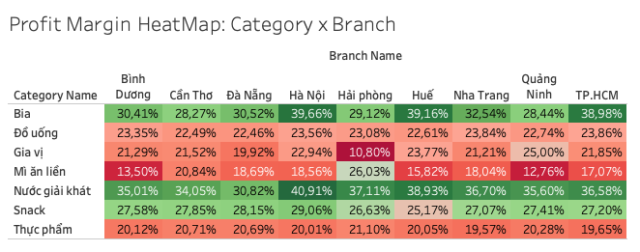
Chart Description
This 7×9 heatmap matrix displays profit margin for every category-branch combination. Color intensity encodes margin level, exposing localized anomalies that aggregate regional or category averages mask. A category performing well nationally may conceal a critically underperforming branch that signals structural problems in pricing, cost allocation, or distribution.
Two Critical Anomalies:
- Gia vi at Hai Phong: 10.80% versus category average 20.8% a 10.0pp gap, the largest single-cell deviation in the entire matrix. This requires immediate investigation into local distribution costs, pricing practices, or inventory shrinkage at Hai Phong.
- Mi an lien at Quang Ninh: 12.76% and at Binh Duong: 13.50%, both ~4–5pp below category average 17.8%. The pattern in industrial-zone markets (Quang Ninh, Binh Duong) suggests possible bulk discount agreements with large distributors that are not reflected in the allocated cost base, understating true margin in those branches.
Largest Strategic Margin Spread: Bia margin ranges from 28.27% Can Thon to 39.66% Ha Noi an 11.39pp spread. Ha Noi 39.66%, Hue 39.16%, and TP.HCM 38.98% all exceed 38%, while Can Tho, Hai Phong, and Quang Ninh cluster at 28–30%. Since Bia is the second-highest margin category nationally 33.4%, this urban premium effect is highly impactful. Urban markets likely sell a higher proportion of premium beer SKUs (Tiger, Heineken) versus value SKUs (333, Saigon Special) in secondary cities. Aligning SKU push strategy to this premium geography split intensifying premium Bia promotion in Ha Noi and TP.HCM while reviewing price-band positioning in Can Tho, Hai Phong, and Quang Ninh could close 2–4pp of margin gap across the network.

5.7 Dashboard 4: Time & Channel Analysis
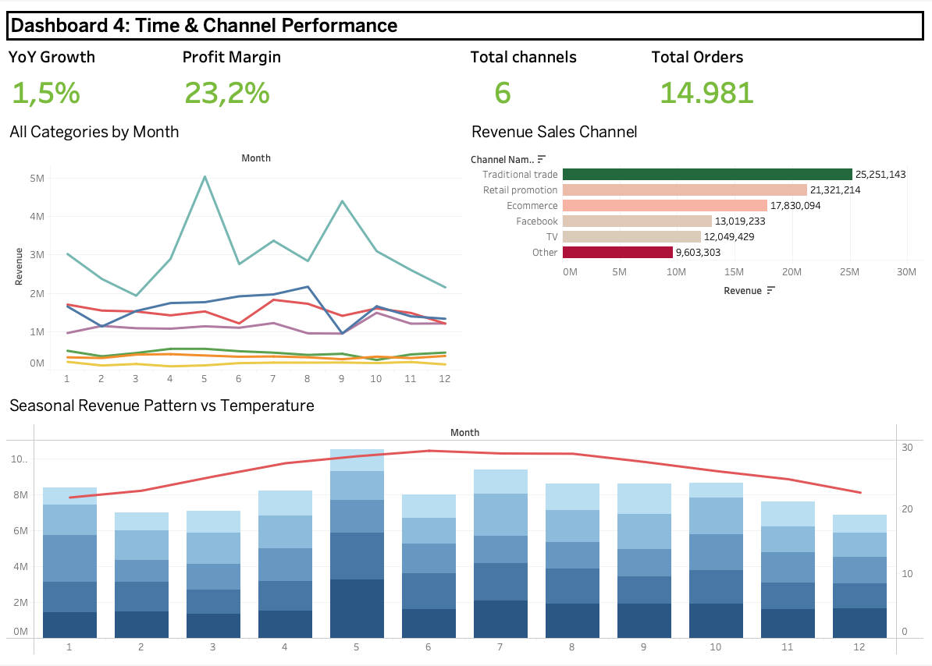
Dashboard 4 serves as the temporal and channel intelligence layer of the VNRetail BI system, built for marketing managers and channel directors who need to understand when demand peaks and troughs, which sales channels deliver the best return, and whether external environmental factors such as weather measurably influence consumer purchasing behavior.
The dashboard is structured around two analytical axes. The first is time: a 7-category monthly revenue trend chart spanning the full 2021–2025 period reveals the seasonal rhythm of the business the May stockpiling spike driven by Mì ăn liền, the summer Bia surge in July–August, and the year-end moderation in November–December. These patterns are not incidental; they represent predictable demand cycles that procurement, logistics, and promotional planning teams can act on with sufficient lead time. The second axis is channel: a horizontal bar chart ranks all 6 sales channels by revenue and margin simultaneously, quantifying the shift toward e-commerce and exposing which channels carry hidden cost-to-serve disadvantages reflected in below-average margins.
Supplementing these two core charts, a weather-correlation scatter plot leverages the dw.v_sales_weather view to test whether temperature and precipitation levels in each region correspond to measurable changes in category revenue providing evidence-based justification for weather-triggered promotional campaigns. Four KPI cards at the top of the dashboard anchor the analysis with period-level totals for revenue, profit, margin, and order count, giving managers immediate context before engaging with the trend detail below.
Together, Dashboard 4 equips marketing and channel teams with the analytical foundation to time campaigns more precisely, allocate channel investment more efficiently, and respond proactively to seasonal and environmental demand signals.
5.7.1 Chart Revenue Trend by Category
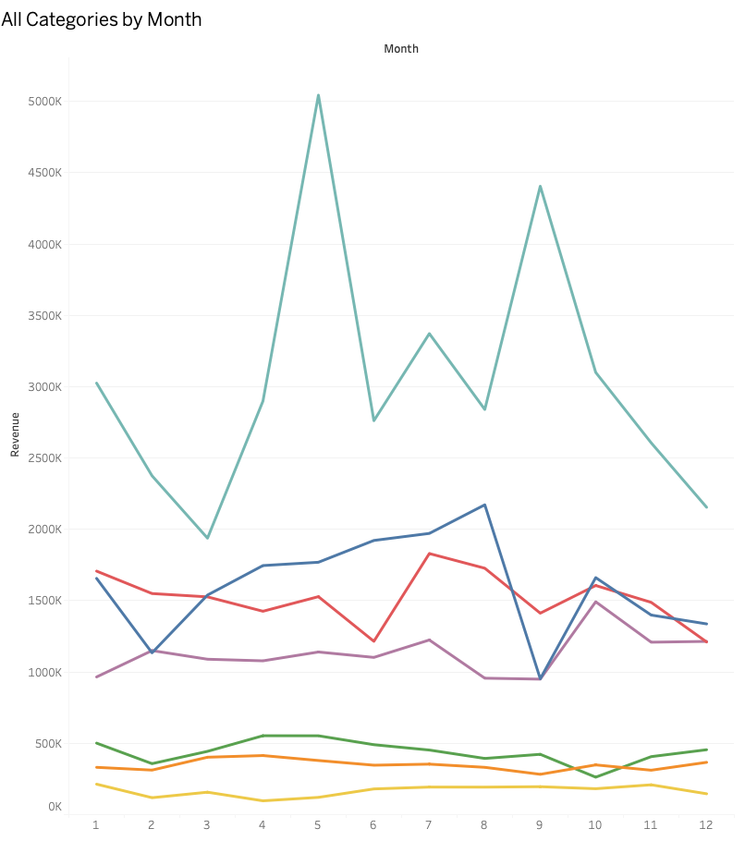

Chart Description
H7 is a multi-line time-series chart displaying monthly revenue for all 7 categories simultaneously over the full 5-year period. Each category is represented by a distinct color line. This chart is the primary tool for identifying seasonal demand patterns and category-level growth trajectories.
Key Seasonal Patterns Observed
Month | Total Revenue | Dominant Category | Seasonal Driver
January | 8.4 B | Mi an lien | Post-Tet stocking
February | 7.0 B | Mi an lien | Post-Tet normalization
March | 7.1 B | Mi an lien | Off-season
April | 8.2 B | Mi an lien | Back-to-school
May | 10.5 B | Mi an lien 5.0B | Highest in May spike (stock-up season)
June | 8.0 B | Mi an lien | Rainy season begins
July | 9.4 B | Bia 2.0B | Beer peak because summer heat
August | 8.6 B | Bia 2.2B | Beer high because hottest month
September | 8.6 B | Mi an lien 4.4B | Autumn campaign
October | 8.7 B | Thuc pham 1.5B | Food gifting season
November | 7.6 B | Mi an lien | Pre-Tet early stock
December | 6.9 B | Mi an lien | Year-end, holiday prep
The Most Important Business Pattern: May records the highest monthly revenue at 10.5B about 50% above February's low of 7.0B. This spike is driven almost entirely by Mi an lien 5.0B in May alone, likely representing distributor and retail stockpiling ahead of the summer heat season. Understanding this pattern allows procurement and logistics teams to pre-position inventory 4–6 weeks in advance, avoiding stock-outs and reducing emergency logistics costs.
Beer shows a clear summer peak in July to August versus a winter trough in November to January. For a high-margin category, this seasonal gap of ~700M/month represents significant untapped revenue. Winter marketing campaigns and bundled promotions could partially smooth this curve.

5.7.2 Chart Revenue by Sales Channel
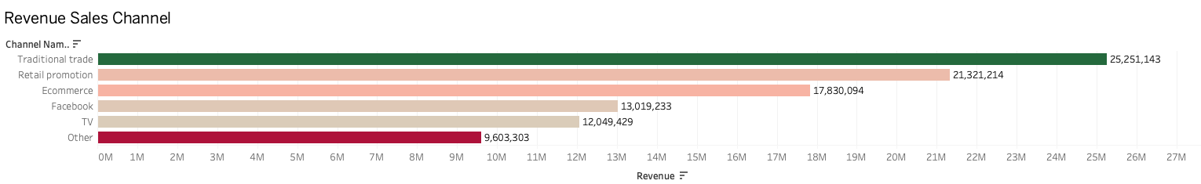
Chart Description
H8 is a horizontal bar chart ranking all 6 sales channels by total revenue. Margin values are shown as labels, enabling a direct channel efficiency comparison: which channels generate the most revenue AND the most profit per dollar of revenue.
Results and Analysis
Rank | Channel | Revenue (B) | Share | Margin | Channel Type
1 | Traditional trade | 25.3 B | 25.5% | 24.5% | Offline grocery stores, wet markets
2 | Retail promotion | 21.3 B | 21.5% | 24.4% | Offline in-store promotions
3 | Ecommerce | 17.8 B | 18.0% | 24.5% | Online e-commerce platforms
4 | Facebook | 13.0 B | 13.1% | 21.7% | Digital social commerce
5 | TV | 12.0 B | 12.2% | 23.9% | Broadcast TV shopping/infomercials
6 | Other | 9.6 B | 9.7% | 21.7% | Mixed

Digital Channels Closing the Gap: Offline channels Traditional trade and Retail promotion still dominate at 47.0% combined revenue share. However, Ecommerce alone has reached 18.0% exceeding Facebook 13.1% and TV 12.2% combined, and achieving the same 24.5% margin as Traditional trade. This suggests that online-to-offline margin parity has been achieved, removing the traditional objection to digital channel investment. Increasing Ecommerce investment now carries low risk and favorable margin profile.
Facebook and Other channels both show the lowest margin at 21.7% about 2.8 percentage points below the top channels. These channels either attract more price-sensitive customers or carry higher fulfillment costs. Before increasing spend on these channels, a deeper cost-to-serve analysis is recommended.

5.7.3 Chart Revenue vs. Temperature
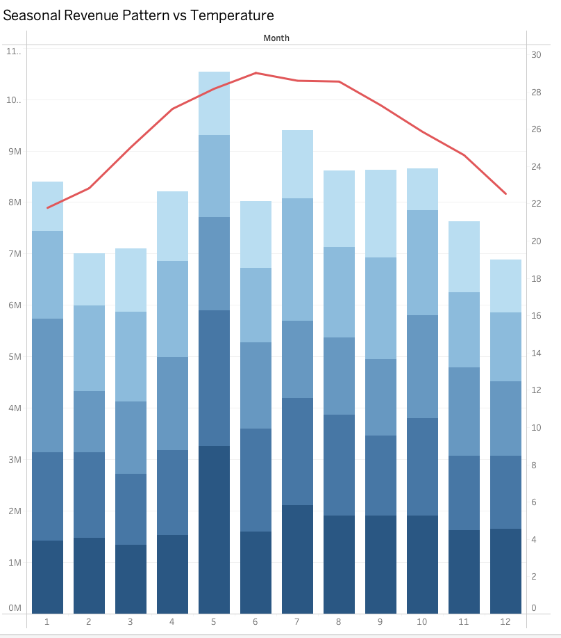
Chart Description
H_Weather is a dual-axis chart combining stacked bar chart monthly revenue by year, 2021–2025 stacked, left Y-axis with a line chart monthly mean temperature in °C, right Y-axis, shown in red. This chart is unique in the dashboard suite as it integrates data from two separate fact tables fact_marketing_sales and fact_weather_daily joined through the pre-built view dw.v_sales_weather.
Results and Analysis
Month | Monthly Revenue (avg) | Temp North (°C) | Temp South (°C) | Pattern
Jan–Mar | 7.5 B | 12–18°C | 27–29°C | Cold North reduces beer; Mi an lien peaks
Apr–Jun | 8.6 B | 22–28°C | 28–31°C | Warming drives soft drink growth
Jul–Aug | 9.0 B | 28–32°C | 27–30°C | Heat peak, Beer and beverages peak
Sep–Oct | 8.7 B | 24–28°C | 27–29°C | Autumn, food gifting, diverse categories
Nov–Dec | 7.3 B | 15–22°C | 26–28°C | Cooling, Mi an lien returns, Beer declines

Temperature-Demand Correlation Confirmed: The weather chart reveals a clear positive correlation between temperature and Beer/Soft Drink revenue, and an inverse relationship between temperature and Instant Noodle revenue. Northern Vietnam's temperature range 12°C in winter to 38°C in summer creates significantly larger seasonal demand swings than the South 25–35°C year-round. Regional inventory planning should therefore apply different seasonal adjustment factors for North versus South branches.

5.8 Dashboard 5: Customer Segment Analysis
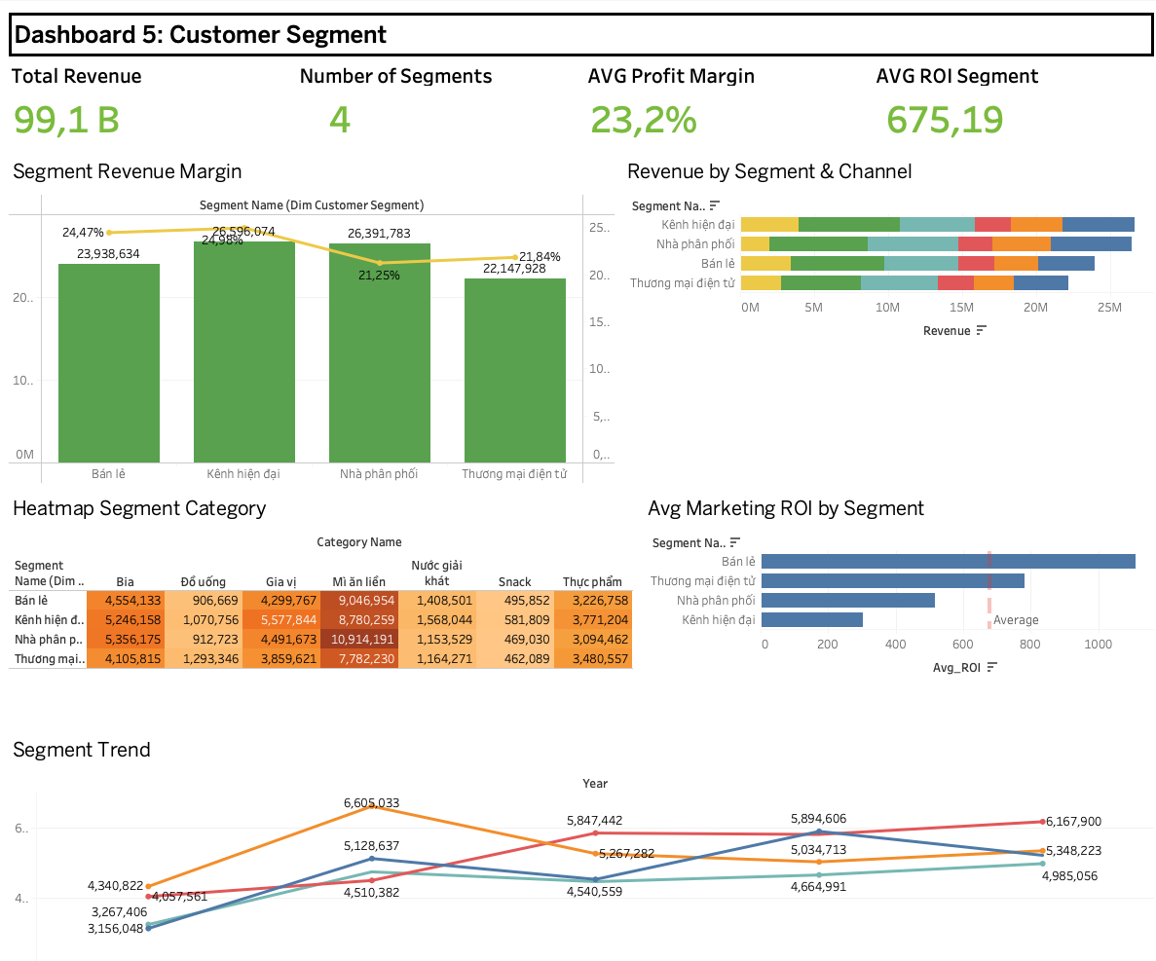
Dashboard 5 serves as the customer intelligence layer of the VNRetail BI system, designed for CRM teams and key account managers who need a granular, multi-dimensional view of how different customer segments behave, contribute, and respond to marketing investment. Where the previous dashboards answer questions about products, geographies, time, and channels at the business level, Dashboard 5 reframes every question through the lens of who which segments generate the most value, which are growing, which are being reached efficiently by marketing spend, and which channels each segment prefers.
The dashboard is built around four analytical dimensions. Revenue contribution and margin profile establish the baseline: a dual-axis chart comparing segment revenue against profit margin reveals whether high-volume segments are also high-quality segments, or whether volume is being bought at a margin cost. Growth trajectory adds the time dimension: a segment revenue trend chart across 2021–2025 identifies which segments are accelerating, plateauing, or in structural decline, enabling proactive reallocation of sales effort before problems compound. Marketing efficiency connects advertising investment to sales outcome: by cross-referencing Facebook Ads spend from fact_ad_spend with segment-level revenue from fact_marketing_sales, the dashboard surfaces ROI differentials across campaigns and segments quantifying which marketing spend is generating returns and which is not. Channel preference closes the picture: a breakdown of each segment's revenue by sales channel reveals whether segments are shifting toward e-commerce, remaining loyal to traditional trade, or splitting across multiple touchpoints in ways that complicate fulfillment and margin management.
Four KPI cards anchor the dashboard with segment-level aggregates, providing immediate orientation before managers engage with the six analytical charts beneath. Taken together, Dashboard 5 gives CRM and key account teams the evidence base to differentiate their approach by segment tailoring pricing, promotion, channel strategy, and marketing budget allocation to the specific behavioral and financial profile of each customer group rather than applying a single undifferentiated commercial strategy across all four segments.
5.8.1 Chart Revenue and Margin by Segment
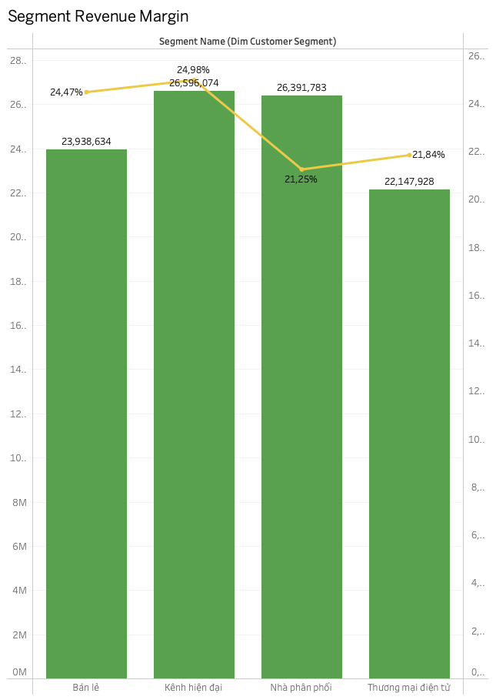
Chart Description
This chart is a combined chart displaying total revenue and average profit margin for each of the 4 customer segments. This provides a direct revenue-to-margin comparison at the segment level, identifying which segments deliver the best combination of volume and profitability.
Results and Analysis
Segment | Revenue (B) | Share | Orders | Avg Margin | Revenue/Order
Kenh hien dai (Modern Trade) | 26.6 B | 26.8% | 3,782 | 24.5% | 7.0M VND
Nha phan phoi (Distributor) | 26.4 B | 26.6% | 3,771 | 22.7% | 7.0M VND
Ban le (Retail) | 23.9 B | 24.2% | 3,727 | 24.1% | 6.4M VND
Thuong mai dien tu (E-commerce) | 22.1 B | 22.4% | 3,701 | 23.7% | 6.0M VND
Segment Balance: Unlike the category distribution where Mi an lien dominates at 36.9%, the customer segment distribution is remarkably balanced: the gap between the largest Modern Trade 26.8% and smallest E-commerce 22.4% is only 4.4 percentage points. This diversification reduces dependency risk. However, Modern Trade commands the highest margin 24.5% making it the priority segment for growth, while Distributor margin 22.7% should be the focus for profitability improvement.
5.8.2 Chart Revenue Trend by Segment
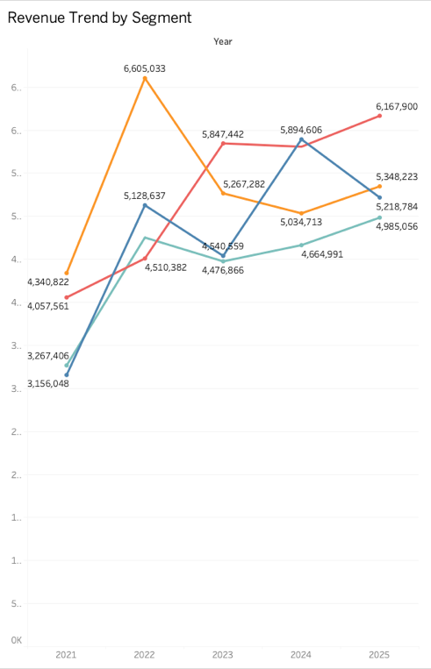
Chart Description
This is a multi-line chart showing annual revenue by customer segment from 2021 to 2025. Each segment is a distinct color line, enabling direct year-over-year comparison of segment growth rates and relative performance shifts.
Results and Analysis
Year | Modern Trade | Distributor | Retail | E-commerce | E-com Growth
2021 | 4.3 B | 4.1 B | 3.2 B | 3.3 B | —
2022 | 6.6 B | 4.5 B | 5.1 B | 4.8 B | +45.5%
2023 | 5.3 B | 5.8 B | 4.5 B | 4.5 B | -6.3%
2024 | 5.0 B | 5.8 B | 5.9 B | 4.7 B | +4.4%
2025 | 5.3 B | 6.2 B | 5.2 B | 5.0 B | +6.4%
Distributor Channel Structural Growth: The Distributor segment shows the most consistent growth trajectory: revenue increased from 4.1B in 2021 to 6.2B in 2025 +51.2% total, +0.525B/year average. Notably, Distributor was the only segment to grow in 2023 the contraction year for all other segments, reaching 5.8B vs. 4.5B in 2022. This resilience indicates distributors serve as a buffer during market downturns, absorbing inventory from weaker direct channels. The Distributor segment merits priority attention for key account development.
5.8.3 Chart Revenue Heatmap: Segment and Category
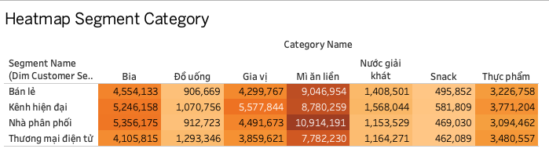
Chart Description
This is a heatmap using Tableau's Square mark type with a Green Sequential color encoding revenue intensity. Rows represent customer segments; columns represent product categories. This chart identifies which segments buy which categories disproportionately revealing cross-sell opportunities and potential over-dependencies.
Key Observations
- Mi an lien is the dominant category for all segments, but especially for the Distributor segment where it accounts for an outsized share consistent with bulk distributor purchasing patterns.
- Beer (Bia) shows stronger concentration in the Modern Trade and Retail segments, where in-store display and cold chain access drive impulse purchases.
- E-commerce segment shows relatively even distribution across categories compared to other segments, suggesting online shoppers are more exploratory and less brand-loyal.
- Soft Drinks (Nuoc giai khat) are weakest across all segments in absolute revenue supporting the case for active push campaigns to increase trial and repeat purchase.
5.8.4 Chart Revenue Segment with Channel
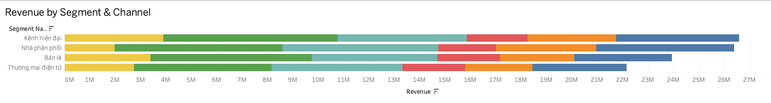
Chart Description
This stacked bar chart with customer segments on the Y-axis and revenue on the X-axis, with each bar stacked by sales channel color. This reveals the channel mix within each segment show how different customer types prefer to purchase.
Results and Analysis
Segment | Top Channel | 2nd Channel | 3rd Channel | Digital % | Traditional %
Modern Trade | Trad. trade 6.9B | Retail promo 5.1B | Ecommerce 4.8B | ~30% | ~45%
Distributor | Trad. trade 6.6B | Retail promo 6.1B | Ecommerce 5.4B | ~29% | ~48%
Retail | Trad. trade 6.4B | Retail promo 4.9B | Ecommerce 3.9B | ~29% | ~45%
E-commerce | Trad. trade 5.4B | Retail promo 5.2B | Ecommerce 3.7B | ~28% | ~45%
Counter-intuitive Finding: The E-commerce customer segment despite being defined by its channel still generates its highest revenue through Traditional trade 5.4B followed by Retail promotion 5.2B, with actual Ecommerce platform revenue at only 3.7B. This suggests the segment classification likely reflects the customer's business type(online retailer reselling VNRetail products rather than the purchase channel used. All four segments show similar 28–30% digital channel mix, indicating no segment has yet made a decisive shift to fully digital procurement.

5.8.5 Chart Marketing ROI by Segment
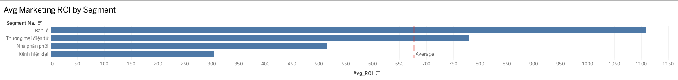
Chart Description
This is a horizontal bar chart displaying average Marketing ROI (profit / marketing cost) by customer segment, with a vertical reference line showing the overall average. Bars are sorted descending. This chart directly answers: "Which customer segments deliver the highest return on marketing investment?"
Results and Analysis
Rank | Segment | Avg Marketing ROI | vs. Average | Interpretation
1 | Ban le (Retail) | 1,109.5 | +2.8× | Retail customers generate highest ROI per marketing spend
2 | Thuong mai dien tu (E-commerce) | 780.4 | +1.9× | Digital native efficient marketing response
3 | Nha phan phoi (Distributor) | 514.9 | Above avg | Bulk buyers marketing investment scales well
4 | Kenh hien dai (Modern Trade) | 304.0 | Below avg | Highest cost-to-serve segment
Best Margin Segment Yields Lowest Marketing ROI: Modern Trade has the highest profit margin (24.5%) but the lowest marketing ROI (304.0). This is because Modern Trade requires the highest marketing investment trade promotions, display fees, key account management which drives down the return per marketing dollar. Retail, by contrast, shows 1,109.5 ROI, nearly 3.7 time higher than Modern Trade. A strategic budget reallocation moving 10% of Modern Trade marketing spend to Retail would significantly improve overall Marketing ROI without materially impacting revenue.

CHAPTER 6: CONCLUSIONS AND STRATEGIC RECOMMENDATIONS

6.1 Summary of Key Findings
Finding | Evidence | Urgency
Margin compression despite revenue growth | Margin fell 25.3% → 22.7% while revenue grew +46.5% | HIGH
Mi Omachi near-breakeven | 3.1% margin on 10.2B revenue product | CRITICAL
Raw material cost escalation | RM cost share rose 36.3% → 37.4% of revenue | HIGH
Central region underdeveloped | 21.7% revenue with highest margins (24.4% avg) | MEDIUM
Question Mark products with 40–48% margin | 14 products with high margin but low distribution | MEDIUM
E-commerce parity with offline margins | Online margin matches traditional trade at 24.5% | OPPORTUNITY
Retail segment's marketing ROI 3.7× higher than Modern Trade | ROI 1,109 vs. 304 | OPPORTUNITY
May demand spike (50% above February) | Driven by Mi an lien stockpiling | PLANNING

6.2 Strategic Recommendations
Short-Term (0–6 months)
- CRITICAL: Initiate an immediate cost review for Mi Omachi. At 3.1% margin, this 10.2B product is one supply shock away from a loss position. Options: price increase, ingredient substitution, or volume reduction to focus on higher-margin Mì ăn liền variants.
- Seasonal inventory pre-positioning: Place Mi an lien orders 6 weeks before May to avoid stock-outs during the peak month. Place Beer orders 4 weeks before July.
- Reallocate 10–15% of Modern Trade marketing budget to Retail and E-commerce channels based on 3.7 time superior ROI.

Medium-Term (6–18 months)
- Invest in Central region expansion: Open or expand the Da Nang branch, which currently generates only 4.3B vs. Ha Noi's 13.5B despite comparable demographics. Target Da Nang to reach 7–8B within 18 months.
- Accelerate Question Mark development: Prioritize Nuoc khoang Vinh Hao 48.3% margin, Wake-up 247 44.2% margin, and Nuoc tang luc Compact 36.0% margin with dedicated distribution pushes and targeted digital campaigns.
- Beer category investment: Three Beer products already in Top 10; Bia category margin 30.5% is 2.1× that of Mi an lien. Expanding Beer SKUs and distribution especially in Northern and Central regions should be a portfolio priority.
Long-Term (18+ months)
- Category rebalancing: Reduce dependency on Mi an lien from 36.9% to below 30% of revenue over 3 years, replacing volume with higher-margin Beer, Soft Drinks, and Snack categories.
- Full e-commerce channel migration: Given proven margin parity (24.5% online = offline), build a direct-to-consumer e-commerce capability to reduce trade channel dependency and improve marketing measurement.
- Weather-responsive supply chain: Implement automated demand forecasting models that incorporate weather data (already in the data warehouse) to predict regional demand 30–60 days in advance.

6.3 Technical Recommendations
- Add real-time data ingestion: Replace monthly Excel uploads with an API connection to the ERP system, reducing data latency from monthly to daily.
- Implement data quality scoring: Extend the current validation system to generate a monthly Data Quality Score tracking trends in null rates, format violations, and duplicate rates over time.
- Tableau Server deployment: Migrate from Tableau Desktop to Tableau Server for scheduled data refresh and role-based access control, enabling branch managers to access their branch's dashboard without requiring Tableau Desktop licenses.
- Add predictive analytics: Integrate Python-based forecasting Prophet or ARIMA into the pipeline to generate 3-month revenue forecasts by category and region, surfaced directly in Dashboard 1.

