Name : Dinh Nguyen

CS 260 – Assignment 9

Question 1:

1. 7 nodes
2. Edges: (A, B); (A, C); (B, D); (B, E); (C, F); (C, G)
3. Node A is parent of C
4. Node F and node G are children of C
5. Root node of the tree is node A
6. Leaves of the tree: D, E, F, G
7. Height of the tree = 2

Question 2:

1. 3 comparisons (1<5, 1<2, 1==1)
2. 4 comparisons (7>5, 7<8, 7>6, 7==7)
3. 3 comparisons (12>5, 12>8, 12>9)

Question 3:

1. Height = 3
2. Value in the tree requires the least comparisons is 5 (root) which only needs 1 comparison
3. Best case is when it founds the value right at the first node or root. So only 1 comparison needed for best case.
4. Value in the tree requires most comparisons is 7
5. The worst case is when the search goes into the longest branch (reaching 7), so number of comparisons needed for the worst case is: 4
6. The maximum number of comparisons to determine a value is not in the tree is when it reaches the worst case but then couldn’t find the value: so it is 4 comparisons.
7. C(h) = h + 1

Question 4:

1. New Tree

Null

Question 5:

1. Preorder: 5 2 1 N N 3 N N 8 6 N 7 N N 9 N N
2. Inorder: N 1 N 2 N 3 N 5 N 6 N 7 N 8 N 9 N
3. Postorder: N N 1 N N 3 2 N N N 7 6 N N 9 8 5

Question 6:

Null

Null

Question 7:

1. Min of all descendants of 5 is 1
2. Max of all descendants of 5 is 8
3. Min of all descendants of 15 is 11
4. Max of all descendants of 15 is 18
5. Min of all descendants of 2 is 1
6. Max of all descendants of 2 is 4
7. Min of all descendants of 17 is 16
8. Max of all descendants of 17 is 18

Question 8:

1. The result is a valid Binary Search Tree because 11 is the leaf node and the min of the right child’s side, so it’s smaller than everything on the right child’s side and bigger than everything on the left child’s side.
2. The max of 5’s descendants or 8 also works because it’s also a leaf node and it is the max of the left child’s side. Thus, everything on the left child’s side is smaller than 8 and everything on the right child’s side is bigger than 8. Hence, it can fit in the root position as well.

Question 9: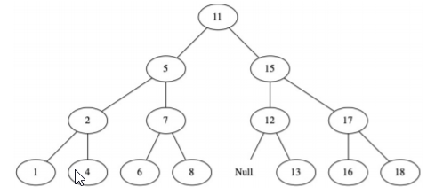

Question 10: All possible orders: 123, 132, 213, 231, 312, 321. But 213 and 231 give the same tree. So there are 5 total.

Null

Null

Null

Null

Null

Null

Null

Null

Question 11:

Heights of trees: 2, 2, 1, 2, 2

Average height = (2+2+1+2+2)/5 = 1.8