Name and Username: Dinh Nguyen (dln45)

Question 4:

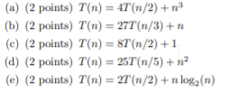

1. c = log2(4) = 2, f(n) = n3. We find that n3 = Ω(n2 + e) where e = 1. So Case 3 selected, T(n) = Θ(n3)
2. c = log3(27) = 3, f(n)=n. We find that n = O(n3 - e) where e = 2. So Case 1 selected, T(n) = Θ(n3)
3. c=log2(8)=3, f(n) = 1. We find that 1 = O(n3 - e) where e = 3. So Case 1 selected, T(n) = Θ(n3)
4. c=log5(25)=2, f(n)=n2. Because n2 = Θ(n2log0n), so case 2 selected, k = 0. T(n) = Θ(n2logn)
5. c=log2(2)=1, f(n)=nlog2n. Because nlog2n = Θ(n1log1n), so case 2 seleccted, k=1. T(n)= Θ(nlog2n)