Name and Username: Dinh Nguyen (dln45)

Question 5

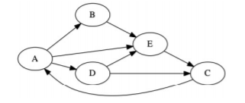

1. Start and end: 1 and 10
2. Start and end: 2 and 7
3. Start and end: 4 and 5
4. Start and end: 8 and 9
5. Start and end: 3 and 6