Name and Username: Dinh Nguyen (dln45)

Question 6:

|  |  |  |  |  |  |
| --- | --- | --- | --- | --- | --- |
| Index | A | B | C | D | E |
| Value | 0 | ∞ | ∞ | ∞ | ∞ |

1. 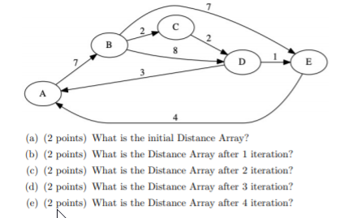After 1 iteration

|  |  |  |  |  |  |
| --- | --- | --- | --- | --- | --- |
| Index | A | B | C | D | E |
| Value | 0 | 7 | ∞ | ∞ | ∞ |

c)

|  |  |  |  |  |  |
| --- | --- | --- | --- | --- | --- |
| Index | A | B | C | D | E |
| Value | 0 | 7 | 9 | 15 | 14 |

d)

|  |  |  |  |  |  |
| --- | --- | --- | --- | --- | --- |
| Index | A | B | C | D | E |
| Value | 0 | 7 | 9 | 11 | 14 |

e)

|  |  |  |  |  |  |
| --- | --- | --- | --- | --- | --- |
| Index | A | B | C | D | E |
| Value | 0 | 7 | 9 | 11 | 12 |