MEMO

**Drexel University**

To: Dr. Christopher Peters, ECE 303 Fall 2020

From: Dinh Nguyen

Date: Oct 16st, 2020

Re: Lab 3 Pulse Width Modulation

**Purpose**

Photoresistor or photocell is a device that is used to detect surrounding light and change it resistor accordingly. The goal of the lab is to study the behavior of the photoresistor, how to use PWM to control duty cycle and brightness of LED and the relationship between the photoresistor and the LED.

**Discussion**

Hardware: Figure 1 shows how the photoresistor and the LED are connected in series with a 1k Ohm resistor to the Arduino board. Photoresistor will be connected to pin A0 to read its voltage in bits. LED will be connected to pin 5 to be controlled by PWM and duty cycle to adjust its brightness.

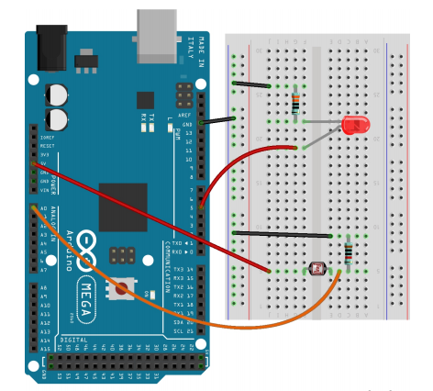

Figure 1. Photoresistor and LED circuit

Software: In order to change the duty cycle over time, a for loop is used to add up 5% at a time for duty cycle variable. It is then multiplied by the OCR of the timer to control the frequency of the input signal to the LED. Because the frequency is too fast, our human eyes can only see the light of the LED is increasing over time. The duty cycle will be reset when reaching 100%. Using analogRead, photocell reading will be recorded in bits and from that, we can calculate the voltage across the photocell by dividing the reading by 255 bits and multiply by 5. Since the photocell is in series with the resistor, the voltage across the resistor in photocell circuit is 5 – voltage of photocell. On the other hands, the voltage across the LED is equivalent to 5 (the input voltage) multiplied by the duty cycle. Thus, the voltage across the resistor of the LED circuit is 5-voltage of LED. We will use serial terminal to output the voltages across the resistors in both circuit and the duty cycle. From the data collected, we can develop some plots to study the relationship between LED and photocell.

**Plots**

**Figure 2. LED current vs Duty cycle of RED LED**

**Figure 3. LED Resistance and Duty cycle of RED LED**

**Figure 4. Photocell Current vs Duty cycle of RED LED**

**Figure 5. Photocell Resistance vs. Duty Cycle of Red Led**

**Figure 6. Photocell Resistance and LED current of RED LED**

**Figure 7. LED current vs Duty cycle of Yellow LED**

**Figure 8. LED Resistance vs Duty Cycle of Yellow LED**

**Figure 9. Photocell current and Duty cycle of Yellow LED**

**Figure 10. Photocell Resistance and Duty Cycle of Yellow LED**

**Figure 11. Photocell Resistance vs LED current of Yellow LED**

**Figure 12. LED Current vs Duty Cycle of Green LED**

**Figure 13. LED Resistance vs Duty Cycle of Green LED**

**Figure 14. Photocell Current vs Duty cycle of Green LED**

**Figure 15. Photocell Resistance vs Duty Cycle of Green LED**

**Figure 16. Photocell Resistance vs LED Current of Green LED**

**Figure 17. LED Current vs Duty Cycle of Blue LED**

**Figure 18. LED Resistance vs Duty Cycle of Blue LED**

**Figure 19. Photocell Current vs Duty Cycle of Blue LED**

**Figure 20. Photocell Resistance vs Duty cycle of Blue LED**

**Figure 21. Photocell Resistance vs LED Current of Blue LED**

**Recommendation**

From the plots, we can observer a variation in the data points which is due to the inconsistency of the testing environment and the performance of the photocell. A slight spot of light can easily alter the data and distort our graph. Additionally, the distance between the LED and the photocell also affect the results and it is difficult to keep the distance the same when switching between different LED. Those limitation will be responsible for the variety of the data collected. However, we can see an overall pattern among the 4 LEDs. The LED current is always go down as the duty cycle go up, this is because the voltage across the LED increase, the voltage across the resistor will decrease while the resistor value remains unchanged. Same scenario will happen for the photocell circuit, however the data is more distorted and we can only observe a slight decrease in the current. Moreover, the Red LED seems to produce a more significant contact with the photocell compare to the other LED. Further experiments with better testing environment and more details data point (1% duty cycle margin for example) needs to be carried out to improve the results and analysis.

**Arduino Sketch**

