MEMO

**Drexel University**

To: Dr. Christopher Peters, ECE 303 Fall 2020

From: Dinh Nguyen

Date: Sep 28th, 2020

Re: Lab 1 Blinking LED – Digital Pin Operation and Analog Pin Operation

**Purpose**

The goals of this lab are to help students get used to Arduino tools and writing basic sketch for it. The lab will include 2 experiments. The first one is blinking LED by Digital writing to a pin and the second one is Analog Reading/Writing to a pin. The LED should be turned on and off with 1 second delay. There will be 2 parts for each section: hardware and software.

**Discussion**

We will use the same hardware setup for both experiments in this lab. I started with the hardware part by building the circuit. To reduce the current through the LED, the positive leg of LED will be connected in series to a 330 Ohm resistor to the positive pin 13 on Arduino. The negative leg of LED is connected to ground pin.

Software Part Arduino Sketch

For experiment 1 – Blinking LED with Digital Pin Operation

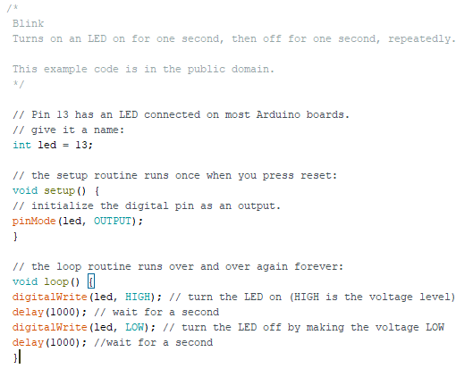

For experiment 2 – Blinking LED with Analog Pin Operation

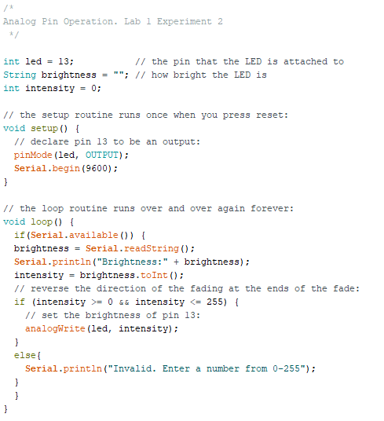

**Recommendation**

The lab provided a good basic introduction to Arduino and how the hardware works with the software to produce the desired outcomes. It is also introduce about the setup to parse input from users. This will be the foundation for a lot of other experiments and labs with Arduino.