MEMO

**Drexel University**

To: Dr. Christopher Peters, ECE 303 Fall 2020

From: Dinh Nguyen

Date: Oct 26th, 2020

Re: Lab 5 Graphical User Interfaces

**Purpose**

The goal of this lab is to continue the study of lab 3 and 4 on the photoresistor and the relationship between the photoresistor and the LED. The lab also covers basics about serial communication, how Arduino communicates through serial terminal to another local scripts (Python or MATLAB). From that, in lab 5, we will use the data from the Arduino via serial communication to establish an user interface in Python or MATLAB script.

**Discussion**

Hardware: Figure 1 shows how the photoresistor and the LED are connected in series with a 1k Ohm resistor to the Arduino board. Photoresistor will be connected to pin A0 to read its voltage in bits. LED will be connected to pin 5 to be controlled by analogWrite and duty cycle to adjust its brightness. In this lab, only RED LED is used for the experiment.

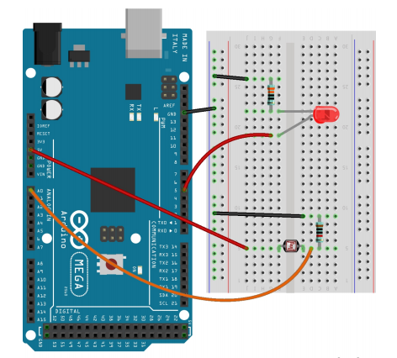

Figure 1. Photoresistor and LED circuit

Software: In order to change the duty cycle over time, I uses analogWrite and the duty cycle will be incremented by 1% which is 2.55 bits at a time. There will be 5 reading at each iteration so retry variable will keep track of that. We will have 100 iteration in total matching 100% duty cycle. The duty cycle will be reset when reaching 100%. Using analogRead, photocell reading will be recorded in bits and send to the Python script and from that, the Python script will read data from the serial, check if the data is valid (within +- 1 standard deviation) and then calculate the average voltage from 5 points of each iteration. Using the results, we can calculate the voltage across the photocell by dividing the reading by 255 bits and multiply by 5. Since the photocell is in series with the resistor, the voltage across the resistor in photocell circuit is 5 – voltage of photocell. On the other hands, the voltage across the LED is equivalent to 5 (the input voltage) multiplied by the duty cycle. Thus, the voltage across the resistor of the LED circuit is 5-voltage of LED. We will write the data collected to a log file and use matplotlib to develop some plots to study the relationship between LED and photocell.

For the user interfaces, I use the tkinter library in Python to set up a start button and a duty cycle information. The script will start when the user clicks on the start button and the serial communication will start between the Python script and Arduino. All the data will be plotted into 5 graphs as in figure 2.

To run, upload the Arduino sketch to the board and run python script by command ‘python3 lab5.py’.

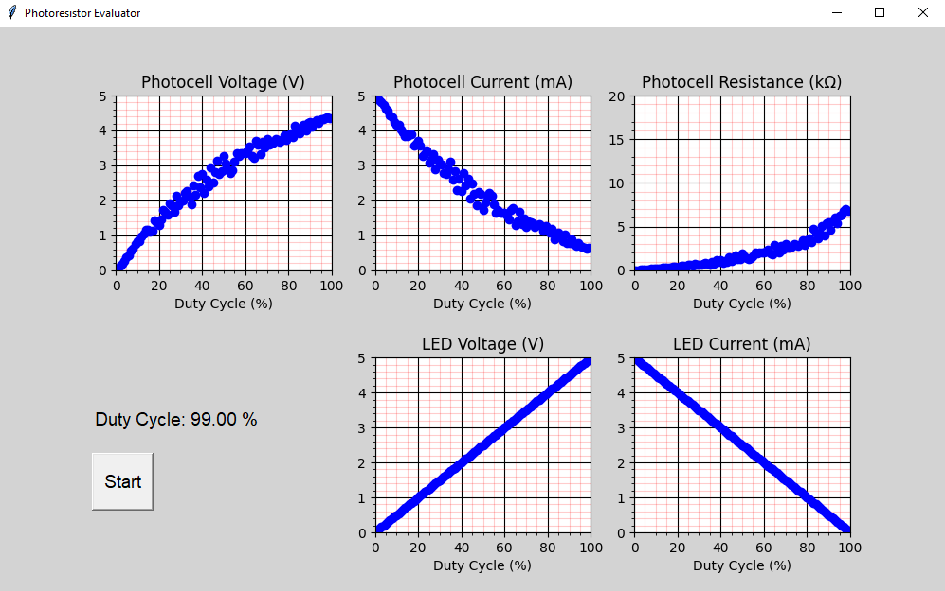

Figure 2. User Interface and Plots Results

**Recommendation**

From figure 2, we can observe quite a few distortion in the data points which is due to the inconsistency of the testing environment and the performance of the photocell. A slight spot of light can easily alter the data and distort our graph. Those limitation will be responsible for the variety of the data collected. However, we still can observe a consistent result with previous lab 3 and lab 4. The LED current goes down linearly as the duty cycle go up. The photocell voltage is also increasing overtime and getting more saturated when duty cycle is going to 100%. The photocell Resistor also increase with duty cycle. Further experiments with better testing environment and more details data point (1% duty cycle margin, 10 points each iteration for example) needs to be carried out to reduce the distortion and improve the results and analysis.

**Arduino** **Sketch**

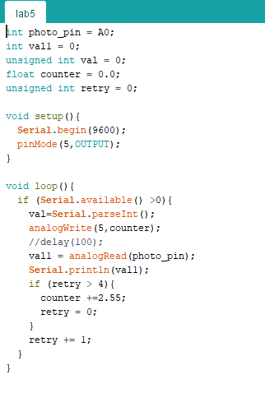

**Python Script**

import serial

import matplotlib.pyplot as plt

import time

import numpy

import tkinter as tk

import tkinter.font as tkFont

from tkinter import *

from tkinter import messagebox

from matplotlib.backends.backend_tkagg import FigureCanvasTkAgg

plt.close('all')

root = tk.Tk()

root.geometry("1000x600")

root.title("Photoresistor Evaluator")

root.configure(bg='grey')

figure1 = plt.Figure(figsize=(12,6), dpi=100)

ax1 = figure1.add_subplot(231)

fig1 = FigureCanvasTkAgg(figure1,root)

fig1.get_tk_widget().pack(side=tk.LEFT, fill=tk.BOTH)

figure1.set_facecolor('lightgrey')

line1, = ax1.plot([],[],'bo')

ax1.set_xlabel('Duty Cycle (%)', fontsize=10)

#ax1.set_ylabel('Photocell Voltage (V)', fontsize=10)

ax1.set_title('Photocell Voltage (V)')

ax1.grid(b=True, which='major', color='k', linestyle = '-')

ax1.grid(b=True, which='minor', color='r', linestyle = '-', alpha = 0.2)

ax1.minorticks_on()

ax2 = figure1.add_subplot(232)

line2, = ax2.plot([],[],'bo')

ax2.set_xlabel('Duty Cycle (%)',fontsize=10)

#ax2.set_ylabel('Photocell Current (mA)', fontsize=10)

ax2.set_title('Photocell Current (mA)')

ax2.grid(b=True,which='major',color='k',linestyle='-')

ax2.grid(b=True,which='minor',color='r',linestyle='-',alpha=0.2)

ax2.minorticks_on()

ax3 = figure1.add_subplot(233)

line3, = ax3.plot([],[],'bo')

ax3.set_xlabel('Duty Cycle (%)',fontsize=10)

#ax3.set_ylabel('Photocell Resistance (k\u03A9)', fontsize=10)

ax3.set_title('Photocell Resistance (k\u03A9)')

ax3.grid(b=True,which='major',color='k',linestyle='-')

ax3.grid(b=True,which='minor',color='r',linestyle='-',alpha=0.2)

ax3.minorticks_on()

ax4 = figure1.add_subplot(235)

line4, = ax4.plot([],[],'bo')

ax4.set_xlabel('Duty Cycle (%)',fontsize=10)

#ax4.set_ylabel('LED Voltage (V)', fontsize=10)

ax4.set_title('LED Voltage (V)')

ax4.grid(b=True,which='major',color='k',linestyle='-')

ax4.grid(b=True,which='minor',color='r',linestyle='-',alpha=0.2)

ax4.minorticks_on()

ax5 = figure1.add_subplot(236)

line5, = ax5.plot([],[],'bo')

ax5.set_xlabel('Duty Cycle (%)',fontsize=10)

#ax5.set_ylabel('LED Current (mA)', fontsize=10)

ax5.set_title('LED Current (mA)')

ax5.grid(b=True,which='major',color='k',linestyle='-')

ax5.grid(b=True,which='minor',color='r',linestyle='-',alpha=0.2)

ax5.minorticks_on()

figure1.subplots_adjust(hspace=0.5)

fontStyle= tkFont.Font(family="Lucida Grande", size=14)

var = StringVar()

label= Label( root,textvariable=var,font=fontStyle,bg='lightgrey')

label.place(x=100,y=400)

def get_valid_avg (buff):

    temp_mean = numpy.mean(buff)

    temp_std = numpy.std(buff)

    temp_buff = []

    for val in buff:

        # Error check, only store valid values to new buffer and return new mean

        if val <= (temp_mean + temp_std) and val >= (temp_mean - temp_std):

            temp_buff.append(val)

    return numpy.mean(temp_buff)

def startCallBack():

    arduino=serial.Serial('COM4',9600,timeout=5)

    time.sleep(1)

    DC=[]

    V_res=[]

    V_pc=[]

    I=[]

    R=[]

    LED_I=[]

    LED_V=[]

    print("***********Lab5***************")

    with open('lab5logs.txt', 'w') as logFile:

        logFile.writelines("***********Lab5***************\n")

        logFile.writelines("Measurements:\n")

        for i in range(100):

            buff_V_pc = []

            DC.append(i)

            var.set("Duty Cycle: {:.2f} %".format(DC[-1]))

            for count in range(5):

                arduino.reset_input_buffer()

                arduino.reset_output_buffer()

                #time.sleep(0.01)

                arduino.write(b'1')

                #time.sleep(0.5)

                #a=int(arduino.read(4).decode("ascii"))

                a = int(arduino.readline().decode("utf-8"))

                v = float(a)*5.0/255.0         # voltage on photocell

                buff_V_pc.append(v)

                print("Iteration: %d, Arduino: %f, Pcell Volt: %f" % (i,a,v))

            # Store output to buffers

            V_pc.append(get_valid_avg(buff_V_pc))

            print ("Duty cycle: %d, Average Voltage Photocell: %f" %(i, get_valid_avg(buff_V_pc)))

            logFile.writelines("Duty cycle: %d, Average Voltage Photocell: %f \n" %(i, get_valid_avg(buff_V_pc)))

            V_res.append(5-V_pc[-1])

            I.append(V_res[-1]*1000.0/1000.0) #mA

            R.append(V_pc[-1]/I[-1])           #kOhm

            vol_R = 5.0-(i*5/100.0)

            LED_I.append(vol_R*1000.0/1000.0)       # mA

            LED_V.append(i*5/100.0)

        # Write logFile

        logFile.writelines("Calculations:\n")

        logFile.writelines("Photocell voltage: 5 * Arduino_reading/255\n")

        logFile.writelines("Photocell Current: (5 - Photocell_vol)/1000 Ohm\n")

        logFile.writelines("Photocell Resistance: Photocell_vol/Photocell_current\n")

        logFile.writelines("LED Current: (5 - LED_voltage)/1000 Ohm\n")

        logFile.writelines("LED Resistance: LED_voltage/LED_current\n")

        for idx in range(100):

            logFile.writelines("Photocell Voltage: %f, Photocell current: %f, Photocell Resistance: %f, LED Current: %f, LED Resistance: %f\n" % (V_pc[idx], I[idx], R[idx], LED_I[idx], LED_V[idx]))

        logFile.close()

    line1.set_data(DC,V_pc)

    axa = fig1.figure.axes[0]

    axa.set_xlim(0,100)

    axa.set_ylim(0, 5)

    line2.set_data(DC, I)

    axb = fig1.figure.axes[1]

    axb.set_xlim(0, 100)

    axb.set_ylim(0, 5)

    line3.set_data(DC, R)

    axc = fig1.figure.axes[2]

    axc.set_xlim(0,100)

    axc.set_ylim(0,20)

    line4.set_data(DC, LED_V)

    axd = fig1.figure.axes[3]

    axd.set_xlim(0, 100)

    axd.set_ylim(0, 5)

    line5.set_data(DC, LED_I)

    axe = fig1.figure.axes[4]

    axe.set_xlim(0, 100)

    axe.set_ylim(0, 5)

    fig1.draw()

    plt.pause(0.05)

    plt.show()

    arduino.close()

    return

# Create Start button

start_button = Button(root, text ="Start", font=fontStyle, height=2, width=5, command = startCallBack)

start_button.place(x=100, y=450)

root.mainloop()