BÁO CÁO THỰC HÀNH LAB 1- LAB 1 REPORT  
LẬP TRÌNH HƯỚNG ĐỐI TƯỢNG - Object oriented programming

# The Very First Java Programs

## *2.2.1* Write, compile the first Java application:

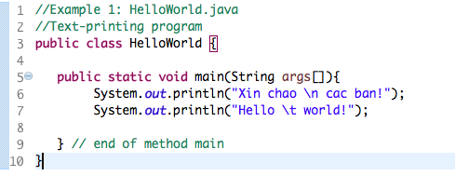

*Result-Kết quả*

## 2.2.2 Write, compile the first dialog Java program

### Screen Shot 2019-02-12 at 12

## 2.2.3 Write, compile the first input dialog Java application

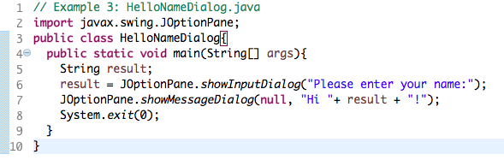

## 2.2.4 Write, compile, and run the following example:

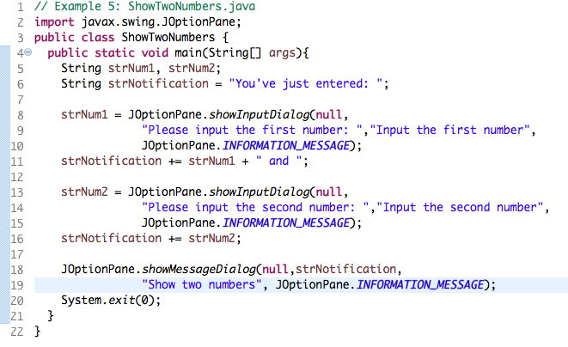

## 2.2.5 Write a program to calculate sum, difference, product, and quotient of 2 double numbers which are entered by users.

**Notes**

* To convert from String to double, you can use

**double num1 = Double.parseDouble(strNum1)**

* Check the divisor of the division

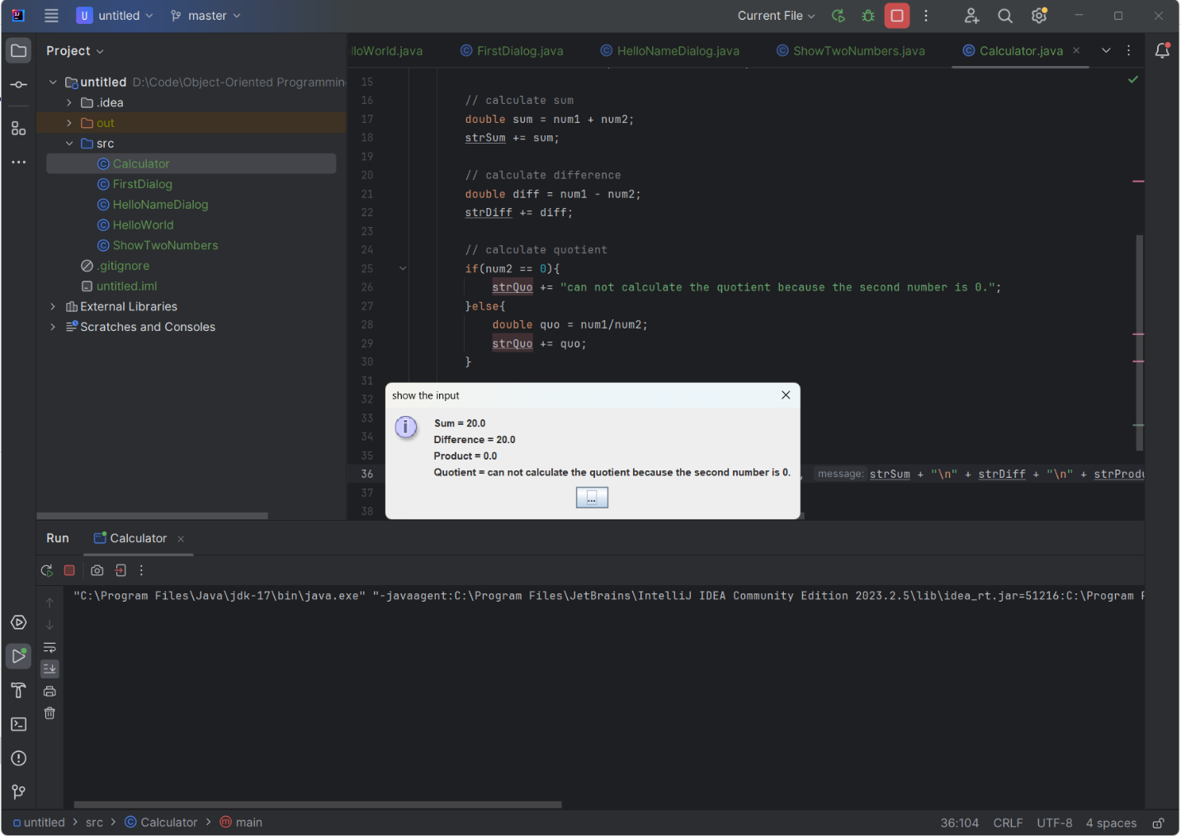

*2.2.6* Write a program to solve:

- the first-degree equation (linear equation) with one variable

- the system of first-degree equations (linear system) with two variables

- the second-degree equation with one variable

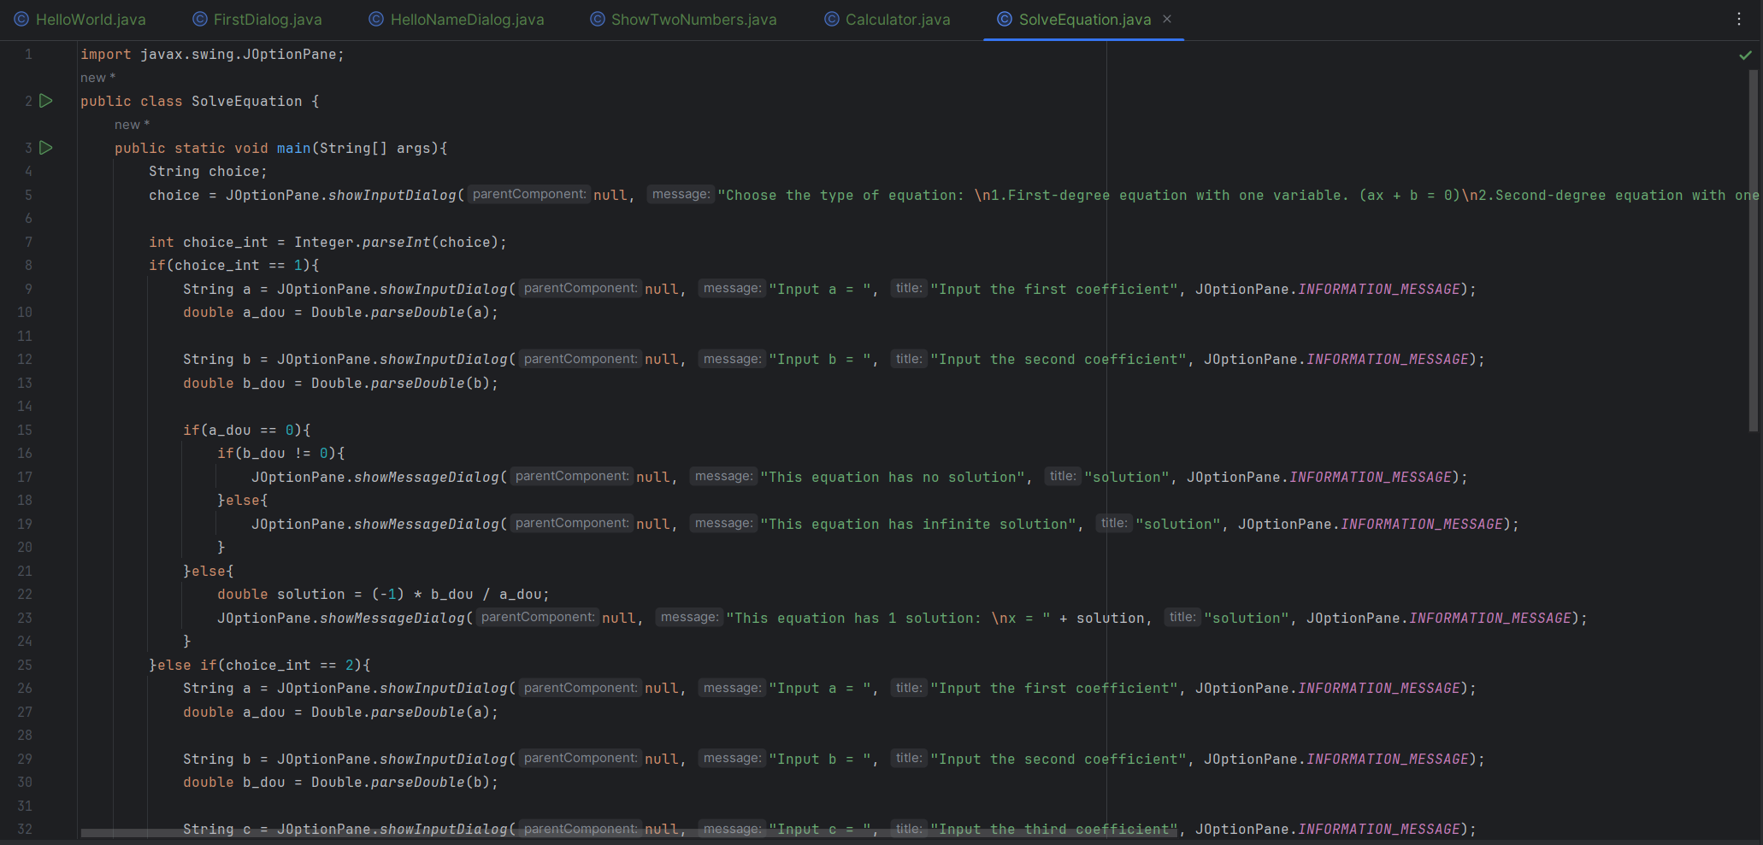

**Result**

* 1. First equation:
     1. 1 solution

* + 1. No solution

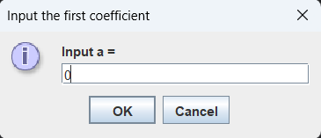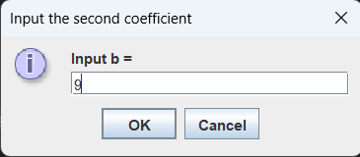

* + 1. Infinite solution

* 1. Second degree with one variable

*6.3* Write a program to display a triangle with a height of n stars (*), n is entered by users:

*6.4* Write a program to *display the number of days of a month, which is entered by users (both month and year). If it is an invalid month/year, ask the user to enter again.*

*6.5 Write a Java program to sort a numeric array, and calculate the sum and average value of array elements.*

1. Default Array

1. Input Array

