Github-link: <https://github.com/VuSnow/OOP-Lab-20242>

5. Use case diagram

6. Class Diagram

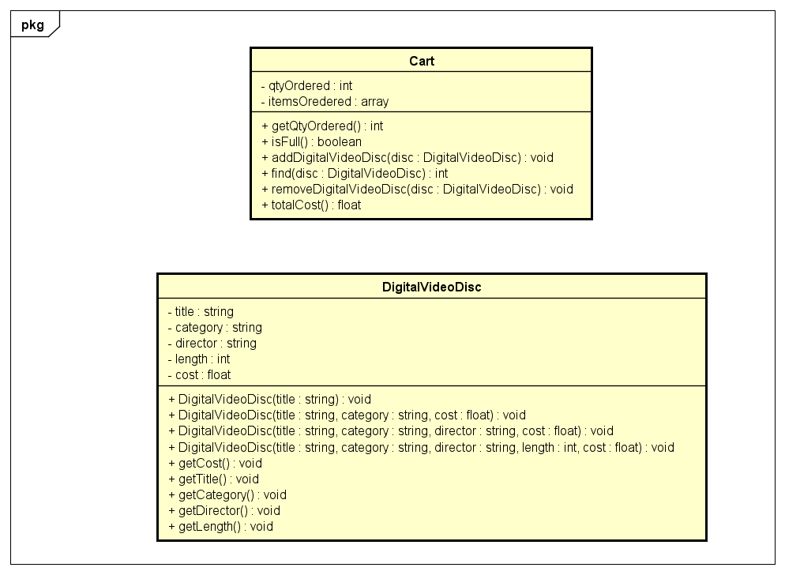

8. The DigitalVideoDisc class including:

- attributes

- constructors

11. Cart class:

