**WRITING**

**Writing Task 2:** **Throughout history, people have dreamed to live in a perfect society while they haven’t agreed what the ideal society would be like. What do you think is the most important element of a perfect society in the modern world? What can people do to achieve an ideal society?**

**Opening:** Viết lại đề ngắn gọn, sau đó tóm tắt câu trả lời – không cần trả lời trực tiếp cũng được.

**Main:**

Khổ 1 – trả lời câu hỏi 1

Khổ 2 – trả lời câu hỏi 2

Tóm tắt lại mọi thứ 1 cách đơn giản

**Opening:**

Since ***the dawn of*** human society, living in an ideal society has persistently been the ***ultimate*** desire of many individuals despite that fact that what ***constitutes*** a perfect society is ***up for*** debate. In this essay, I would ***explore*** factors and requirements ***leading to*** the creation of a perfect society before ***proposing*** what can be done to achieve it.

**Main:**

Khổ 1:

***What do you think is the most important element of a perfect society in the modern world?***

**Kỹ thuật viết: Object 🡪 [reason why need to create the object] 🡪 [the method to create the object]**

**Education:**

An ideal society **[object]** ***would mean that*** everyone is ***entitled to*** the ability to achieve their full potential **[reason why]**. As a result, universal access to education **[method]** should be ***granted***, and no one should be ***restricted from*** learning and pursuing higher education.

An ideal society **[object]** is ***characterized by*** people having the chance to improve themselves and enhance their ability to ***comprehend*** everything that is morally and socially appropriate **[reason why]**. As a result, in order to achieve such an ***idealistic*** world, we must have universal access to high-quality education **[method]**, ***meaning that*** no one should be financially ***restricted from*** learning opportunities.

**Healthcare:**

An ideal society **[object]** ***means that*** each individual must have a high quality of living ***characterized by*** a lower frequency of severe ***illnesses*** **[reason why]**. As a result, ***granting*** universal access to healthcare ***regardless of*** a person’s ***socioeconomic*** background **[method]** can help achieve this by giving people the best treatment possible without any cost requirement.

**Crimes:**

An ideal society **[object]** must have the ability to ensure the safety of all citizens, allowing them to ***lead a life*** with stability and peacefulness **[reason why]**. As a result, it must be ***absent of crimes*** **[method]**, as no harm could be ***inflicted on anyone*** due to illegal activities.

Khổ 2:

***What can people do to achieve an ideal society? 🡪 Paying tax money.***

**Kỹ thuật viết: Object 🡪 [reason why need to create the object] 🡪 [the method to create the object]**

**Healthcare:**

As universal access to healthcare **[object]** ***means that*** we completely remove the cost barriers that often ***prohibit*** poorer individuals to get access to medical treatment, the contribution of each individual is important **[reason why]**. By paying more tax money **[method]**, we can create a ***societal*** fund that helps provide medical service for everyone in society regardless of their economic backgrounds.

**Education:**

Granting universal access to education **[object]** ***means that*** we must allow children from all families regardless of their income to go to high-quality schools. As the cost my be large due to the requirements for facilities and human resources, only the unification of all people in society could be the solution **[reason why]**. By summitting more tax money **[method]**, we can help the government fund educational opportunities, creating a perfect society that many have always wanted.

**Crimes: [Tự viết đi ku]**

**…**

**Closing:**

In conclusion, the creation of a perfect society has always been an ***elusive*** goal that many people have been chasing. As universal healthcare is a critical factor in such an ***idealistic*** world, each individual should focus on removing the cost barriers against medical treatment.

**Writing Task 1:** **The charts below show the global market ratio of three computer operating system compared to other from 2012 to 2015.**

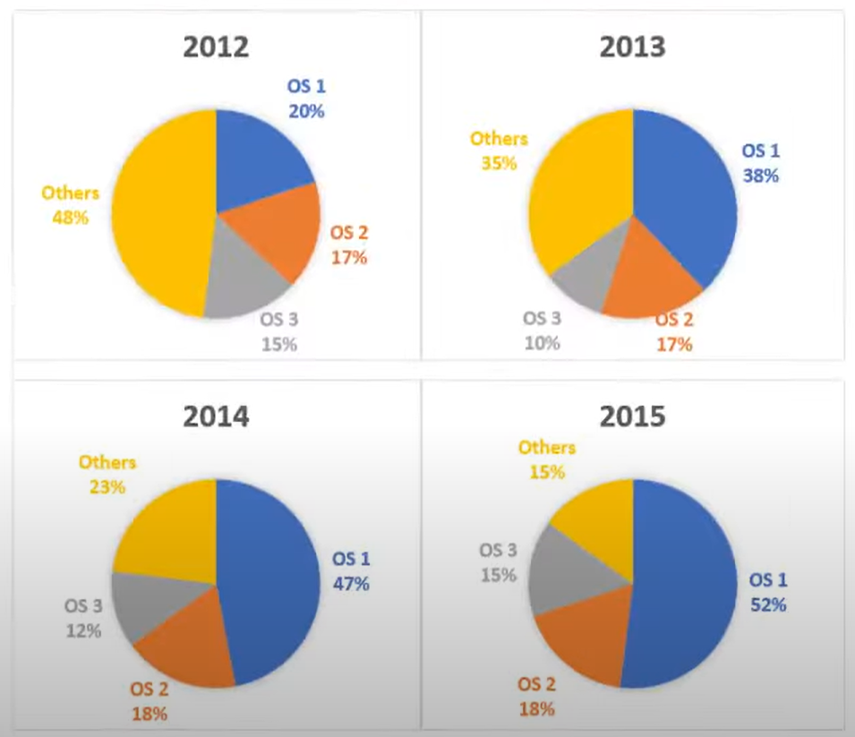

The supplied pie charts depict the proportion of the universal market of three computer operating systems in the comparison from 2012 to 2015. Overall, the market share of OS1 increased and eventually became the largest at the end of this period. While the total proportions of OS2 and OS3 stayed stable, the market shares of other OS in combination decreased significantly.

Although the market share of other non-mentioned operating systems was the largest initially, this position was taken over by the proportion of market share occupied by OS1. In 2012, OS1 only made up 20% of the entire market. However, the percentage surged to 52% in 2015. In the same period, the figures for other operating systems in combination plunged from 48% to 15%.

In contrast, there were no remarkable changes in the market shares of OS2 and OS3. The sales of OS2 only changed by 1% in the entire period, staying in the range of 17% and 18%. Nevertheless, the figure for OS3 decreased from 15% to 10% in the first year before recovering back to 15% in 2015.

**Writing Task 2: Mobile phones and the internet bring a lot of benefits to people nowadays. However, older people use them the least.**

**In what aspects do mobile phones and the internet benefit older people? How can we encourage them to use these technologies?**

**Opening:** Viết lại đề, sau đó trả lời câu hỏi – không chi tiết cũng không sao.

**Main:**

* Khổ 1: Viết về câu hỏi 1 – aspects do mobile phones and the internet benefit older people.
* Khổ 2: Solution để encourage older people to ué smartphones/the internet more.

**Conclusion:** tóm tắt lại nội dung đã nói. Hạn chế không đưa ra thông tin mới, cũng như lời kêu gọi thì có cũng được, không có không sao

**Opening:**

Although a ***myriad*** of benefits can be enjoyed by people who use mobile phones and the Internet, older people tend to use them more limitedly compared to other age groups. In the essay, I would explore the range of advantages that older people can experience if the rely on the technologies before ***proposing*** solutions to encourage them.

**Main:**

**Khổ 1 – giải thích các lợi ích của đt + internet đối với người lớn tuổi.**

***In what aspects do mobile phones and the internet benefit older people?***

**Kỹ thuật viết: Object 🡪 [reason why need to create the object] 🡪 [the method to create the object]**

There are some major advantages when older people increase their reliance on mobile phones and the Internet.

**Keep in touch with other members in their families**

Older people **[Object]** are often characterized by a lack of physical mobility, making it hard for them to travel and have direct interactions with other members in their families or friends. This can lead to social isolation and eventually other mental health disorders. With the connectivity of mobile phones and the Internet, older people can connect easily with their beloved ones, helping them sustain relationships and directly benefit their mental health.

**Kiểm tra sức khỏe liên tục – (chronic illnesses – diabetes / cardiovascular diseases / hypertension)**

People of older ages tend to have a higher frequency of chronic medical problems, such as diabetes, cardiovascular diseases, or hypertension, which need to be monitored consistently for optimal treatment. Unfortunately, older people tend to be more physically limited in terms of mobility, making it hard for them to make frequent visit to medical facilities. Thus, when they can use the Internet and mobile phones, they can get access to telemedical services, helping them supervise their health and provide them support without have to travel.

**Khổ 2: Solution để encourage older people to ué smartphones/the internet more.**

***How can we encourage them to use these technologies?***

**Solution:**

* **Educational solutions**

The government should organize educational campaigns that promote the benefits of technological advancements among the group of older people. By encouraging them to use and experience benefits, future generations can follow the step and create a larger reliance on technology.

* **Financial incentives**

The government should subsidize the cost of technical devices, such as smartphones, as well as the Internet fee for older people, helping them increase their usage.

**Closing:**

In conclusion, despite the benefits of mobile phones and the Internet, older people tend to be skeptical of using them. As these technologies can help older people’s mental and physical health, the government should implement measures that boost the overall usage by educating about the potential benefits and providing discounts that can incentivize older people to use them more.