SE LAB 1

Châu Thanh Vũ – 523K0032

Lab01:

**Ex01:**

* Choose Label from ToolBox, drag into Form:

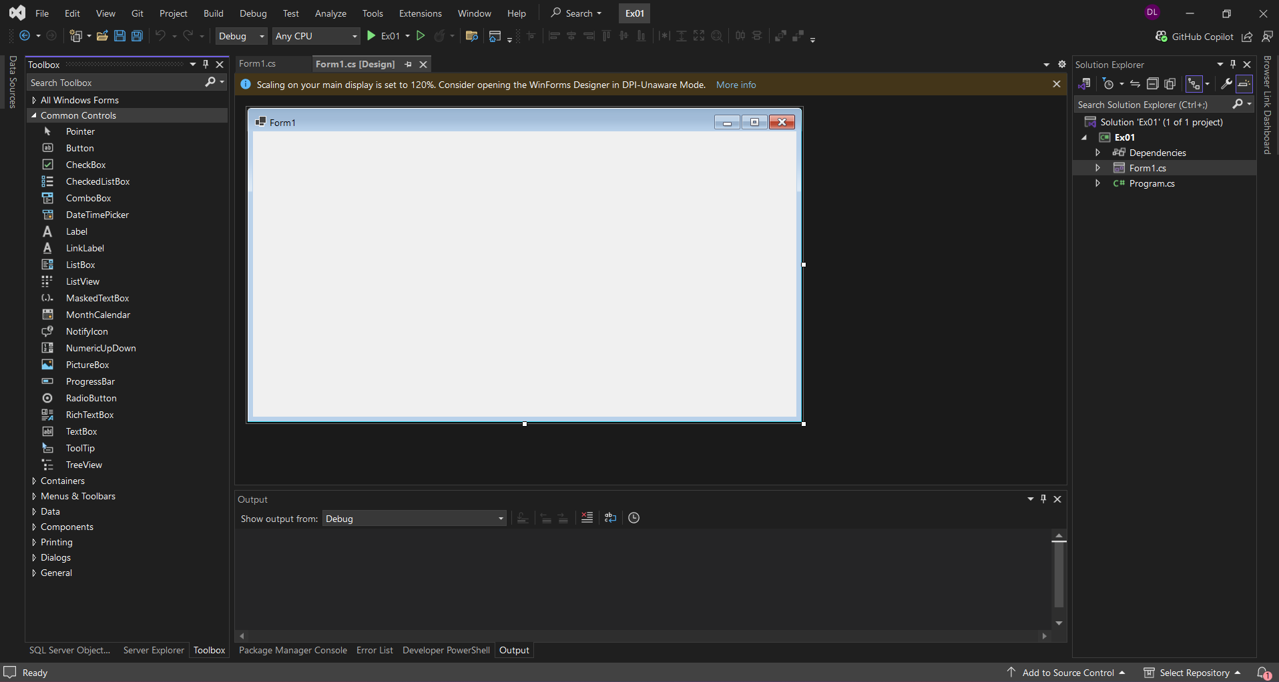

* Set the text of the label to "Hello, World!":

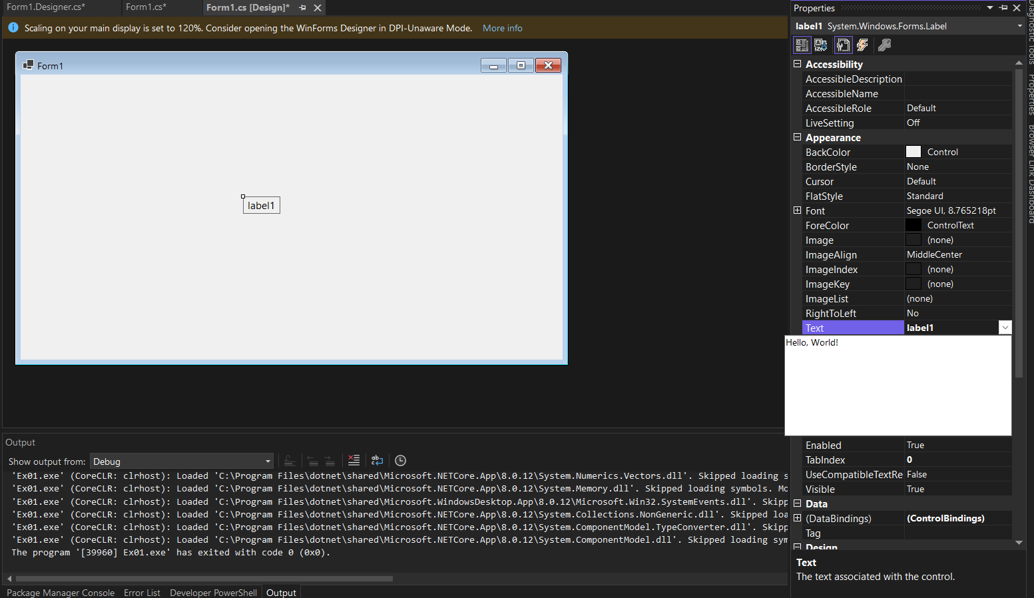

* Run the application to see the form with the label:

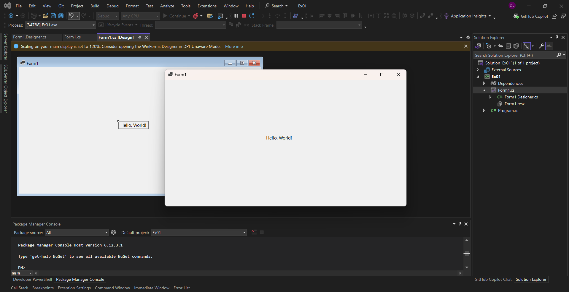

**Ex02:**

* Open the project from Exercise 1.
* Drag a Button control from the Toolbox to the form:

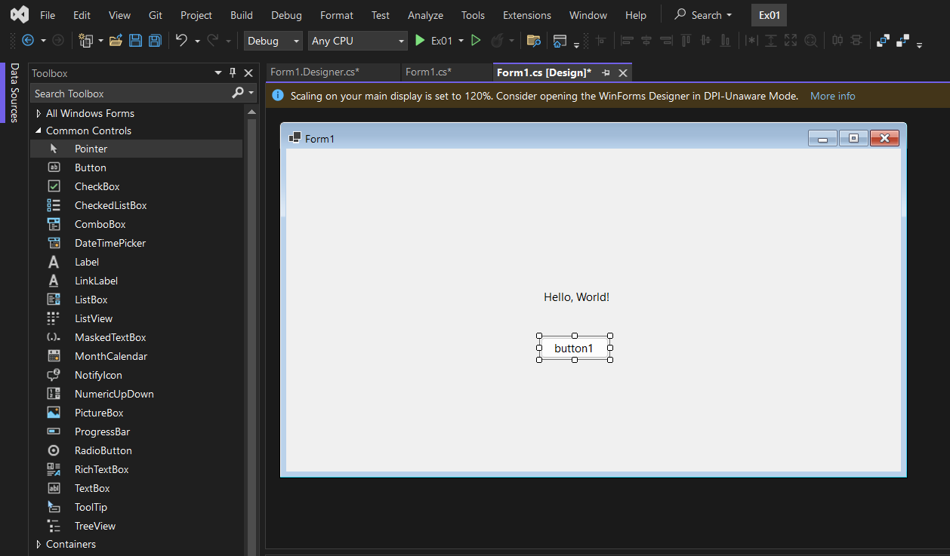

* Set the text of the button to "Click Me!":

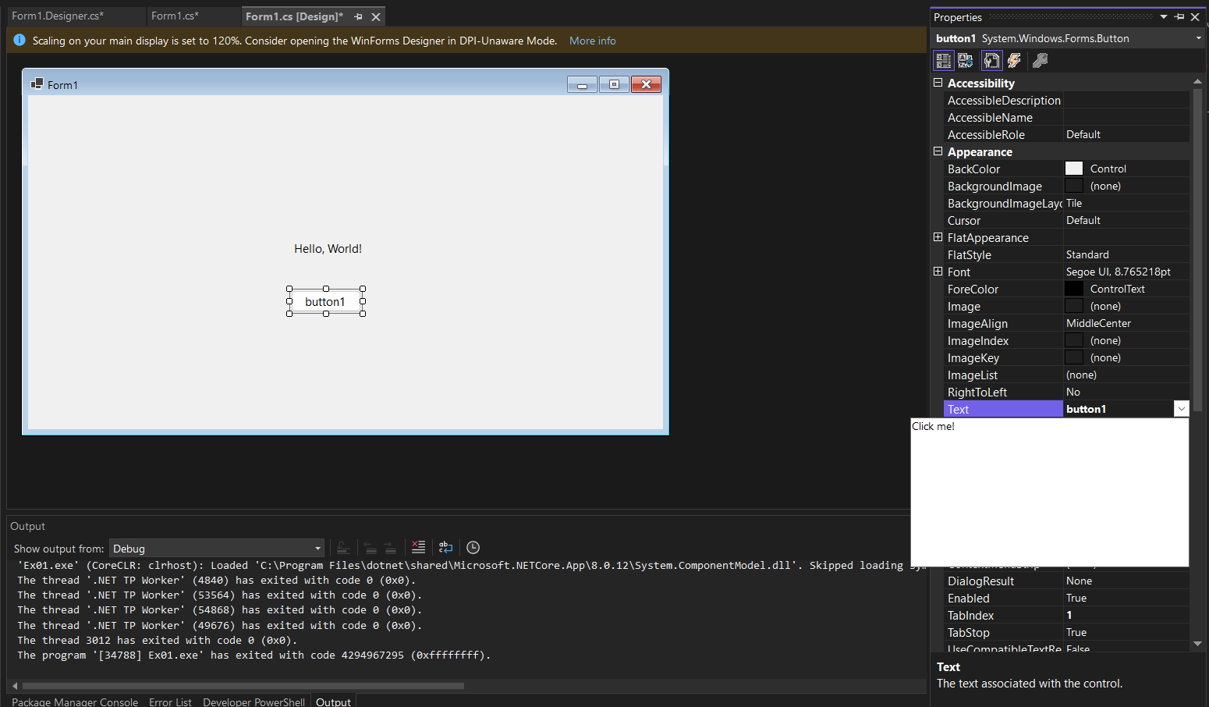

* Double-click the button to create a click event handler:

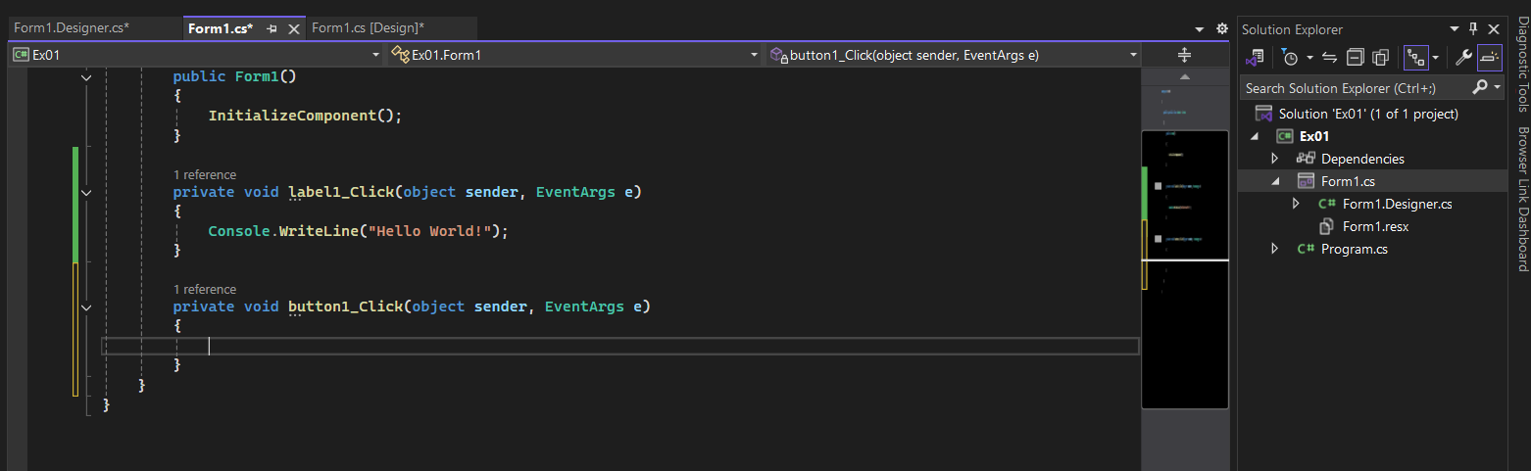

* In the event handler, add code to change the label's text to "Button Clicked!":

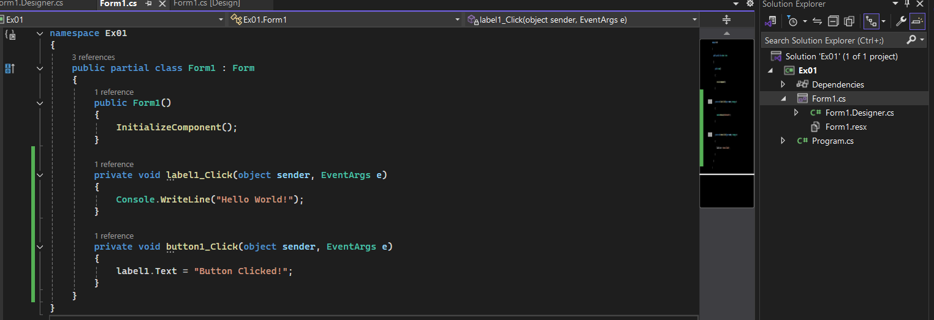

* Run the application and click the button to see the label text change:

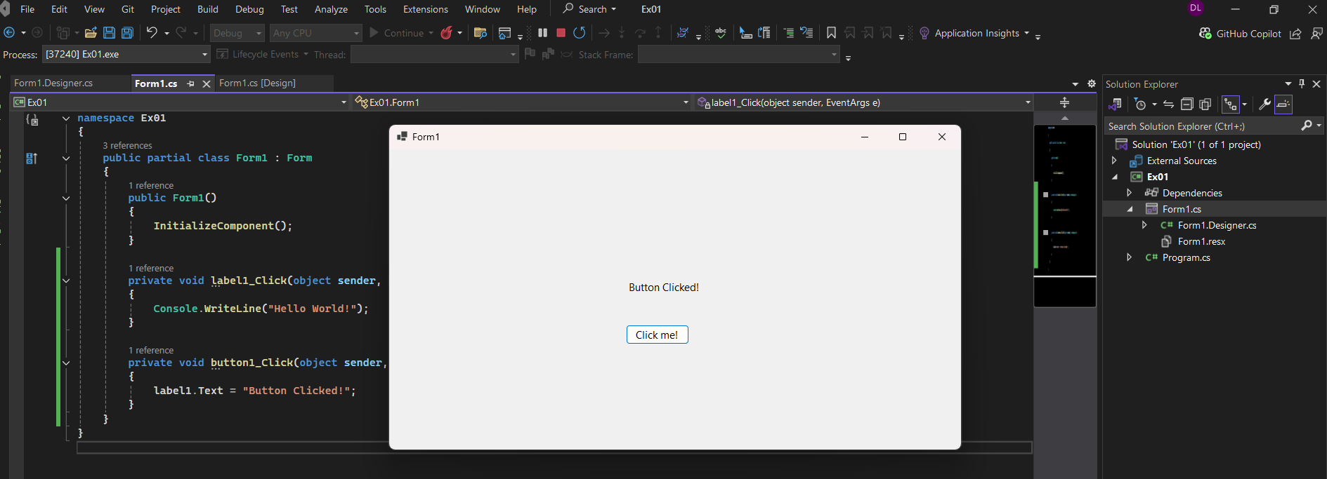

**Ex03:**

* Open the project from Exercise 2:
* Drag a TextBox control from the Toolbox to the form.

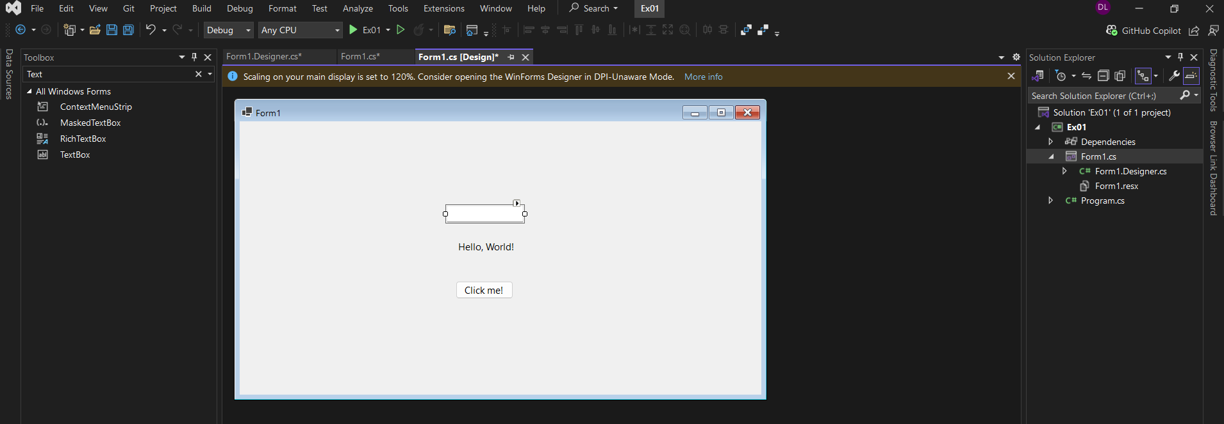

* Modify the button click event handler to display the text from the TextBox in a MessageBox:

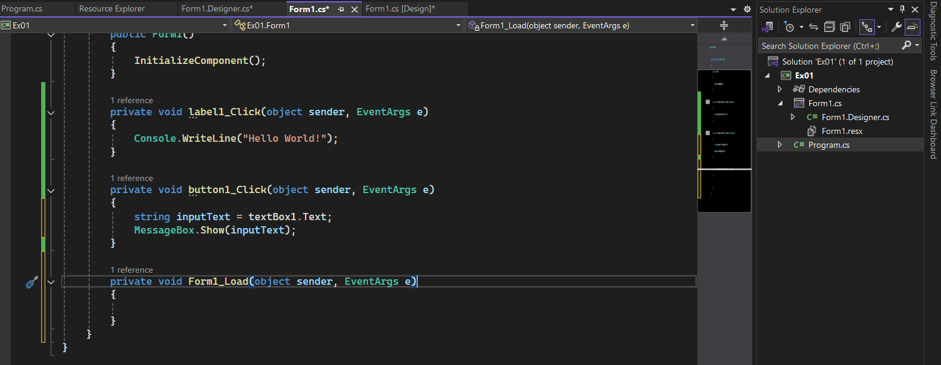

* Run the application, enter text in the TextBox, and click the button to see the message box:

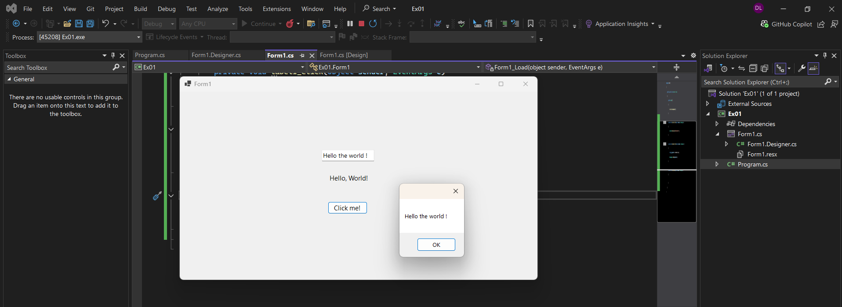

**Ex04:**

* Create a new Windows Forms project:
* Add two TextBox controls for input numbers:
* Add four Button controls for addition, subtraction, multiplication, and division:
* Add a Label control to display the result:

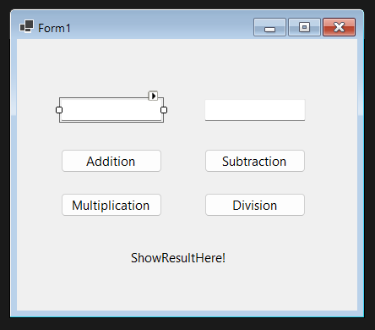

* Write event handlers for each button to perform the corresponding arithmetic operation and display the result in the label:
* Repeat similar code for subtraction, multiplication, and division:

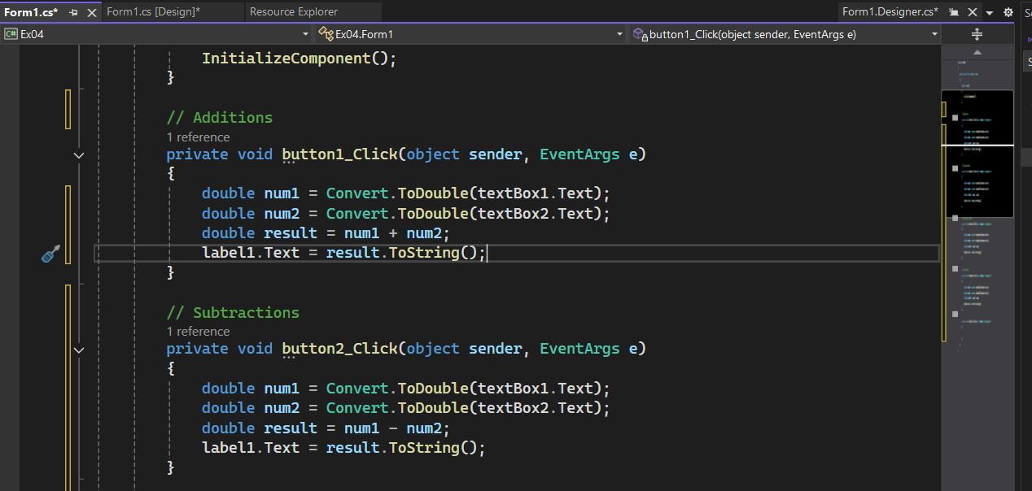

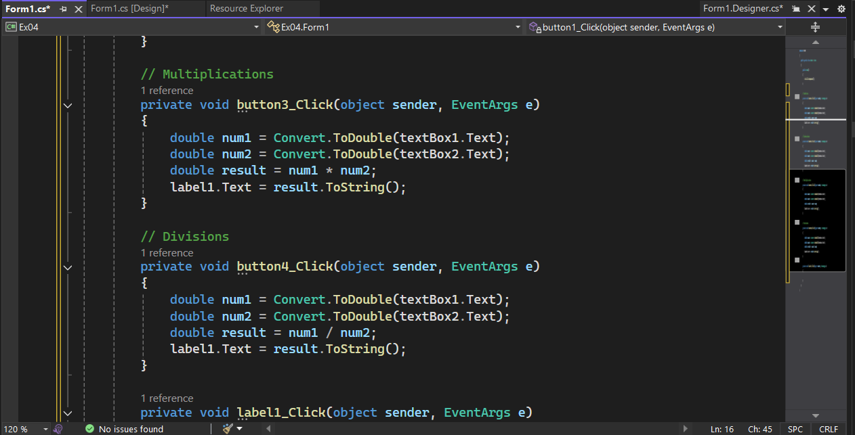

**Ex05:**

* Create a new Windows Forms project:
* Drag a ListBox control and a ComboBox control from the Toolbox to the form:

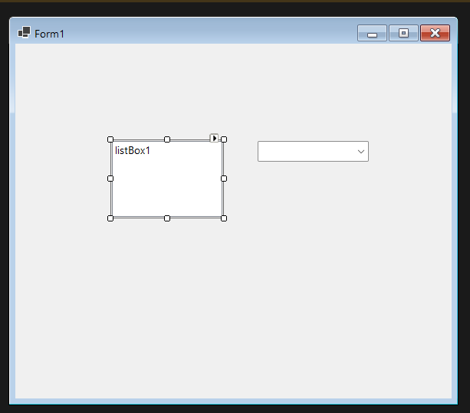

* Add items to the ListBox and ComboBox in the form's Load event:

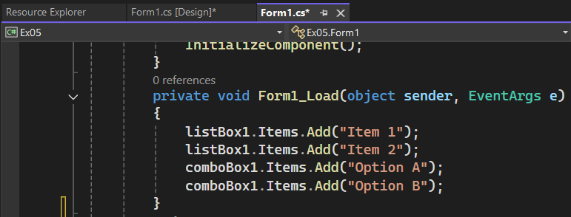

* Add a Button control to display the selected item from the ListBox and ComboBox in a MessageBox:

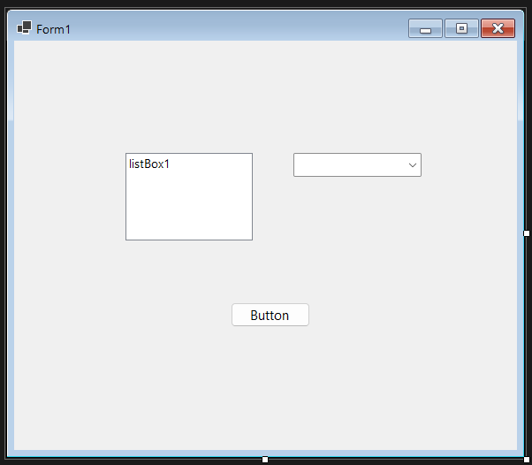

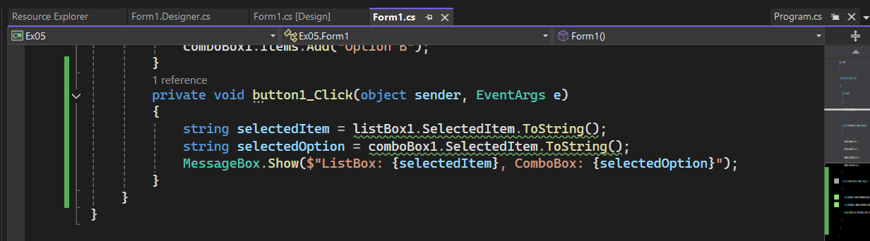

**Ex06:**

* Create a new Windows Forms project:
* Drag a DataGridView control from the Toolbox to the form:

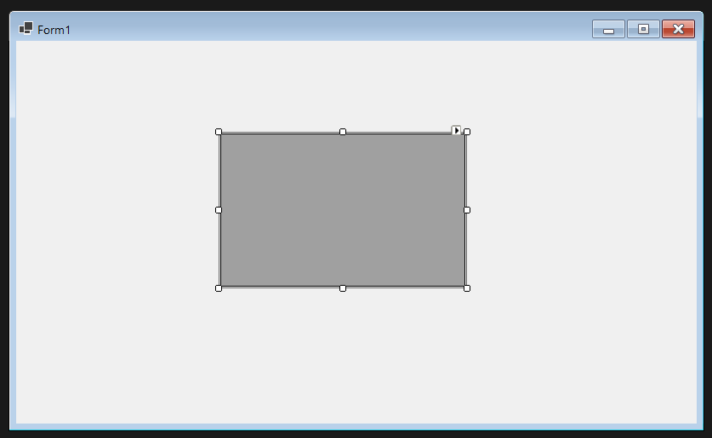

* In the form's Load event, populate the DataGridView with sample data:

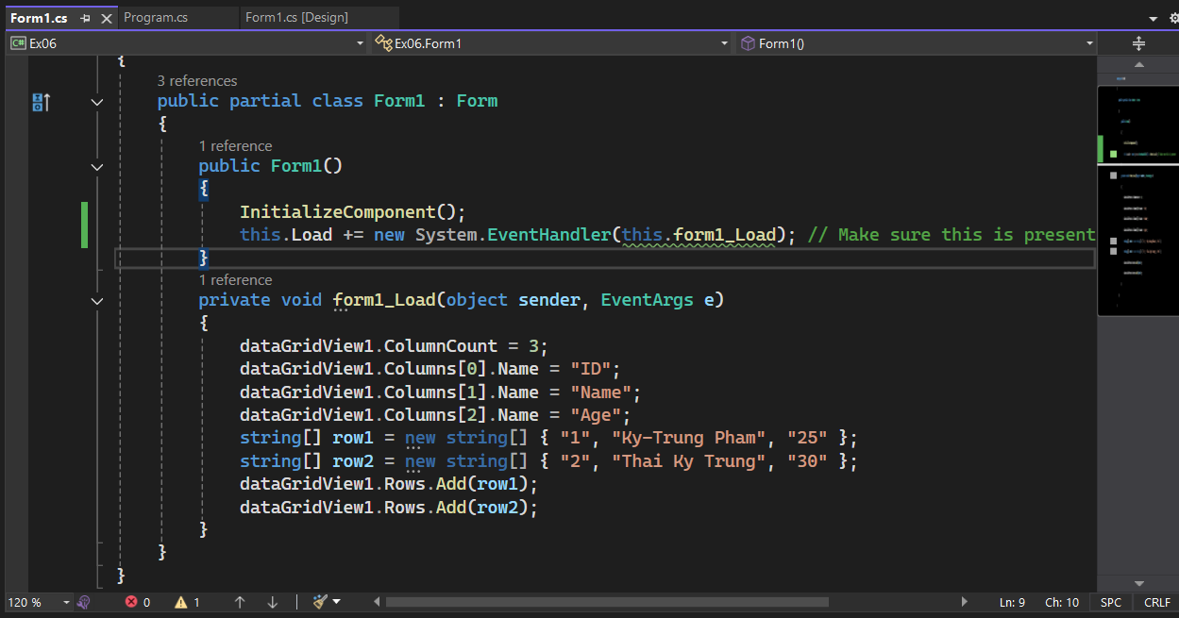

* Run the application to see the DataGridView populated with data:

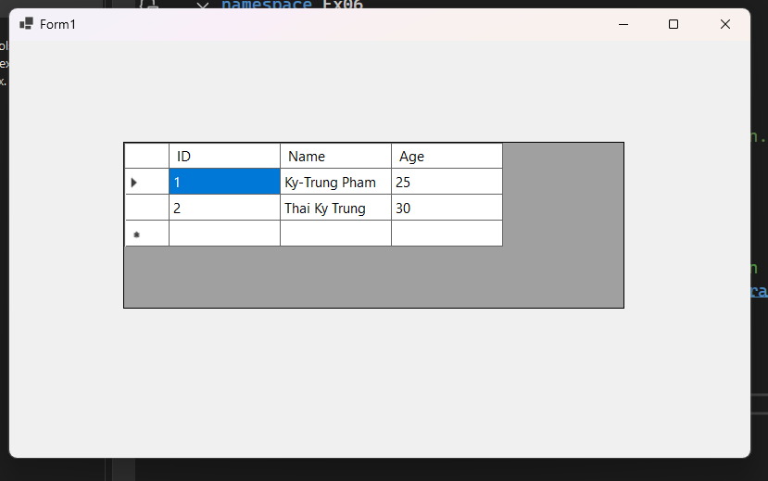

**Ex07:**

* Open the project from Exercise 6.
* Add TextBox controls for ID, Name, and Age:

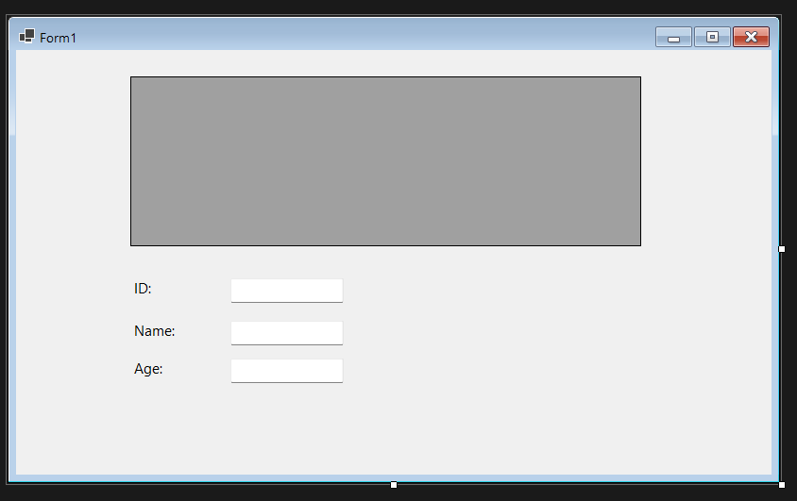

* Add a Button control to add a new row to the DataGridView:

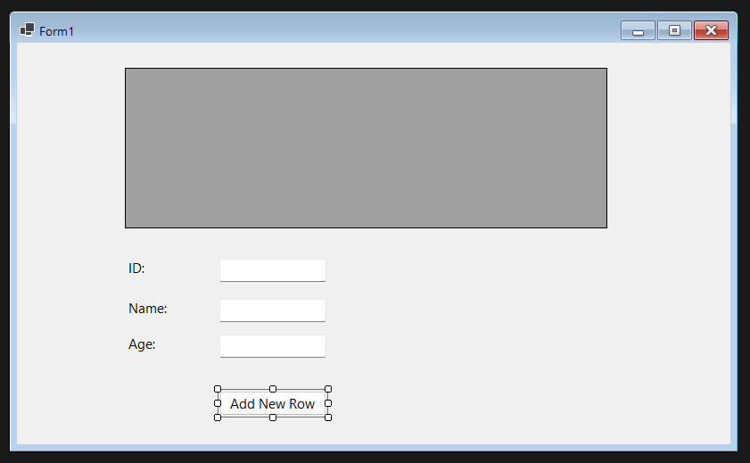

* Write the event handler for the button to add a new row:

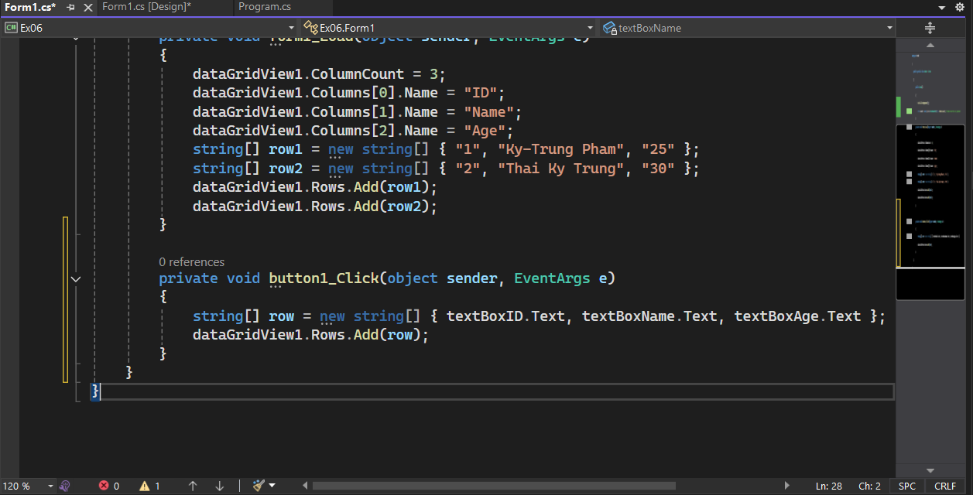

* Run the application, enter data in the TextBoxes, and click the button to add a new row:

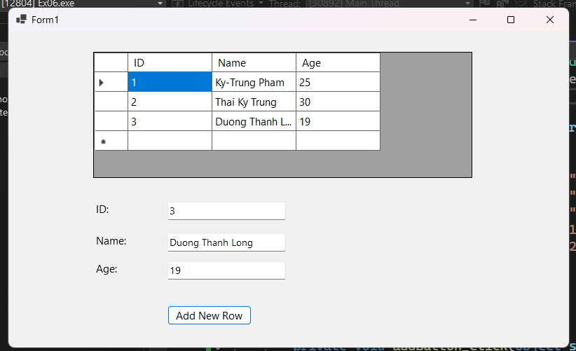

**Ex8:**

* Open the project from Exercise 7.
* Enable editing in the DataGridView by setting:

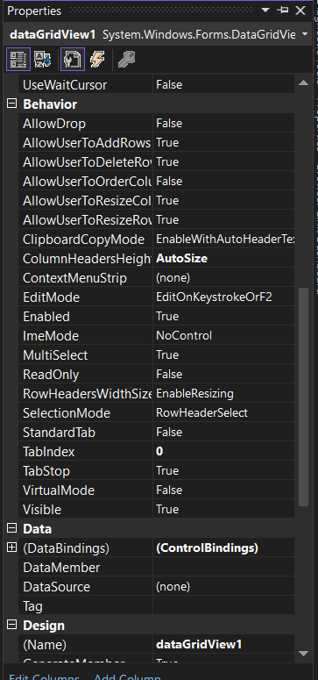

* Add a Button control to delete the selected row:

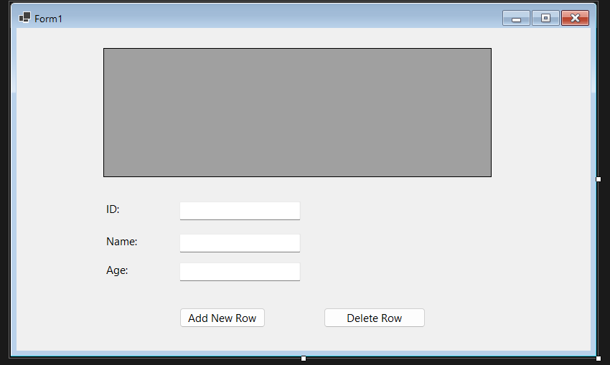

* Write the event handler for the button to delete the selected row:

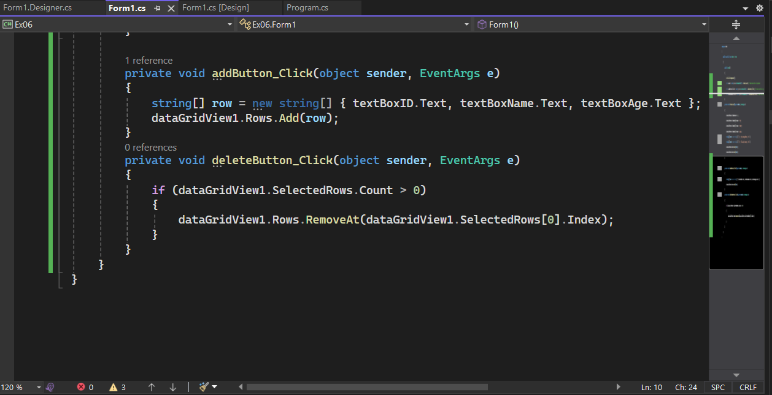

* Run the application, select a row, and click the delete button to remove it:

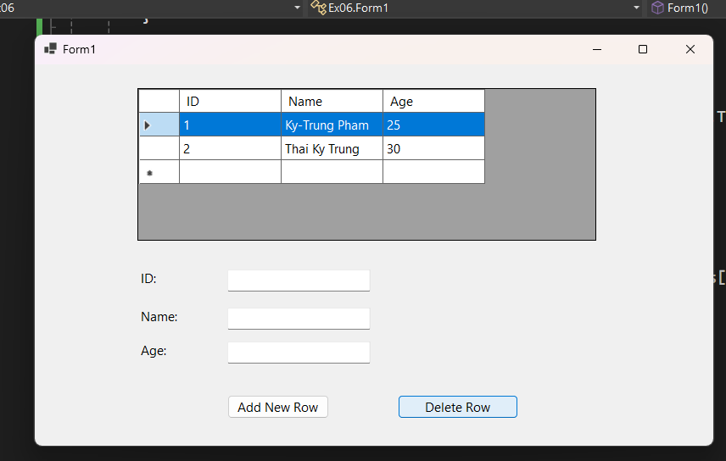

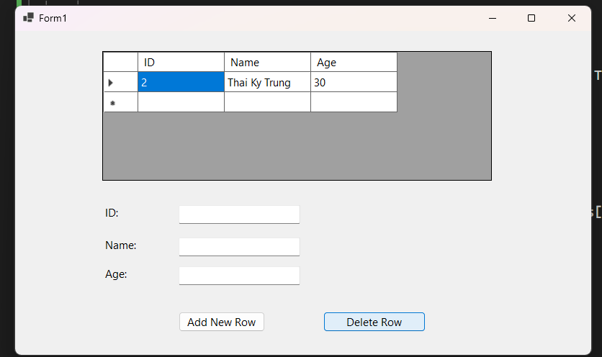

**Ex09:**

* Open the project from Exercise 8.
* Add a ComboBox column to the DataGridView:

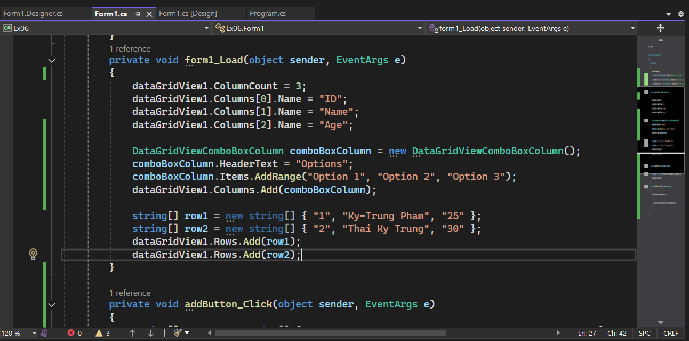

* Run the application to see the ComboBox in the DataGridView:

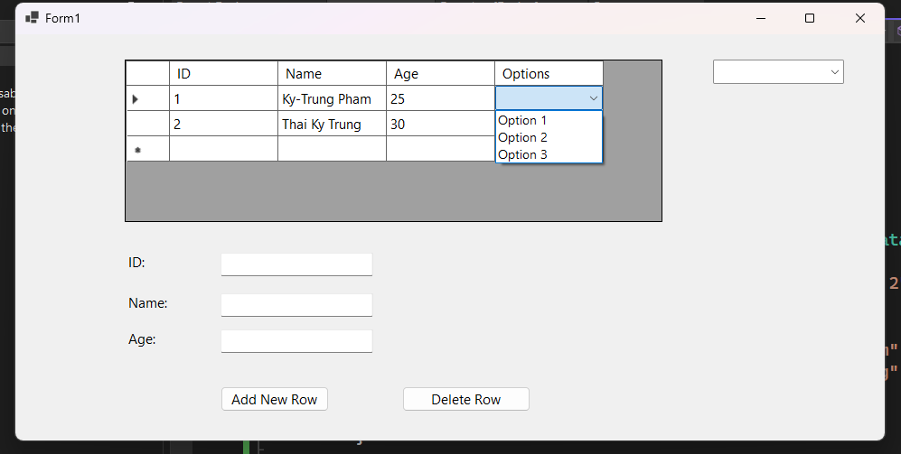

**Ex10:**

* Create a new Windows Forms project.
* Drag a DateTimePicker control and a ProgressBar control from the Toolbox to the form:
* Add a Button control to start a progress simulation:

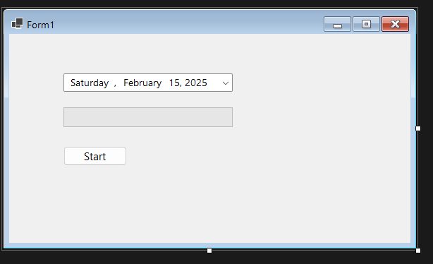

* Write the event handler for the button to update the ProgressBar based on a timer:

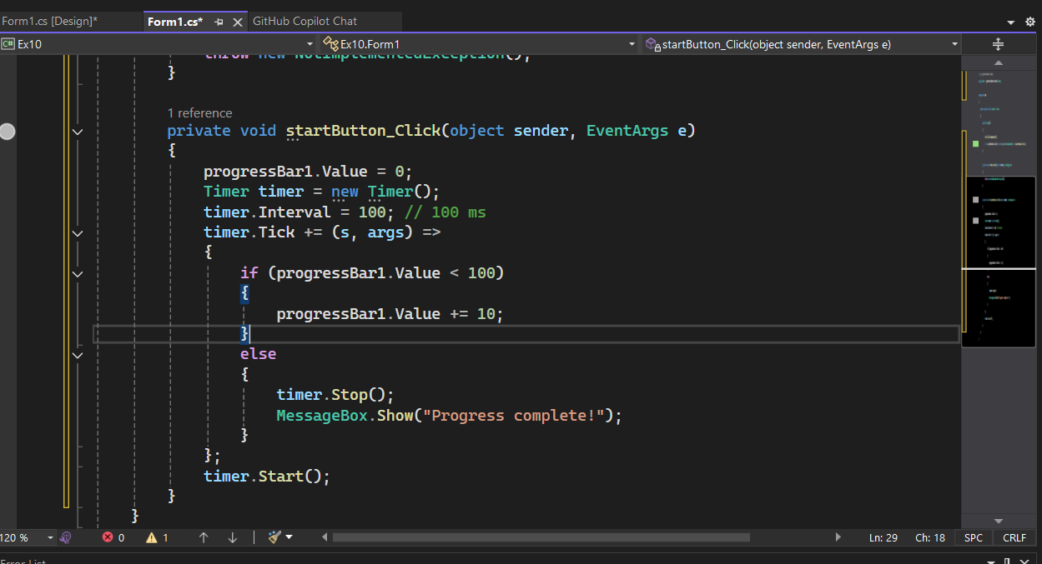

* Run the application, select a date, and click the button to see the progress bar update:

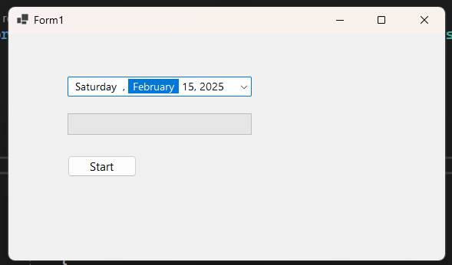

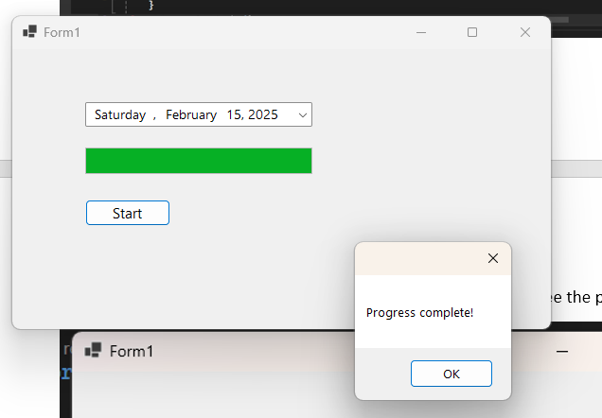

**Ex11:**

* Drag a TreeView control from the Toolbox to the form:

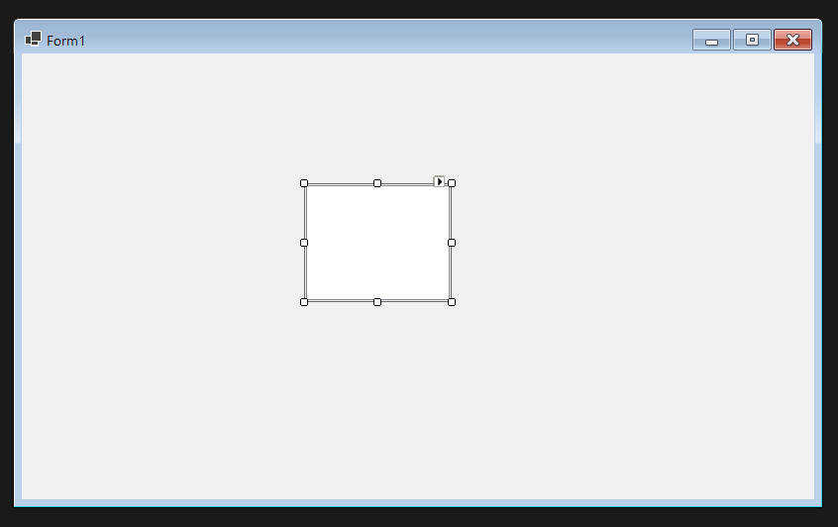

* Populate the TreeView with nodes in the form's Load event:

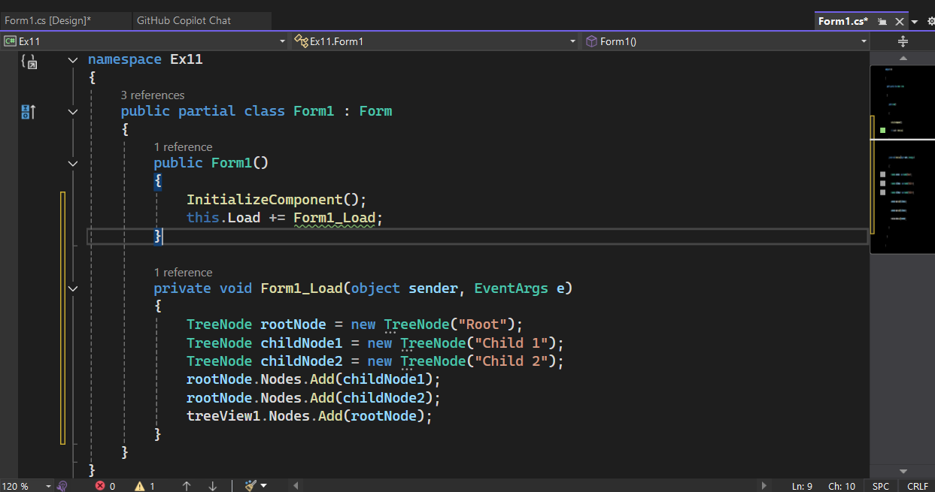

* Run the application to see the hierarchical structure:

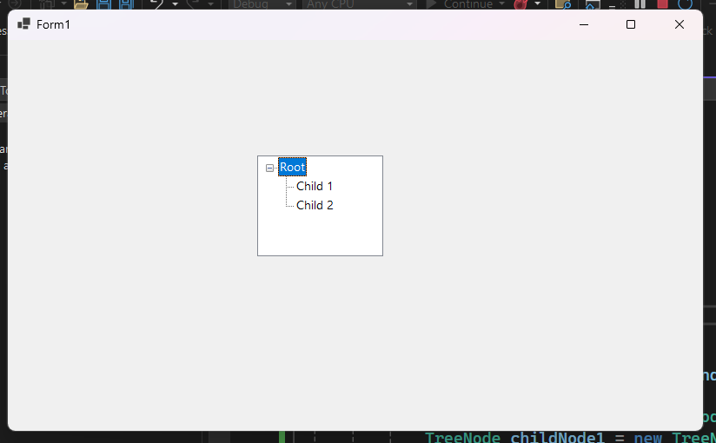

**Ex12:**

* Create a new Windows Forms project.
* Drag a ListView control from the Toolbox to the form:

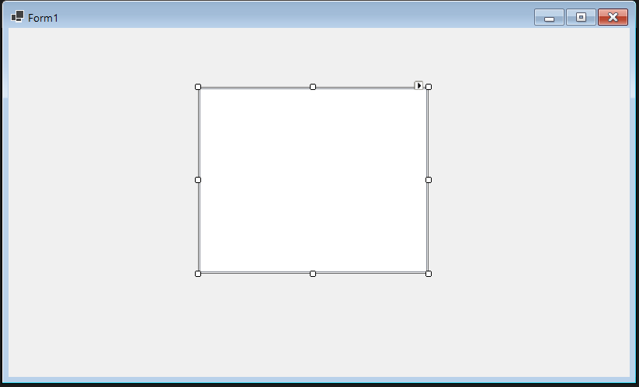

* Set the View property of the ListView to Details:

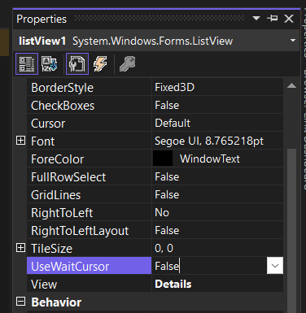

* Add columns and items to the ListView in the form's Load event:

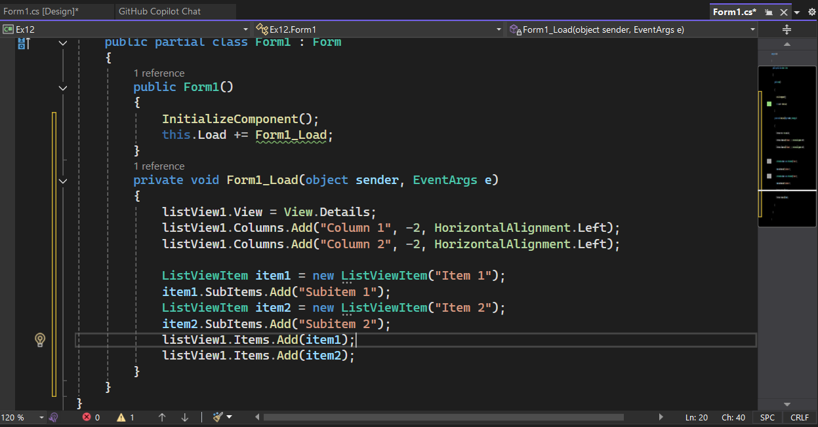

* Run the application to see the ListView in details view:

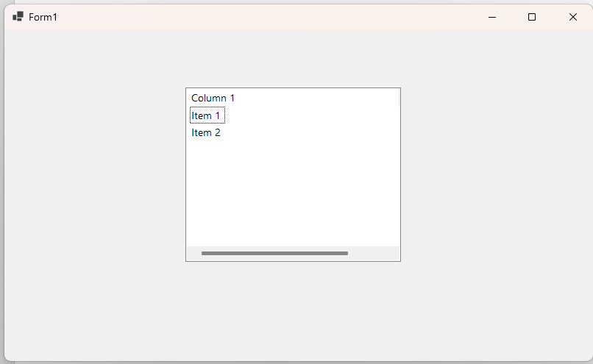

**Ex13:**

* Create a new Windows Forms project.
* Drag a TabControl from the Toolbox to the form:

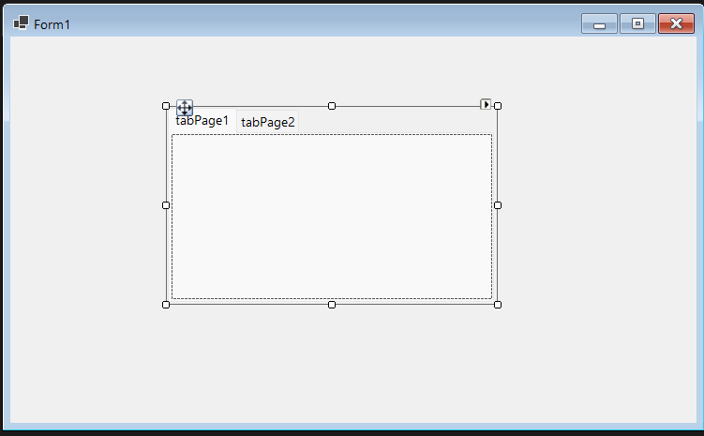

* Add tabs and controls to each tab:

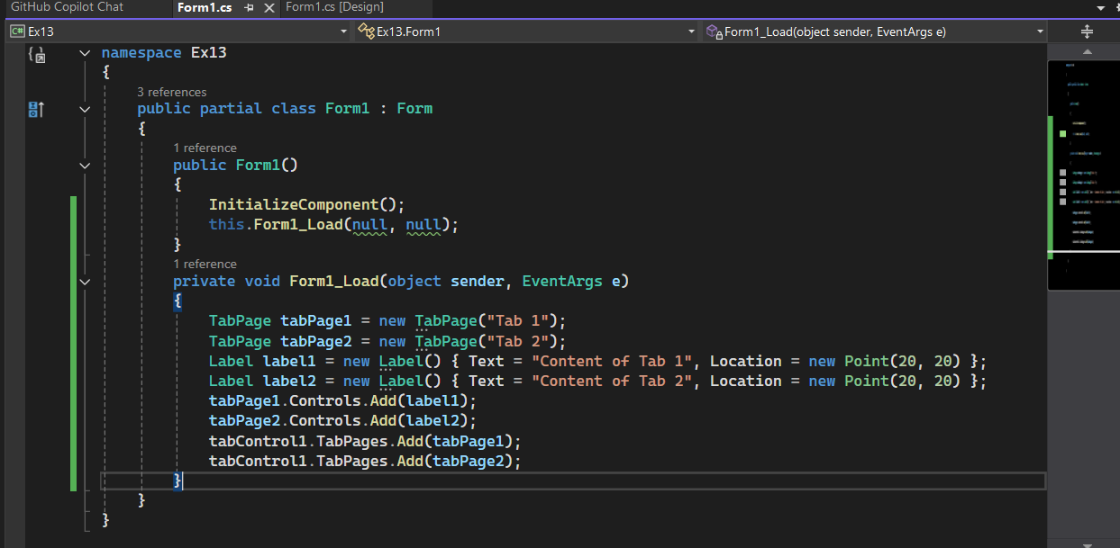

* Run the application to see the tabbed interface:

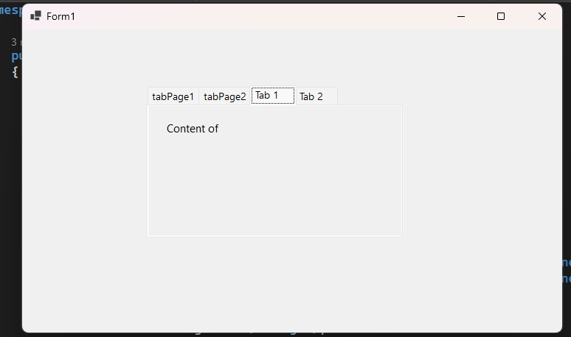

**Ex14:**

* Create a new Windows Forms project.
* Drag a MenuStrip control from the Toolbox to the form:

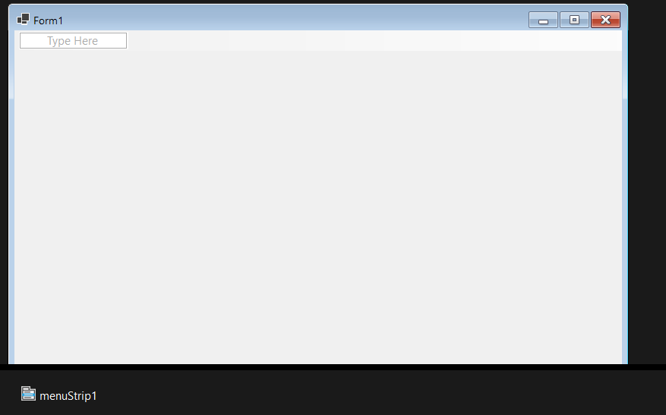

* Add menu items and sub-items:

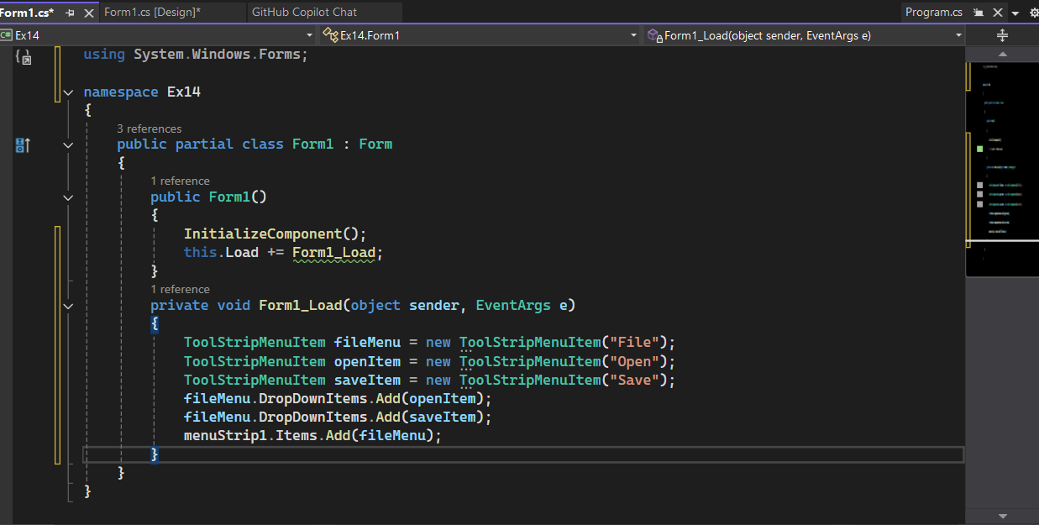

* Run the application to see the menu:

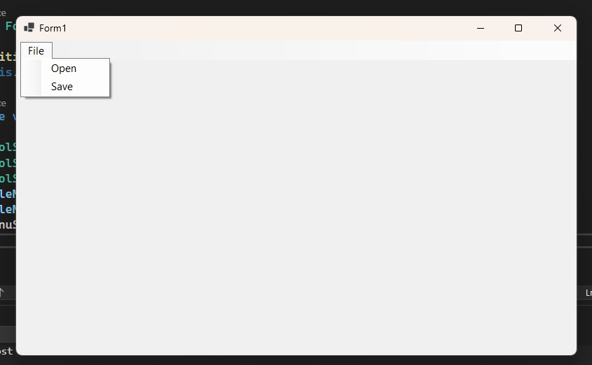

**Ex15:**

* Create a new Windows Forms project.
* Drag a ContextMenuStrip control from the Toolbox to the form:

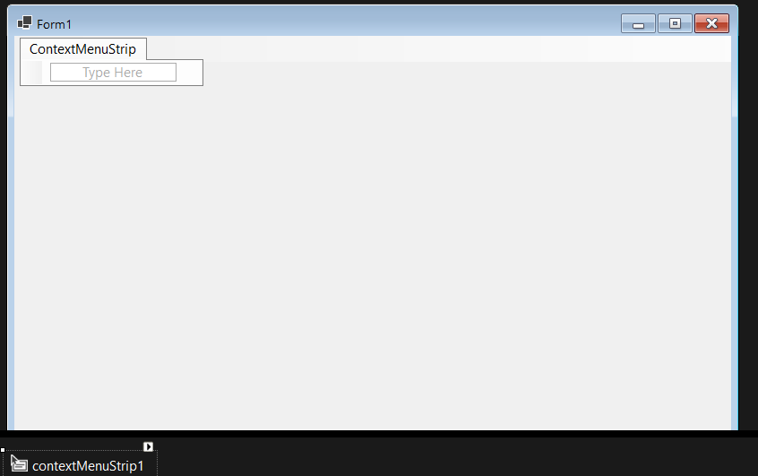

* Add context menu items:

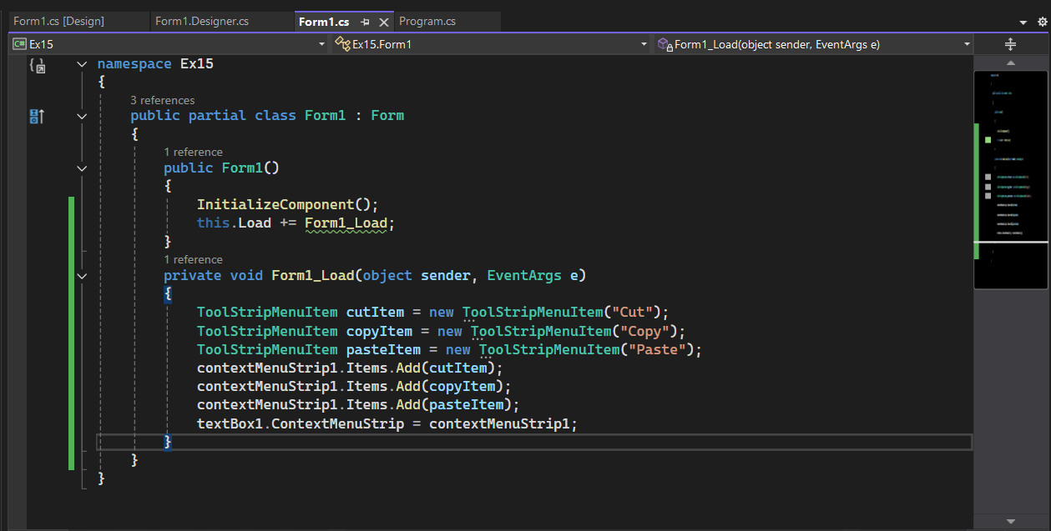

* Run the application, right-click on the TextBox to see the context menu:

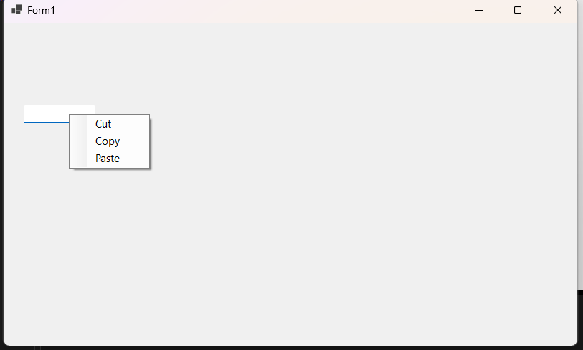

**Ex16:**

* Create a new Windows Forms project.
* Drag a ToolStrip control from the Toolbox to the form:

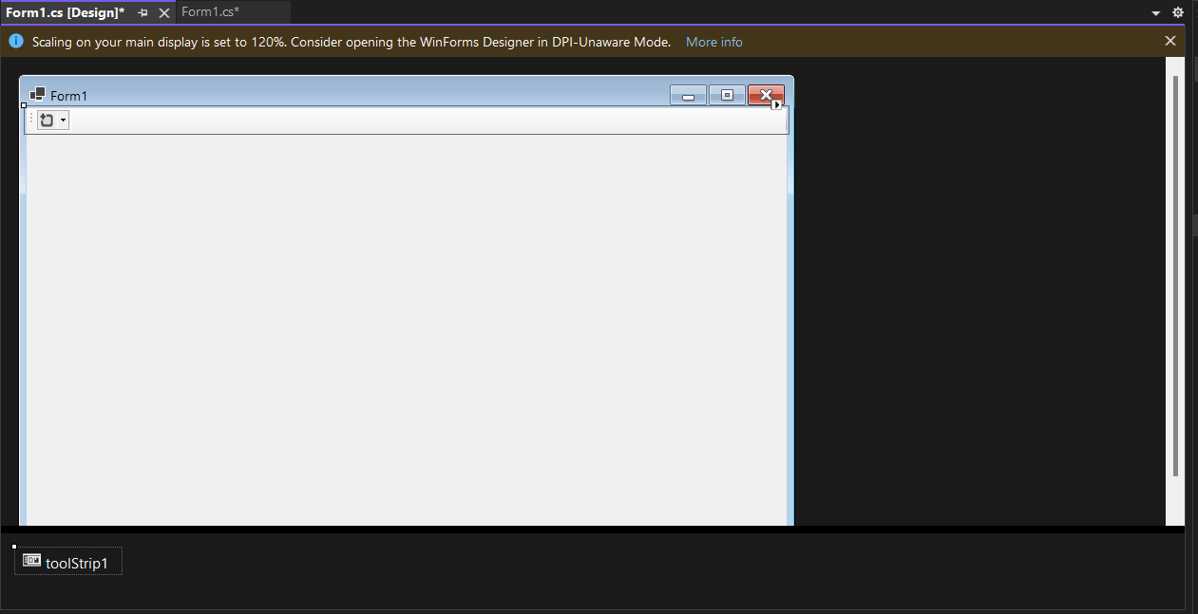

* Add buttons and other items to the ToolStrip:

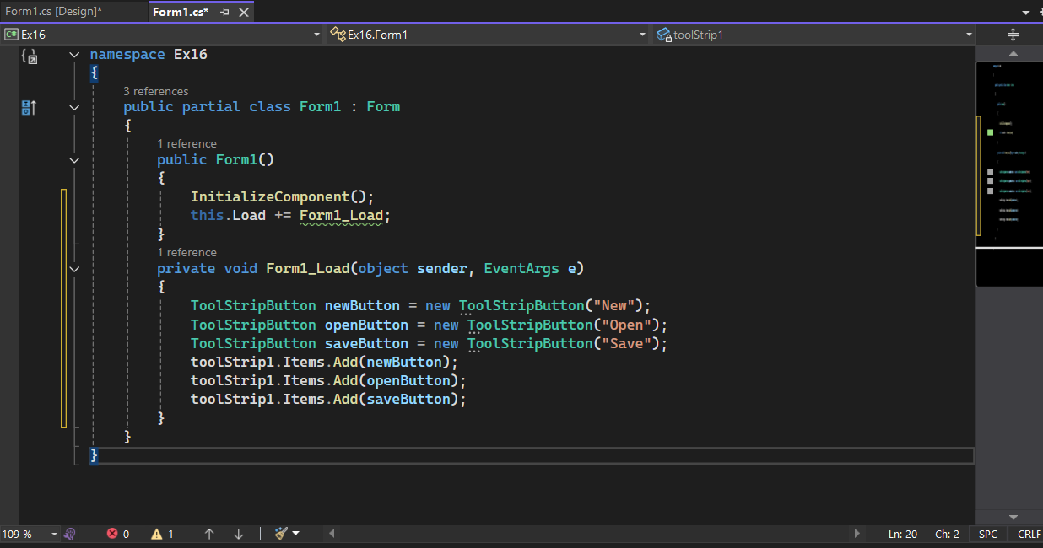

* Run the application to see the toolbar:

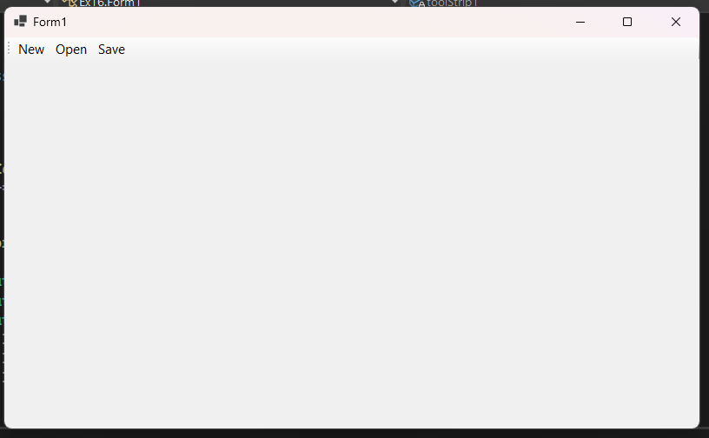

**Ex17:**

* Create a new Windows Forms project.
* Drag a StatusStrip control from the Toolbox to the form:

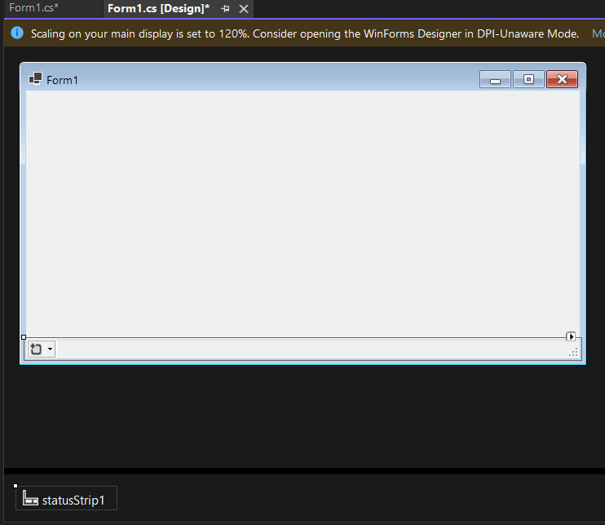

* Add status labels and other items to the StatusStrip:

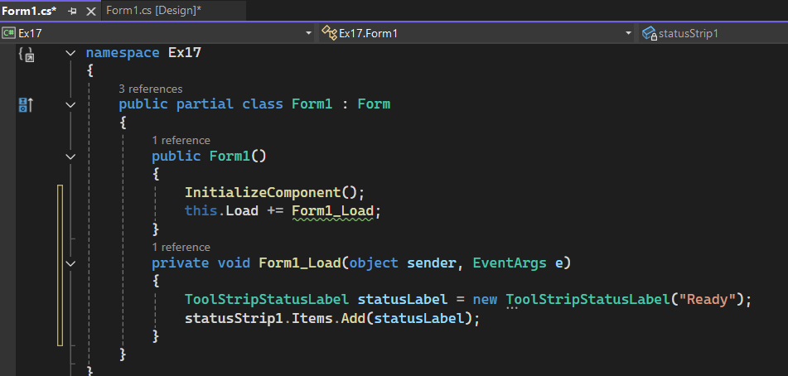

* Run the application to see the status strip:

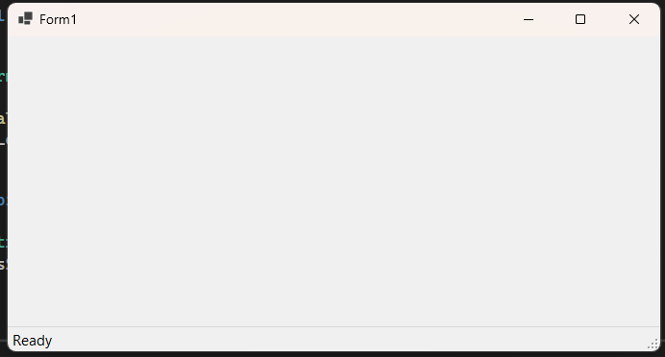

**Ex18:**

* Create a new Windows Forms project.
* Drag a SplitContainer control from the Toolbox to the form:

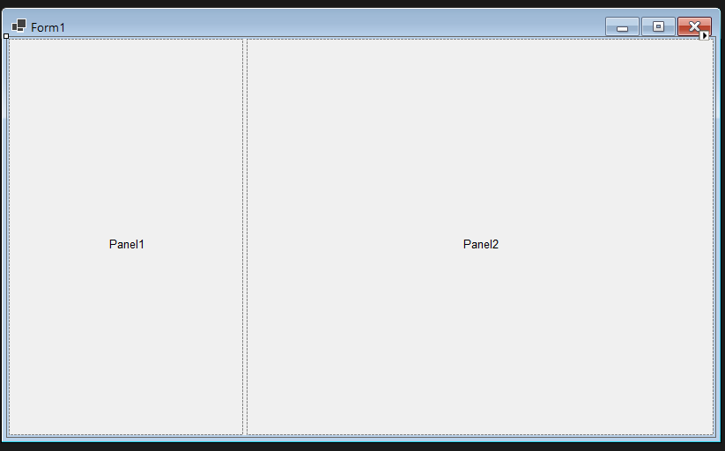

* Add controls to each panel of the SplitContainer:

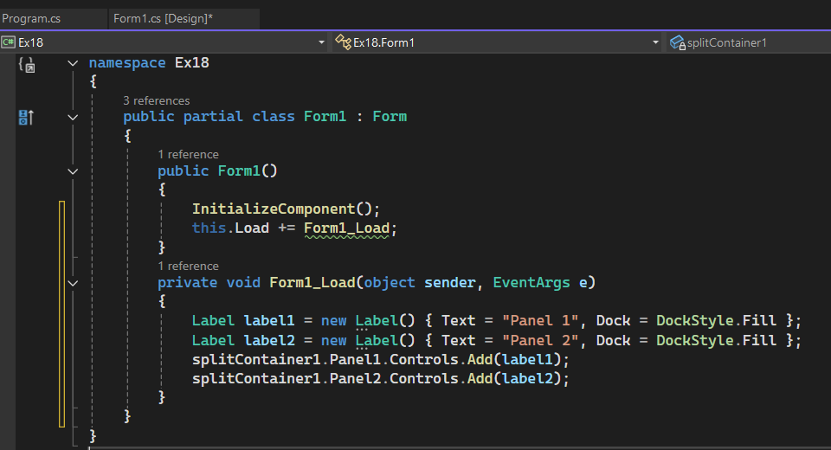

* Run the application to see the resizable panels:

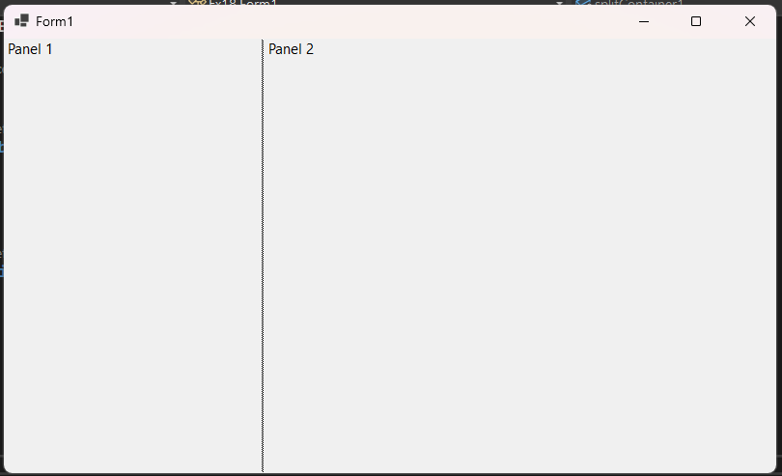

**Ex19:**

* Create a new Windows Forms project.
* Drag a FlowLayoutPanel control from the Toolbox to the form:

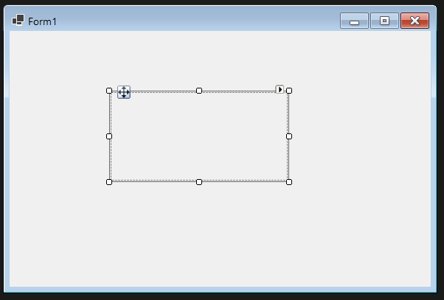

* Add controls to the FlowLayoutPanel:

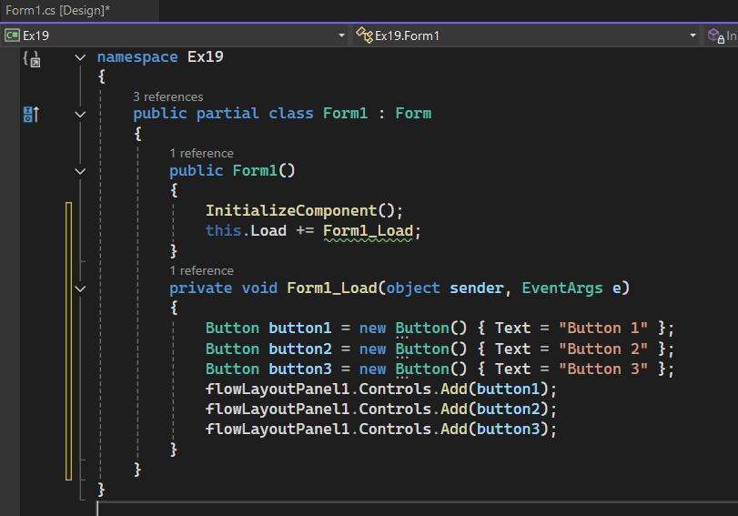

* Run the application to see the flow layout:

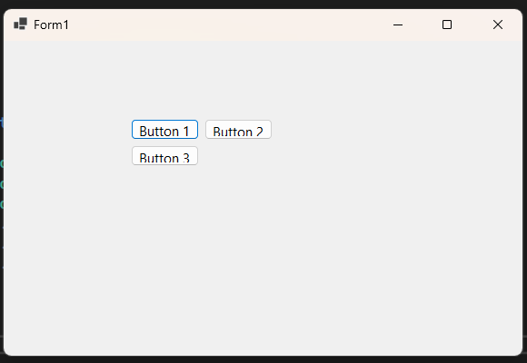

**Ex20:**

* Create a new Windows Forms project.
* Drag a TableLayoutPanel control from the Toolbox to the form:

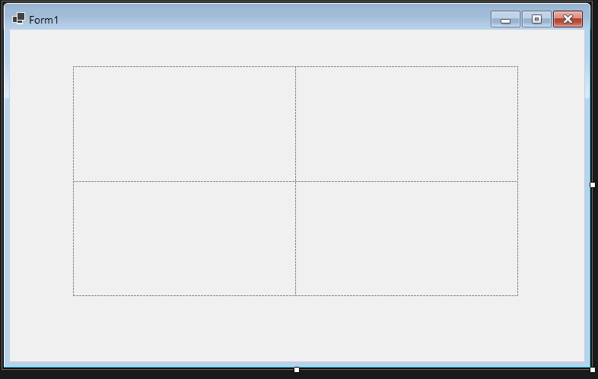

* Add controls to the TableLayoutPanel and configure rows and columns:

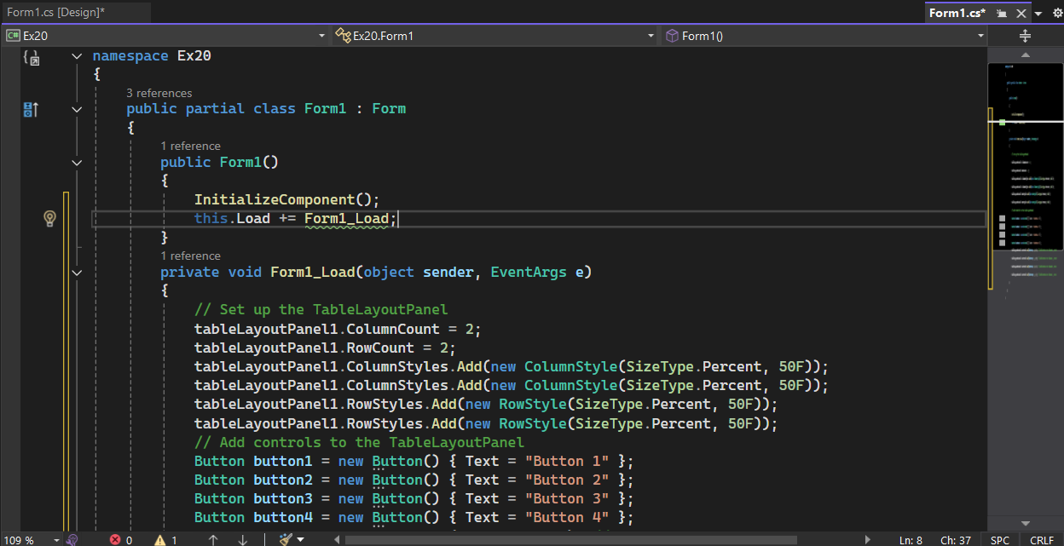

* Run the Application:

