Name: Châu Thanh Vũ

SID: 523K0032

LAB_02 SOFTWARE ENGINEERING

Step 1: Setting Up the Database

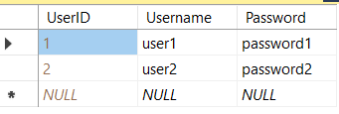

User Table

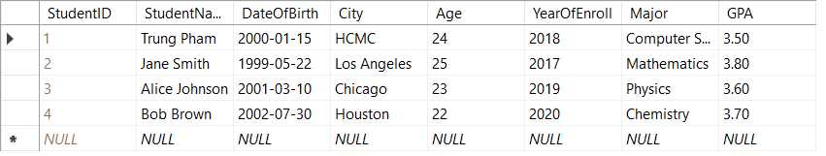

Student Table

Student Course Table

Course Table

Instructor Table

Department Table

Step 2: Creating the Windows Forms Project

Step 3: Implementing the Login Logic

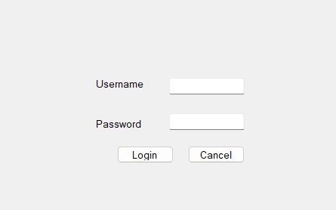

Login Form

Step 4: Designing the Main Form

Main Form

Step 5: Creating Forms for Students, Courses, Instructors, and Departments

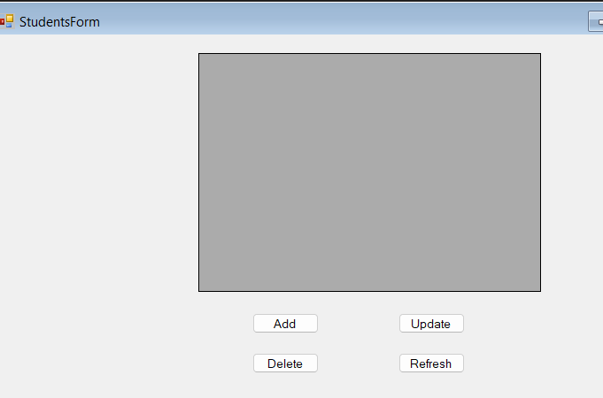

Student Form (Course, Instructor and Department Form are also the same)

Step 6: Designing the Sub-Form (Student Enrollments)

Student Enrollment Form

Outputs:

Student Form

Course Form

Instructor Form

Department Form