SE_Lab03

Vũ Tấn Minh-523V0012

Homework: Implement a 3-Tier Architechture into th9e Student Management App form Lab02.

* First I create all necessary project and references for the Student Management System:
  + Repository for queries to database, View for saving ViewForm, AddForm, DeleteForm, UpdateForm, Services for handling request from ViewForm.

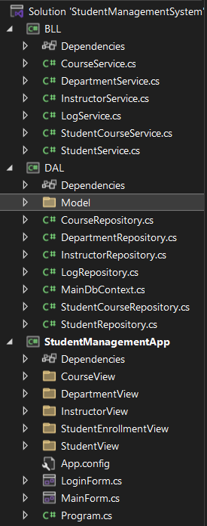

* In the DAL layer, i have created all necessary models need for each table in the SchoolDB:

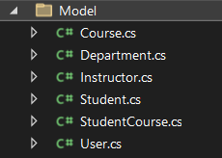

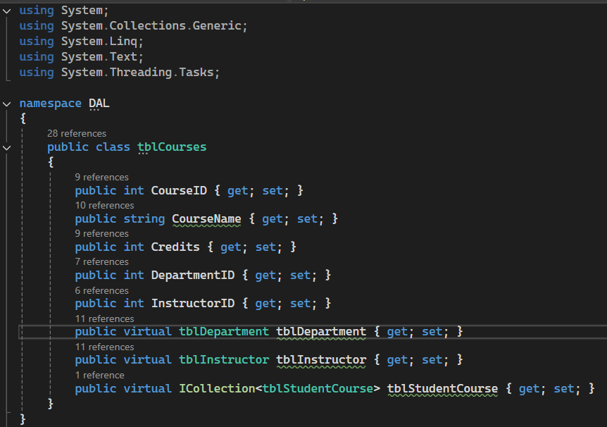

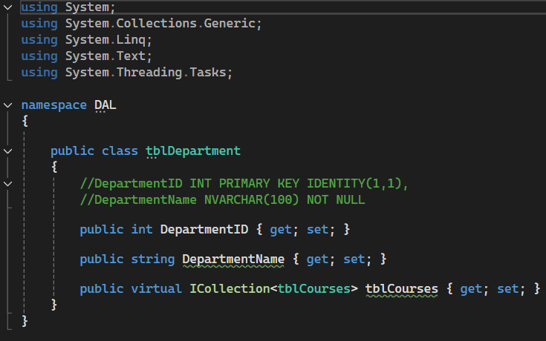

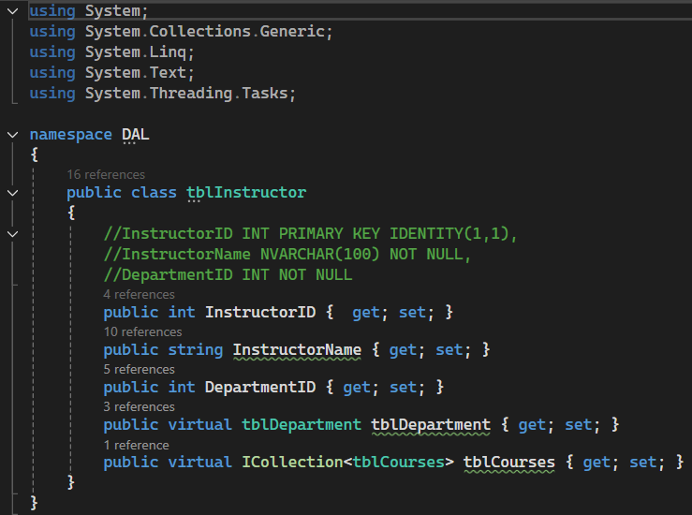

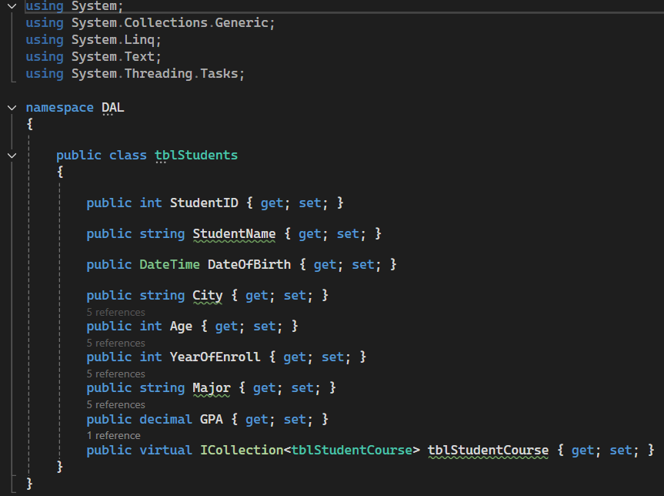

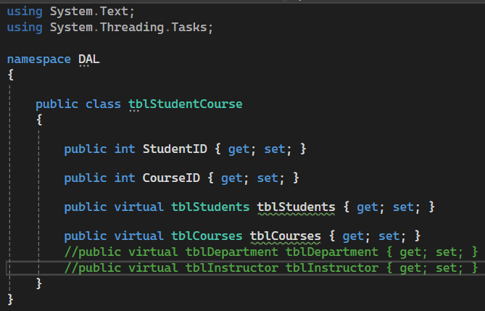

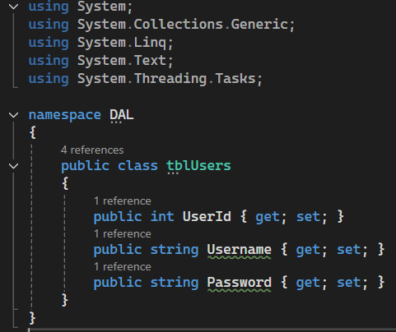

* Then set the App.config for the connect to the SchoolDB:

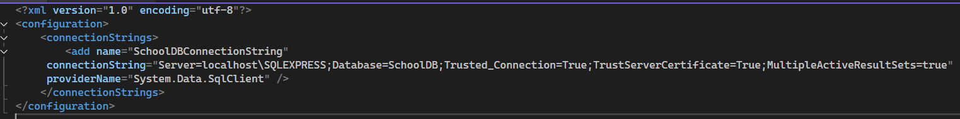

* Set the conection to the database through MainDbContext:

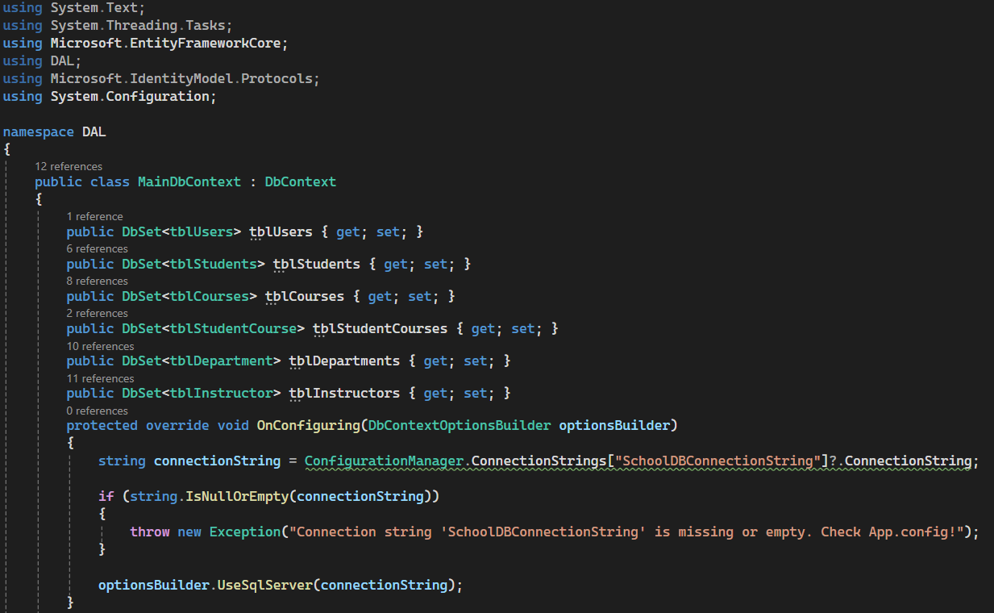

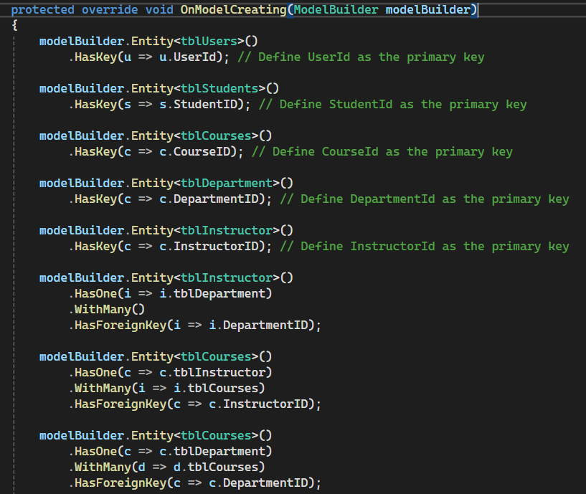

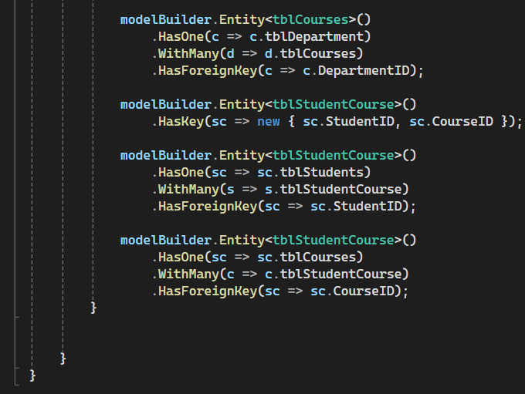

* Then design a form for UI (Take StudentForm as an example, other forms works the same):

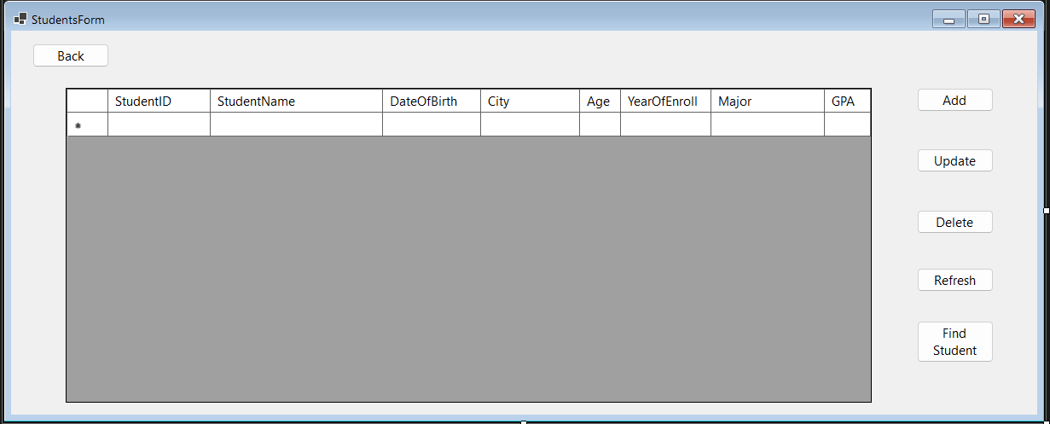

* In the StudentCourseView, write the code to handle each button in the UI:

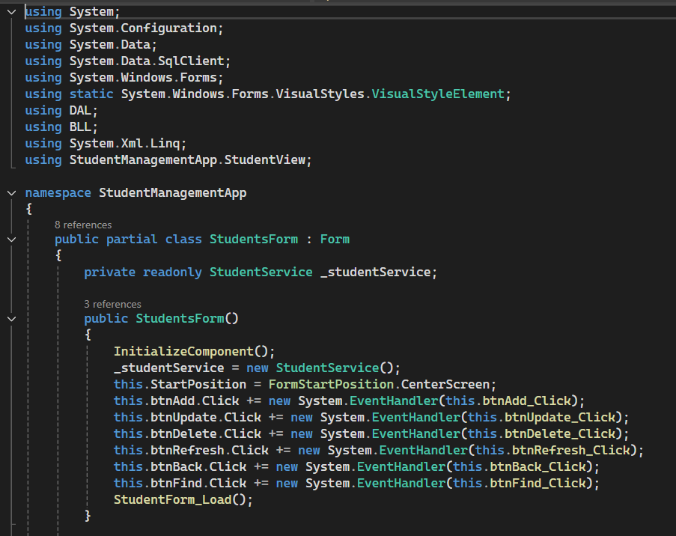

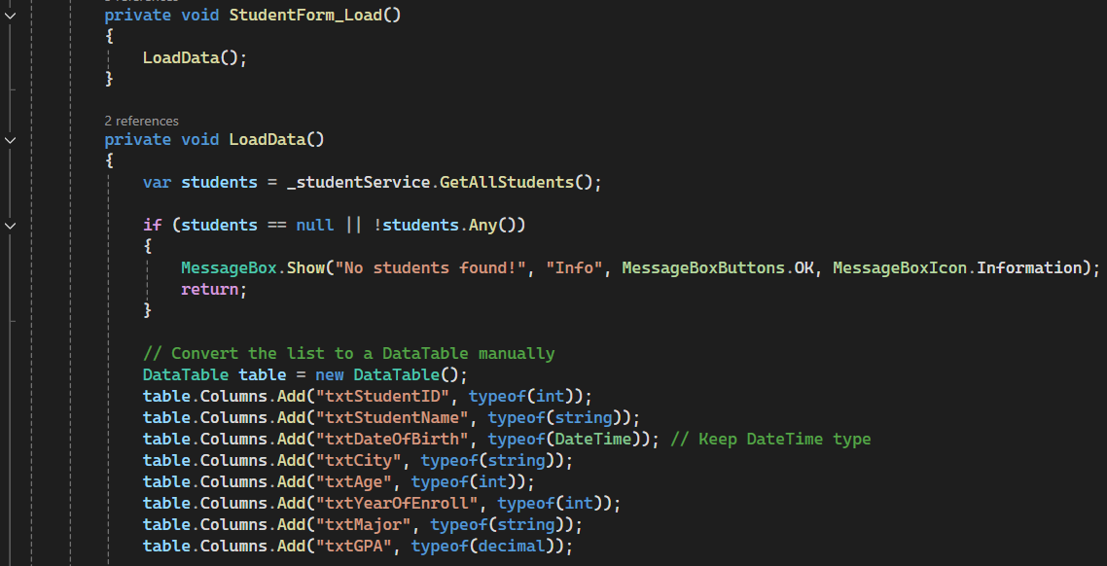

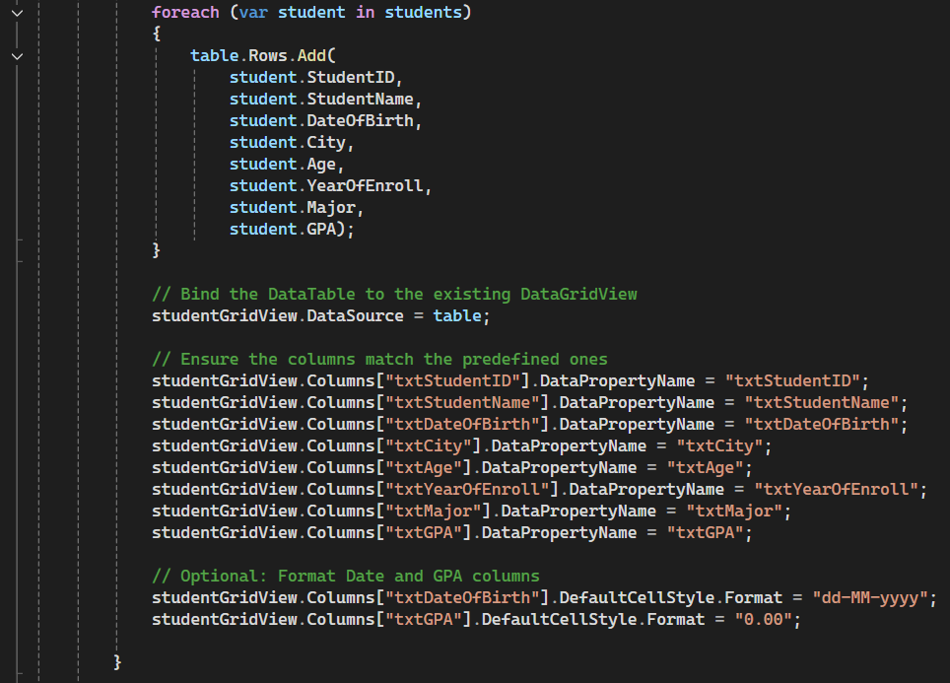

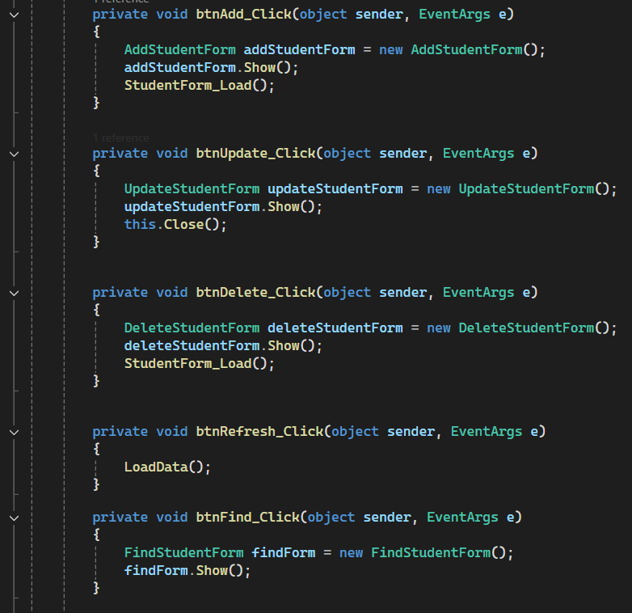

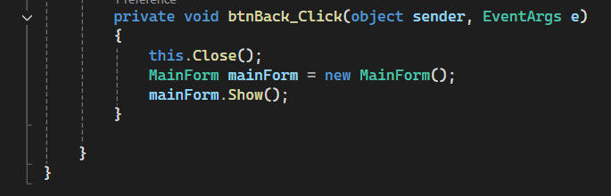

* Context: I have tried using EntityFrameworj but it likely I don’t know why it can’t run on my computer, so I decided to use the Entityframework Core. So if I want to run it on other computer I will need:
  + Entity Framework Core.
  + Entity Framework Core.Tools.
  + Entity Framework Core.Design.
  + Entity Framework Coew.SqlServer.
  + Microsoft.Configuration Manager.
* Other form will have the work flow as the above example I shows to you.
* Then create method in StudentService to handle those request:

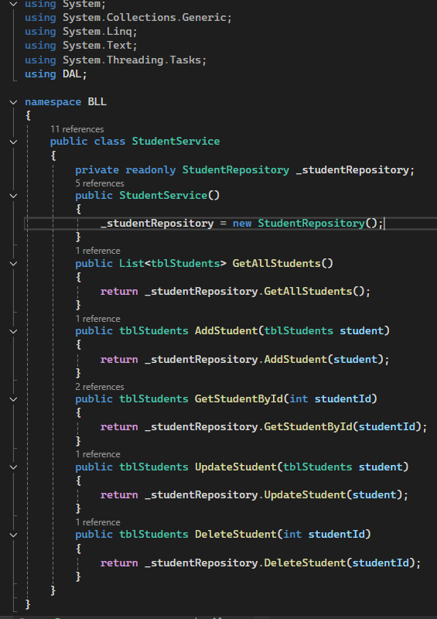

* Then in StudentRepository, create method for queries to the SchoolDB to have the required data:

