Name: Châu Thanh Vũ

StudentID: 523K0032

Introduction: Creating a School Management Web App using ASP.NET Core

Exercise 1: Develop a School Management Web App with ASP.NET Core Web Application using Razor Pages

Screenshots:

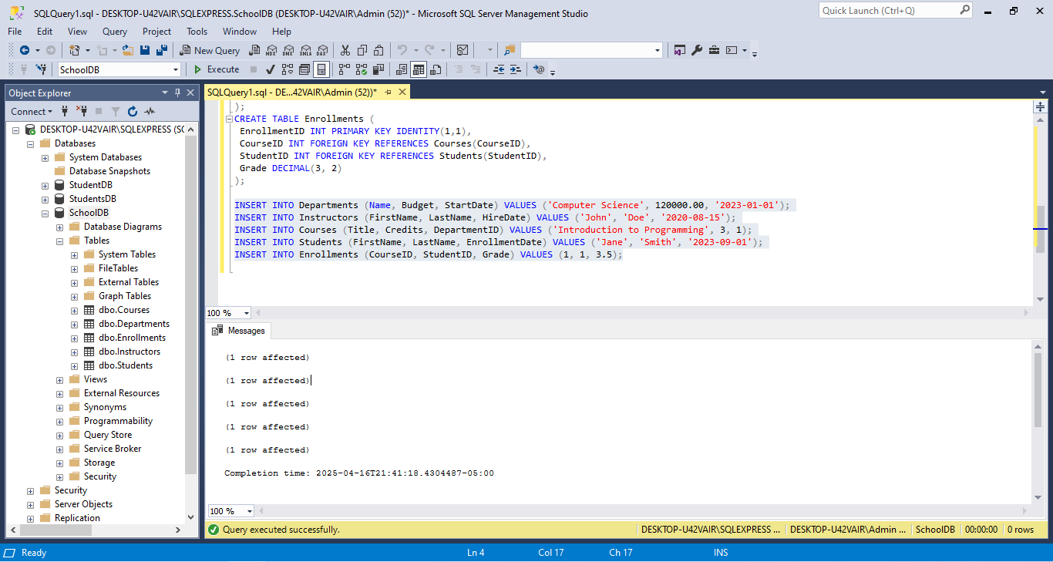

Figure Setting up Database

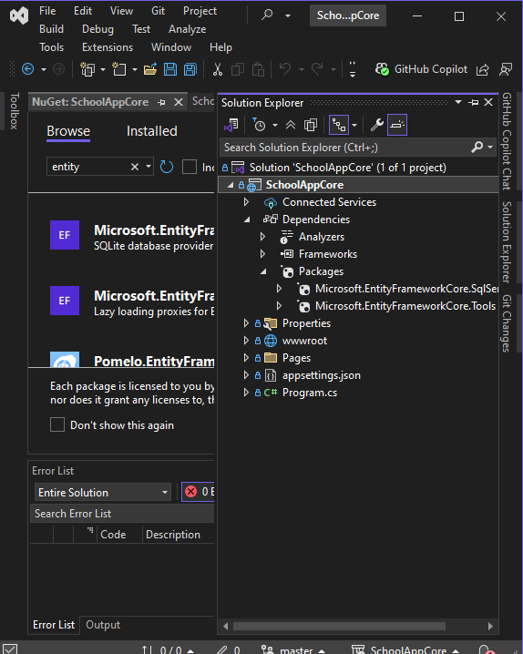

Figure Creating the ASP.NET Core Web Application

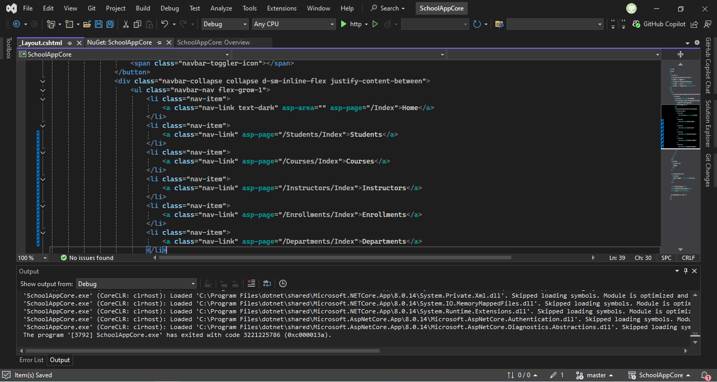

Figure Modify the Menu in _Layout.cshtml

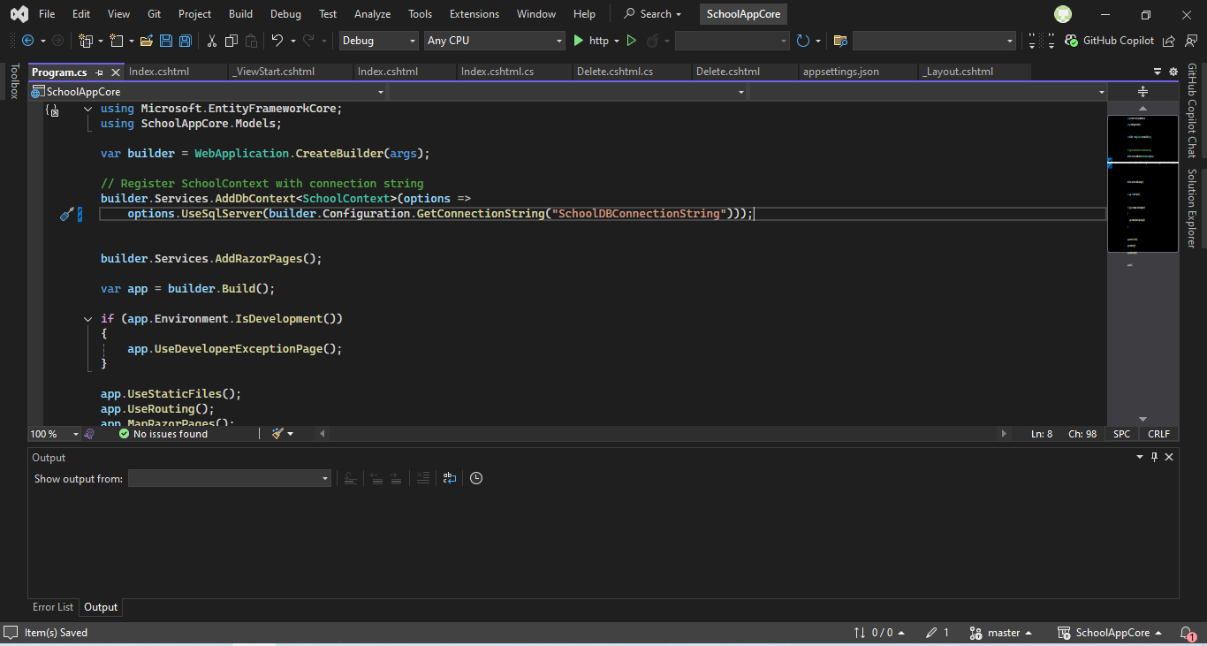

Figure Setting Up the Database Connection

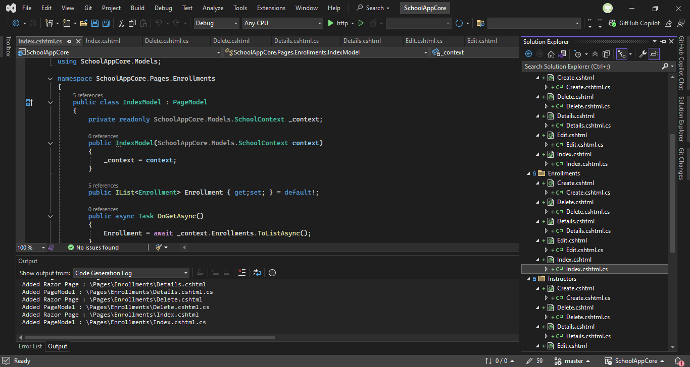

Figure Creating Razor Pages

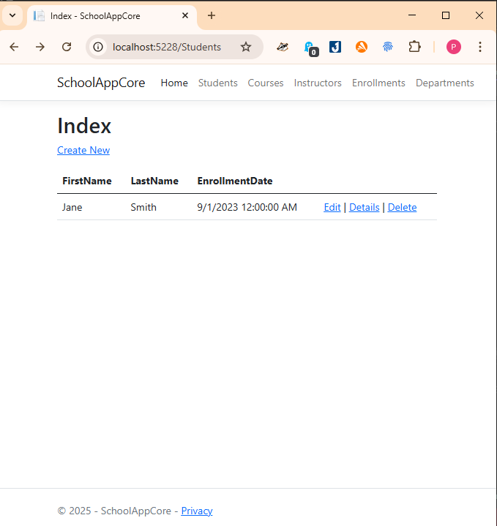

Figure Testing the Application

Exercise 2: Develop a School Management Web App with ASP.NET Core Web App (MVC)

Screenshots:

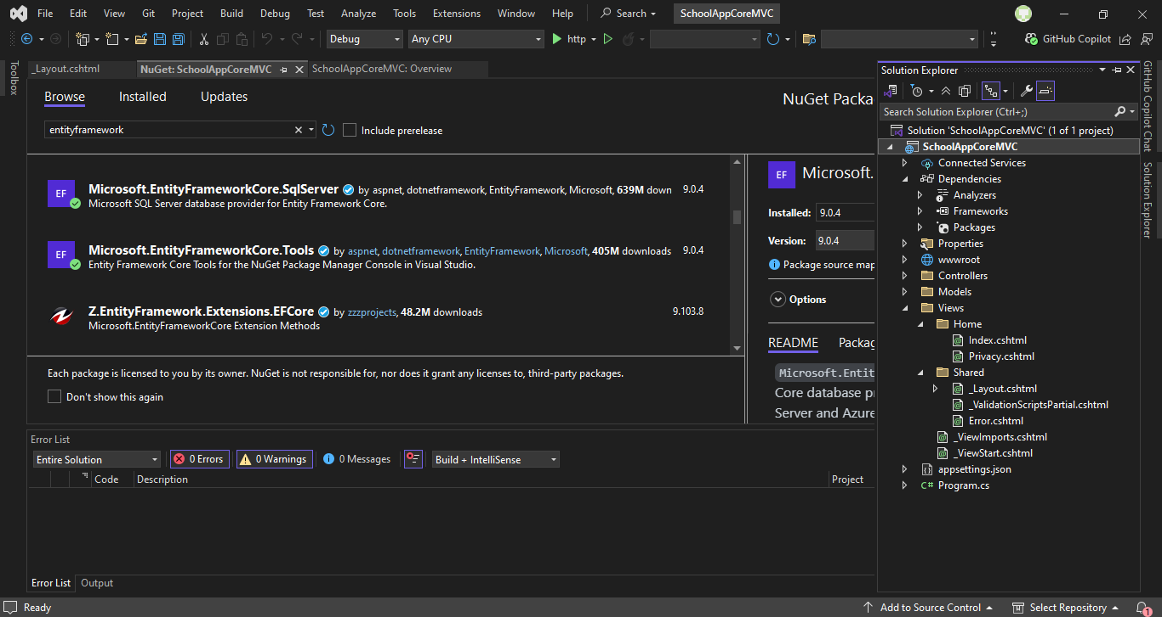

Figure Setting up an environment

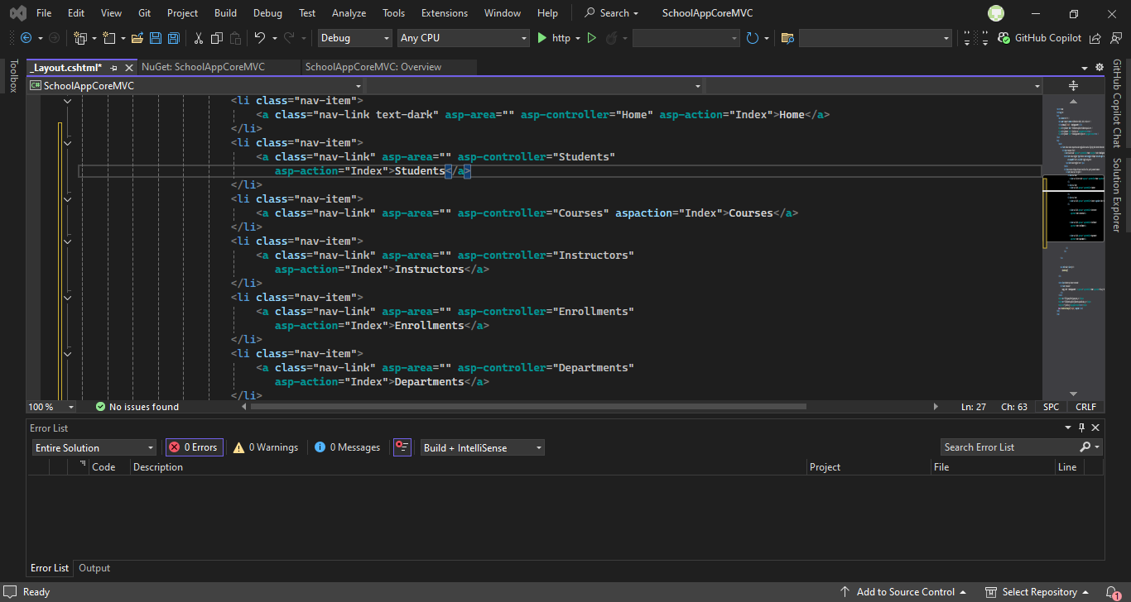

Figure Modify the Menu in _Layout.cshtml

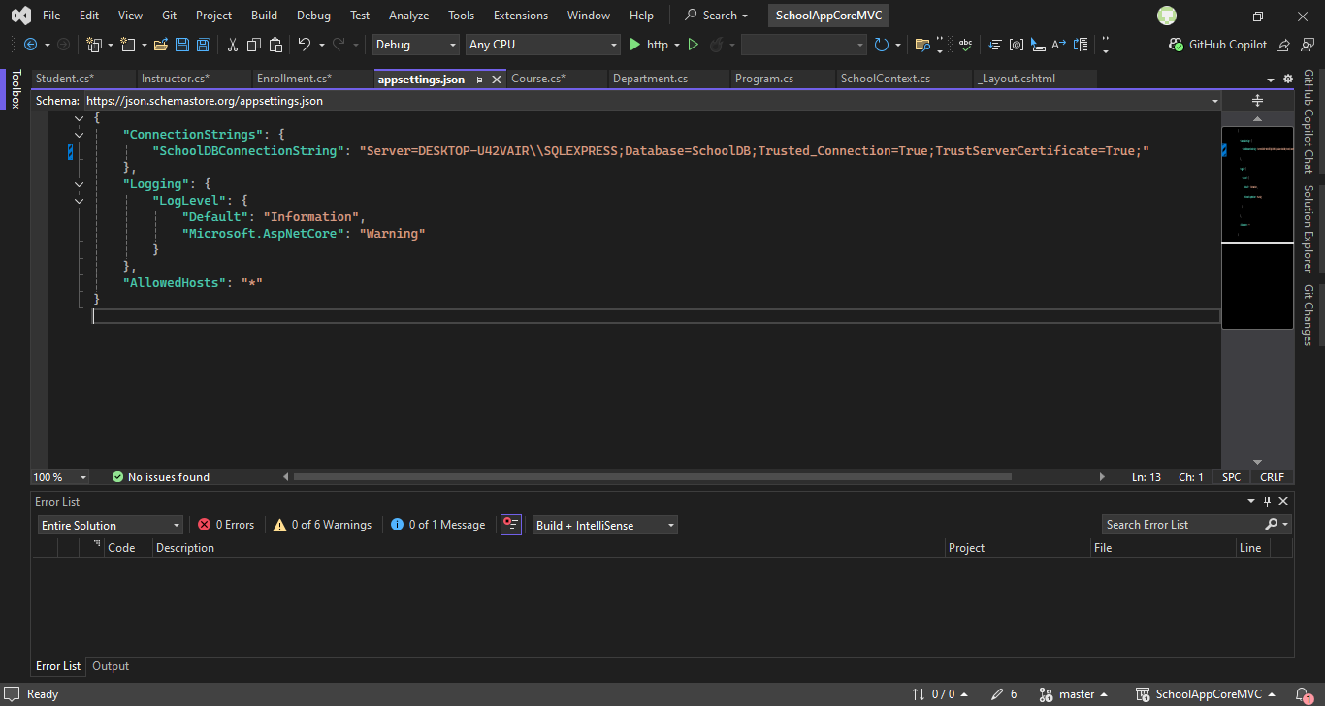

Figure Setting Up the Database Connection

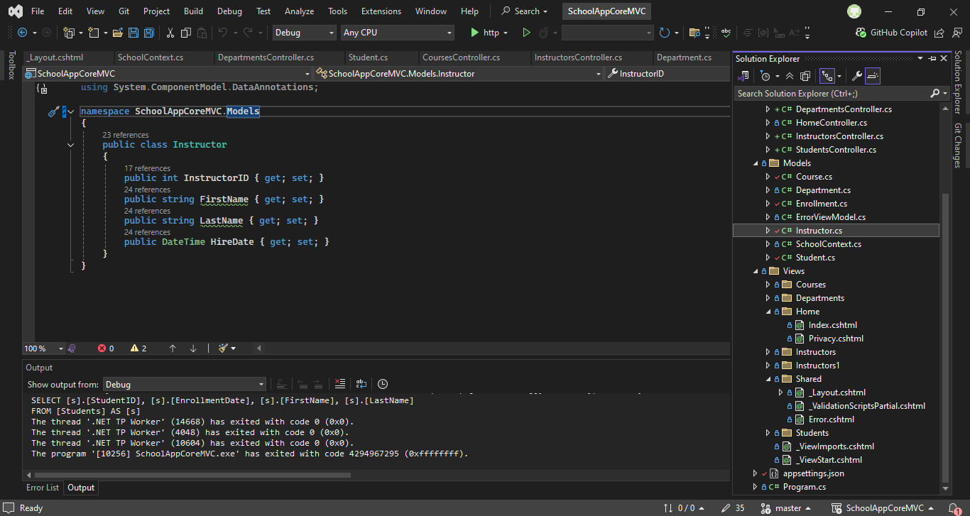

Figure Creating Controllers and Views

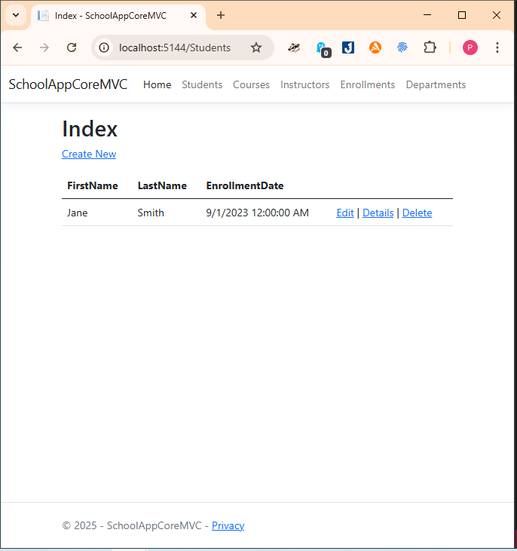

Figure Testing the Application

Conclusion: Relatively easy to use and understand, the tutorial was concise and I learnt how to create an application using ASP.Net core. Still couldn’t create a report.