|  |  |
| --- | --- |
| *https://lh5.googleusercontent.com/lc0oqqVOQtsL-_-e-FtRhphPi9h9VIwQB-EfQ21UCETgICPdsXe_WZcYPK3FBTITTNYudNcoEzPbSoq0lubTQhyQtSZUrPZfcl9kZYEURTieN6PDX31_9wOY4MDhtFgD-2Rlk0xB* | ***Review*** |

**Exercise 1:**

Read about HTML <form> and <input>. Assume that you want users to submit something for you: A survey, a Registration form ...

Write a html file with <form> and <input> tags in it to present this form

|  |  |
| --- | --- |
| *6iporAnbT.jpg* | ***Serious exercises*** |

**Exercise 1:**

Create a HTML file containing a form for adding new bike for a Bike Rental Service (no styles needed)

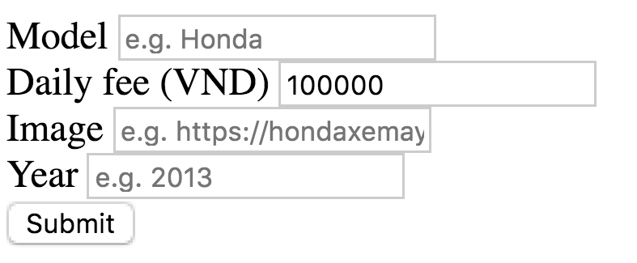

**Exercise 2:**

Create Flask App, serve (render) the HTML file created in Exercise 1 in /new_bike route

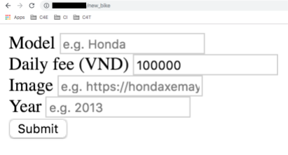

**Exercise 3:**

Handle submission (users clicking Submit button): receive form dictionary and unpack it, use print() to check the results

**Exercise 4 [OPTIONAL]:**

Add style to the page, reference:

