**State Management Quiz**

1. Can post requests be bookmarked? What are the problems?

A **POST** cannot be **bookmarked**. Attempting to **bookmark** a **POST will** just result in a GET operation on the URL. There's a very good reason for this, GET **requests** are supposed to be idempotent - that is, making the same GET **request** numerous times should result in the same response. **POST requests** on the other hand are not

1. What is the purpose of request dispatching?

Request Dispatcher is an interface whose implementation defines an object which can dispatch the request to any resources on the server. In this tutorial, we will see how the javax. servlet. RequestDispatcher interface is used to forward or include the response of a resource in a Servlet

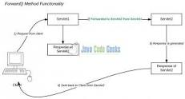

1. What is the difference between redirect and request dispatch?

When a servlet does a **redirect**, it's like asking the client to call someone else instead. In this case, the client is the browser, not the user. ... When a servlet does a **request dispatch**, it's like asking a co-worker to take over working **with a** client.

1. What is an attribute ?

An **attribute** is an object that is used to share information in a web app. **Attribute** allows **Servlets** to share information among themselves. **Attributes** can be SET and GET from one of the following scopes : request. session.

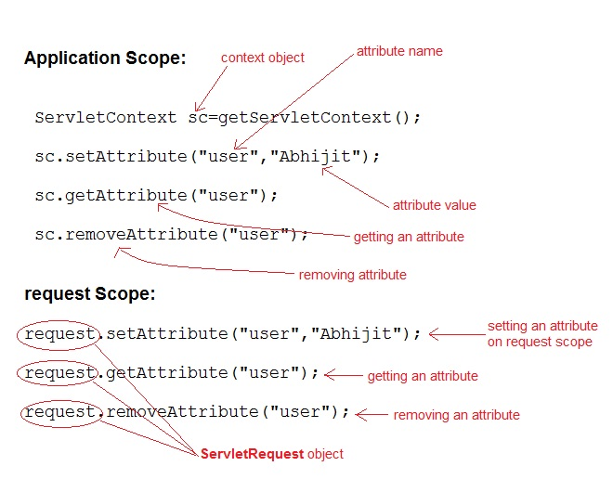

1. What is the difference between attributes and parameters?

Key **Difference** – **Attribute** vs **Parameter**

The key **difference between attribute and parameter** is that an **attribute** is a variable of any type that is declared directly **in a** class while a **parameter** is a variable defined by the function that receives a value when it is called

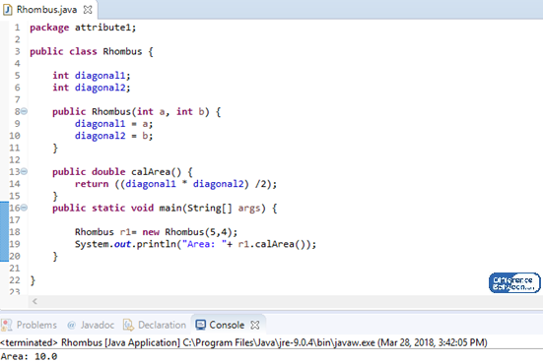

1. What are dangers of using attributes?

You're more likely to see problems arise if you remove **attributes**. The reason you won't see a lot of problems stemming from additional **attributes** is that methods are dispatched on the class of an object. As long as the class doesn't change, methods will be dispatched in much the same way.

1. What does it mean to say that http is stateless? Give an example of a stateful protocol.

**HTTP** is called as a **stateless protocol** because each command is request is executed independently, without any knowledge of the requests that were executed before it. ... A **stateless protocol does** not require the server to retain information or status about each user for the duration of multiple requests

1. Give 5 different methods for maintaining state information (count each attribute scope as one method).

Session in Java **Servlet** are managed through **different ways**, such as Cookies, ... Session is **a** conversional **state** between client and server and it can consists of ... the only way to **maintain a** session is when some unique **information** about the ... these **methods** of session tracking to **provide** session management in **all** cases

1. How long does a session last?

30 minutes

How long does a session last? By default, a session lasts until there's 30 minutes of inactivity, but you can adjust this limit so a session lasts from a few seconds to several hours. Learn more about adjusting session settings.

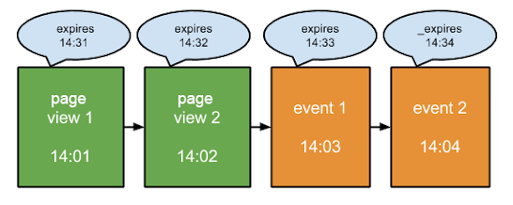

1. What is a cookie, and how long does a cookie last?

xml then **the** session remains active for 30 minutes. **Cookie** remains active as **long** as **the** user's browser is running, as **soon** as **the** browser is closed, **the cookie** and associated session info is destroyed. So when **the** user opens **the** browser again and sends request to web server, **the** new session is being created

1. What is the purpose of URL rewriting?

Url rewriting is a **process** of appending or modifying any url structure while loading a page. The request made by client is always a new request and the server can not identify whether the current request is send by a new client or the previous same client.

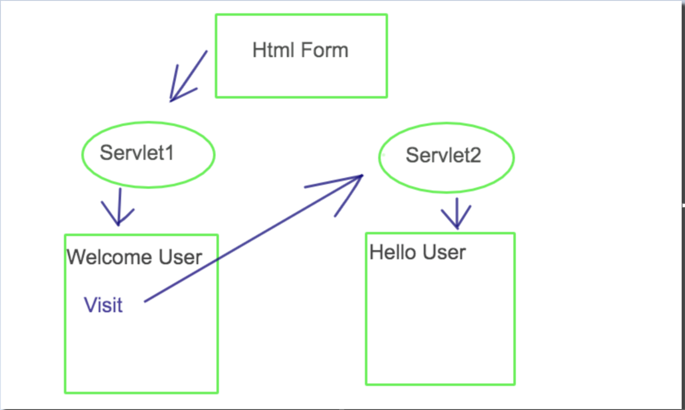

1. Why does the request attribute report ‘null’ for the maintaining state demo?

Session variable is null when accessed second time.

requestState: null

Because after Requesting the information will destroy. This means after finish it works local.

In case you want to you use this attribute again use forwarding to other servlet to use or change it to resuse.

Change to Model MVC.

 Singleton

Lazy loading

Autofocus on input HTML to use when you don’t want to use mouse.