Mirish

Landing page

Customers can choose the category directly on the landing page, that will take them to the shop opening the selected category.  
  
Catalog

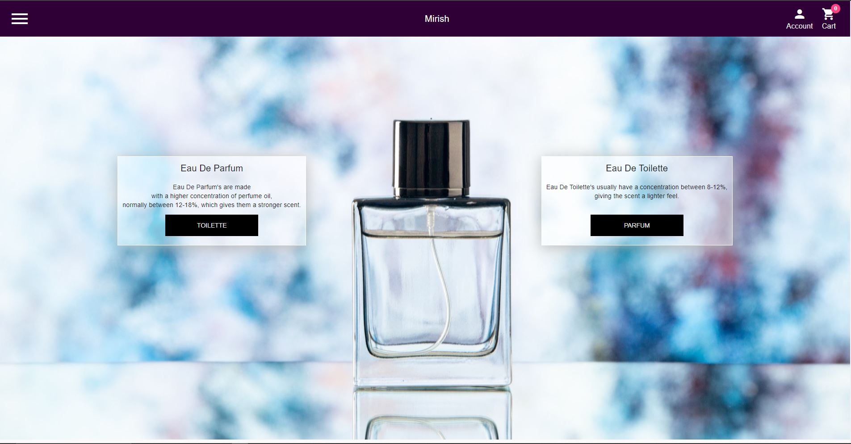

Under the landing image we have a catalog of products. Choosing the size changes the price.

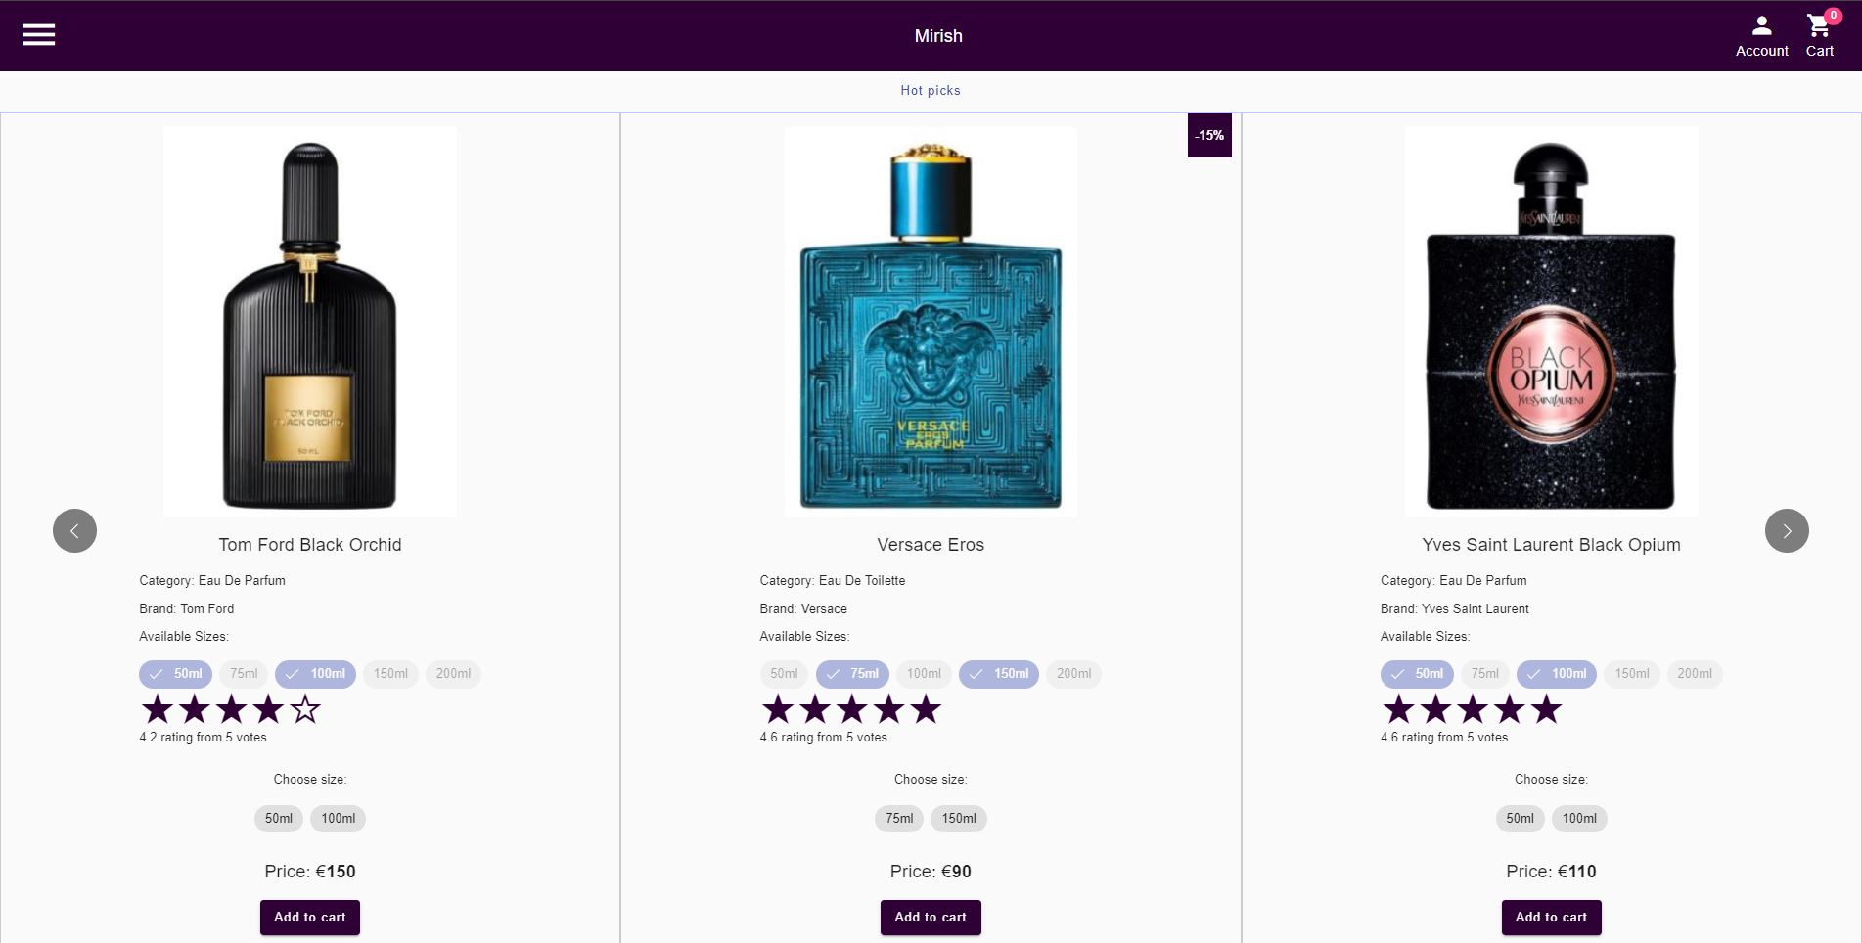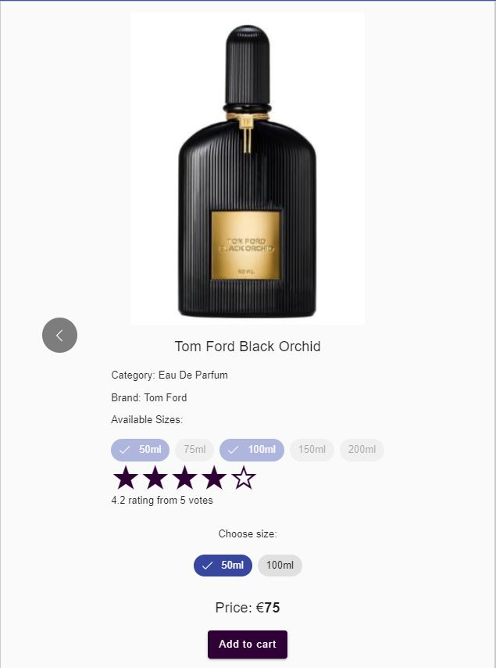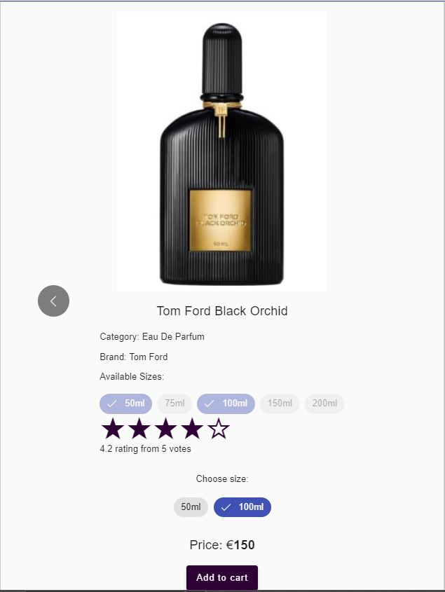

In order to add the item to cart customers must register on the platform. Data is not stored in the database and it gets lost after reentering the page.

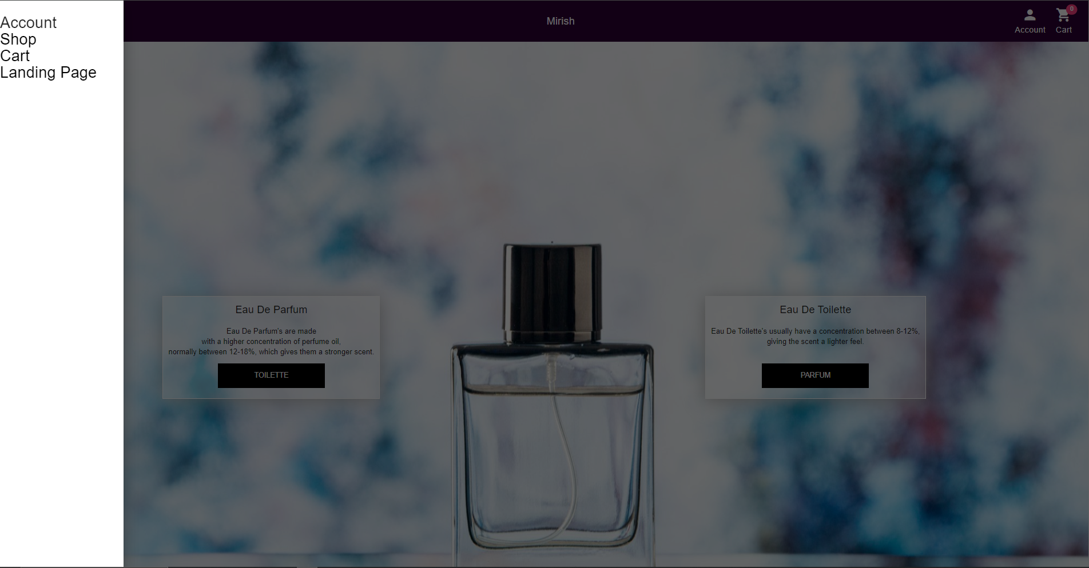

Using the navigation icon in the left corner customers can navigate through the page with ease.  
After entering the shop, customers can see a variety of parfumes.  
  
Customers can register and log in using the Account button. One in the right corner, or in the navigation menu.  
After creating an account and adding item to cart customers can order.  
They can also see past orders, change the profile information and log out.  
  
Future features  
Customers can rate perfume longevity and scent sillage.

