FACE RECOGNITION
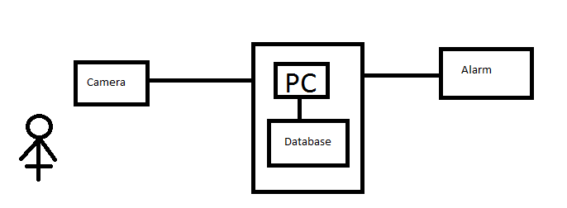
- The people should be registered in DB to access.
- Camera will recognize the people who enter the room.
+ If found him/her in DB:
- DB will record time go in – go out of each people (in another table in DB).
- Name and position will be displayed on the screen.
+ If not found:
- Mark the people who enter the room as Red.
- Speaker sounds an alarm.

System requirements:
- Windows 7
- Microsoft SQL Server 2008
- Visual Studio 2010
- Open CV 2.2 (or newer)
- Camera
- Speaker

