To run the code use the following commands or ones similar

python3 server.py -p 9000 -s abc23432sal

This is to start the server, make sure to use the same port, designated after a -p for the client.

Then run the client with the following or something similar

python3 client.py -a 127.0.0.1 -p 9000 -s 100 -f /home/file.txt

This one needs to have the save port after -p as the server. Also it requires the IP Address after the -a to be 127.0.0.1

Output to the console from the server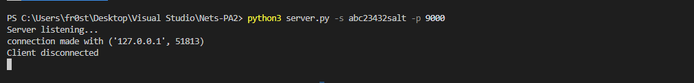

Output to the console from the client



Here is a few test files and their outputs

