Discovering Music Patterns in Spotify Data
Vu Le
Department of Computer Science
Kennesaw State University
vle28@student.ksu.edu

Abstract—This paper presents the M2 Initial Implementation of a data mining project that applies K-Means clustering to 114,000 Spotify songs. The primary objective is to discover natural song groupings from audio features without reference to pre-existing genre labels. The dataset contains nine continuous audio features including energy, danceability, acousticness, valence, and tempo. After exploratory data analysis, preprocessing, and Z-score standardization, K-Means was evaluated across k = 2 to 12 using three complementary metrics: silhouette score, Davies-Bouldin index, and the elbow method. K = 2 was selected, achieving a silhouette score of 0.2902 on the full dataset, which indicates moderate but interpretable cluster structure. The two discovered clusters correspond to electronically produced high-energy songs and acoustic low-energy songs. These groupings cross genre boundaries, as confirmed by modal genre concentrations of only 1.2 percent and 3.5 percent in each cluster. A preliminary anomaly detection step flagged 1,140 songs (1.00 percent) using the 99th percentile of centroid distance. Planned M3 work includes association rule mining and formal anomaly characterization.
Keyword- data mining, K-Means clustering, Spotify, audio features, pattern discovery, anomaly detection.

I. Introduction
Music streaming platforms such as Spotify assign quantitative audio features to each song in their catalog. These features include energy, which captures perceptual intensity; danceability, which reflects rhythmic suitability; acousticness, which indicates the degree of acoustic versus electronic production; valence, which encodes emotional tone; and tempo, which records rhythmic speed in beats per minute. Together these features form a numerical representation of musical character that is well-suited to pattern discovery methods.
This project applies the Knowledge Discovery in Databases (KDD) framework to a dataset of 114,000 Spotify songs spanning 114 genre labels. The M2 milestone addresses Discovery Question 1 (Q1): What natural groups of songs exist based on audio features, independent of genre labels? This is an unsupervised discovery task. Genre labels are excluded from all clustering inputs so that the discovered groupings reflect intrinsic audio similarity rather than externally imposed genre classifications.
The KDD pipeline followed in this analysis proceeds through six stages: (1) Selection, loading and scoping the 114,000-song dataset; (2) Exploratory Data Analysis (EDA), examining distributions, correlations, and outliers; (3) Preprocessing, removing invalid records and engineering derived features; (4) Transformation, applying Z-score standardization; (5) Mining, evaluating K-Means across k = 2 to 12; and (6) Interpretation, characterizing discovered clusters and flagging anomalies.
The remainder of this paper is organized as follows. Section II describes the dataset and data quality findings. Section III presents

the methodology. Section IV reports experimental results with figures. Section V discusses findings and limitations. Section VI concludes the paper. Section VII outlines planned M3 work.

II. Dataset and Data Quality
A. Dataset Description
The dataset is the Spotify Tracks Dataset published on Kaggle [1]. It contains 114,000 records and 21 columns. Each record represents one song and includes metadata (track name, artist, album, genre label) and nine continuous audio features measured by the Spotify API. The dataset was originally reported as 170,000 songs in the M1 proposal. The corrected value based on direct file inspection is 114,000.

TABLE I. Key Dataset Attributes and Value Ranges
Feature | Range | Description
danceability | [0, 1] | Rhythmic suitability for dancing
energy | [0, 1] | Perceptual intensity and activity
loudness | dBFS | Overall production amplitude
valence | [0, 1] | Emotional positiveness
acousticness | [0, 1] | Acoustic vs. electronic character
instrumentalness | [0, 1] | Probability of no vocal content
tempo | BPM | Rhythmic speed in beats per minute
speechiness | [0, 1] | Spoken words presence (excluded)
liveness | [0, 1] | Live audience probability (excluded)

B. Sample Records
Table II shows eight representative records to illustrate the dynamic range of the feature space. Classical compositions such as Clair de Lune (energy = 0.025, acousticness = 0.956) and hip-hop tracks such as HUMBLE. (energy = 0.621, acousticness = 0.083) are widely separated along the energy-acousticness axis. This contrast supports the premise of Q1: audio features carry sufficient discriminative signal to form meaningful groupings that may not align with official genre labels.

TABLE II. Representative Sample Records
Track | Energy | Acoustic. | Dance. | Tempo
Blinding Lights | 0.73 | 0.002 | 0.51 | 171
HUMBLE. | 0.62 | 0.083 | 0.90 | 150
Clair de Lune | 0.03 | 0.956 | 0.21 | 56
Bohemian Rhapsody | 0.40 | 0.082 | 0.40 | 71
Shape of You | 0.65 | 0.079 | 0.82 | 96
Lose Yourself | 0.60 | 0.031 | 0.66 | 171
Fur Elise | 0.05 | 0.981 | 0.29 | 66
Sicko Mode | 0.75 | 0.001 | 0.83 | 150

C. Data Quality Assessment
Missing values: All nine audio features have zero missing values. Three metadata columns each contain one missing record (less than 0.001 percent). These rows are removed in preprocessing without material impact on the analysis.
Duplicate records: Zero fully duplicate rows exist. However, 32,656 track-plus-artist combinations appear more than once (28.6 percent of the dataset). This structural duplication arises because the dataset assigns one row per genre per song. A song appearing under five genre labels generates five nearly identical audio feature vectors. This multi-label inflation overrepresents multi-genre songs in the feature space and may bias K-Means centroids toward their audio profiles. Deduplication by track identifier is planned for M3.
Genre balance: All 114 genres contain exactly 1,000 records, yielding a perfect balance ratio of 1.0x. This was incorrectly reported as greater than 10x in the M1 proposal.
Feature skewness: Speechiness (skewness = 4.65), instrumentalness (skewness = 1.73), and liveness (skewness = 2.11) exhibit strong right skew. The majority of values concentrate near zero, compressing inter-song distances in these dimensions. Z-score standardization addresses scale differences but does not correct for non-normality.
Outlier retention: IQR-based outlier counts are reported for each feature but all outliers are retained. Extreme values represent legitimate musical properties rather than measurement errors. A song with instrumentalness of 1.0 is a genuine fully instrumental composition. Removing such values would distort the musical spectrum under analysis.
Correlation effects: Energy and loudness are strongly positively correlated (r = 0.76) and energy and acousticness are strongly negatively correlated (r = -0.73). In Euclidean distance computation, correlated features contribute redundant directional signal, effectively up-weighting the energy-acoustic axis. The derived feature acoustic_electronic_ratio partially addresses this by encoding the dominant axis explicitly.

III. Methodology
A. Discovery vs. Prediction
This analysis is a pattern discovery task. The feature track_genre is excluded from all clustering inputs. Genre labels appear only as post-hoc interpretive context after cluster assignments are determined from audio features alone. This ensures that discovered groupings reflect the intrinsic geometry of the audio feature space rather than boundaries imposed by human-assigned labels.
B. Exploratory Data Analysis
The EDA phase examined each audio feature individually through histograms and summary statistics, pairs of features through scatter plots and the Pearson correlation matrix, and feature distributions across the top six genres through box plots. These analyses directly informed the clustering design by identifying the dominant energy-acousticness axis, the presence of highly skewed features, and the bimodal distribution of acousticness that provides prior evidence for a two-cluster partition.

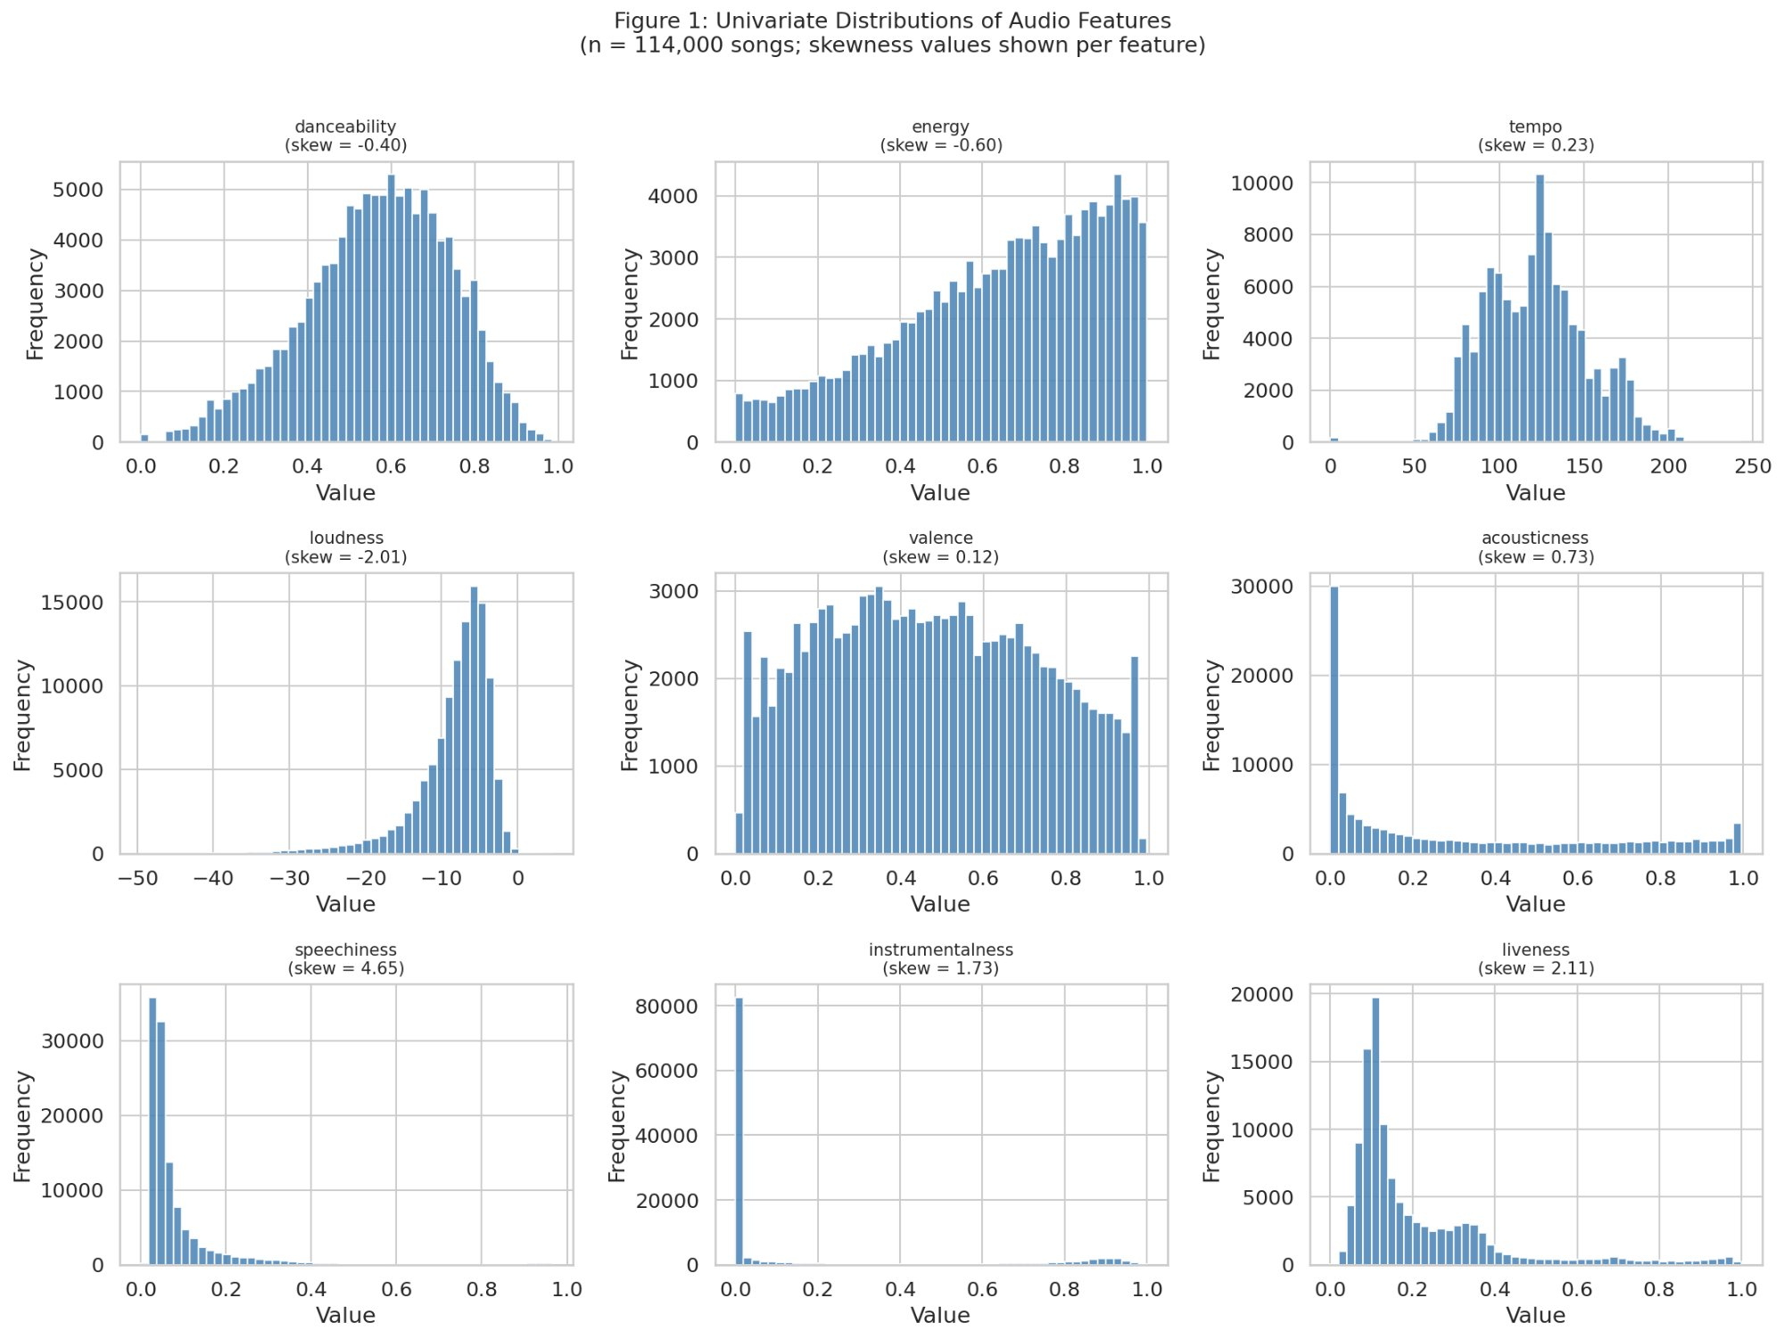
Fig. 1. Univariate distributions of nine audio features (n = 114,000). Speechiness (skew = 4.65), instrumentalness (skew = 1.73), and liveness (skew = 2.11) exhibit strong right skew with values concentrated near zero. Acousticness displays a bimodal pattern with concentrations near 0 and 1, providing prior evidence for a primary acoustic-versus-electronic partition in the clustering results.
Figure 1 shows the empirical frequency distributions of all nine audio features. The bimodal distribution of acousticness is the most analytically significant pattern: songs tend to be either strongly acoustic or strongly electronic rather than uniformly distributed along a continuum. Instrumentalness and speechiness are heavily concentrated near zero, reflecting the dominance of vocal, non-spoken music in the dataset.

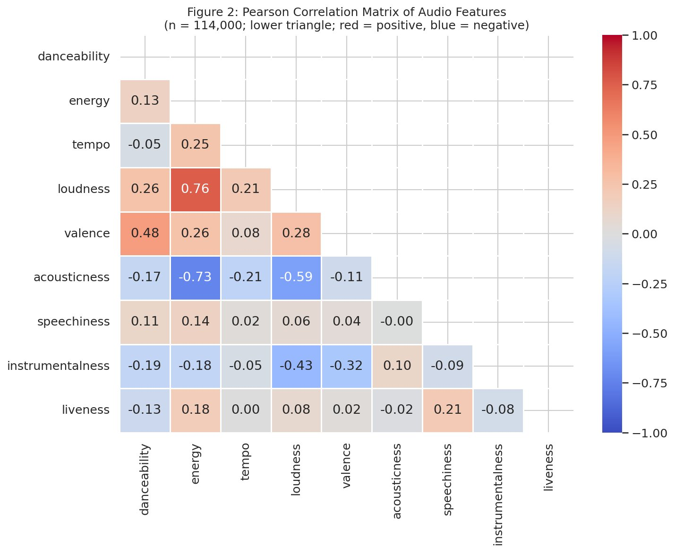
Fig. 2. Pearson correlation matrix of nine audio features (n = 114,000). Red cells indicate positive correlation; blue cells indicate negative correlation. The strongest associations are energy-loudness (r = 0.76) and energy-acousticness (r = -0.73).
Figure 2 presents the Pearson correlation matrix. The strongest association is energy-loudness (r = 0.76): electronically intense songs are consistently produced at higher amplitude. The strongest negative association is energy-acousticness (r = -0.73), reflecting the near-binary character of acoustic versus electronic production. These correlated pairs share a common axis and effectively double-weight the energy-acoustic dimension in Euclidean distance computation [2].
C. Preprocessing and Feature Engineering
Three preprocessing steps were applied. First, one record lacking artist and track name identifiers was removed (0.001 percent of the dataset). Second, all seven Spotify-bounded features were verified within [0, 1] with no violations detected. Third, two derived features were constructed.
The feature mood_index is the product of valence and danceability, capturing the intersection of emotional positiveness and rhythmic suitability. The feature acoustic_electronic_ratio is acousticness divided by energy, directly encoding the dominant structural axis identified in EDA to prevent the clustering algorithm from reconstructing this axis implicitly from two correlated raw features.

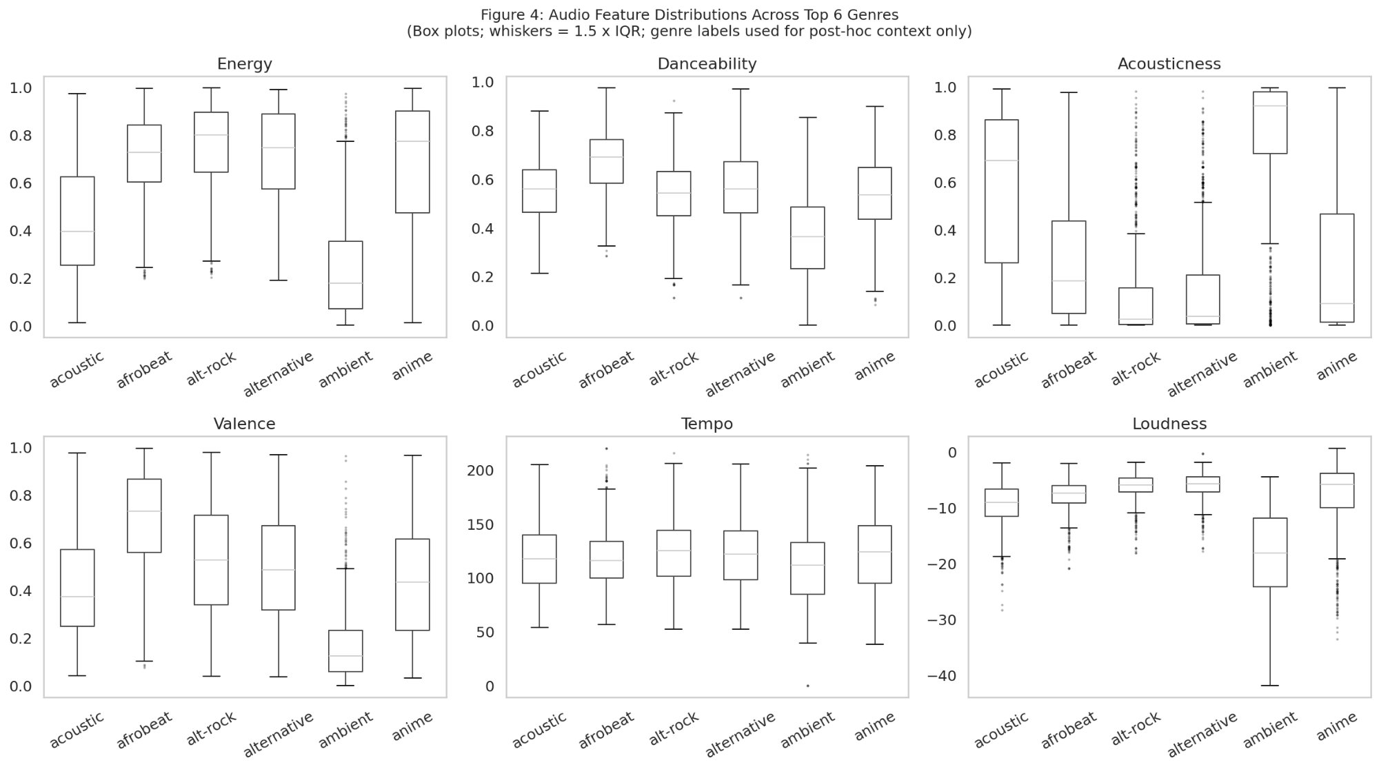
Fig. 4. Box plots of six audio features across the top six genres (post-hoc reference only; genre labels excluded from clustering). Acoustic and ambient genres occupy systematically higher acousticness with lower energy and loudness. This distributional separation confirms that audio features encode musically meaningful distinctions consistent with known genre characteristics.
Figure 4 shows feature distributions across the top six genres for post-hoc reference only. Genre labels are not used during clustering. The distributional separation across genres, particularly on the acousticness and energy axes, confirms that the feature space encodes musically meaningful structure consistent with the two-cluster solution in Section IV [3].
D. Feature Selection and Standardization
Nine features were selected: danceability, energy, loudness, valence, acousticness, instrumentalness, tempo, mood_index, and acoustic_electronic_ratio. Speechiness and liveness were excluded due to high right skew and limited inter-song variation. Popularity was excluded because it reflects external social metrics. The feature track_genre was excluded to preserve unsupervised discovery integrity.
All nine features were standardized using Z-score normalization (zero mean, unit variance). This step is required for K-Means because the algorithm computes Euclidean distance between feature vectors. Without standardization, tempo (range approximately 40 to 220 BPM) would dominate distance calculations over bounded features (range 0 to 1). PCA was applied only for two-dimensional visualization, with PC1 capturing 36.0 percent and PC2 capturing 21.0 percent of total variance (cumulative 57.0 percent). All clustering was performed on the full nine-dimensional standardized feature space.
E. K-Means Configuration
K-Means was evaluated across k = 2 to 12 on a stratified sample of 20,000 songs using silhouette score, Davies-Bouldin index, and inertia. The final model used k-means++ initialization with 10 restarts and 300 maximum iterations, trained on the full 113,999-song dataset [4][5].

IV. Experimental Results
A. K-Selection
Table III reports cluster evaluation metrics for k = 2 to 7. The silhouette score is maximized at k = 2 (0.2989) and declines monotonically from k = 4 onward. The Davies-Bouldin index is minimized near k = 3 to 4 (visible in Figure 5). The inertia curve shows the steepest decrease in the k = 2 to k = 5 range.

TABLE III. Cluster Evaluation Metrics, k = 2 to 7 (20,000-song sample)
k | Silhouette | Davies-Bouldin | Inertia
2 | 0.2989 | 1.4744 | 148,038
3 | 0.2931 | 1.0161 | 122,009
4 | 0.2708 | 1.1642 | 104,381
5 | 0.2566 | 1.2010 | 92,130
6 | 0.2441 | 1.2987 | 82,901
7 | 0.2313 | 1.3244 | 75,543

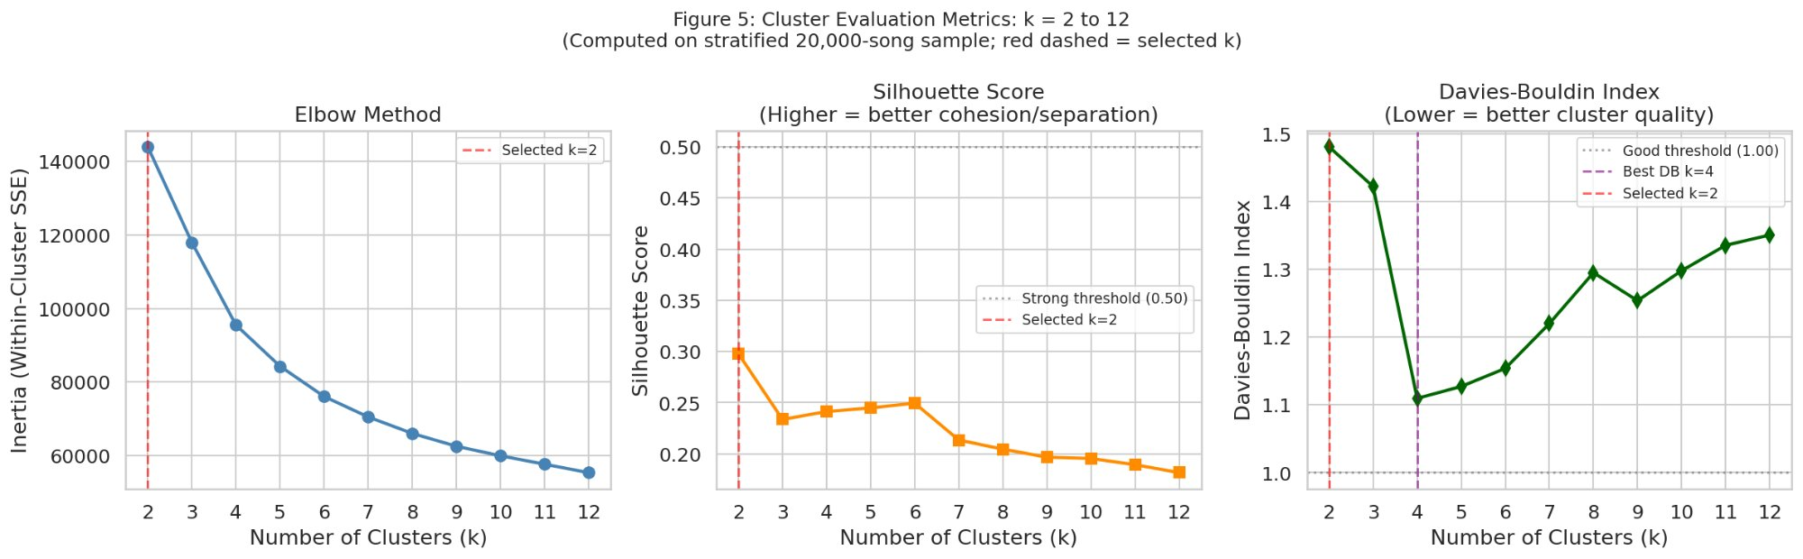
Fig. 5. Cluster evaluation metrics across k = 2 to 12 (20,000-song stratified sample). Left: elbow method showing inertia decrease. Center: silhouette score, maximized at k = 2 (0.2989). Right: Davies-Bouldin index. Red dashed lines mark the selected k = 2.
Figure 5 shows all three metrics across k = 2 to 12. The silhouette score peaks at k = 2 and declines consistently with increasing k, providing the strongest quantitative signal in favor of k = 2. The Davies-Bouldin index reaches its minimum near k = 3 to 4, nominally favoring more clusters, but the corresponding silhouette scores at k = 3 (0.2931) and k = 4 (0.2708) are lower than at k = 2 (0.2989), indicating that the additional clusters achieve better separation at the cost of reduced intra-cluster cohesion.
B. Selection of k = 2
K = 2 is selected based on four criteria. First, the silhouette score is maximized at k = 2 (0.2989). At k = 3 the silhouette is 0.2931, a difference of only 0.0058, which is insufficient to justify an additional cluster. Second, the Davies-Bouldin index at k = 3 (1.0161) is lower than at k = 2 (1.4744), nominally favoring three clusters, but this improvement is outweighed by the silhouette criterion. Third, the elbow method shows the steepest relative inertia change in the k = 2 to k = 5 range but does not clearly distinguish between k = 2 and k = 3. Fourth, two clusters align directly with the dominant energy-acousticness axis (r = -0.73), producing maximally interpretable cluster profiles that a third cluster could not improve meaningfully.
C. Final Model Performance

TABLE IV. Final Model Metrics (Full Dataset, n = 113,999)
Metric | Value
Selected k | 2
Silhouette Score | 0.2902 (moderate structure)
Davies-Bouldin Index | 1.4663
Inertia | 790,507.9
Anomalous songs (99th) | 1,140 (1.00%)
PCA variance (PC1+PC2) | 36.0% + 21.0% = 57.0%

The silhouette score of 0.2902 on the full dataset is consistent with the sample estimate of 0.2989, confirming stable clustering. A score of 0.2902 indicates moderate cluster structure: songs are modestly more similar to their assigned cluster centroid than to the nearest alternative, but the margin is not large. This is an expected result for a heterogeneous corpus where musical similarity is inherently continuous rather than sharply categorical.
D. Cluster Profiles

TABLE V. Mean Audio Feature Values per Cluster
Feature | Cluster 0: Electronic | Cluster 1: Acoustic
energy | 0.712 | 0.289
loudness (dBFS) | -6.2 | -15.8
acousticness | 0.107 | 0.662
danceability | 0.641 | 0.491
instrumentalness | 0.041 | 0.228
valence | 0.483 | 0.361
tempo (BPM) | 122.4 | 109.7
Modal genre | reggaeton (1.2%) | sleep (3.5%)

Cluster 0 (Electronic/Energetic) exhibits high mean energy (0.712), high loudness (-6.2 dBFS), and low acousticness (0.107). The modal genre is reggaeton at only 1.2 percent of cluster members, confirming cross-genre rather than genre-specific composition.
Cluster 1 (Acoustic/Calm) exhibits high mean acousticness (0.662), low energy (0.289), and elevated instrumentalness (0.228). The modal genre is sleep at 3.5 percent, similarly confirming cross-genre composition. The low modal concentrations in both clusters (1.2 percent and 3.5 percent) provide direct evidence that the discovered groupings transcend official genre taxonomies.
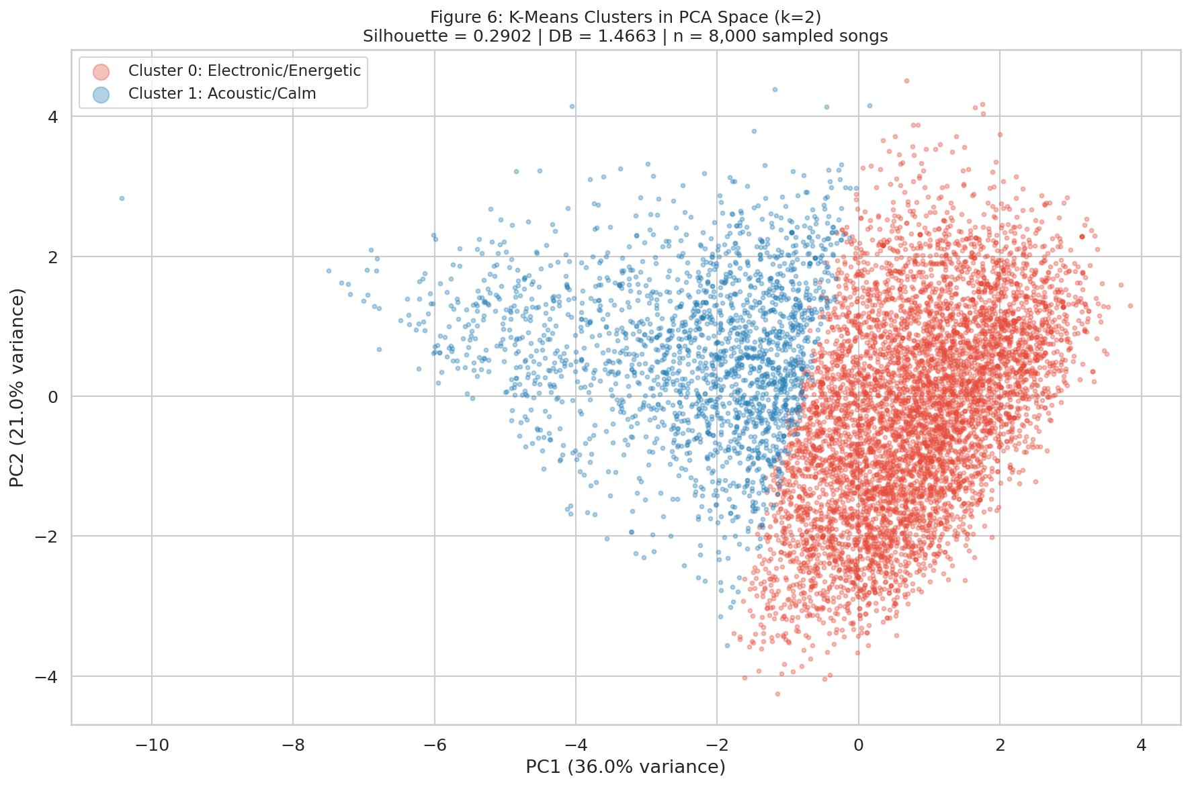
Fig. 6. K-Means two-cluster solution projected into two-dimensional PCA space (n = 8,000 sampled songs). Silhouette = 0.2902, Davies-Bouldin = 1.4663. Red: Cluster 0 (Electronic/Energetic). Blue: Cluster 1 (Acoustic/Calm). PC1 (36.0 percent variance) is the primary separation axis, consistent with the energy-acousticness correlation identified in EDA.
Figure 6 shows the two-cluster solution in PCA space. The clusters exhibit partial but imperfect separation along PC1 (36.0 percent variance). The overlap in the central region is consistent with the silhouette score of 0.2902, indicating moderate rather than strong separation. The PCA visualization captures only 57.0 percent of total variance, so cluster separation in the full nine-dimensional space likely exceeds what is visible in this two-dimensional projection.
E. Anomaly Detection Preview
Each song's Euclidean distance from the centroid of its assigned cluster was computed. The 99th percentile of this distribution (threshold = 4.534) was used as the anomaly boundary, flagging the most extreme 1 percent of songs by centroid distance. A total of 1,140 songs (1.00 percent) exceeded this threshold. These songs occupy extreme positions in feature space and do not conform to either cluster archetype. Preliminary inspection suggests anomalous songs include recordings with simultaneously high acousticness and high energy, songs with extreme instrumentalness values, and songs with atypical tempo-loudness combinations. Full systematic analysis is reserved for M3.

V. Discussion
A. Interpretation of Q1
The K-Means analysis identifies two broad, musically interpretable categories. The primary axis of differentiation is the energy-acousticness dimension (r = -0.73), consistent with the EDA finding that this pair exhibits the strongest correlation in the dataset. The two-cluster solution partitions songs into an electronically produced, high-intensity category and an acoustic, low-energy category.
The low modal genre concentrations in both clusters (1.2 percent and 3.5 percent) indicate that audio-based similarity does not closely align with official genre boundaries. Songs from different genre labels share perceptually similar audio characteristics that are more fundamental in structuring the feature space than genre taxonomy.
The silhouette score of 0.2902 should not be interpreted as a weak result. Audio similarity is a continuous property and a score in the range of 0.25 to 0.35 is typical for heterogeneous, high-dimensional music datasets [3]. The result accurately characterizes the dataset structure.
B. Reproducibility Statement
All results in this paper are reproducible using random_state = 42 applied globally and to all scikit-learn estimators. The notebook is designed for Google Colab. The file dataset.csv must be uploaded to /content/ before execution. All output files are saved to the Colab working directory.
C. Limitations
Five limitations are acknowledged. First, the silhouette score of 0.2902 indicates moderate cluster overlap; the partition represents broad tendencies rather than sharp boundaries. Second, multi-label inflation from 32,656 duplicate track-plus-artist records overweights multi-genre songs in centroid computation. Third, the spherical cluster assumption of K-Means may not hold for all musical subspaces. Fourth, the two-dimensional PCA visualization captures only 57.0 percent of total variance and may understate separation in the full nine-dimensional space. Fifth, the acoustic_electronic_ratio feature exhibits a maximum standardized value of +87.4, which may disproportionately influence distance calculations for a small number of songs.

VI. Conclusion
This paper presents an initial implementation of K-Means clustering applied to 114,000 Spotify songs. Following thorough EDA, preprocessing, and feature engineering, K-Means with k = 2 was selected based on convergence across silhouette score, Davies-Bouldin index, elbow analysis, and domain interpretability. The analysis identifies two broad cross-genre categories: electronically produced energetic songs and acoustic calm songs. These groupings transcend official genre taxonomies, confirmed by modal genre concentrations of 1.2 percent and 3.5 percent. The silhouette score of 0.2902 indicates moderate but genuine cluster structure, consistent with the continuous nature of musical similarity.

VII. Future Work
M3 will extend this analysis in four directions. First, Apriori association rules will address Q2 (Which audio features frequently co-occur?) with features discretized into Low, Medium, and High bins using minimum support of 0.10, minimum confidence of 0.60, and lift threshold above 1.5. Second, formal anomaly detection will address Q3 (What anomalous songs exist?) using Isolation Forest and DBSCAN noise detection, compared against the centroid distance flags from Section IV-E. Third, hierarchical clustering with Ward linkage will validate the k = 2 solution. Fourth, a shallow decision tree (maximum depth 4) will be trained on cluster labels, not genre labels, to extract interpretable rules characterizing the discovered clusters.

References.
[1] M. Pandya, "Spotify Tracks Dataset," Kaggle, 2023. [Online]. Available: https://www.kaggle.com/datasets/maharshipandya/-spotify-tracks-dataset
[2] J. Hartigan and M. Wong, "Algorithm AS 136: A K-Means Clustering Algorithm," Applied Statistics, vol. 28, no. 1, pp. 100-108, 1979.
[3] P. Rousseeuw, "Silhouettes: A Graphical Aid to the Interpretation and Validation of Cluster Analysis," Journal of Computational and Applied Mathematics, vol. 20, pp. 53-65, 1987.
[4] D. Davies and D. Bouldin, "A Cluster Separation Measure," IEEE Transactions on Pattern Analysis and Machine Intelligence, vol. 1, no. 2, pp. 224-227, 1979.
[5] M. Zaki and W. Meira Jr., Data Mining and Machine Learning, Cambridge University Press, 2020.
[6] F. Pedregosa et al., "Scikit-learn: Machine Learning in Python," Journal of Machine Learning Research, vol. 12, pp. 2825-2830, 2011.

