Development of site assistant for students

Matvey Sukhikh   
Department of Computer Systems and Technologies  
National Research Nuclear University MEPhI (Moscow Engineering Physics Institute)Moscow, Russian Federation  
Vulkii@yandex.ru Vlada Prihodchenko  
Department of Computer Systems and Technologies  
National Research Nuclear University MEPhI (Moscow Engineering Physics Institute)Moscow, Russian Federation  
lamparuv@mail.ru

*Abstract -* The article is devoted to web-resource development, which will be useful for students and teachers. This article presents basic methods and structures, which we are using in the research. Here you can see Python, Django, HTML, CSS, work with databases and analysis of the influence of different colours shades on human. The main goal of the research is creating a site template, which is easy to adapt and integrate into various educational institutions.

Key Words – web-resource, Django, HTML, CSS, colours.

# Introduction

At the beginning of 2020, about five billion people use the Internet – a worldwide network of computer networks for working with information. [12] and every day the number of active users is growing, the World wide web penetrates every home and every area of our lives.

But what made the Internet so natural nowadays? In addition to being one of the quickest methods of trading information, it is available to nearly everyone, and anyone can bring something of their individual in it.

Also, the most significant reasons for using it are convenience and versatility. If the user does not like a particular web-resource or a person has his own opinion that can change something, it can be easily implemented into the system. [13]

In connection with the recent shifts in the world, diverse employees were sent to work remotely, including students from multiple institutes. But for qualitative training, they need to have a lot of beneficial information that is pretty challenging to obtain on the Internet, on a single, centralized source, in the interpretation that they require. As a rule, each learner demands assistance in understanding the material, which was passed, as well as finding further information on training programs.

Constructing a website that will bring together people who can help students is a very vital task today. Such web-resource will allow learners to receive assistance in solving their queries in a short time, as well as quickly accessing relevant tutorial materials in various subjects.

# Research Materials And Methods

PyCharm was chosen as the development environment. This is one of the best IDE for Python. It is simple to work with Git in it. It has a quite convenient and pleasant interface, multiple commands end automatically, including various templates for Django. It is pretty clear to understand how to organize a project in this environment. Even a person who is far from programming will comprehend it.

Before starting the research, it was necessary to determine what the user interface and functionality would be developed on and everything that the site users see when they open the web-resource.

In addition, was selected the environment where the backend part of the site will be implemented, which is the one that implements the logic of the web resource, which unites the server itself with the user. You had to choose a database and a system to manage it.

Each web-resource consists of two components: the frontend part and a backend part.

To implement the first one, you can use languages such as PHP, Python, JavaScript, Java, .NET, C#, Go, and countless others.

But for the research was chosen the Django web Framework. [3-10] It was taken as the main one because it is a very traditional environment for developing web applications. It has numerous advantages which people can highlight, for example:

* Excellent documentation, which is extremely easy to understand.
* A simple scalability.
* Great safety.
* A well-developed ecosystem.

The speed with which various works are written in this framework is much faster than its analogues, which makes it attractive in research projects with a definite deadline.

The frontend part of the site is implemented on languages such as HTML, CSS, and JavaScript. [11]

JavaScript permits you to make the site alive, add different variants of the site's responses to various user operations.

HTML is used to communicate some information to the learner, and CSS is used to connect a specific style to structured documents.

HTML code elements are similar to containers. They provide specific information about the text, images to the user. This container consists of a header, a description of the web resource and its content, the site object.

The SQLite database was selected to save various data. First of all, its advantage is that it is elementary to edit and migrate (since initially, the database is a single file in the site directory). It also has many built-in functions and is exceptionally reliable. It covers the code with 100% tests.

During the research, it was decided to use shades of dark colours on the site. This solution has a lot of advantages [1,2]:

* Information that is written on a dark background is more comfortable to read by the user.
* Dark colours reduce eye pressure in low-light places.
* Dark pixels consume less power on devices, where they are used.

Additionally, an individual database of people who are ready to help students to study various educational programs for free was collected.

To collect this information was chosen as the most appropriate method – a survey. It is a method of collecting original report based on indirect interaction between the researcher and the interviewer.

The survey was conducted on specialized service-Google Forms. Participation in it is difficult to fake since you need to log in to Gmail to fill out the form.

The hosting for the site was selected, the main criteria for choosing, which was its cost per month of services, the amount of available memory for the site itself, as well as for the database.

The site was uploaded to one of the possible hosting sites to detect some errors. Real students were chosen as testers.

All the student's responses were structured according to charts and various tables, which made it possible to see the user response and respond to it instantly. One of the worthy suggestions was to add a photograph of MEPhI on the background of the site. A vast number of options were tested, and some of them had their colours adapted to find the most suitable one.

# Results

As a result of the research, a template for the site was obtained. Every person can quickly adapt it to any University.

Realized a registration window, which adds the user to the database after passing it:

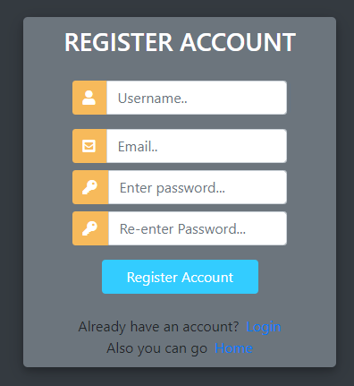

Fig. 1. Registration window

Also was implemented a login window, which compares login information with the data in the database:

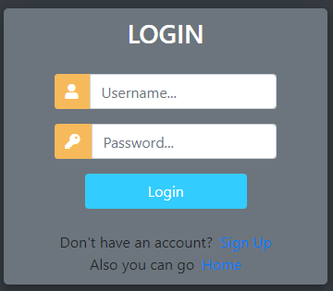

Fig. 2. Login window

Besides, was created an adaptive sidebar menu.

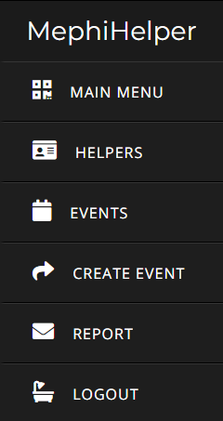

Fig. 3. Sidebar

A section of the site was implemented where you can see several events taking place at the University. Special access rights have been added, and they are combined into a group that can be requested by a particular user to edit this section.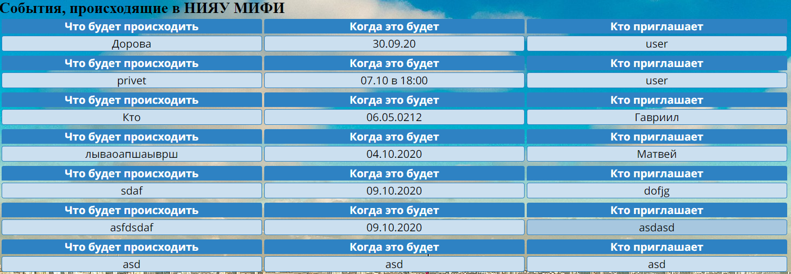

Fig. 4. Table of the events

A real photo of MEPHhI is displayed on the background of the site:

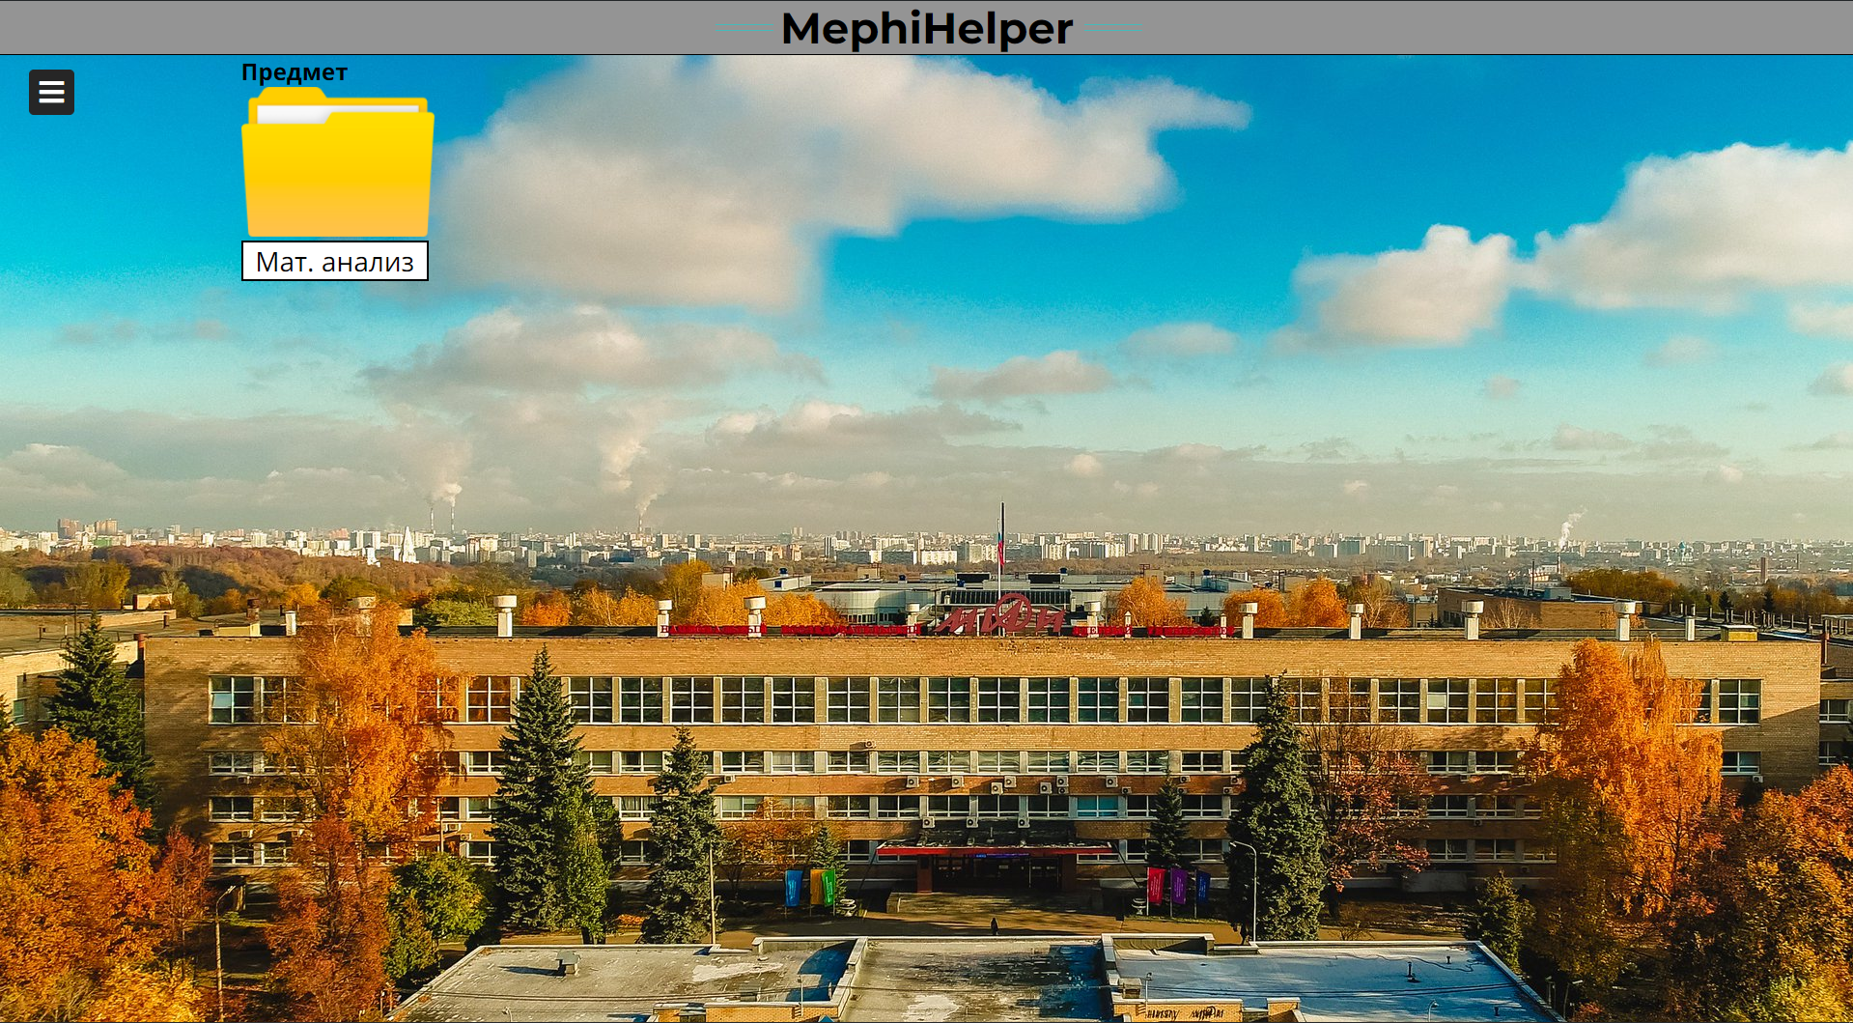

Fig. 5. Background of the site

And it can be easily be changed on any other photo.

The site header was completed, which consists of a grey background, the name of the web-resource, and four turquoise lines:



Fig. 6. Head of the site

A feedback system has been built to guarantee personal contact with the site creator to fix any glitches or bugs. It may also receive various suggestions for improving the web-resource. The link is presented in the form of hyperlinks through images to telegram and the Creator's vk:

.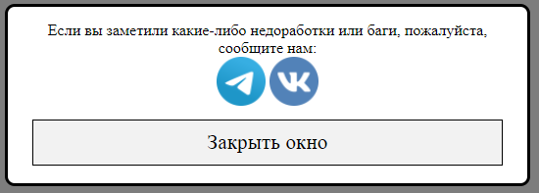

Fig. 7. Report window

Performed a system of contacting with helpers, where you can see the first and last name of each helper, the subject on which he provides support, the person, who taught him and the course that he can assist:

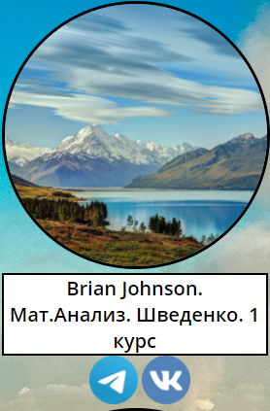

Fig. 8. Helper's window

Was created a folder system that provides learners with the necessary information in a short time. These folders transfer students to select folders on Google disk that contain various training materials.



Fig. 9. Folder

The site was released to the Internet and verified by a mass user. There are no errors in the site's operation or other shortcomings.

In addition to all of the above, was formed a unique database of people who are ready to provide students with support in obtaining additional information and mastering it in various educational programs.

This site can be easily improved by adding an internal database of files, but this is not possible at this stage, because you need expensive hosting with a large amount of memory stored.

You can also correct the colours used on different objects, add some shadows for details, and several animations to make the site more lively and pleasant for the user.

Each version of the site was uploaded on Github, from where everyone can easily download it and use it as they wish.

The web-resource has various access rights that allow you to make changes to the event database only for users who have been granted these rights. Also, a special "Eventor" group was created, the assignment of which automatically adds all access rights associated with changing information in the event-related database. These rights will only be issued to verified people who will use them for their intended purpose.

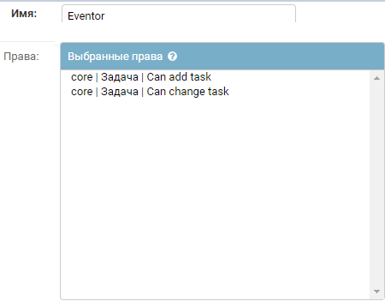

Fig. 10, group rights (for Eventor)

These users have access to a particular page where they can add events. Such user needs to write the name of the activity that will take place, the date when it will be, and the name of the person who invites students on the event. It should be noted that Eventor can write the name of any person in the last field, but in the administrative panel will remain just their username, and "name" will be in a separate area, as well as the name of the event itself.

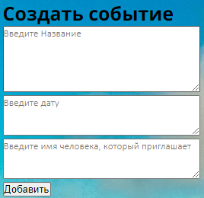

Fig. 11, create an event table

Events that were added this way can be easily edited from the admin panel.

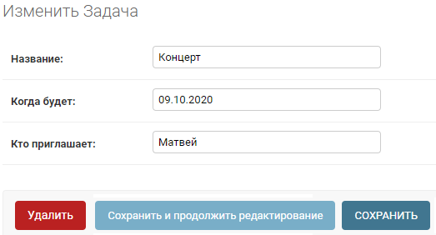

Fig. 12, edit event table

# Discussion And Conclusions

The study resulted in a user-friendly website where you can quickly find materials on academic subjects, as well as contacts of a person who can help in solving educational issues.

The work is done, and the web portal can significantly facilitate the learning process.

This research brought skills to work with Python and Django, developed the ability to collect and organize information, taught how to work with design, and influenced the ability to analyze the impact of various tools on the dynamics of web portal traffic.

The survey highlighted the problem solved by this study, namely the lack of a centralized database of people who are ready to help in getting an education and showed its relevance because in just two days five people took part in it. This figure is not so high, but if you consider that it was published on only one resource with an active audience of only 250 people – this result is excellent. A superior service, Google forms, was selected for the survey. It is very convenient and easy to use,

and also immediately systematized all user responses, which will allow you to transfer them to the site database successfully.

The information obtained from the survey allowed us to determine how real users react to various changes on the site, find out what is missing for the average user, and add the missing tools to the site.

##### References

1. Elliot, A. J., & Maier, M. A. (2014). Color Psychology: Effects of Perceiving Color on Psychological Functioning in Humans. Annual Review of Psychology, 65(1), 95–120. https://doi.org/10.1146/annurev-psych-010213-115035
2. Stoll, M., Baecke, S., & Kenning, P. (2008). What they see is what they get? An fMRI-study on neural correlates of attractive packaging. Journal of Consumer Behaviour, 7(4–5), 342–359. https://doi.org/10.1002/cb.256
3. Адриан Головатый, Джейкоб Каплан (2010). Django. Подробное руководство Мос. СПб.: Питер, 97 с.
4. Antonio Mele. Packt Publishing (2015). Django By Example 24 с.
5. [Рябова К. М.](https://www.elibrary.ru/author_items.asp?refid=537497746&fam=%D0%A0%D1%8F%D0%B1%D0%BE%D0%B2%D0%B0&init=%D0%9A+%D0%9C) (2018). Фреймворк DJANGO: архитектура и возможности // Современные технологии: актуальные вопросы, достижения и инновации: сборник статей XIII Международной научно-практической конференции в 2 ч.Ч 1. - Пенза: МЦНС «Наука и Просвещение». -. - С. 118 -120.
6. [Форсье Д.](https://www.elibrary.ru/author_items.asp?refid=537497747&fam=%D0%A4%D0%BE%D1%80%D1%81%D1%8C%D0%B5&init=%D0%94) Django (2009). Разработка веб-приложений на Python / пер. с англ. А. Киселёв. - СПб.: Символ-Плюс, - 456 с
7. Владимир Дронов (2019). Django 2.1. Практика создания веб-сайтов на Python. Санкт-Петербург: БХВ-Петербург, - 523 с
8. Владимир Дронов (2016). Django: Практика создания Web-сайтов на Python. Санкт-Петербург: БХВ-Петербург, - 523 с
9. Michael Dawson (2014). Программируем на python. - СПб.: Питер, 2014. - 416 с.: ил.
10. Mark Summerfield (2009). Программирование на Python 3. Подробное руководство. – Пер. с англ. – СПб.: Символ‑Плюс, 2009. – 608 с.
11. HTML и CSS. Разработка и дизайн веб-сайтов /Джон Дакетт; [пер. с англ. М. А. Райтмана]. - М.: Эксмо, 2013. -480 с.: ил.+ 1 CD. - (Мировой компьютерный бестселлер).
12. Digital 2020: global digital overview, website.
13. The use of the Internet for educational purposes, Nazan Dogruera, Ramadan Eyyamb, Ipek Menevisab, Procedia - Social and Behavioral Sciences 28 (2011) 606 –