Android application fundamental
android use Java, there is 2 types of Java, Google & Oracle, google is open source and oracle is private source.

AndroidMainfest.xml
- references https://developer.android.com/guide/topics/manifest/manifest-intro.html
- AndroidMainFest.xml contain XML elements, some of them contain sub-elements and so on.\
- there is some attributes that begin with (.), it is treated as relative as package name, specified in the manifest elements attributes, ex. Com.example.elern had an elements attribute specified .test as value, it would be equivalent to using com.example.elern.test.
- <use-sdk> elements has one or more attribute.[minSdkversion, targetSdkVersion, and/or maxSdkversion]
- support old version of android without apply security changes on the code could rise security risks.
- targetSdkVersion, maxSdkversion have no security impact on the application
Intents
- references https://developer.android.com/reference/android/content/Intent.html
- intents means which android apps communicate between there components or with other apps.
- These message object could carry data between apps or components, similar to how get and post request works.
- intents used to invoke set of actions in the receiving component or application.
- could be sent out without a recipient designed.

Intent Structure
Primary attributes
- action: The general action to be performed, such as ACTION_VIEW, ACTION_EDIT, ACTION_MAIN, etc.
- data: The data to operate on, such as a person record in the contacts database, expressed as a Uri.
secondary attributes
- category: Gives additional information about the action to execute. For example, CATEGORY_LAUNCHER means it should appear in the Launcher as a top-level application, while CATEGORY_ALTERNATIVE means it should be included in a list of alternative actions the user can perform on a piece of data.
- type: Specifies an explicit type (a MIME type) of the intent data. Normally the type is inferred from the data itself. By setting this attribute, you disable that evaluation and force an explicit type.

- component: Specifies an explicit name of a component class to use for the intent. Normally this is determined by looking at the other information in the intent (the action, data/type, and categories) and matching that with a component that can handle it. If this attribute is set then none of the evaluation is performed, and this component is used exactly as is. By specifying this attribute, all of the other Intent attributes become optional.

- extras: This is a Bundle of any additional information. This can be used to provide extended information to the component. For example, if we have a action to send an e-mail message, we could also include extra pieces of data here to supply a subject, body, etc.

implicit intents
- implicit intents: do not specify a particular apps component, but rather than specify an action to be taken and therefore potentially allow any application to receive and process the intent.
- intent sending mailto link to an application is capable of generation an email message.
- in the receiving app it should have a component with intent-filter elements, which matches with our action
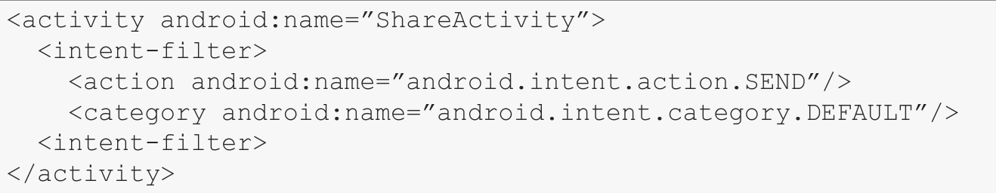
- in this example the component is an activity and the action name attribute specified in the hierarchically form.
- in order to receive the implicit intent, the app also need to specify the default category, as an in the previous example android.intent.category.DEFULT.
- the implicit intent the recipient is not specified so malicious app could stole the data.
Intent resolution is a process of queries the system package manager process, used to determine which apps can handle the intent based on if they match the category, action and types.
- the resolution process also considers the priority attribute which can be specified in the intent filter for a component, the app with higher priority will be selected if there is multiple matches on the other criterion.
- during the resolution process, if conflict arise, the default behavior is that the ‘chooser’ window appears, which prompts the user to choose the application to use to handle the intent.
- Google play in-blilling library hacked references https://seclists.org/fulldisclosure/2013/Oct/277
- which allows to impersonate the Google Play billing service and circumvent the signature verification. I was able to retrieve unlimited amounts of in-app items in games like Temple Run 2, which uses this library.
- references https://developer.android.com/guide/components/intents-filters.html

explicit intent
explicit intent: is one that specify the class name it is targeting the intent contractor, this ensure the receiving app that the one you intent and prevents a malicious app from intercepting or eavesdropping on the intent contact.
Example….

For classes in the other applications, you’d use either the setComponent or setClass methods from intent constructor
example…..
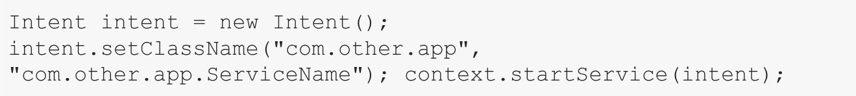
Broadcast intent
Broadcast intent: unlike the intents we’ve previously discussed, which are ultimately received by one app, when sending broadcasts, care needs to be taken so that no sensitive data is leaked in the process.
If you want to ensure that only selected app receives a broad cast you can set that by intent.setPackage starting with API version 14 (android 4)
also, you can set permission when sending broadcast message, the receiving apps would need to specify user-permission element in their androidmainfest.xml file.
References https://developer.android.com/guide/topics/manifest/uses-permission-element.html
types of broadcast
Normal Broadcast
normal broadcast are asynchronous and can be processed by multiple application in any order, or potentially simultaneous.
Ordered Broadcast
ordered broadcast are run one at a time, in a daisy-chained fashion.
The order determine by the priority defined within the corresponding receiver element, within the receiver app at androidmainfest.xml
this means that each app can process, then relay, or drop the broadcast.

You can set permission for the broadcast
example..
unless the permission you declare is reserved in the system level apps, any app could have declare the same permission, the only protection offered in this situation is at app install time, even this suffer from vulnerability.
Local broadcast
if the broadcast needs to be received by component within the same application it is begin sent from, you can use sendbroadcast method from the localbroadcastmessanger class
references https://developer.android.com/reference/android/support/v4/content/LocalBroadcastManager.html

sticky broadcast
sticky broadcast are similar to broadcast in that many apps may receive the data.
The difference here is that the system maintains these broadcast, so they can be accessed long time after they sent.
They could be also modified and leaked like the broadcast, the documentation of android suggest to not use sticky broadcast.
Reference https://developer.android.com/reference/android/content/Context.html
if find any method contain sticky like sendstickybroadcast or sendstickybroadcastasuser, it should be defined as a potential impact.

Pen ding intent
pending intent allow other application to take action on behalf of your application, using your apps identity and permission.
When constructing intent the developers specify an intent and action to preform.
If the intent is not an explicit intent, a malicious application could receive it and preform actions on behalf on victim app.
Reference https://seclists.org/fulldisclosure/2014/Nov/81

Deep links
allow the user to trigger an intent via url, embedded in the website.
This allows data to start and pass in data.
When a clicked link or programmatic request invokes a web URI intent, the Android system tries each of the following actions, in sequential order, until the request succeeds:
1. Open the user's preferred app that can handle the URI, if one is designated.
2. Open the only available app that can handle the URI.
3. Allow the user to select an app from a dialog.
Reference https://developer.android.com/training/app-links/deep-linking

in order to receive the intent, you need to configure the androidmainfest.xml to confirm the action, category and data in the deep links URL, match up with the intent-filter element for the receiving component.
The intent filter must also include a category with the following value (android.intent.category.BROWSABLE )
the data in the deep links should be validated or it could leak to vulnerability like xss even if it just web view.
AIDL (Android Interface Definition Language)
It allows you to define the programming interface that both the client and service agree upon in order to communicate with each other using interprocess communication (IPC)
- On Android, one process cannot normally access the memory of another process.
- they need to decompose their objects into primitives that the operating system can understand.
- marshall the objects across that boundary for you.
- The code to do that marshalling is tedious to write, so Android handles it for you with AIDL.
- Cross-application services in Android are based on Binder, a kernel-level IPC system (this is where the IBinder class name comes from). When you bind to a remote service (that is, one outside of your application), it can return an object to you. However, since you don't know what the actual type is (methods, fields, etc), you can't cast it to a usable type.
- This is where AIDL comes in - it is a language-agnostic way of specifying interfaces - collections of methods and their parameters (it also looks deceptively like Java - it's not). If both the client and the server use the same .aidl file, you can bind to the object via the generated Java interfaces - IRemoteService.Stub.asInterface(obj). On the service side you just have to implement that same interface in some language (some of the services in the framework are in C++) and the IPC mechanism will take care of the rest.
- That said, you don't need to use AIDL unless you export your service and want external applications to be able to use it. If not, just implement IBinder in your application and cast the object received in onServiceConnected directly, since you know its type.
Messenger
- Messenger is a Handler sent to the remote process.
- Specified in androidmainfest.xml.
- Messenger is much easier to implement than the AIDL technique because it creates and uses AIDL files in the background.
- with AIDL, you are able to do concurrent operations. In Messenger, the calls are queued and executed sequentially. It is guaranteed that calls will be received from at most one process/thread at a time of t.
- the client will bind to the server’s service. In this way, the server will return the Messenger object to the client. Thus, the two applications will be able to communicate through Message objects.
Binder
- man in the binder https://www.youtube.com/watch?v=O-UHvFjxwZ8
- Binder is an Android-specific interprocess communication mechanism, and remote method invocation system.
- That is, one Android process can call a routine in another Android process, using binder to identify the method to invoke and pass the arguments between processes.
- the binder implementation is in the kernel source at: drivers/android/binder.c, with include file: include/uapi/linux/android/binder.h
- Base class for a remotable object, the core part of a lightweight remote procedure call mechanism defined by IBinder. This class is an implementation of IBinder that provides standard local implementation of such an object.
- Most developers will not implement this class directly, instead using the aidl tool to describe the desired interface, having it generate the appropriate Binder subclass. You can, however, derive directly from Binder to implement your own custom RPC protocol or simply instantiate a raw Binder object directly to use as a token that can be shared across processes.
- This class is just a basic IPC primitive; it has no impact on an application's lifecycle, and is valid only as long as the process that created it continues to run. To use this correctly, you must be doing so within the context of a top-level application component (a Service, Activity, or ContentProvider) that lets the system know your process should remain running.
Component
Each android application contain 4 component, they implemented in java but each one of them has a corresponding element in the androidmainfest.xml
- Activity
  - The visual screens you see in application, every image, button, web page..etc Implemented via an activity
  - all activity classes must have a corresponding <activity> declaration in their package's AndroidManifest.xml.
  - The Activity class is a crucial component of an Android app, and the way activities are launched and put together is a fundamental part of the platform's application model. Unlike programming paradigms in which apps are launched with a main() method, the Android system initiates code in an Activity instance by invoking specific callback methods that correspond to specific stages of its lifecycle.

- Services
  - Services are used to preform long-running processes, even if the user starts using a different application, services run in the background and therefore don’t provide a UI themselves.
  - In addition to the supporting java code, services are defined in a service element in the androidmainfest.xml file.
  - If the client calls a service using the startservice method, it will run until stopservice method is invoked.
  - If the service is only needed as ling as the client is connected, the client should bind to it using the bindservice method.
- Broadcast receivers
  - Are components which listen for broadcast intents sent from applications.
  - Broadcast receivers can be statically defined in androidmainfest.xml, in a receiver element, or dynamically defined using the registerreceiver method.
  - Receivers are primary used for processing input from other application, the key of properly securing them are.
    - Validating the data received from other applications.
    - Potentially limiting which application’s broadcast your receiver accepts, by accept through the use of permissions within the receiver elements, defined in the androidmainfest.xml, When defined it as an argument to the registerreceiver method.
- Providers
  - A content provider manages access to a central repository of data. A provider is part of an Android application, which often provides its own UI for working with the data.
  - content providers are primarily intended to be used by other applications, which access the provider using a provider client object. Together, providers and provider clients offer a consistent, standard interface to data that also handles inter-process communication and secure data access.
  - Typically you work with content providers in one of two scenarios; you may want to implement code to access an existing content provider in another application, or you may want to create a new content provider in your application to share data with other applications.
  - A content provider presents data to external applications as one or more tables that are similar to the tables found in a relational database. A row represents an instance of some type of data the provider collects, and each column in the row represents an individual piece of data collected for an instance.
  - A content provider coordinates access to the data storage layer in your application for a number of different APIs and components as illustrated in figure 1, these include:
    - Sharing access to your application data with other applications
    - Sending data to a widget
    - Returning custom search suggestions for your application through the search framework using SearchRecentSuggestionsProvider
    - Synchronizing application data with your server using an implementation of AbstractThreadedSyncAdapter
    - Loading data in your UI using a CursorLoader
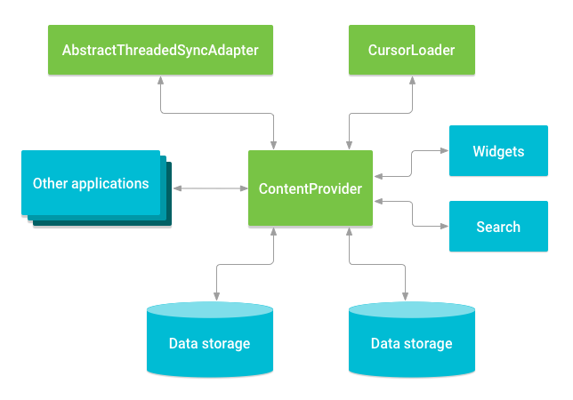
Permission
Requested permission
This permission is when receive prompt message the application request to use the location or the camera.
This is uses-permission elements and it in the androidmainfest.xml file.
It contains 2 elements name and maxsdkversion.
- The name attribute will be either standard system permission or custom one that defined in another app.
- In android 5.1 and lower this permissions were only requested at the time of the installation.
- Starting with android 6 it is possible for the users to control the permission after install the application.
- The maxsdkversion attribute simply stops your app from asking for permission on versions higher than the one specified.

Custom permission
When an app want to expose some data to another application, it will export it and make it available by defining a custom permission.
Using permission element the app can limit the access to only apps that have specified permission.
The permission element has 3 attributes
Name: string identify the permission
Protection-Level: dictate how permissions are granted, there four types of protection.
Normal: These permissions allow access to data and actions that extend beyond your app's sandbox. However, the data and actions present very little risk to the user's privacy, and the operation of other apps, so the user not need to approve for it.
Dangerous: Runtime permissions, also known as dangerous permissions, give your app additional access to restricted data, and they allow your app to perform restricted actions that more substantially affect the system and other apps. Therefore, you need to request runtime permissions in your app before you can access the restricted data or perform restricted actions. When your app requests a runtime permission, the system presents a runtime permission prompt, as shown in Figure.
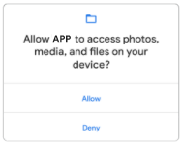
Many runtime permissions access private user data, a special type of restricted data that includes potentially sensitive information. Examples of private user data include location and contact information.

Signature: If the app declares a signature permission that another app has defined, and if the two apps are signed by the same certificate, then the system grants the permission to the first app at install time. Otherwise, that first app cannot be granted the permission.
signatureOrsystem: Same as signature but add system level apps.

Permission-group: allow grouping related permission.
The app requiring the permission would define the Uses-permission elements name attribute, which matched the name element in the hosting app permission element.
Webviews
Webviews are web browsers embedded into the application, can render HTML & JS and even run active content
The content could be pulled from remote sites or form local files, it’s better to make it from local files and if them are bulled from local files it’s better to make them dynamically update without need to update the app because if there is vuln found in the theme you use.
Webviews are potential vulnerable to OWASP top 10.
There are two types of webviews
WebViewClient is the best suit for simple HTML rendering.
- It will not run the javascript alert() function so you have to try different types of exploits.
- Have their cookie jar and they have no access to the native browser cookie.
- There are several steps involved in creating a functional WebView.
- They include passing in the URL or content to load, using the loadUrl, loadData or loadDataWithBaseURL methods.
- ensure that the parameters to these methods are not derived from unsanitized, user-controlled data.
- JavaScript is enabled/disabled by using the setJavaScriptEnabled method and passing it the value, true or false.
- WebViews can be allowed to access Content Providers via content:// URLs by passing true to the setAllowContentAccess function.
- Local files within the app, can be accessed via file:// URLs by default.
- Passing false to setAllowFileAccess prevents access to the filesystem
- There are two additional related methods which can control the ability for a WebView to access file:// URLs: setAllowFileAccessFromFileURLs and setAllowUniversalAccessFromFileURLs. Both methods take a single Boolean argument.
- If the getter method for getAllowUniversalAccessFromFileURLs returns true, the getAllowFileAccessFromFileURLs method’s return value is ignored.
WebChromeClient is effectively as chrome browser.
In android 4.4 the webviews became based on the open-source chromium browser that help to solve rendering issues.
WebViews have their own cookie storage, separate from the rest of the application. Unless a developer modifies this, an XSS will not have access to the cookies used by the other parts of the app.
Share UID
w every application must be signed to identify the application author and allow the developer to update or edit his applications.
applications signed with the same key can share the same UID (User ID) and Application Sandbox.
To share the same UID, applications must define the same ‘android:sharedUserId’ value in their manifests
In the same way, application B must declare the same sharedUserID in its manifest
Since both applications share the UID, every file stored in the application A folder, is accessible to application B and vice versa. Indeed if we run app B, we are able to access the file created by application A and read its content.
if we delete the sharedUserID entry from one of the two applications manifests, the application B is not able to read the file anymore and we get a permission denied error:

