**EVENT DRIVEN PROGRAMMING | PROJECT 3**

GALAN, MARK FRANCIS N. DATE: 09-04-23

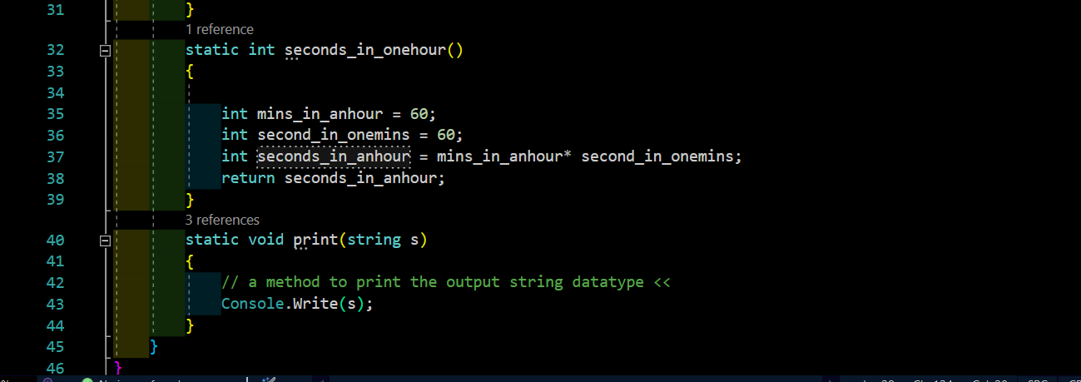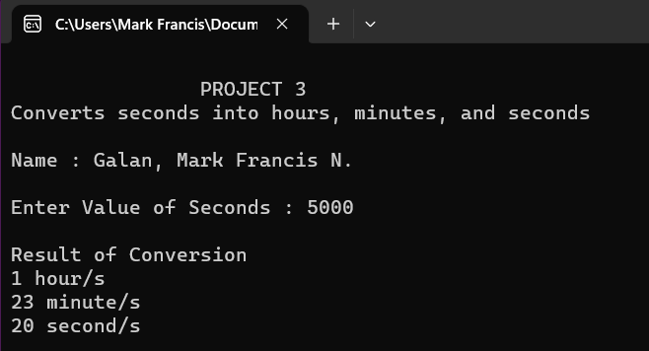

OUTPUT

CODES