**EVENT DRIVEN PROGRAMMING | PROJECT 7**

GALAN, MARK FRANCIS N.

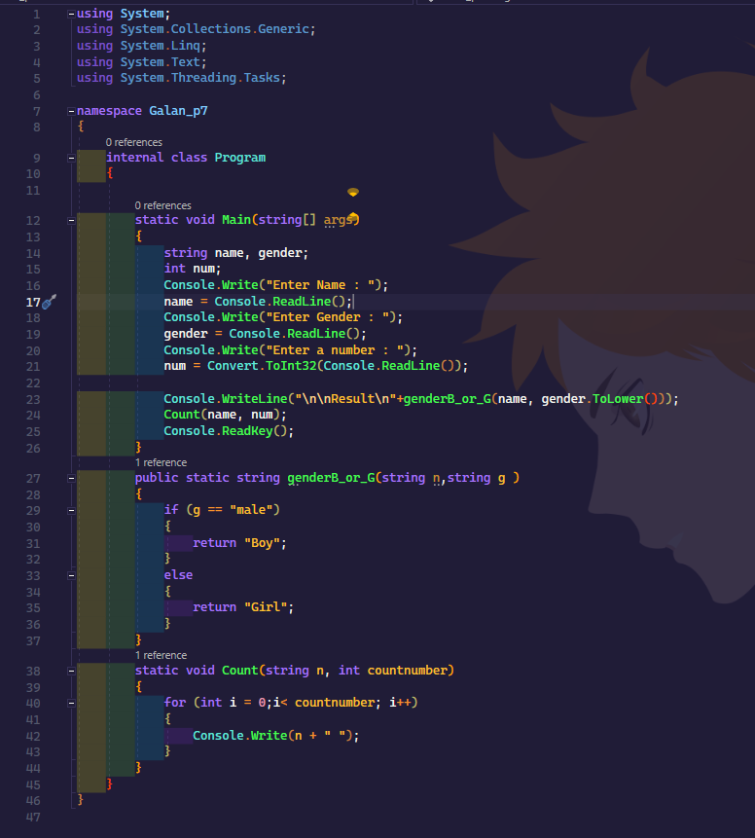CODES:

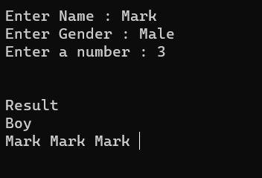OUTPUT: