Name: Galan, Mark Francis N. Student Number: 202001578

Section: BSIT 3A Sir Randy Quibic

Event Driven Programming

Assignment 1

1. Clicking NEW PROJECT through GET STARTED

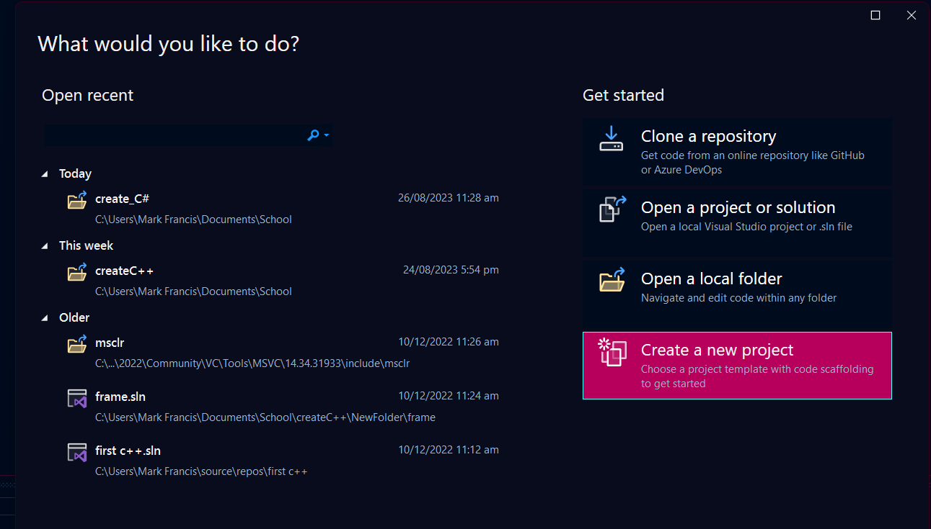

1. Clicking NEW PROJECT through FILE MENU

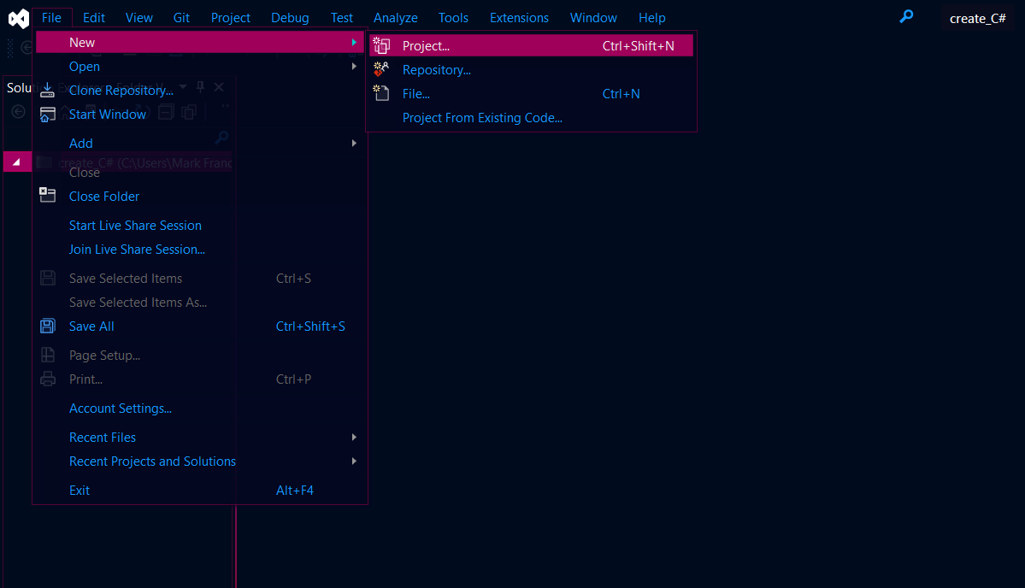

1. Create a New Project