**EVENT DRIVEN PROGRAMMING | PROJECT 6**

GALAN, MARK FRANCIS N. DATE: 09-15-23

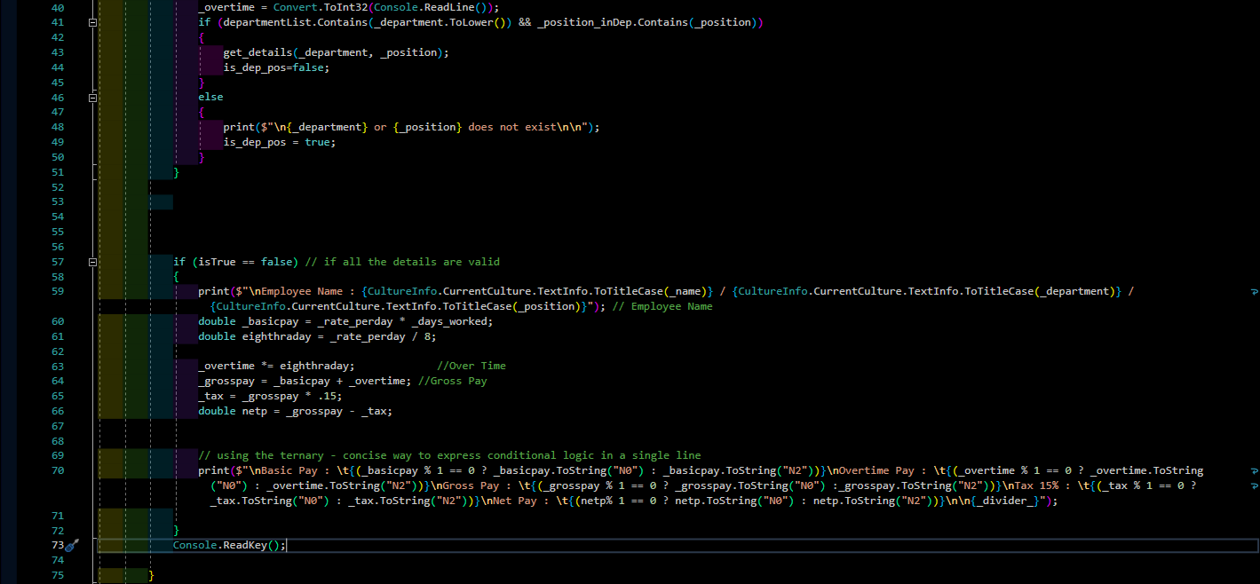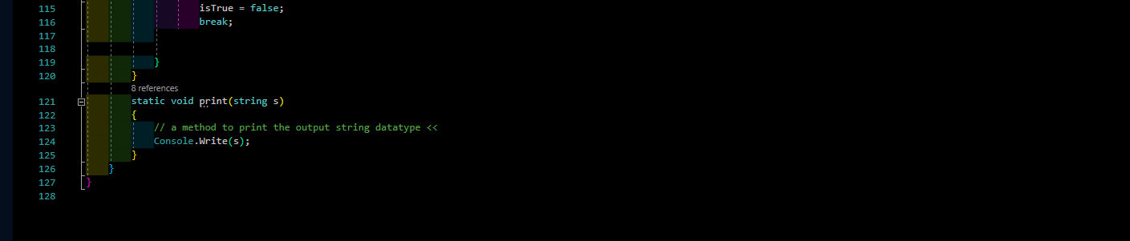

**CODES**

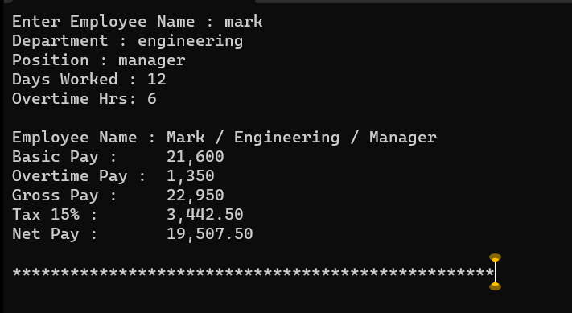**OUTPUT**