**EVENT DRIVEN PROGRAMMING | PROJECT 2**

GALAN, MARK FRANCIS N. DATE: 09-04-23

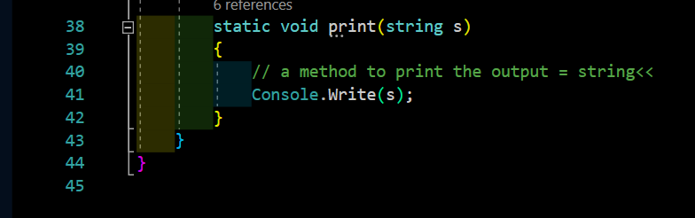

CODES

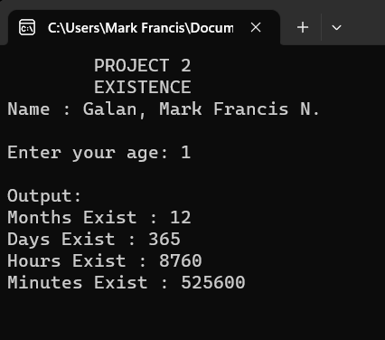

OUTPUT