**EVENT DRIVEN PROGRAMMING | PROJECT 5**

GALAN, MARK FRANCIS N. DATE: 09-09-23

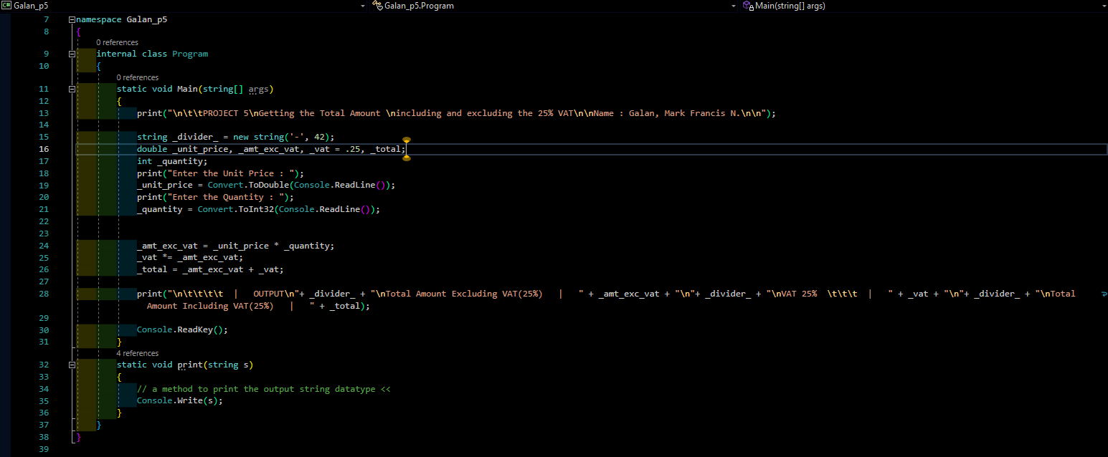

CODES

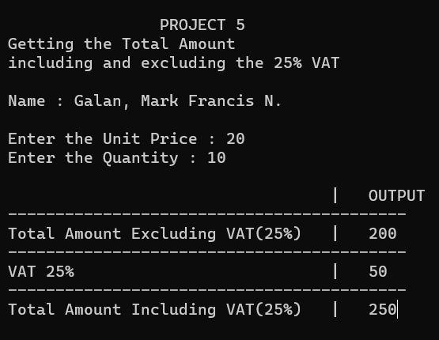

OUTPUT