**EVENT DRIVEN PROGRAMMING | PROJECT 8**

GALAN, MARK FRANCIS N.

CODES:

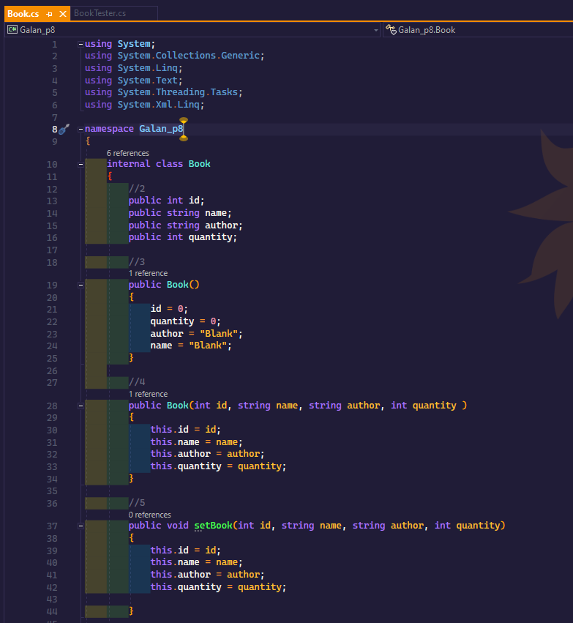

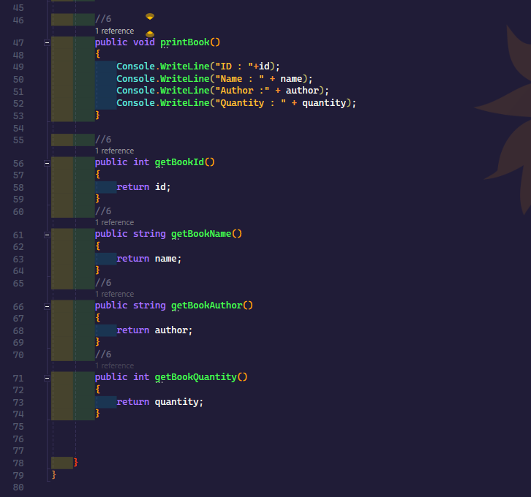

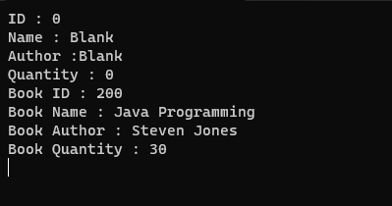OUTPUT: