**EVENT DRIVEN PROGRAMMING | PROJECT 4**

GALAN, MARK FRANCIS N. DATE: 09-09-23

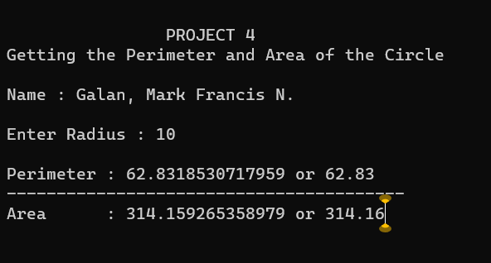

OUTPUT

CODES