**EVENT DRIVEN PROGRAMMING | PROJECT M1**

GALAN, MARK FRANCIS N.

CODES (FORM 1):

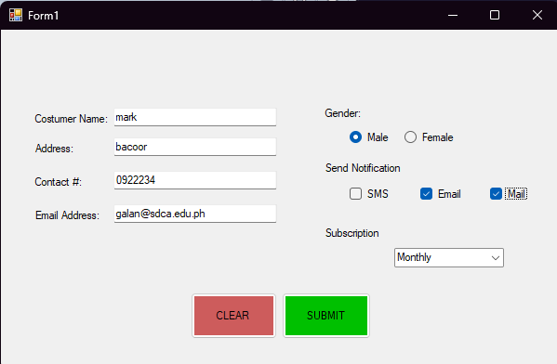OUTPUT (FORM 1)

CODES (FORM 2)

OUTPUT (FORM 2)

