**EVENT DRIVEN PROGRAMMING | PROJECT M3 (Assignment)**

GALAN, MARK FRANCIS N. DATE: 11-18-23

CODES:

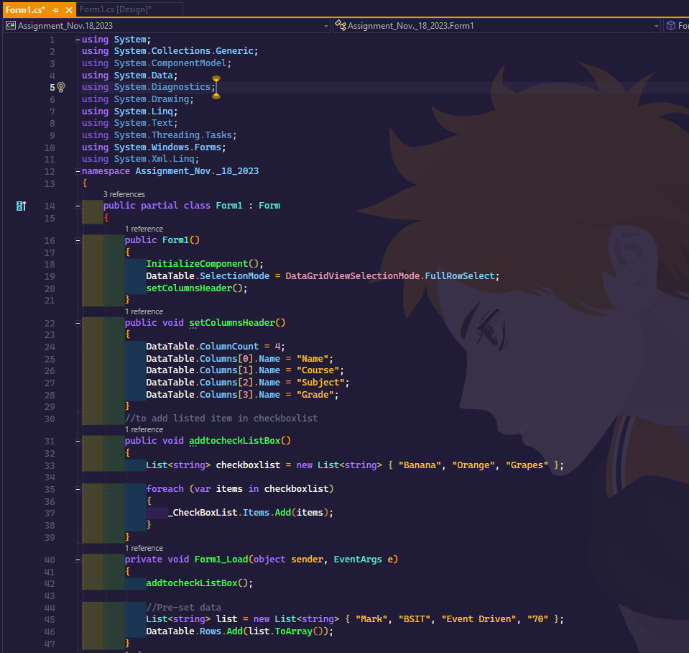

OUTPUT: “ADD” Button clicked

OUTPUT: “UPDATE” Button clicked

OUTPUT: “DELETE” Button clicked

