**EVENT DRIVEN PROGRAMMING | PROJECT M@**

GALAN, MARK FRANCIS N.

CODES (FORM 1)

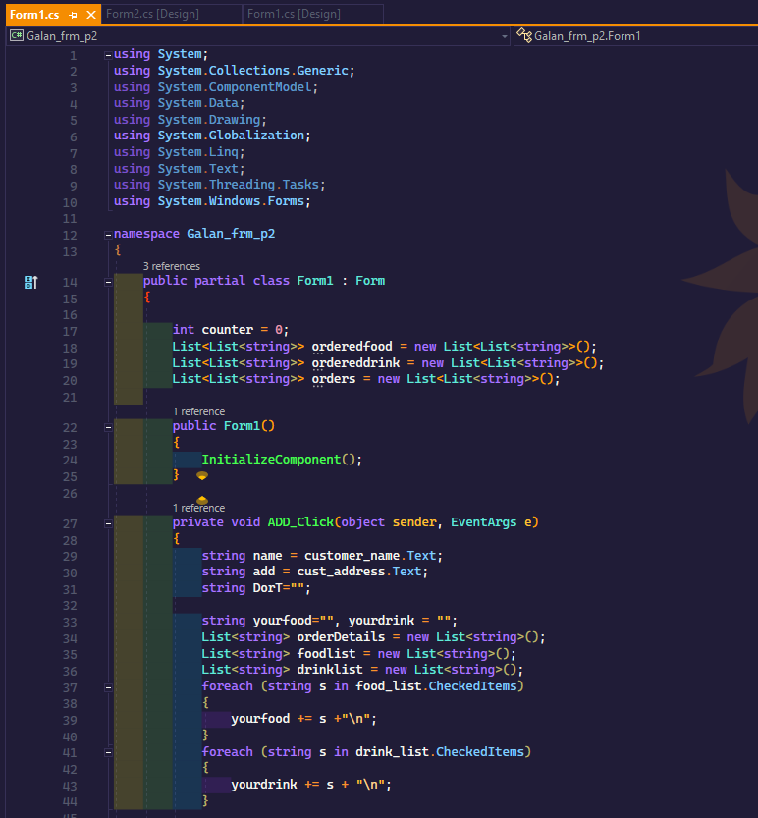

CODES (FORM 2)

OUTPUT (FORM 1)

OUTPUT (FORM 2) “NEXT” Button clicked

OUTPUT (FORM 1) “VIEW” Button clicked

