AIRFLOW ENVIRONMENTAL SOLUTIONS
Additional Features Specification
Business Development & Marketing Campaigns · Director-Only Initiative Boards
Project Work-Breakdown & Progress Tracking · Statutory Returns Hub · Back-Pay & Acting Allowances
Multinational Readiness · Long-Contract Site Monthly Reporting & Performance vs Target
Supplement to the AES System Design & Process Flow Document | Version 1.0 | July 2026
Includes explanations of what each feature is and how it works, for the development team.

Contents

1. The Sample Data Pack (what the developers receive and how to use it)
What it is: five Excel workbooks populated entirely with fictional sample data — generated Zimbabwean names, national IDs (format NN-NNNNNNLNN), NSSA numbers, employee numbers (AES-E001…), bank account numbers and client-issued works numbers. No real employee or client-payment identity data remains. The files are:
- Operational_Cashflow_Report.xlsx — 10 sample orders across every health state (Paid, Advance Paid, Awaiting/Overdue Payment, Overdue Service, Open), matching expenses, three months of overheads, five loans, contract claims for three contracts, tax debt and all dashboards computing live — including a Financial Summary that lands on an ACT verdict, so developers can see the danger logic firing.
- Mimosa_Payroll_March_2025.xlsx and Unki_Payroll_June_2023.xlsx — site payrolls demonstrating per-employee USD/ZWG ratios, hourly pay from timesheet hours, UG/night/OT premia and the full statutory stack (PAYE + AIDS levy per currency, NSSA, ZIMDEF, NEC, MIPF, Nyaradzo), plus bank schedules and payslips driven by formulas from the Paysheet.
- Head_Office_Payroll_March_2025.xlsx — fixed-salary pattern with leave days, simpler statutory set and the Sage journal export.
- AES_MANHOURS_2022-23_-NEW.xlsx — daily hour grids per employee per month, the source pattern for the Timesheets module and the client manhours report format.
How to use it: these files are the developers' reference implementation — the schema in the main design document maps one-to-one onto their columns, and the migration parity test (Appendix A.10 of the main document) can be rehearsed against this pack before ever touching production data. The identities are consistent across files: the same fictional person keeps the same name, ID and works number wherever they appear.
Note: derived sheets (payslips, bank schedules, dashboards) recalculate from the input sheets; all formulas have been recalculated and verified error-free. If a value looks stale after editing, press F9/recalculate in Excel.

2. Business Development & Marketing Campaigns

2.1 What it is
A module that manages how AES finds and wins work: the contacts and organisations pursued, the marketing campaigns that generate interest (social media and physical fliers), the responses those campaigns produce, and the conversion of responses into opportunities and finally into orders and contracts. It extends the Phase 3 CRM outline in the main design into a full specification.

2.2 How it works
- Campaigns: each campaign is a record with objective, audience, budget, start/end dates, and one or more channels. Channels are typed: Facebook, LinkedIn, WhatsApp, X, Instagram, expo/event, and flier (physical). Costs are logged per channel (design, boosting spend, printing, distribution) so cost-per-lead is computable per channel, not just per campaign.
- Capturing responses — digital: each digital channel gets a unique campaign link (UTM-tagged) pointing to a landing/enquiry form; submissions create a Response (lead) automatically tagged with campaign and channel. Manual entry covers phone/WhatsApp replies: a BD user logs the response and picks which campaign prompted it (“How did you hear about us?” is a required field).
- Capturing responses — fliers: physical fliers cannot click, so each flier print run carries a QR code and a short reference code (e.g. AES-FL-07). The QR opens the same tagged enquiry form; callers who quote the code are logged manually against it. This makes flier performance measurable side by side with social channels — responses, cost per response, and conversions.
- Social performance metrics: per channel per campaign the BD user records (or, later, syncs via platform APIs) reach/impressions, engagements, clicks and spend. The module never depends on the APIs — manual weekly entry is the baseline, API sync an enhancement — so it works from day one.
- Conversion chain: Response → qualified → Opportunity (with estimated value and expected close) → Won/Lost. A Won opportunity converts into an Order or Contract in one action, so marketing attribution flows all the way to invoiced revenue: every order can show which campaign originated it.
- Dashboards: funnel per campaign (see figure), leaderboard of campaigns by cost per lead and by value won, channel comparison (flier vs social), response ageing (untouched leads escalate), and BD officer activity.
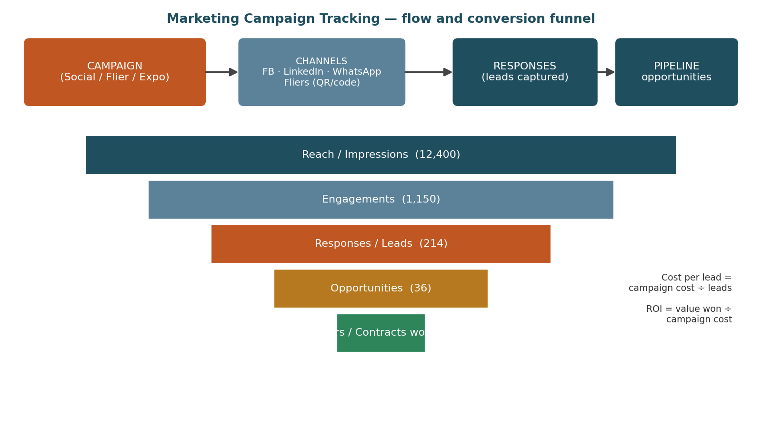
Figure 1 — Campaign flow and conversion funnel; the numbers shown are illustrative sample data.

2.3 Data entities
Entity | Key fields
campaigns | name, objective, audience, budget, start/end, status, owner
campaign_channels | campaign FK, channel type, cost, tracking link / flier code, print run qty (fliers)
channel_metrics | channel FK, week, impressions, engagements, clicks, spend
responses (leads) | source channel FK, person/org, contact details, date, status (new/contacted/qualified/dead), owner
opportunities | response FK nullable, client/prospect, description, est. value, stage, expected close, won/lost reason
conversions | opportunity FK → order_id / contract_id (one-click conversion)

3. Director-Only Initiative Boards (confidential layer)

3.1 What it is
The designers have implemented a Trello-style board workflow (boards → lists/columns → cards) for team task management. This feature adds a second, confidential layer of boards that only directors can see, for big initiatives that directors drive personally — strategic tenders, investments, restructuring, acquisitions — which must not be visible to the rest of the team, even by accident.

3.2 How it works
- Same board engine, different visibility class: a board carries a visibility attribute: Team (default) or Director-Confidential. Confidential boards use the identical card/checklist/comment features — no separate codebase — but are governed by a hard access rule.
- Server-side enforcement (the critical requirement): confidentiality is enforced in the API, not the UI. Non-director sessions never receive confidential records at all — they are absent from board lists, search results, global activity feeds, notification streams, file listings, exports, and Fabric datasets (excluded from general semantic models; a director-only model covers them). Hiding in the front end only would leak through the API and is explicitly not acceptable.
- Membership: all users holding the Director role see the director layer by default; a specific confidential board can be restricted further to named directors (e.g. an initiative only two directors run). The System Administrator does not automatically see contents — admins can manage the container (backup, restore) without content read access, and any admin content access is prominently audited.
- No metadata leakage: mentions, due-date reminders and emails generated from confidential cards go only to director members and carry a [Confidential] marker; card titles never appear in shared calendars or Teams channels.
- Graduation: when an initiative becomes public (tender won, project starts), the board can be reclassified to Team visibility in one action — with an audit entry — or its cards converted into a Project (§4) for execution by the wider team.
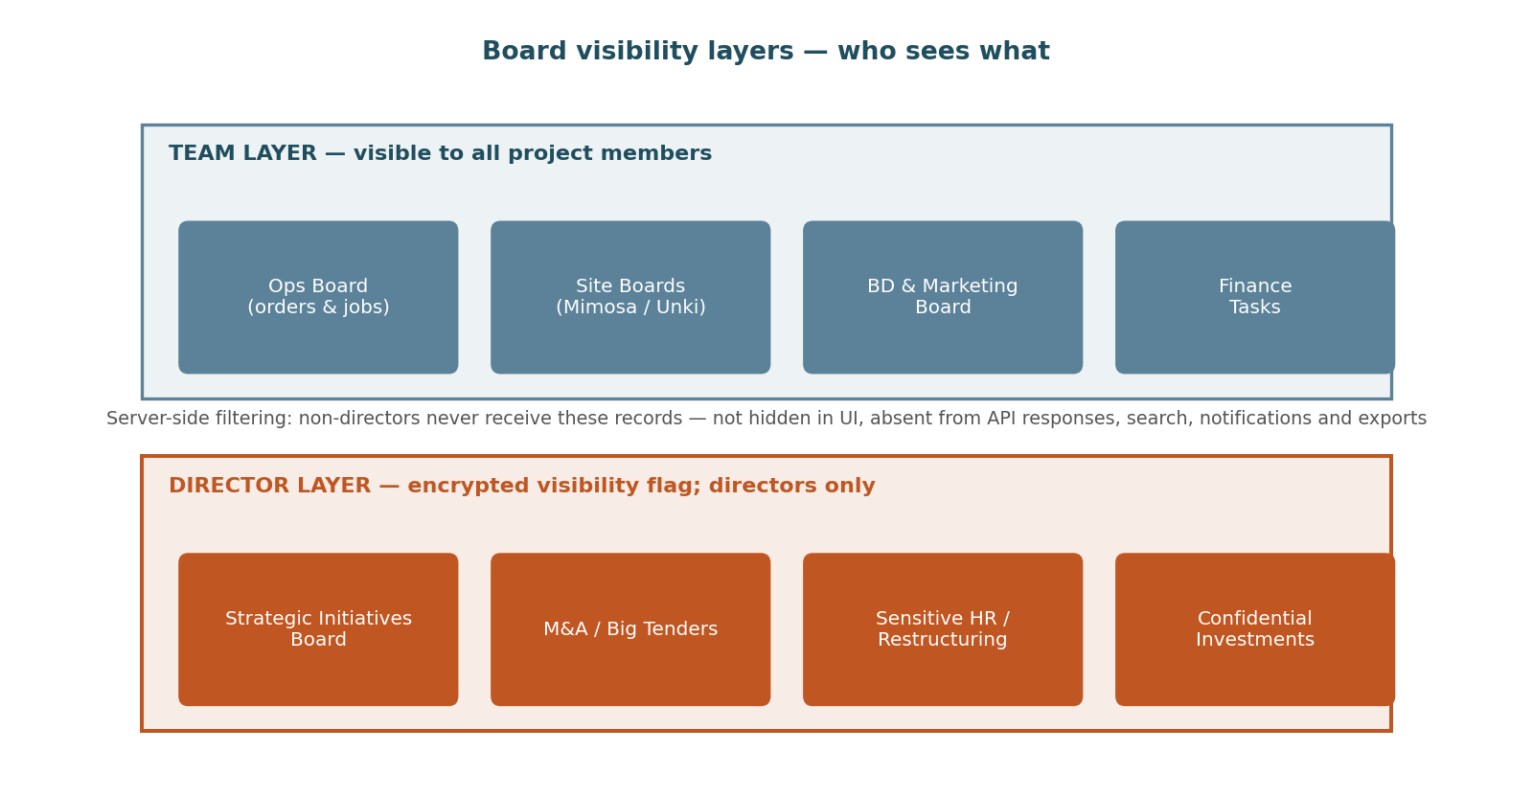
Figure 2 — Two visibility layers over one board engine; the confidential layer is filtered out server-side for non-directors.

4. Project Work-Breakdown & Progress Tracking (“exploding” projects)

4.1 What it is
For every project the company is pursuing or executing (a contract, a large order, or an internal initiative), the project is broken open — “exploded” — into the steps involved in delivering it, in a Microsoft-Project-like structure: phases, tasks and sub-tasks with dates, dependencies and percent-complete. Each project team (“project tenant” — the site or crew responsible) updates what has been done and adds brief notes, and progress rolls up automatically so directors see how far each project has moved without asking.

4.2 How it works
- Structure (WBS): Project → Phases → Tasks → Sub-tasks. Every node has: title, owner, planned start/finish, actual start/finish, percent complete, weight (its share of the parent — defaults to equal or value-based), dependencies (finish-to-start as the baseline), and a notes thread.
- Progress roll-up: a task's % feeds its phase as a weighted average; phases feed the project. Marking the last sub-task complete completes its parent automatically. The roll-up is what powers the single “Vent walls Ph2 — 62%” number a director sees.
- Tenant updating: each project is assigned to a site/team; members of that tenant can update only their project's tasks (RBAC per project, consistent with §4 of the main design). Updating is deliberately light for mobile: tap a task → slide the % or tick complete → type a one-line note (“Wall A cast, curing 3 days”) → optionally attach a photo. Notes are timestamped and attributed, forming the project diary.
- Views: (a) outline/tree view like Microsoft Project's task sheet; (b) Gantt view with today-line, baseline vs actual bars and dependency arrows; (c) board view — the same cards engine as §3, so a crew that prefers Trello-style working drags cards while the WBS stays in sync; (d) portfolio view listing all projects with % complete, days ahead/behind and a red/amber/green schedule flag.
- Schedule health: planned % (from dates) vs actual % gives ahead/behind; slipping past a milestone raises a Watch alert to the project owner, and a project-level slip beyond a configurable threshold appears on the directors' Command Centre.
- Templates: recurring job types (e.g. refuge chamber install, vent wall build) are saved as WBS templates so a new project is exploded in seconds and then adjusted.
- Finance link: a project can reference its contract/order, so the portfolio view shows progress next to invoiced-to-date and budget consumption — physical progress vs financial progress on one line.
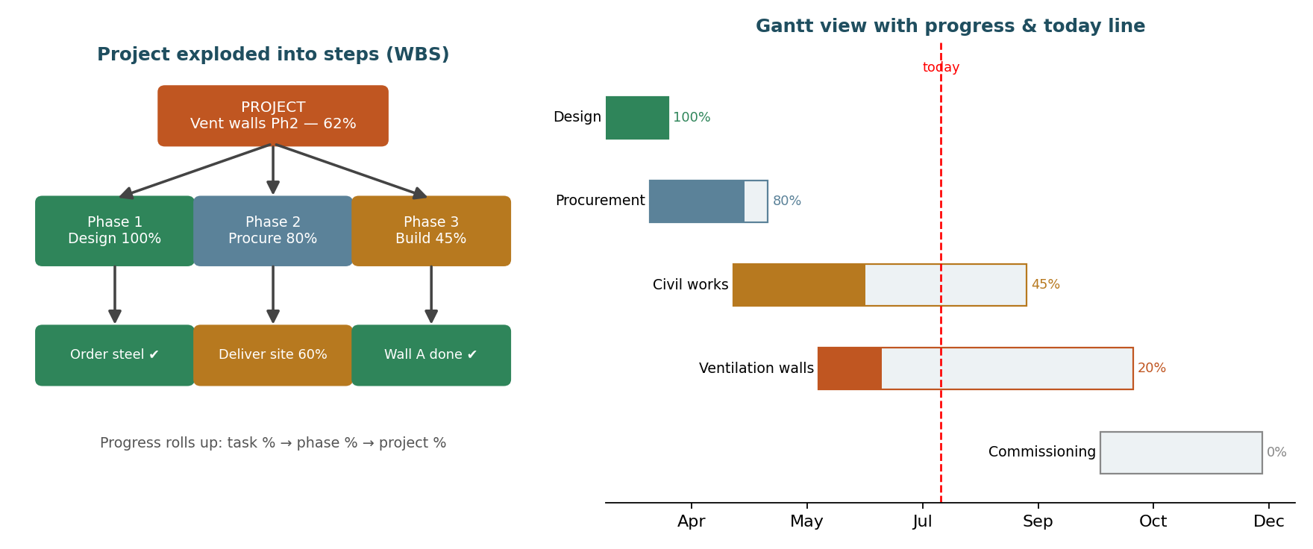
Figure 3 — A project exploded into weighted steps (left) and the same project as a Gantt with progress and today-line (right).

5. Statutory Returns Hub (the “Returns page”)

5.1 What it is
A single finance page that gathers every tax and statutory amount the business must file and pay — from payrolls, from invoices, and withholding tax — one row per tax type per period, each with amount due, amount paid, balance, filing deadline and status. It answers, at a glance: what returns are due, what has been remitted, and what is overdue and accruing interest.

5.2 How it works
- From payrolls: every approved payroll run posts its statutory totals automatically — PAYE and AIDS levy (per currency), NSSA (employee + employer), ZIMDEF, NEC and MIPF contributions, and third-party deductions (e.g. Nyaradzo) — into the hub for that period.
- From invoices: output VAT from serviced orders and contract claims, less recoverable input VAT from expenses (per the consolidation rules in Appendix A.5 of the main document), lands as the VAT row per tax period.
- Withholding tax (WHT), both directions: (a) WHT suffered — amounts a client withholds from AES's invoice payments (typically where a valid tax clearance is not held); recorded against the receipt, accumulated as a credit the accountant offsets against income tax; the hub tracks certificates received. (b) WHT payable — amounts AES must withhold when paying suppliers without tax clearance and remit to ZIMRA; captured at payment entry (the payment form asks: supplier tax clearance held? if no, the configured WHT % is withheld automatically) and shown in the hub as a liability with its own deadline. All WHT rates and rules are effective-dated configuration — rates and thresholds change, so nothing is hard-coded, and current rates must be confirmed with ZIMRA/the tax practitioner.
- Deadlines and status: each tax type carries its statutory filing/payment day; the hub computes days-to-deadline and flips status Due → Overdue automatically. Overdue rows accrue ZIMRA interest (per the configured rate) and raise Danger alerts — the hub is wired into the compliance calendar and the danger engine from the main design.
- Remittance capture: marking a row paid records date, amount, reference and proof attachment; partial payments leave a balance. Everything reconciles back to the Accounts Ledger.
- Exports: per-period remittance packs (summaries formatted for ZIMRA/NSSA submission) and a year-to-date statutory summary for the accountant.
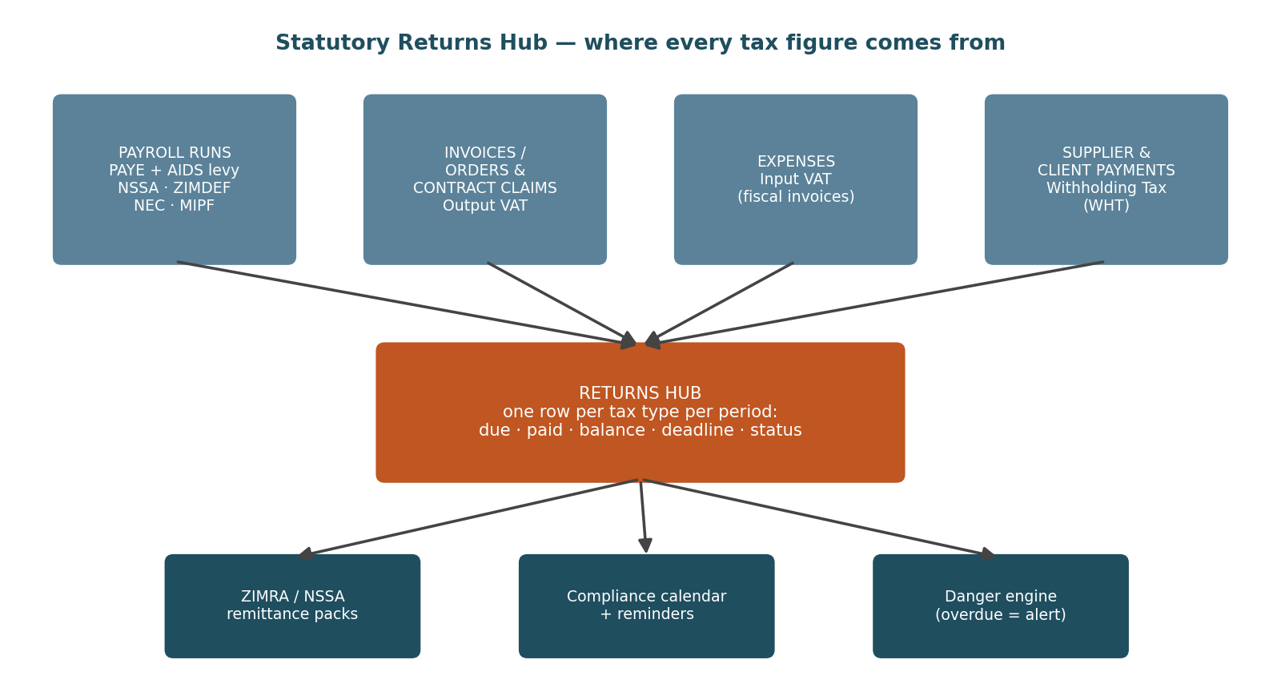
Figure 4 — The Returns Hub consolidates payroll statutory totals, invoice VAT and withholding tax into one filing view.

6. Payroll Additions: Back-Pay and Acting Allowances

6.1 Back-pay (what it is)
Bodies such as the NEC periodically gazette wage increases with retrospective effect — e.g. an increase announced in June effective 1 March. Employees were paid March–May at the old rate, so the difference for those months must be paid as back-pay. Today this is a painful manual recalculation; the system automates it.

6.2 How back-pay works
- Rates are effective-dated: the payroll administrator enters the new NEC basic/hourly rates with their effective date (1 March), even though the entry happens in June. Historical runs are never altered — they remain locked.
- The back-pay engine recomputes each affected employee's affected periods (March–May) at the new rates — including knock-on components that derive from basic (overtime premia, allowances defined as % of basic) where the rules say they apply — and compares against what was actually paid.
- The per-employee difference is loaded into the next payroll run as a single, clearly-labelled Back-pay earning line, itemised per month in the payslip note (“NEC back-pay Mar–May 2026”).
- Tax and statutory treatment: PAYE on the back-pay follows ZIMRA's rules for the year of receipt; NSSA/NEC/MIPF bases are adjusted per each body's own rules. All treatments are configuration flags per component (taxable? pensionable? NSSA-able?), verified with the tax practitioner — the engine applies whatever is configured, never a hard-coded assumption.
- The whole calculation is stored: which rates changed, which periods, per-employee workings — auditable and reprintable, and the FD approves the back-pay batch like any payroll run.
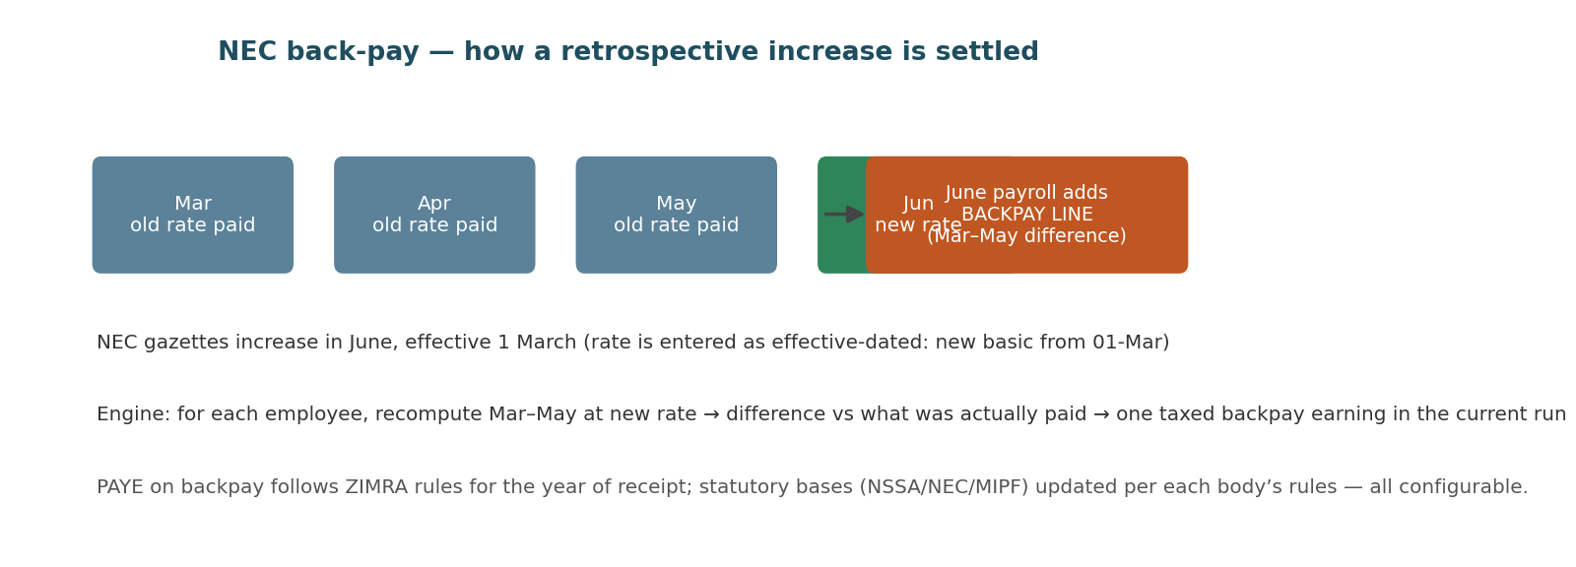
Figure 5 — A NEC increase gazetted in June, effective 1 March, settled as one taxed back-pay line in the June run.

6.3 Acting allowances (what it is and how it works)
- What it is: when an employee temporarily acts in a higher position (e.g. an Overseer Miner acting as Site Manager while the incumbent is on leave), they are paid an acting allowance for the acting period.
- Assignment: HR/payroll records an acting assignment: employee, acting position/grade, date from–to, and the basis — either a fixed amount per period, or a percentage of the difference between the acting grade's basic and the employee's own (percentage and minimum-qualifying-days are configurable; NEC rules for the sector are captured as the defaults and verified with the NEC).
- Approval: an acting assignment is an approvable item (site manager → FD or per matrix), so allowances cannot appear in payroll without sign-off.
- Payroll effect: the payroll engine pro-rates the allowance across runs the acting period spans, shows it as its own earning line on the payslip, and applies configured tax/statutory flags. Overlapping acting assignments for the same person are blocked; an assignment ending mid-month pro-rates automatically.
- Reporting: an acting register shows who acted in what, for how long, and the cost — useful for both NEC compliance and for spotting positions that are chronically covered by acting arrangements.
As throughout the main design: statutory rates, NEC rules, WHT rates and tax treatments referenced here change frequently in Zimbabwe and are implemented as effective-dated configuration to be verified with ZIMRA, NSSA, the NEC and a registered tax practitioner at build time — this document is a system specification, not tax advice.

7. Multinational Readiness (Zimbabwe-first, international-ready)

7.1 What it is — an explicit instruction to the developers
Everything in the finance and HR/payroll specifications is written against the Zimbabwean system: ZIMRA (PAYE bands, AIDS levy, VAT, WHT, penalty interest), NSSA, ZIMDEF, NEC, MIPF, the USD/ZWG multi-currency regime and RBZ/parallel exchange rates. AES, however, operates and intends to operate multinationally. The system must therefore be built so that Zimbabwe is the first country, not a hard-coded assumption — leaving room to accommodate international operations, if not in this build then in future versions without re-architecture.

7.2 How it works — what must be done now (cheap) vs later
- Legal entities and country as first-class dimensions (NOW): an entities table (AES Zimbabwe today; future AES entities elsewhere) with country, base/functional currency and chart-of-accounts reference. Every site, employee, account, tax rule and statutory rate is keyed to an entity/country. No table, report or calculation may assume “Zimbabwe” implicitly.
- Statutory logic as pluggable country packs (NOW): all gross-to-net payroll rules, tax types, filing calendars and validation rules (national-ID formats, bank account formats) load from configuration keyed by country + effective date, behind a single interface (calculate statutory lines; list returns due; validate identifiers). Zimbabwe is simply the first country pack. Adding a country later means adding a pack — not touching the payroll engine.
- Currency framework generalised (NOW): the multi-currency design in the main document (amount + currency + effective-dated rate + rate type) already supports any currency; developers must not special-case the USD/ZWG pair. Each entity has its own base currency; group reporting converts to a chosen presentation currency in Fabric.
- Localisation hooks (NOW): timezone, date/number formats, language strings and public-holiday calendars per entity; Africa/Harare and English are defaults, not constants.
- Deferred to future versions (LATER): actual foreign country packs, multi-entity consolidation and eliminations, inter-company transactions and transfer-pricing support, and country-specific payroll compliance — each becomes feasible precisely because the NOW items were respected. The Returns Hub (§5), back-pay engine (§6) and PPE/site reporting (§8) all inherit the country dimension automatically.
Acceptance test for this section: a developer should be able to create a second entity in a fictitious country with a different currency and two dummy tax types, run a payroll and see its returns in the hub — with zero code changes. If that demo fails, Zimbabwe has been hard-coded somewhere.

8. Long-Contract Sites: Monthly Reporting & Performance vs Target

8.1 What it is
Several AES contracts run for years — 3-to-7-year contracts with resident site teams (e.g. Unki refuge chambers and lifelines; Mimosa roadway and ventilation construction). For these, project WBS tracking (§4) is not enough: each such site must submit a structured monthly site report covering admin, operations, finance, the PPE matrix, withdrawals (fuel, stores, logistics) and SHE, among other sections — and the site's performance must be measured against target every month for the life of the contract.

8.2 How the monthly report works
- A reporting period opens automatically for each long-contract site on the 1st of the month. The report is a structured pack of standard sections (below), each with an owner on the site.
- Sections are largely auto-populated from the modules the team already uses daily — timesheets feed manhours, the WBS feeds progress, petty cash feeds the float summary, requisitions and expenses feed cost-vs-budget, the stores ledger feeds fuel/consumables — so the monthly report is mostly review-and-comment, not retyping.
- Section owners complete their sections through the month; the Site Manager reviews, adds the narrative summary, and submits by the configured deadline (e.g. working day 5). Late submission escalates automatically and scores against the site's timeliness KPI.
- Head office and directors review; a cross-site comparison dashboard puts all long-contract sites side by side. The pack exports as a branded PDF/XLSX for submission to the client mine, which typically requires contractor monthly reports.
- Every submitted report is locked and archived, building a month-by-month history for the full 3–7 year contract life — invaluable at contract reviews, claims and renewals.
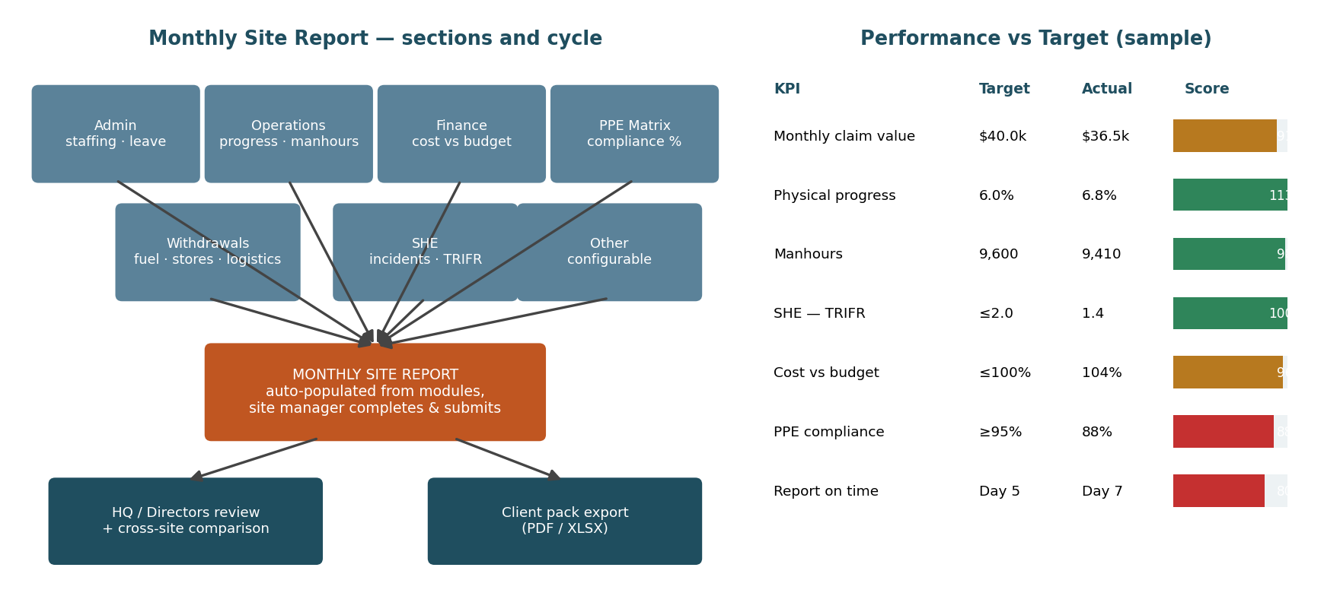
Figure 6 — Monthly site report: sections auto-populated from daily modules (left); performance measured against target with RAG scoring (right).

8.3 The standard sections, explained
Section | What it contains and where the data comes from
Admin | Site headcount and movements, leave taken/planned (HR-lite), attendance summary, disciplinary/HR notes, key correspondence with the client
Operations | Work executed in the month, WBS progress vs plan (§4), manhours worked (timesheets), plant/equipment utilisation and downtime, next month's plan
Finance | Site cost vs budget lines (budgets module), requisitions raised/funded, petty cash summary and reconciliation, claims invoiced for the month vs contract budget (contract variance, main design A.3)
PPE Matrix | Role-based PPE requirements per employee (hard hat, lamp, boots, overalls, respirators…) vs issue register: issue dates, sizes, lifespan/replacement-due dates, condition checks. Compliance % = items in-date and issued ÷ items required; expiring items generate replacement requisitions automatically
Withdrawals | Stores/consumables ledger: fuel, oils, materials, tools drawn from site stores or supplier accounts — quantity and value per draw, per vehicle/equipment where applicable, drawn vs monthly allocation with variance flags (e.g. fuel overdraw investigated)
Logistics | Vehicle movements, deliveries in/out, hires, breakdowns and costs
SHE | Incidents and near misses (with investigations), toolbox talks and drills held, medicals/inductions due, safety statistics (LTIs, TRIFR trend), client SHE requirements status — aligned to the SHE capture flagged in the main design (§16 item 10)
Other | Configurable sections per contract — clients differ in what they demand; admins can add sections and fields without code changes

8.4 Performance vs target
- Targets: each long-contract site carries a KPI set with monthly targets, configured per contract: claim value invoiced, physical progress %, manhours, cost-vs-budget ratio, SHE indicators (e.g. TRIFR ceiling, zero LTIs), PPE compliance %, stores variance, and report timeliness. Targets can step over the contract's life (e.g. higher claim targets in peak construction years).
- Actuals: computed automatically from the same modules that populate the report — no self-marking. Each KPI scores against target with RAG status (green ≥ on-target band, amber within tolerance, red outside), and a weighted site score summarises the month.
- Trends and consequences: 12-month trend charts per KPI; persistent reds escalate to the Operations Director and appear on the Command Centre; site scores feed cross-site comparison so directors see at a glance which long contracts are healthy and which need intervention.
- Contract-life view: because these contracts run 3–7 years, every KPI also accumulates a contract-to-date view — total claimed vs contract value, cumulative progress vs elapsed time, lifetime SHE record — the long-horizon counterpart of the monthly RAG.
As throughout the main design: statutory rates, NEC rules, WHT rates and tax treatments referenced in this document change frequently in Zimbabwe and are implemented as effective-dated configuration to be verified with ZIMRA, NSSA, the NEC and a registered tax practitioner at build time — this document is a system specification, not tax advice.

