Knowledge Guided AI for Sales Data Analysis and Marketing Performance
A Hybrid Forecasting Model
Short Communication
Bharat Kumar Vulugundam
Doctor of Business Administration Program | Affiliation and corresponding-author email to be added

Abstract
Retail sales forecasting systems often encode promotion and calendar information as ordinary variables, leaving the model to rediscover stable commercial structure. This Short Communication proposes a knowledge-guided hybrid in which an explicit store-weekday norm and a bounded, store-specific promotion uplift form an inspectable marketing prior. Histogram gradient boosting learns nonlinear corrections using this prior, calendar signals, store history, and operational indicators; a projection layer prevents negative forecasts and sets closed-store demand to zero. The method was evaluated on 1,017,209 daily records from 1,115 Rossmann stores using three non-overlapping rolling 42-day tests and 365-day training windows. Across folds, the hybrid achieved mean absolute error 659.17, weighted absolute percentage error (WAPE) 11.05%, and RMSPE 15.15%. Relative to data-only AI, WAPE improved by 17.1%; the hybrid produced lower daily WAPE on 84.1% of 126 matched days (one-sided paired Wilcoxon p = 1.03 x 10^-16). Removing promotion knowledge increased WAPE to 11.47%, while removing the hard business-rule projection produced no aggregate benefit for the hybrid. Segment analysis showed gains on promotion, non-promotion, school-holiday, and open-store observations. The contribution is a compact and reproducible mechanism for injecting auditable marketing knowledge into scalable sales prediction, together with evidence identifying which knowledge component adds value.
Keywords: knowledge-guided AI; sales forecasting; marketing performance; hybrid learning; promotion analytics; decision support

1 Introduction
Retail forecasts link operational execution with marketing decisions. A biased forecast can distort inventory, staffing, campaign evaluation, and budget allocation, while an accurate but opaque forecast may be difficult to challenge when promotion plans or store conditions change. Large retail forecasting studies show that tree-based machine-learning systems can exploit cross-series structure and known explanatory variables effectively [1]. Yet accuracy alone does not establish whether a model uses commercially meaningful information in a stable or inspectable way.
Promotion is especially important because it is known before the forecast is issued and can shift the sales-generating process. Promotion forecasting research therefore treats campaign status as more than a passive historical correlate [2,3]. Contemporary multi-horizon models can combine static, observed, and known-future variables [4], but their architectural complexity is not always justified for a focused managerial decision or a short retraining cycle. Informed machine learning offers another route: prior knowledge can enter the learning pipeline explicitly rather than being left entirely implicit in parameters [5].
This study asks whether a transparent marketing prior can improve a compact gradient-boosting forecast. The contribution is threefold. First, it defines a store-weekday norm and bounded promotion uplift that can be inspected independently of the learner. Second, it embeds that prior as an additional knowledge feature while applying explicit feasibility rules after prediction. Third, it separates the contribution of promotion knowledge from the rule projection using rolling-origin evaluation, ablation, paired daily testing, and marketing-segment diagnostics.

2 Knowledge Guided Forecasting Framework

2.1 Knowledge representation
For store s and weekday d, let B(s,d) be the median non-promotion sales observed in the training window. If the store-weekday pair has insufficient history, the estimator falls back to the store median and then the global median. Let U(s) be the ratio between promotional and non-promotional store medians. To limit unstable ratios, U(s) is bounded to [0.8, 2.0]. The knowledge prior for observation i is K(i) = B(s,d)U(s) when a promotion is active and K(i) = B(s,d) otherwise. This representation is deliberately small: each term has a direct managerial interpretation, can be audited, and can be replaced when a firm has better campaign knowledge.
The bound does not assert a universal promotion effect. It regularizes the historical ratio so that a small denominator or sparse campaign history cannot dominate the forecast. The prior is predictive rather than causal: it summarizes observed promotional sales differences and must not be interpreted as incremental campaign lift.

2.2 Hybrid learner and operational projection
The data-only comparator and hybrid use the same histogram gradient-boosting configuration: 160 iterations, learning rate 0.09, 25 terminal leaves, 127 histogram bins, L2 regularization 1.0, and random seed 42. Both models use store identifier, weekday, store sales level, promotion, public holiday, school holiday, month, day, week, and time trend. The hybrid adds log(1 + K(i)) as the only extra feature. Both estimate log(1 + sales), after which predictions are transformed to the original scale.
The post-model projection enforces non-negative sales and zero sales when a store is closed. This step makes operational feasibility explicit. Because the Open variable is already available to the learner, the ablation tests whether the hard projection improves predictive accuracy beyond the learned relationship.
Figure 1. Knowledge-guided forecasting architecture. The marketing prior is an explicit, inspectable feature; operational rules are applied after model prediction.
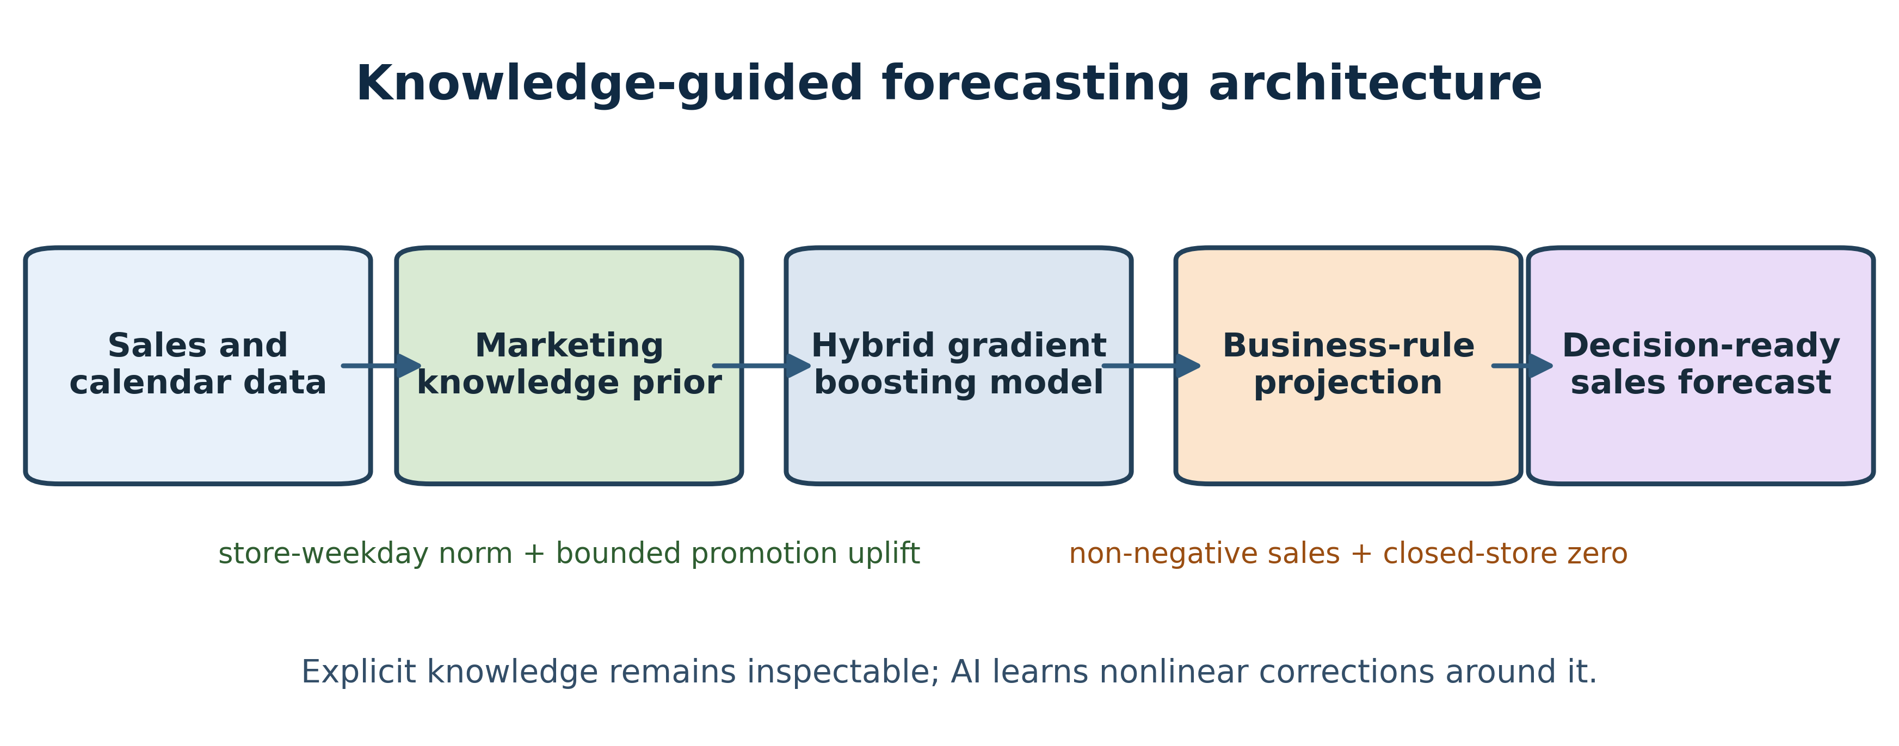

2.3 Relationship to existing approaches
The framework differs from purely data-driven feature engineering because the prior is a complete, separately evaluable forecast. It also differs from post-hoc explanation: the marketing knowledge participates in estimation rather than explaining a completed black-box decision. This follows the informed-learning distinction between embedding knowledge in the learning process and inspecting model behavior afterward [5]. Compared with large sequence models [4,6], the proposed approach sacrifices automatic representation learning for low computational burden, auditability, and rapid recalibration.

3 Experimental Design

3.1 Data and leakage controls
The public Rossmann Store Sales benchmark contains 1,017,209 store-day observations for 1,115 stores from 1 January 2013 through 31 July 2015 [7]. Variables used here are sales, store, date, weekday, store-open status, promotion, public-holiday status, and school-holiday status. Customer count was excluded because it is observed with realized sales and would generally be unavailable when a future forecast is issued. No future sales values, test-period target encodings, or randomly shuffled validation records enter training.
Evaluation uses three consecutive, non-overlapping 42-day test windows: 28 March-8 May, 9 May-19 June, and 20 June-31 July 2015. Each fold uses only the immediately preceding 365 days for estimation. The rolling design exposes the model to changing seasonal and promotional mixtures while preserving temporal order. Together, the folds provide 126 matched forecast days and 140,490 store-day test observations.

3.2 Comparators and ablations
Three principal systems are compared: (i) the explicit knowledge prior without machine learning; (ii) data-only AI with the common feature set; and (iii) hybrid AI with the additional knowledge-prior feature. Two ablations evaluate mechanism claims. The first removes the promotion uplift while retaining the store-weekday norm. The second removes the post-model business-rule projection while retaining promotion knowledge. These comparisons isolate whether the reported gain comes from the marketing representation or the feasibility rules.

3.3 Evaluation and statistical analysis
Mean absolute error (MAE) reports average unit error. WAPE equals the sum of absolute errors divided by realized sales and is the primary measure because it aggregates naturally across stores and is defined when individual observations contain zero sales. RMSPE is calculated only on positive-sales observations to remain comparable with the benchmark convention. Fold means and standard deviations describe temporal stability. For statistical evidence, store-day predictions are aggregated by date, daily WAPE is computed for each model, and a one-sided paired Wilcoxon signed-rank test evaluates whether hybrid daily error is lower than data-only AI. Segment analysis separately examines promotion, non-promotion, school-holiday, and all open-store observations.
Table 1. Rolling-origin forecast performance across three 42-day folds. Values are mean +/- standard deviation; lower is better.
Model | MAE | WAPE % | RMSPE % | WAPE gain
Knowledge prior | 780.08 +/- 89.35 | 13.08 +/- 1.36 | 16.70 +/- 1.30 | 1.9%
Data-only AI | 795.16 +/- 72.80 | 13.33 +/- 0.96 | 20.23 +/- 1.85 | 0.0%
Hybrid AI | 659.17 +/- 62.96 | 11.05 +/- 0.86 | 15.15 +/- 1.61 | 17.1%
Table 1 shows that the hybrid is the only system that improves substantially on both the explicit prior and data-only AI. Its mean WAPE is 11.05%, compared with 13.08% for the knowledge prior and 13.33% for data-only AI. The 17.1% relative WAPE reduction is accompanied by lower MAE and RMSPE, indicating that the gain is not confined to one error definition.

4 Results

4.1 Accuracy and temporal robustness
The hybrid achieved the lowest WAPE in each rolling fold (Figure 2A). Its advantage is therefore not produced by one favorable terminal holdout. At the daily aggregate level, the distribution of paired WAPE differences is predominantly positive (Figure 2B): the hybrid outperformed data-only AI on 106 of 126 days (84.1%). The one-sided Wilcoxon result (statistic 7,376; p = 1.03 x 10^-16) rejects equality in favor of lower hybrid error. This test supports consistency of the advantage across dates; it does not imply independence among stores within a date.
The final-fold trajectory in Figure 2D shows that both learned models capture the dominant weekly closure pattern and demand peaks. The hybrid more closely follows realized daily totals during several high-volume intervals, although both systems overpredict portions of July. This residual pattern suggests that the static promotion ratio cannot fully represent time-varying campaign strength, local events, or demand saturation.
Figure 2. Robustness and marketing-performance diagnostics. Panel A reports WAPE by rolling fold; Panel B shows paired daily WAPE improvements; Panel C reports marketing segments; Panel D compares aggregate sales trajectories in the final fold.
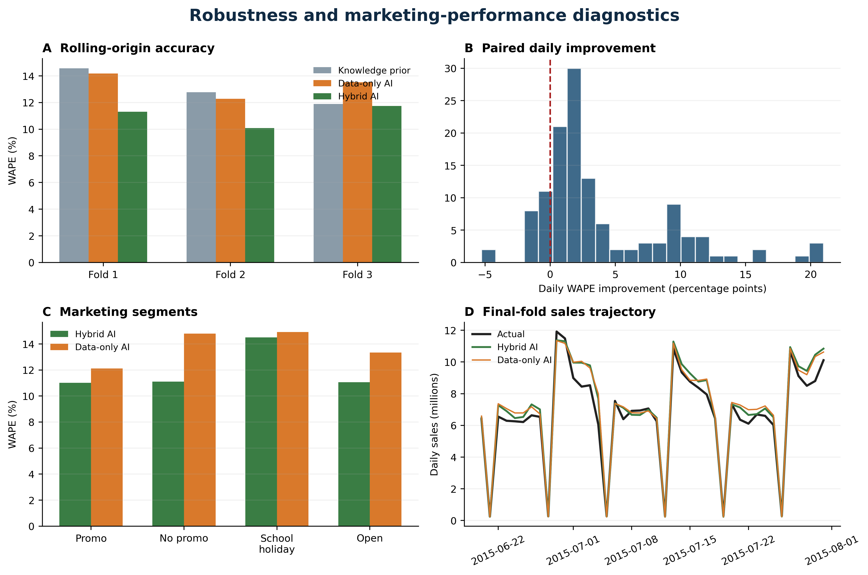

4.2 Marketing-performance segments
The hybrid improved WAPE on all four reported segments (Figure 2C). The largest relative reduction occurred on non-promotion observations, where the explicit store-weekday level appears to stabilize the baseline around which the learner operates. Promotion-day WAPE improved by 9.1%, demonstrating that the model does not obtain its aggregate gain merely from ordinary trading days. School-holiday performance improved by only 2.8% and remained the least accurate segment, revealing that a binary holiday indicator and static store-level uplift do not capture heterogeneous event effects.

4.3 Component Ablation and Mechanism Evidence
Table 2. Component ablations and marketing-segment diagnostics pooled across three rolling folds.
Diagnostic | Hybrid WAPE | Comparator WAPE | Relative gain
Remove promotion knowledge | 11.05% | 11.47% | 3.7%
Remove business rules | 11.05% | 11.01% | -0.4%
Promotion days | 11.01% | 12.12% | 9.1%
Non-promotion days | 11.11% | 14.80% | 24.9%
School holidays | 14.50% | 14.92% | 2.8%
All open days | 11.06% | 13.34% | 17.1%
Removing promotion knowledge increased WAPE from 11.05% to 11.47%, a 3.7% relative deterioration (Table 2). Because the ablated system retains the store-weekday norm, this difference isolates the additional value of the bounded promotion component rather than the whole prior. The result is modest but consistent with the conceptual mechanism: known campaign status changes the expected store-weekday level before the learner adds nonlinear corrections.
The hard business-rule projection did not improve aggregate WAPE: the unprojected variant reached 11.01%, compared with 11.05% for the full hybrid. This does not invalidate the operational rule, because closed-store predictions may still need to be exactly zero for downstream systems. It does show that the Open feature already allows the learner to approximate closure behavior and that hard feasibility can carry a small accuracy cost. Accordingly, the empirical novelty rests on the explicit marketing prior, not on claiming that every rule improves predictive error.

5 Discussion

5.1 Knowledge-based contribution
The study demonstrates a narrow but useful form of knowledge-based AI: an expert-readable forecast is made available to a flexible learner as a structured prior. The model can use, modify, or partially ignore that signal according to the data. This design preserves an audit trail that is difficult to obtain when store identity, promotion, and calendar information are represented only through internal parameters. A manager can inspect the store-weekday norm, review the inferred promotion ratio, change its bound, or substitute an approved campaign estimate without redesigning the learner.
The result also clarifies what knowledge guidance does not mean. The promotion ratio is not a causal treatment effect, and the hybrid does not estimate return on marketing investment. It predicts sales under observed promotional patterns. A causal extension would require assumptions about assignment, price, media, competitor actions, and unobserved demand shocks. The present framework instead addresses predictive decision support: whether an explicit commercial prior improves out-of-time accuracy and remains interpretable.

5.2 Managerial implications
For practitioners, the principal benefit is modularity. The prior can be produced from a database view, reviewed by marketing analysts, versioned, and supplied to the forecast engine. The learned correction then captures nonlinear interactions without erasing the business baseline. Segment diagnostics should accompany aggregate accuracy because a model used for campaign planning can appear strong overall while failing specifically on promotion or event days. The weak school-holiday gain observed here illustrates this risk.
The computational design is intentionally modest. Histogram boosting has demonstrated value on large retail forecasting problems [1], and the single-model cross-store approach avoids maintaining one model per store. Reproducibility is strengthened by a fixed seed, documented windows, explicit exclusions, one-command execution, and code-generated tables and figures.

6 Limitations and Future Work
First, the benchmark represents one retailer and an historical period; the results should not be generalized to different retail formats without external validation. Second, the data identify promotion status but not depth, channel, creative, price elasticity, media exposure, competitor activity, inventory availability, or campaign cost. These omissions restrict both predictive completeness and marketing interpretation. Third, the 365-day training window was selected as an operationally plausible design choice rather than optimized against a broad hyperparameter grid.
Fourth, the statistical test uses paired daily aggregate errors. This avoids treating hundreds of stores on the same date as independent, but temporal dependence can remain across adjacent days. Block bootstrap intervals or forecast-comparison tests with explicit autocorrelation correction would provide additional robustness. Fifth, the knowledge prior uses medians and a fixed uplift bound. Hierarchical shrinkage, uncertainty-aware priors, campaign-specific effects, and store clusters may yield better calibrated knowledge.
Future work should compare the same prior across LightGBM, CatBoost, temporal fusion transformers, and probabilistic forecasting methods; report prediction intervals; and test whether the explicit prior improves calibration and decision utility rather than point accuracy alone. A particularly valuable extension would connect forecast error to inventory cost, promotion profitability, or service level. Causal methods should be introduced only when treatment assignment and confounding can be defended.

7 Conclusion
This Short Communication introduced a reproducible knowledge-guided sales forecaster that exposes a store-weekday norm and bounded promotion uplift to gradient boosting. Across three rolling 42-day tests, the hybrid reduced WAPE by 17.1% relative to data-only AI, won on 84.1% of matched days, and improved all reported marketing segments. Ablation localized the incremental value to promotion knowledge, while the hard operational projection did not improve aggregate accuracy. The findings support a restrained conclusion: explicit marketing knowledge can improve compact sales prediction when it is encoded as an auditable prior, evaluated out of time, and tested independently from the learner and its business rules.

Data Availability
The Rossmann Store Sales data are available from Kaggle [7]. The companion repository contains executable code that downloads the public benchmark, recreates all rolling experiments, and generates the two tables and two figures using fixed settings. The source dataset is not redistributed.

Declaration of Competing Interest
The author declares no known competing financial interests or personal relationships that could have appeared to influence this work.

Declaration of Generative AI and AI Assisted Technologies
During preparation of this manuscript, the author used OpenAI Codex to support code development, language drafting, editing, organization, and document formatting. The author reviewed and edited all outputs, verified the executable results, and takes full responsibility for the content of the article.

Funding
This research did not receive any specific grant from funding agencies in the public, commercial, or not-for-profit sectors.

CRediT Authorship Contribution Statement
Bharat Kumar Vulugundam: Conceptualization, Methodology, Software, Formal analysis, Validation, Investigation, Data curation, Visualization, Writing - original draft, Writing - review and editing.

References
[1] S. Makridakis, E. Spiliotis, V. Assimakopoulos, M5 accuracy competition: Results, findings, and conclusions, Int. J. Forecast. 38 (2022) 1346-1364. https://doi.org/10.1016/j.ijforecast.2021.11.013.
[2] S. Gabel, D. Guhl, D. Klapper, Joint in-season and out-of-season promotion demand forecasting in a retail environment, J. Retail. 97 (2021) 726-745. https://doi.org/10.1016/j.jretai.2021.01.003.
[3] M. Trusov, A.V. Bodapati, L.G. Cooper, Retailer promotion planning: Improving forecast accuracy and interpretability, Dir. Mark. 20 (2006) 181-203. https://doi.org/10.1002/dir.20068.
[4] B. Lim, S.O. Arik, N. Loeff, T. Pfister, Temporal Fusion Transformers for interpretable multi-horizon time series forecasting, Int. J. Forecast. 37 (2021) 1748-1764. https://doi.org/10.1016/j.ijforecast.2021.03.012.
[5] L. von Rueden et al., Informed machine learning - A taxonomy and survey of integrating prior knowledge into learning systems, IEEE Trans. Knowl. Data Eng. 35 (2023) 614-633. https://doi.org/10.1109/TKDE.2021.3079836.
[6] X. Qi, K. Hou, T. Liu, Z. Yu, S. Hu, W. Ou, From known to unknown: Knowledge-guided Transformer for time-series sales forecasting in Alibaba, arXiv:2109.08381 (2021). https://doi.org/10.48550/arXiv.2109.08381.
[7] Kaggle, Rossmann Store Sales: Forecast sales using store, promotion, and competitor data, 2015. https://www.kaggle.com/competitions/rossmann-store-sales.
[8] J.H. Friedman, Greedy function approximation: A gradient boosting machine, Ann. Stat. 29 (2001) 1189-1232. https://doi.org/10.1214/aos/1013203451.
[9] F. Pedregosa et al., Scikit-learn: Machine learning in Python, J. Mach. Learn. Res. 12 (2011) 2825-2830.
[10] R.J. Hyndman, A.B. Koehler, Another look at measures of forecast accuracy, Int. J. Forecast. 22 (2006) 679-688. https://doi.org/10.1016/j.ijforecast.2006.03.001.
[11] C. Rudin, Stop explaining black box machine learning models for high stakes decisions and use interpretable models instead, Nat. Mach. Intell. 1 (2019) 206-215. https://doi.org/10.1038/s42256-019-0048-x.
[12] A. Willard, X. Jia, S. Xu, M. Steinbach, V. Kumar, Integrating physics-based modeling with machine learning: A survey, Nat. Rev. Phys. 4 (2022) 123-138. https://doi.org/10.1038/s42254-021-00314-5.

