**Sales for Retail and Food Services in U.S.A.**

**1)Top-performing industries in terms of sales for a year 2021, and how do their sales compare month-over-month?**

WITH monthly_sales AS (

SELECT

year,

month,

industry,

SUM(sales) AS total_sales

FROM

retail_sales

WHERE

year = 2021

GROUP BY

year,

month,

industry

),

top_industries AS (

SELECT

year,

month,

industry,

total_sales,

RANK() OVER (PARTITION BY year, month ORDER BY total_sales DESC) AS industry_rank

FROM

monthly_sales

)

SELECT

year,

month,

industry,

total_sales

FROM

top_industries

WHERE

industry_rank = 1

ORDER BY

year,

month;

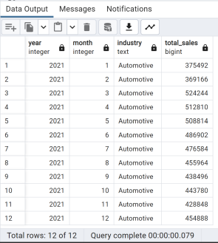

**2)Top-performing industries in terms of sales for a year 2022, and how do their sales compare month-over-month?**

WITH monthly_sales AS (

SELECT

year,

month,

industry,

SUM(sales) AS total_sales

FROM

retail_sales

WHERE

year = 2022

GROUP BY

year,

month,

industry

),

top_industries AS (

SELECT

year,

month,

industry,

total_sales,

RANK() OVER (PARTITION BY year, month ORDER BY total_sales DESC) AS industry_rank

FROM

monthly_sales

)

SELECT

year,

month,

industry,

total_sales

FROM

top_industries

WHERE

industry_rank = 1

ORDER BY

year,

month;

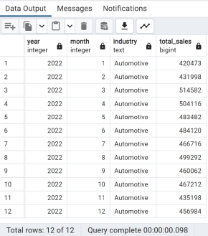

**3)Top-performing industries in terms of sales for a year 2020, and how do their sales compare month-over-month?**

WITH monthly_sales AS (

SELECT

year,

month,

industry,

SUM(sales) AS total_sales

FROM

retail_sales

WHERE

year = 2020

GROUP BY

year,

month,

industry

),

top_industries AS (

SELECT

year,

month,

industry,

total_sales,

RANK() OVER (PARTITION BY year, month ORDER BY total_sales DESC) AS industry_rank

FROM

monthly_sales

)

SELECT

year,

month,

industry,

total_sales

FROM

top_industries

WHERE

industry_rank = 1

ORDER BY

year,

month;

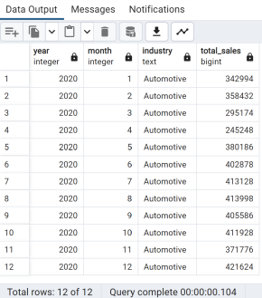

**4)Top-performing industries in terms of sales for a year 2019, and how do their sales compare month-over-month?**

WITH monthly_sales AS (

SELECT

year,

month,

industry,

SUM(sales) AS total_sales

FROM

retail_sales

WHERE

year = 2019

GROUP BY

year,

month,

industry

),

top_industries AS (

SELECT

year,

month,

industry,

total_sales,

RANK() OVER (PARTITION BY year, month ORDER BY total_sales DESC) AS industry_rank

FROM

monthly_sales

)

SELECT

year,

month,

industry,

total_sales

FROM

top_industries

WHERE

industry_rank = 1

ORDER BY

year,

month;

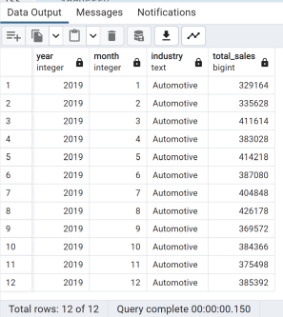

**5) Which specific kind of businesses contribute the most to total sales, and how does their performance vary across industries?**

SELECT

kind_of_business,

industry,

SUM(sales) AS total_sales

FROM

retail_sales

GROUP BY

kind_of_business,

industry

ORDER BY

total_sales DESC;

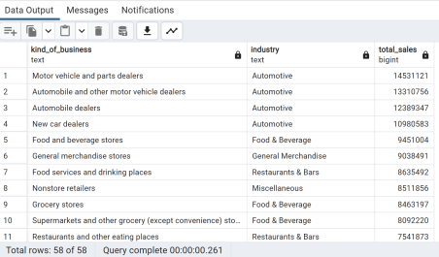

**6) Is there any seasonality in sales for specific industries, and how do they perform month-over-month?**

SELECT

industry,

year,

month,

SUM(sales) AS total_sales

FROM

retail_sales

GROUP BY

year,

industry,

month

ORDER BY

year,

industry,

month;

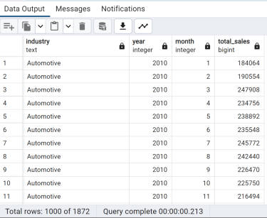

**7) How does the sales distribution vary among industries based on their North American Industry Classification System (NAICS) codes?**

SELECT

naics_code,

industry,

SUM(sales) AS total_sales

FROM

retail_sales

GROUP BY

naics_code,

industry

ORDER BY

naics_code,

total_sales DESC;

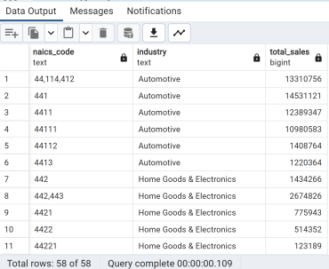

**8) Are there any outliers or significant changes in sales for specific industries during particular months or years?**

SELECT

industry,

year,

month,

sales

FROM

retail_sales

WHERE

(industry, year, month) IN (

SELECT

industry,

year,

month

FROM (

SELECT

industry,

year,

month,

sales,

LAG(sales) OVER (PARTITION BY industry ORDER BY year, month) AS prev_sales,

LEAD(sales) OVER (PARTITION BY industry ORDER BY year, month) AS next_sales

FROM

retail_sales

) AS sales_analysis

WHERE

sales > 1.5 * COALESCE(prev_sales, 0) OR sales > 1.5 * COALESCE(next_sales, 0) )

ORDER BY

industry,

year,

month;

**9)Which businesses all-time average sale was above 10 billiondollars?**

SELECT

kind_of_business,

AVG(sales) AS average_sale

FROM

retail_sales

GROUP BY

kind_of_business

HAVING

AVG(sales) > 10000; *-- 10 billion dollars in cents (1 dollar = 100 cents)*

**10)Which kind of businesses within the automotive industry had the highest sales revenue for 2022?**

SELECT

kind_of_business,

SUM(sales) AS total_sales

FROM

retail_sales

WHERE

industry = 'Automotive' AND year = 2022

GROUP BY

kind_of_business

ORDER BY

total_sales DESC ;

**11)What is the contribution percentage of each business in the automotive industry this year?**

WITH automotive_sales AS (

SELECT

kind_of_business,

SUM(sales) AS total_sales

FROM

retail_sales

WHERE

industry = 'Automotive' AND

year = 2022

GROUP BY

kind_of_business

),

total_sales_automotive AS (

SELECT

SUM(sales) AS total_sales_automotive

FROM

retail_sales

WHERE

industry = 'Automotive' AND

year = 2022

)

SELECT

kind_of_business,

ROUND((total_sales / total_sales_automotive.total_sales_automotive) * 100, 2) AS contribution_percentage

FROM

automotive_sales

CROSS JOIN

total_sales_automotive;

with total_sales as(select year, industry, sum(sales) as sales_sum

from retail_sales

GROUP BY 1,2)

SELECT curr.industry, prev.year as previous_year, curr.year as current_year, (curr.sales_sum - prev.sales_sum) / prev.sales_sum * 100 as YoY

from total_sales as curr

join total_sales as prev

on curr.year=prev.year+1 AND curr.industry=prev.industry

ORDER BY industry, curr.year DESC;

**12 )What are the year-over-year growth rates for each industry per year?** with total_sales as(select year, industry, sum(sales) as sales_sum

from retail_sales

GROUP BY 1,2)

SELECT curr.industry, prev.year as previous_year, curr.year as current_year, (curr.sales_sum - prev.sales_sum) / prev.sales_sum * 100 as YoY

from total_sales as curr

join total_sales as prev

on curr.year=prev.year+1 AND curr.industry=prev.industry

ORDER BY industry, curr.year DESC;

*--OR--*

SELECT

year,

industry,

(sales - LAG(sales) OVER (PARTITION BY industry ORDER BY year)) / LAG(sales) OVER (PARTITION BY industry ORDER BY year) * 100 AS growth_rate FROM

retail_sales

ORDER BY

industry, year;

**13)What are the yearly total sales for women's clothing stores and men's clothing stores?**

SELECT

year,

sum(CASE WHEN kind_of_business = 'Women''s clothing stores' THEN sales ELSE 0 END) as women_sales,

sum(CASE WHEN kind_of_business = 'Men''s clothing stores' THEN sales ELSE 0 END) as men_sales

FROM

retail_sales

GROUP BY

year;

**14)What is the yearly ratio of total sales for women's clothing stores to total sales for men's clothing stores?**

SELECT year, women_sales/men_sales as Women_to_Men_ratio

FROM (

SELECT year,

sum(CASE WHEN kind_of_business = 'Women''s clothing stores' THEN sales ELSE 0 END) as women_sales,

sum(CASE WHEN kind_of_business = 'Men''s clothing stores' THEN sales ELSE 0 END) as men_sales

FROM retail_sales

GROUP BY 1

) subquery;

**15)What is the year-to-date total sale of each month for 2019, 2020, 2021, and 2022 for the women’s clothing stores?**

SELECT

rs.month,

rs.year,

rs.sales,

(

(

SELECT SUM(sales)

FROM retail_sales rs2

WHERE rs2.year = rs.year

AND rs2.month <= rs.month

AND rs2.kind_of_business = 'Women\'s clothing stores'

)

) AS ytd_sales

FROM

retail_sales AS rs

WHERE

rs.kind_of_business = 'Women\'s clothing stores'

AND rs.year IN (2019, 2020, 2021, 2022);

**16)What is the month-over-month growth rate of women’s clothing businesses in 2022?**

*-- Query 1*

SELECT

month,

sales AS current_sales,

*-- now we want the sales from 1 previous period*

LAG(sales, 1) OVER (ORDER BY month) AS prev_sales

FROM

retail_sales

WHERE

kind_of_business = 'Women\'s clothing stores'

AND year = 2022;

*-- Query 2*

SELECT

month,

sales AS current_sales,

LAG(sales, 1) OVER (ORDER BY month) AS prev_sales,

(sales - LAG(sales, 1) OVER (ORDER BY month)) / LAG(sales, 1) OVER (ORDER BY month) * 100 AS growth_rate

FROM

retail_sales

WHERE

kind_of_business = 'Women\'s clothing stores'

AND year = 2022;