Nursery Management System
Application Blueprint & Database Schematic

Version 1.0 · June 2026

1. Application Overview
The Nursery Management System is a full-stack web application built on Next.js 15 (Pages Router) with TypeScript and Supabase (PostgreSQL). It covers the complete operational lifecycle of a plant nursery: from seeding and growing through pest monitoring, inventory, customer reservations, and dispatch.
The application is role-based (admin, manager, staff, viewer) and enforces permissions both in the UI layer (usePermissions hook) and at the database level (role_permissions table).

Technology Stack
Layer | Technology
Frontend Framework | Next.js 15 (Pages Router) + TypeScript
UI Components | shadcn/ui (Radix UI primitives) + Tailwind CSS
Backend / Database | Supabase (PostgreSQL 15)
Authentication | Supabase Auth with custom profiles table
Charts | Recharts + Chart.js
Forms | React Hook Form + Zod
Drag & Drop | dnd-kit
PDF / Print | jsPDF + html2canvas + browser print API
Payments | Stripe

2. Pages & Modules
Route | Module | Description
/ | Auth | Login page with first-time admin initialisation
/dashboard | Dashboard | Live KPI metrics: active batches, harvests, reservations, locations
/plantings | Growing | Manage all plant batches — location, quantity, status, dates
/locations | Growing | Greenhouse zones with capacity and occupancy tracking
/plant-types | Growing | Species catalogue with pricing, growth duration, germination rates
/harvests | Harvest | Log harvests + Dispatch Slips tab (pending/fulfilled/cancelled)
/harvests/bulk | Harvest | Bulk-harvest multiple batches simultaneously
/treatments | Care | Record chemical/biological treatments per batch
/scouting | Care | Pest, disease & nutrient monitoring reports
/inventory | Stock | Supplies, current stock, low-stock alerts, transaction history
/reservations | Sales | Customer pre-orders with payment and collection tracking
/production/bom | Production | Bill of Materials templates with cost breakdowns
/production/calculator | Production | Chemical/nutrient EC mix calculator
/reports/* | Reports | 7 reports: yields, upcoming harvests, customer availability, location utilisation, movement analysis
/admin/user-management | Admin | Create/edit users and assign roles
/admin/roles-permissions | Admin | Configure per-role CRUD permission matrix
/settings/* | Settings | Inventory categories, scouting types, production config

3. Service Layer
All database access goes through typed service files in src/services/. No raw queries appear in page components. Each service maps to one or more Supabase tables and exposes typed async functions.
Service File | Responsibility
authService.ts | Login, logout, profile management, password reset
plantingService.ts | CRUD for plantings, batch tracking, remaining quantity
harvestService.ts | Harvest recording, validation against reservations, bulk harvests
locationService.ts | Location CRUD, capacity and occupancy tracking
plantTypeService.ts | Species/variety catalogue management
treatmentService.ts | Treatment logging, planting associations
scoutingService.ts | Scouting reports + pest/disease/nutrient findings
reservationService.ts | Customer reservations, payment status, quantity management
inventoryService.ts | Stock CRUD, low-stock alerts, transaction history
inventorySettingsService.ts | Inventory category and unit configuration
scoutingSettingsService.ts | Pest/disease/nutrient type configuration
rolePermissionService.ts | Role-permission matrix, CRUD access control
adminService.ts | Admin user operations, system initialisation
bomService.ts | BOM template management, cost calculations
chemicalCalculatorService.ts | EC/nutrient solution calculations
dispatchSlipService.ts | Dispatch slip creation, auto-fulfilment, print support

4. Database Tables — Complete Field Reference
4.1 Core Growing Tables
Table | Key Fields | References
plant_types | id, name, variety, growth_duration, germination_rate, default_selling_price | —
locations | id, name, type, capacity, current_occupancy | —
plantings | id, batch_number, date_planted, expected_harvest_date, quantity, remaining_quantity, status, selling_price | plant_types, locations
harvests | id, harvest_date, quantity_harvested, quality, status, is_closed, notes | plantings
reservations | id, customer_name, customer_phone, customer_email, quantity_reserved, payment_status, collection_date, final_quantity, total_amount | plantings
dispatch_slips | id, quantity_requested, dispatch_date, customer_name, destination, status (pending|fulfilled|cancelled) | plantings, harvests
treatments | id, name, type, dosage, application_method, application_date, applied_by, planting_ids[] | —
planting_treatments | planting_id, treatment_id (junction) | plantings, treatments
planting_bom_costs | id, estimated_*/actual_* costs per category, cost_variance | plantings (1:1)

4.2 Scouting Tables
Table | Key Fields | References
scouting_reports | id, scouting_date, scout_name, crop_type, greenhouse_location, overall_health_rating, weather_conditions | plantings, profiles
scouting_pests | id, pest_name, severity, percent_trays_affected, action_required, distribution_pattern | scouting_reports
scouting_diseases | id, disease_name, severity, percent_trays_affected, recommended_action | scouting_reports
scouting_nutrients | id, symptom, suspected_deficiency, severity, percent_affected | scouting_reports
scouting_pest_types | id, name, is_active, display_order | —
scouting_disease_types | id, name, is_active, display_order | —
scouting_nutrient_types | id, name, is_active, display_order | —
scouting_actions | id, name, category, is_active, display_order | —

4.3 Production & BOM Tables
Table | Key Fields | References
bom_templates | id, name, base_batch_size, estimated_success_rate, target_selling_price, status | plant_types, profiles
bom_items | id, item_type, quantity_value, quantity_formula, custom_name, custom_unit | bom_templates, bom_categories, inventory_items
bom_categories | id, name, color, sort_order | —
bom_headers | id, name, product_name, version, status | —
formula_templates | id, name, formula, variables[] | —
chemical_products | id, name, type, form, ec_factor, npk_n/p/k, min/max/recommended_concentration | inventory_items
saved_mixes | id, concentration, water_volume, calculated_ec, target_ec, applied_to_planting_ids[] | chemical_products, profiles

4.4 Inventory Tables
Table | Key Fields | References
inventory_items | id, name, current_stock, minimum_stock, unit_price, category, unit_of_measure | —
inventory_categories | id, name, color, description | —
inventory_units | id, name, abbreviation, type | —
inventory_suppliers | id, name, contact_person, email, phone, address | —
stock_transactions | id, transaction_type, quantity, unit_price, total_cost, reference_type, reference_id | inventory_items, profiles

4.5 Access Control Tables
Table | Key Fields | References
profiles | id, full_name, email, username, role (admin|manager|staff|viewer), avatar_url | —
permissions | id, module, action, resource, description | —
role_permissions | id, role, can_create, can_read, can_update, can_delete | permissions
user_permissions | id, user_id, can_create, can_read, can_update, can_delete | profiles, permissions
password_history | id, user_id, password_hash, created_at | —

5. UML Entity-Relationship Diagrams
The following diagrams show all foreign-key relationships between tables. Blue boxes are primary entities, blue-shaded boxes are central hubs, green boxes are lookup/configuration tables, and amber boxes are junction or feature tables.

5.1 Core Growing Chain
plant_types and locations feed into plantings, which is the central hub for harvests, reservations, and dispatch slips.
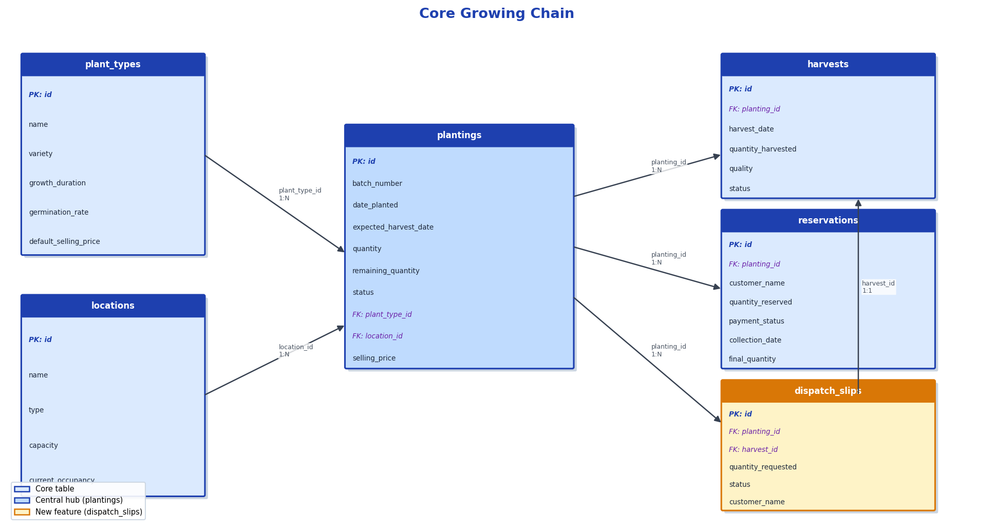

5.2 Scouting System
scouting_reports links to plantings and spawns three child finding tables (pests, diseases, nutrients) and four configurable lookup lists.
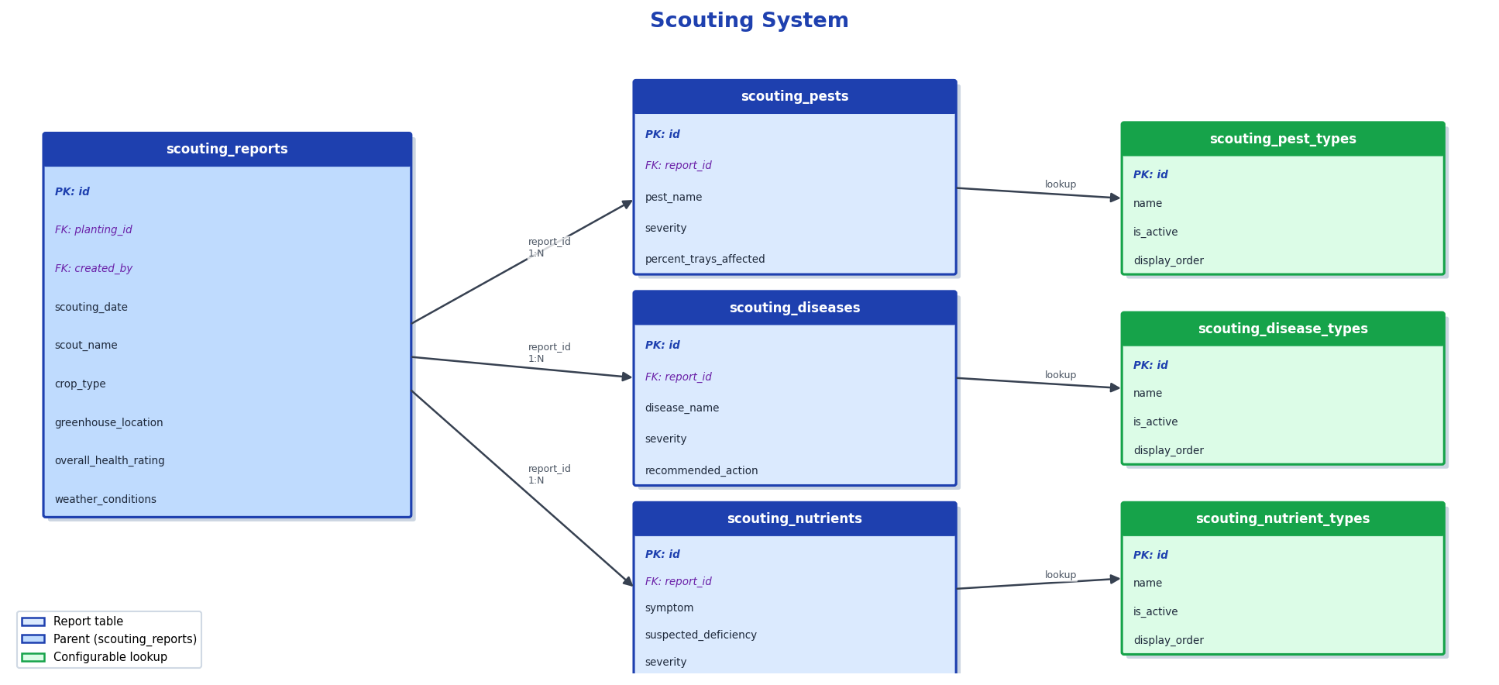

5.3 Production / BOM Chain
bom_templates connect plant types to costed item lists (bom_items) and track estimated vs actual spend per planting (planting_bom_costs).
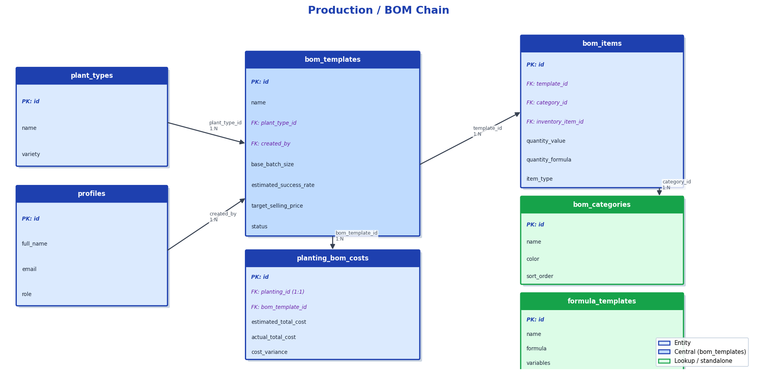

5.4 Inventory & Chemical Chain
inventory_items is the central stock table. stock_transactions provides an audit trail; chemical_products and saved_mixes support the nutrient calculator.
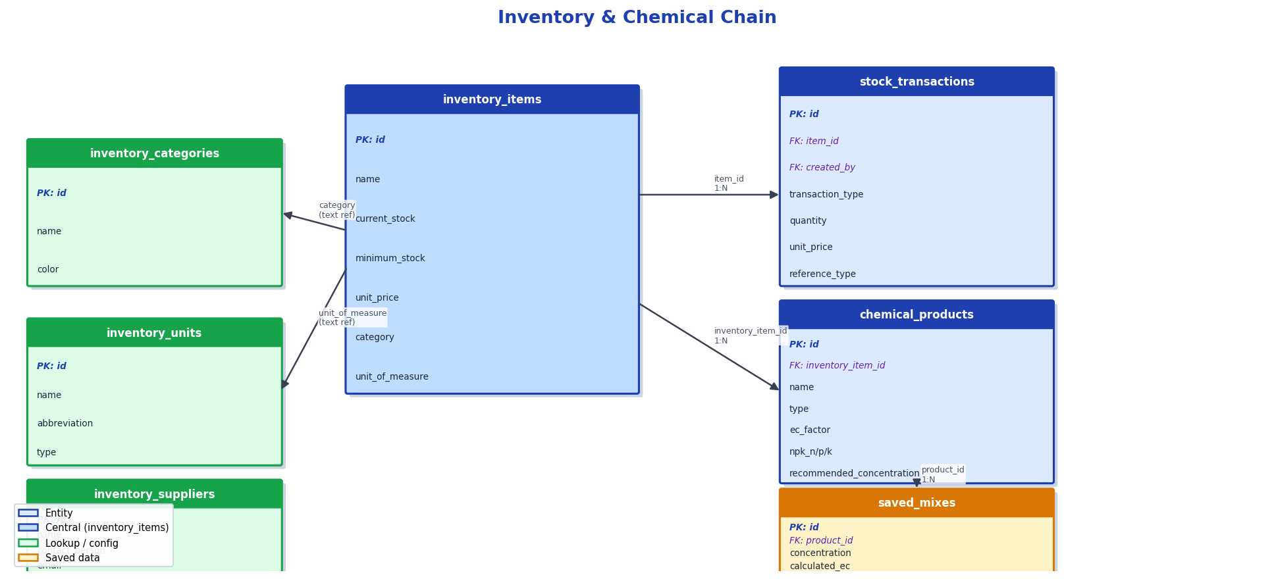

5.5 Access Control & Permissions
profiles holds every user and their role. The permissions table defines per-module actions; role_permissions sets defaults per role while user_permissions allows individual overrides.
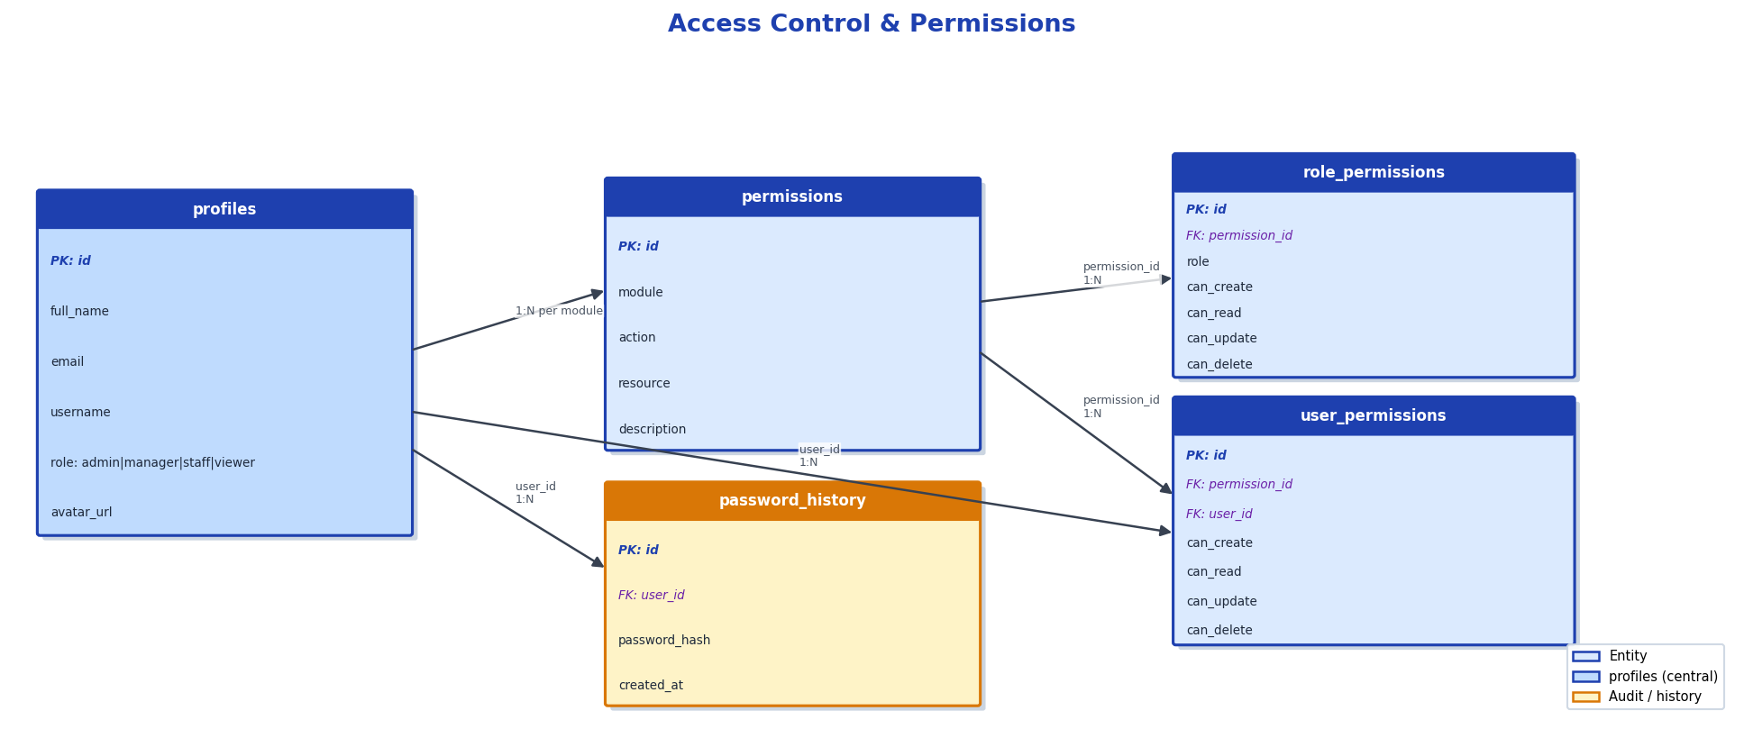

6. Full Relationship Summary
Child Table | Parent Table | Foreign Key | Cardinality
plantings | plant_types | plant_type_id | N:1
plantings | locations | location_id | N:1
harvests | plantings | planting_id | N:1
reservations | plantings | planting_id | N:1
dispatch_slips | plantings | planting_id | N:1
dispatch_slips | harvests | harvest_id | 1:1
planting_treatments | plantings | planting_id | M:N junction
planting_treatments | treatments | treatment_id | M:N junction
planting_bom_costs | plantings | planting_id | 1:1
scouting_reports | plantings | planting_id | N:1 (optional)
scouting_reports | profiles | created_by | N:1
scouting_pests | scouting_reports | report_id | N:1
scouting_diseases | scouting_reports | report_id | N:1
scouting_nutrients | scouting_reports | report_id | N:1
bom_templates | plant_types | plant_type_id | N:1
bom_templates | profiles | created_by | N:1
bom_items | bom_templates | template_id | N:1
bom_items | bom_categories | category_id | N:1
bom_items | inventory_items | inventory_item_id | N:1
chemical_products | inventory_items | inventory_item_id | N:1
saved_mixes | chemical_products | product_id | N:1
saved_mixes | profiles | created_by | N:1
stock_transactions | inventory_items | item_id | N:1
stock_transactions | profiles | created_by | N:1
role_permissions | permissions | permission_id | N:1
user_permissions | permissions | permission_id | N:1
user_permissions | profiles | user_id | N:1

7. Role Permissions Matrix
Module | Admin | Manager | Staff | Viewer
Plantings | CRUD | CRU | CRU | R
Locations | CRUD | CRU | R | R
Plant Types | CRUD | CRU | R | R
Harvests | CRUD | CRU | CRU | R
Dispatch Slips | CRUD | CRU | CRU | R
Treatments | CRUD | CRU | CRU | R
Scouting | CRUD | CRU | CRU | R
Inventory | CRUD | CRU | CRU | R
Reservations | CRUD | CRU | CRU | R
Production | CRUD | CRU | R | R
Reports | CRUD | R | R | R
Admin | CRUD | — | — | —
Settings | CRUD | CRU | — | —

C = Create · R = Read · U = Update · D = Delete

