Nursery Management App
Business Process Flow Diagrams
This document describes how each module interacts with others through end-to-end business processes. Each flow diagram uses the following shape conventions:
Green oval = Start/End | Blue rectangle = Process step | Orange diamond = Decision | Purple parallelogram = Data I/O | Teal = System action

1. System Setup & Onboarding
Before any nursery operations can begin, the system must be configured with reference data — locations, plant types, inventory items, and user accounts. This flow shows the one-time setup sequence performed by an Admin.

Flow 1 – System Setup & Onboarding
Admin configures all reference data before operational modules are used. If any data is missing, the loop returns to fill gaps.
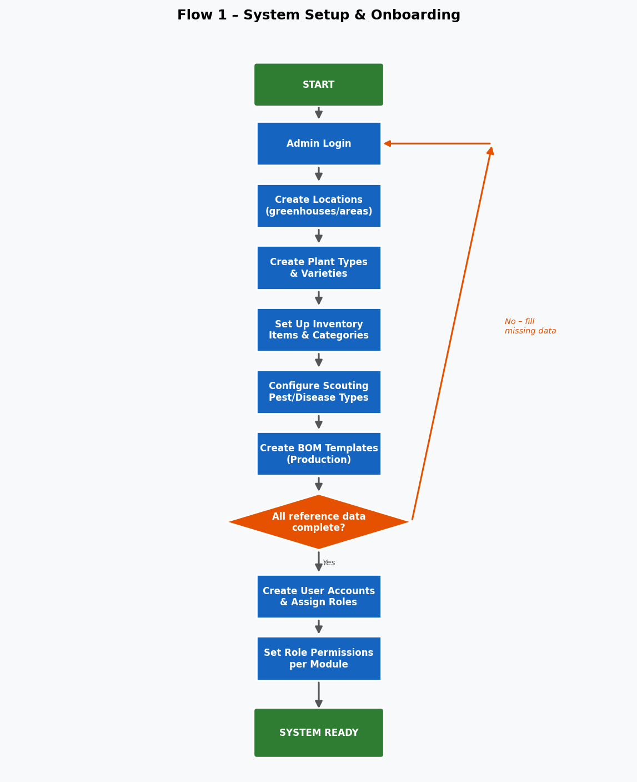

2. Planting Lifecycle
A planting batch is the core operational unit. It links plant types, locations, inventory (seeds), reservations, scouting reports, treatments, and harvests. This flow covers creation through to harvest-readiness.

Flow 2 – Planting Lifecycle
Planting creation optionally deducts seeds from inventory, auto-generates a batch number, and checks for existing reservations. The batch is then monitored via scouting and treatments until harvest.
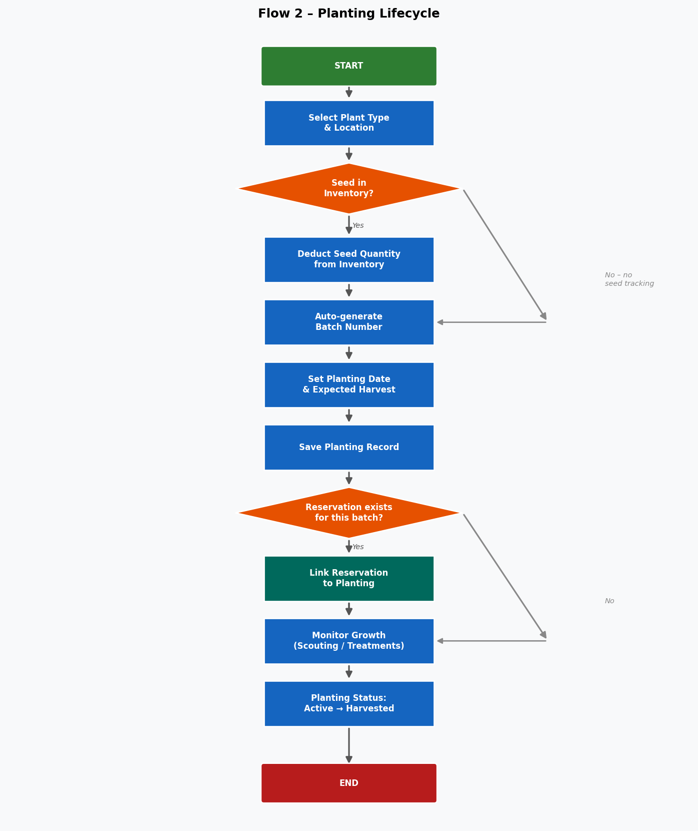

3. Harvest & Dispatch Slip
Two parallel paths exist for moving stock out of the nursery: a direct Harvest Record (used internally) and a Dispatch Slip (used by the dispatch team). The dispatch slip auto-creates a harvest if stock is available, or saves as pending for later fulfilment.

Flow 3 – Harvest & Dispatch Slip
Left lane: standard harvest creation with reservation conflict handling. Right lane: dispatch slip flow — auto-fulfilled if stock exists, saved as pending otherwise. Pending slips can be edited and fulfilled later.
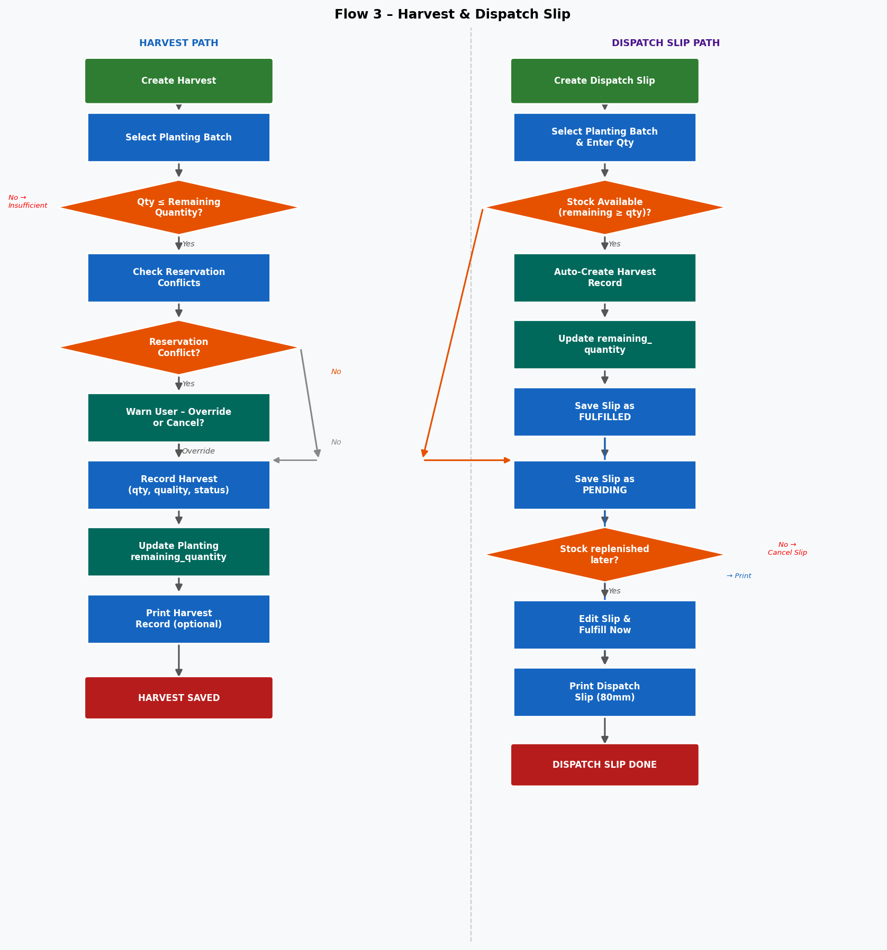

4. Reservation Management
Reservations allow customers to reserve seedlings from one or more planting batches before harvest. The system tracks availability in real time and prevents over-reservation. Completion records actual delivery quantities.

Flow 4 – Reservation Management
Customers can reserve across multiple batches. Each batch gets its own reservation record. On completion, actual delivered quantity is recorded and deducted from the planting's remaining quantity.
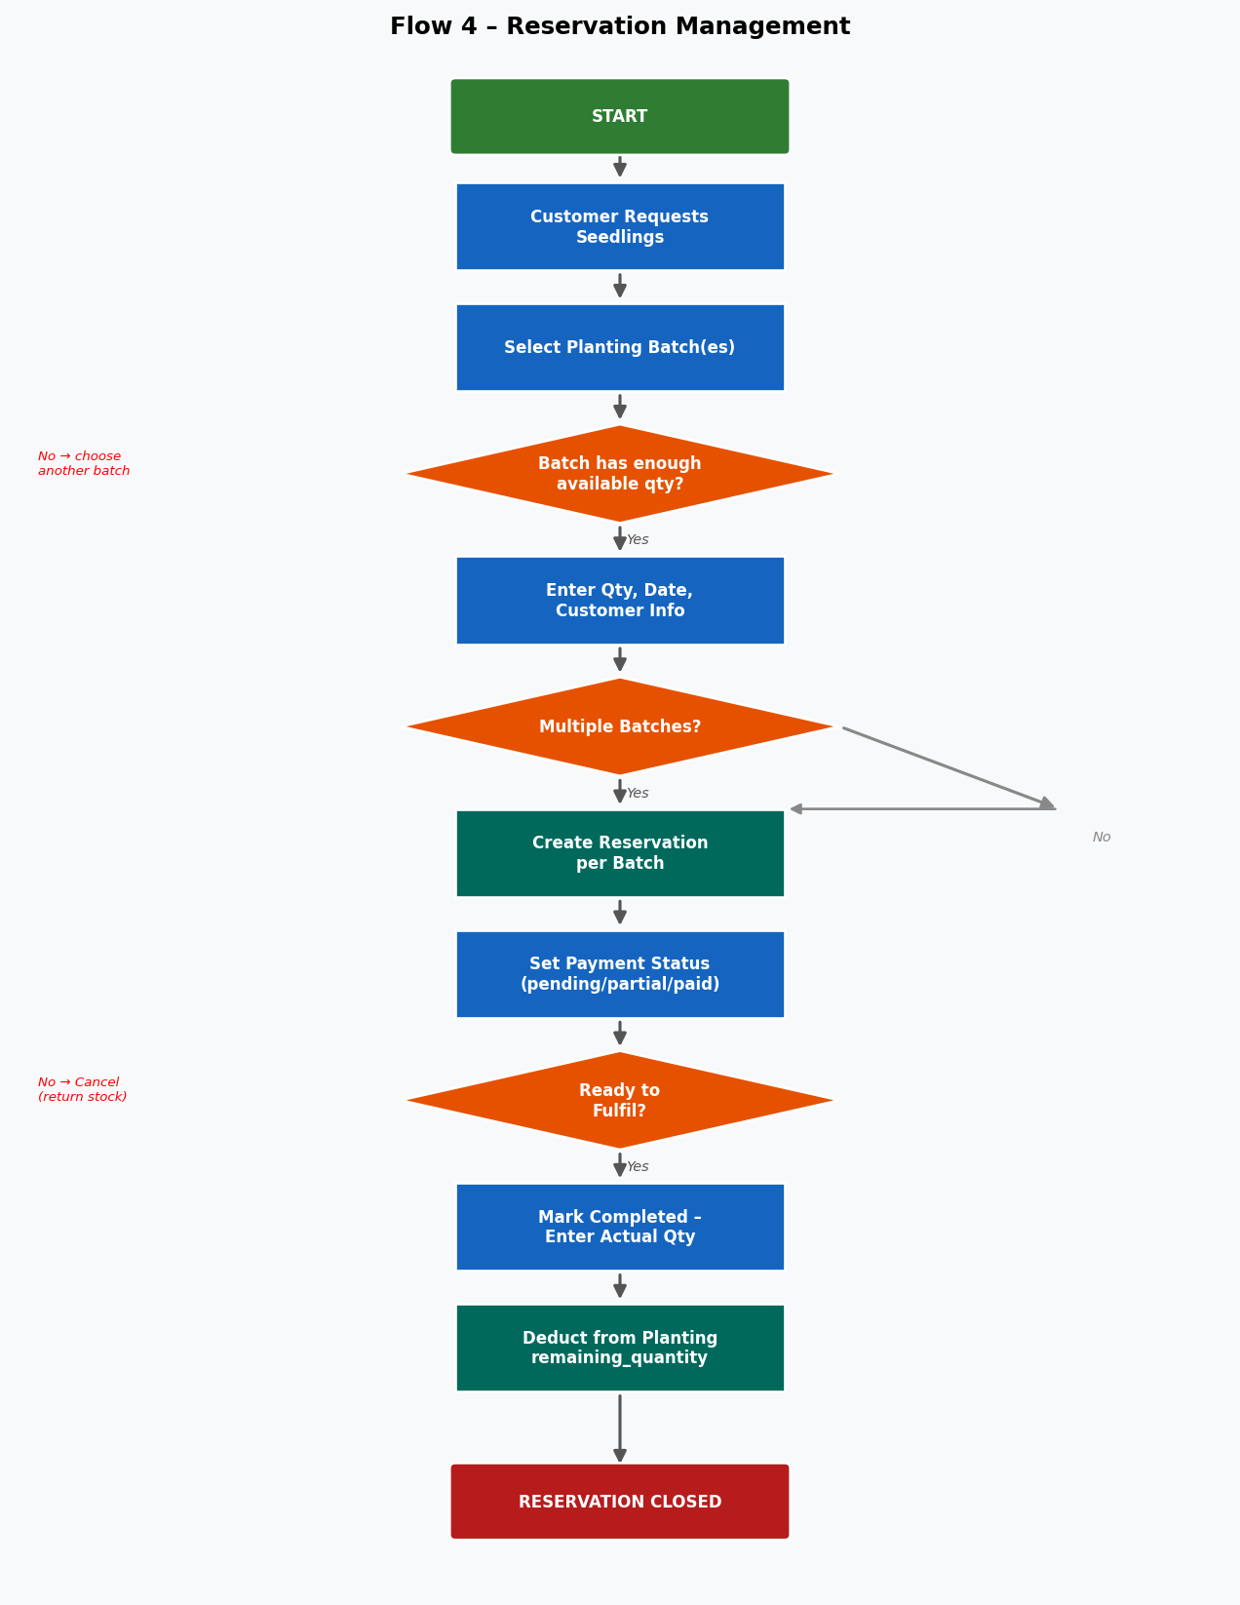

5. Inventory Management
Inventory tracks chemicals, fertilisers, seeds, and supplies. Stock can be updated manually (purchase, usage, adjustment, waste) or automatically when a planting batch is created using seeds.

Flow 5 – Inventory Management
Left lane: manual stock transactions with low-stock alerts. Right lane: automatic seed deduction triggered by planting creation.
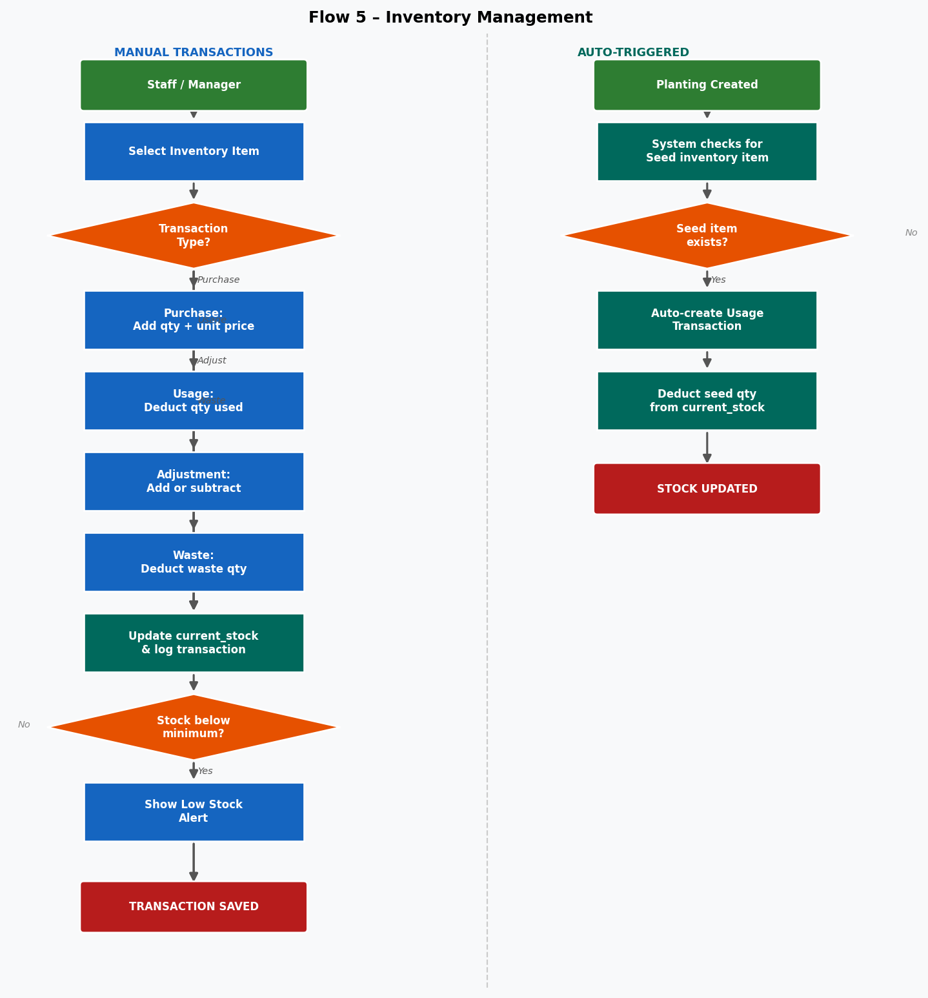

6. Scouting & Treatment
Scouts regularly inspect the nursery and log observations (pests, diseases, nutrient deficiencies) against specific batches. Identified issues trigger treatment records that can be applied to individual batches or bulk-applied across a location.

Flow 6 – Scouting & Treatment
Scouting report captures observations with severity. If treatment is needed, a treatment record is created and linked to one or many plantings via the planting_treatments junction table. Chemical usage is deducted from inventory.
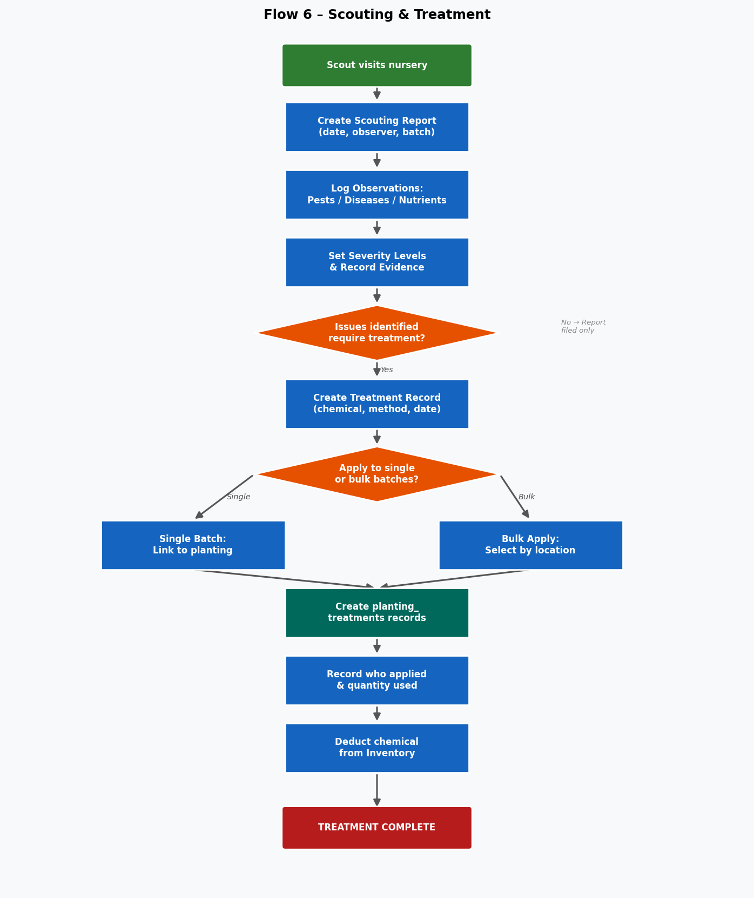

7. BOM & Production Cost Tracking
The Bill of Materials (BOM) module allows managers to define the inputs required to produce a batch of seedlings and calculate the cost per unit. The Chemical Calculator supports mixing ratio decisions before treatments are applied.

Flow 7 – BOM & Production Cost
BOM templates are created once, then assigned to planting batches. Costs are calculated by pulling current inventory prices. Results feed into the profit analysis reports.
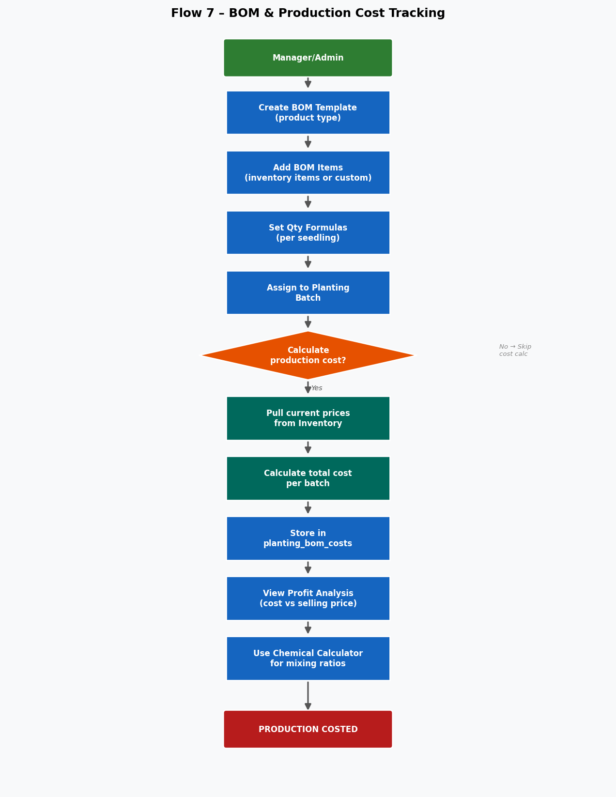

8. Role-Based Access Control
Every module action is gated by the user's role. Four roles are defined: Admin, Manager, Staff, and Viewer. Permissions can be configured at the module level per role, or overridden per individual user.

Flow 8 – Role-Based Access Control
CRUD = full access. CRU = create/read/update (no delete). R = read only. — = no access. Admins have full access to all modules including user management.
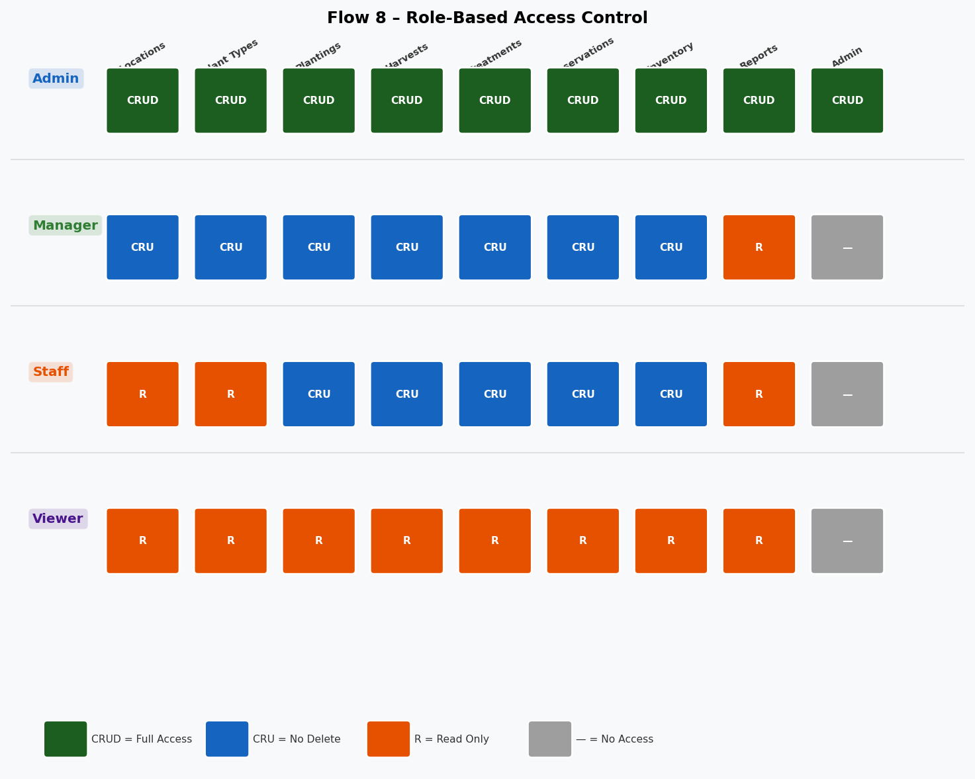

9. End-to-End Cross-Module Process
This diagram shows how all modules connect to each other in terms of data flow and process triggers. It is the high-level view of the entire system working together.

Flow 9 – End-to-End Cross-Module Business Process
Settings and Inventory are foundational. Plantings are the central operational record. Scouting → Treatments loop back to Inventory. Harvests, Reservations, and Dispatch Slips are the output flows. All modules feed Reports & Dashboard.
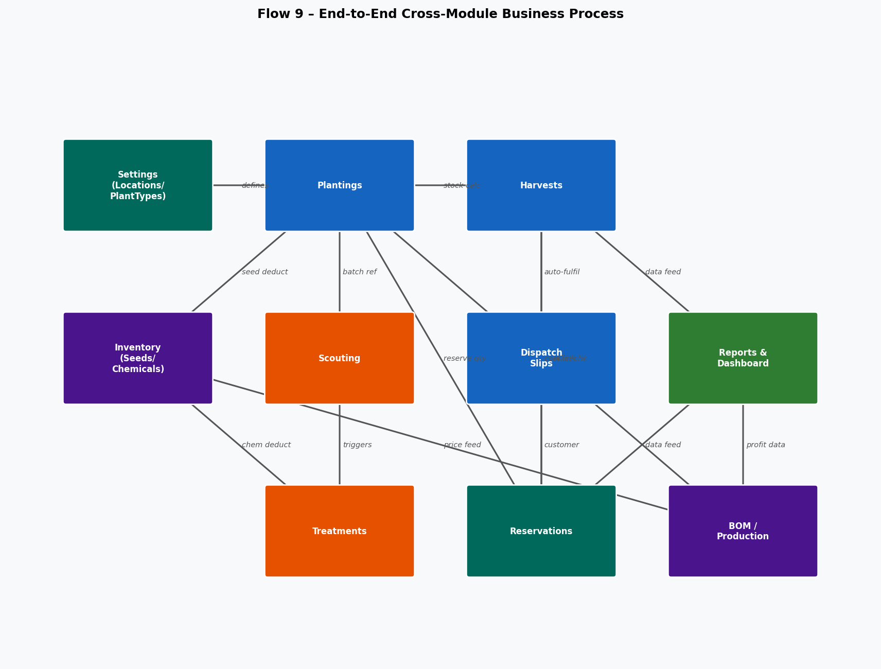

10. Module Interaction Summary
The table below summarises which modules trigger actions in other modules.
From Module | To Module | Interaction
Plantings | Inventory | Auto-deducts seed on creation
Plantings | Reservations | Batch qty drives reservation availability
Plantings | Harvests | remaining_quantity updated on each harvest
Plantings | Scouting | Batch linked to scouting reports
Plantings | BOM | BOM template assigned per batch
Scouting | Treatments | Identified issues trigger treatment creation
Treatments | Inventory | Chemical usage deducted from stock
Harvests | Dispatch Slips | Dispatch slip auto-creates harvest if stock OK
Harvests | Reservations | Checks & warns on reservation conflicts
Reservations | Plantings | Completion deducts from remaining_quantity
Dispatch Slips | Harvests | Fulfilment creates a linked harvest record
Inventory | BOM | Current prices used in cost calculations
All Modules | Reports | All data aggregated in reports & dashboard
Admin | All Modules | Role permissions gate every CRUD action

