1. HIV(Human Immunodeficiency Virus).

- Discovery Date: In 1983, scientists discovered the virus that causes AIDS. The virus was at first named HTLV-III/LAV (human T-cell lymphotropic virus-type III/lymphadenopathy-associated virus) by an international scientific committee. This name was later changed to HIV (human immunodeficiency virus).

- Data: HIV remains one of the most serious global health threats of our time. In 2017, [**1.8 million people**](http://www.unaids.org/en/resources/fact-sheet) were infected with HIV, and [**940,000 died of AIDS-related causes**](http://www.unaids.org/en/resources/fact-sheet). Between 2010 and 2019, there had been a 23% decline in new HIV infections globally. More people are getting treatment than ever before. By keeping the focus on the needs and rights of key populations, we can prevent new HIV infections and ensure those living with AIDS are not left behind. This is what Pathfinder does.

+ Globally, 38 million people are living with HIV―68% of these in sub-Saharan Africa. Despite concerted efforts to stem the HIV epidemic there, disparities in response are evident among countries, geographical locations, populations, and communities.

+ Women and girls comprise 63% of HIV cases, with adolescent girls and young women three times more likely to be infected than men and boys of the same age.

* Structure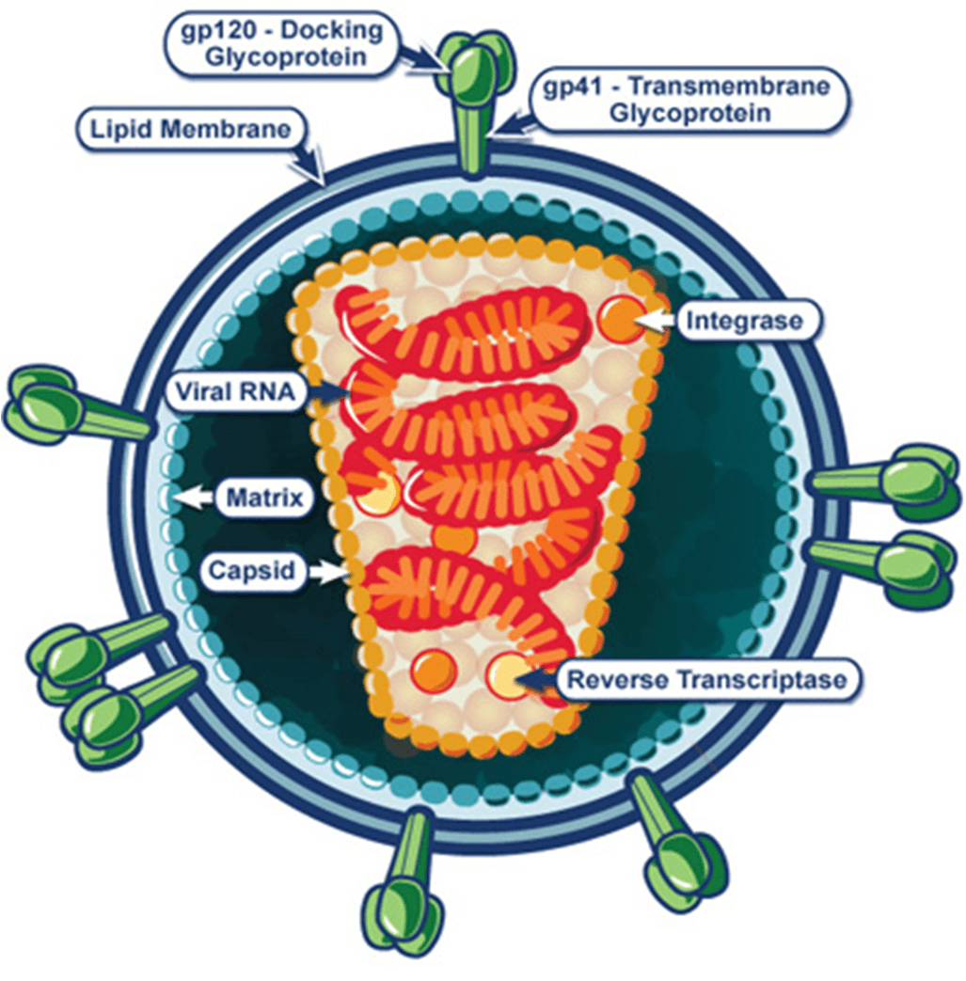
* How does HIV infect a cell

HIV is a retrovirus, which means it carries single-stranded RNA as its genetic material rather than the double-stranded DNA human cells carry. Retroviruses also have the enzyme reverse transcriptase, which allows it to copy RNA into DNA and use that DNA "copy" to infect human, or host, cells. When HIV infects a cell, it first attaches to and fuses with the host cell. Then the virus uses the host cell's machinery to convert the viral RNA into DNA and replicate itself. The new copies of HIV then leave the host cell and move on to infect other cells.

(Video: <https://www.youtube.com/watch?v=GyofqO1TRjU>)

**Key facts**

* **HIV remains a major global public health issue, having claimed 40.4 million [32.9–51.3 million] lives so far with ongoing transmission in all countries globally; with some countries reporting increasing trends in new infections when previously on the decline.**
* **There were an estimated 39.0 million [33.1–45.7 million] people living with HIV at the end of 2022, two thirds of whom (25.6 million) are in the WHO African Region.**
* **In 2022, 630 000 [480 000–880 000] people died from HIV-related causes and 1.3 million [1.0–1.7 million] people acquired HIV.**
* **There is no cure for HIV infection. However, with access to effective HIV prevention, diagnosis, treatment and care, including for opportunistic infections, HIV infection has become a manageable chronic health condition, enabling people living with HIV to lead long and healthy lives.**
* **WHO, the Global Fund and UNAIDS all have global HIV strategies that are aligned with the SDG target 3.3 of ending the HIV epidemic by 2030.**
* **By 2025, 95% of all people living with HIV (PLHIV) should have a diagnosis, 95% of those should be taking lifesaving antiretroviral treatment (ART) and 95% of PLHIV on treatment should achieve a suppressed viral load for the benefit of the person’s health and for reducing onward HIV transmission. In 2022, these percentages were 86% [73–>98%], 89% 75–>98%] and 93% [79–>98%], respectively.**
* **When considering all people living with HIV, 86% [73–>98%] knew their status, 76% [65–89%] were receiving antiretroviral therapy and 71% [60–83%] had suppressed viral loads.**