**1.**

1. Both use HTTP version 1.1 for running.

2. en-US and no

3. IP-address of my computer: 192.1xx.x.xxx

IP-address of my server: 128.119.245.12



4. The status code: 200 OK



5. Last-Modified: Wed, 25 Jan 2023 06:59:02 GMT\r\n

6. 128 bytes



7. No I don’t see any of them

8. No I don’t see them

9. The server did! I know it because of the status code and file date generated from the server.

10. I do see the “IF-MODIFIED-SINCE:” line.

If-Modified-Since: Wed, 25 Jan 2023 06:59:02 GMT\r\n

11. HTTP code: 304.

Phrase: Response Phrase: Not Modified

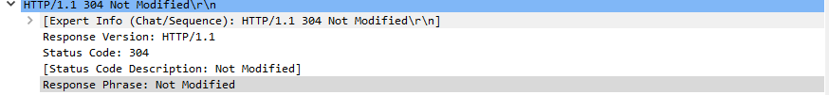

In the second server respond, we can not see the content-length normally. However, there are 3 links that link to the previous GET and Response earlier. I assume that the server still explicitly return the contents of the file, but the “last-modified” date will not be changed .

