SQL TABLES

SELECT * FROM Branch;

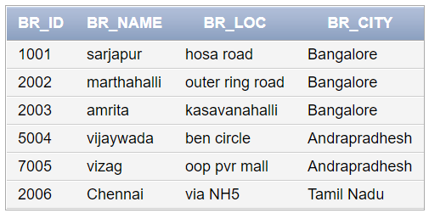

SELECT * FROM Customer;

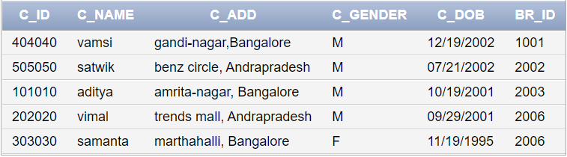

SELCT * FROM CUST_PHNO;

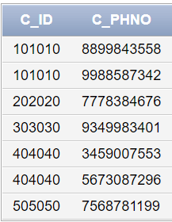

SELECT * FROM Employee;

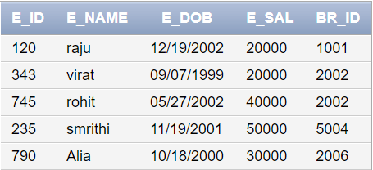

SELECT * FROM EMP_PHNO;

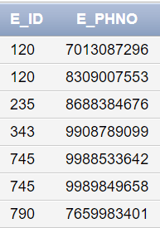

SELECT * FROM Account;

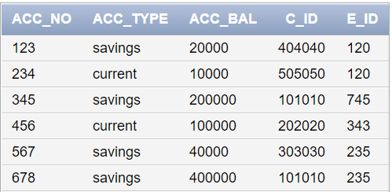

SELECT * FROM Loan;

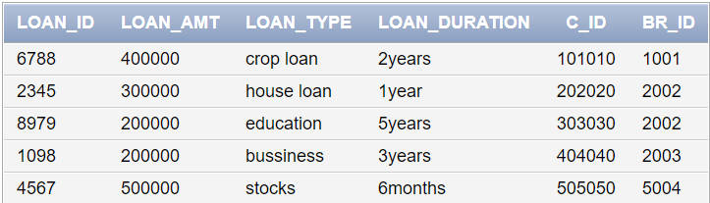

SELECT * FROM Trans;

