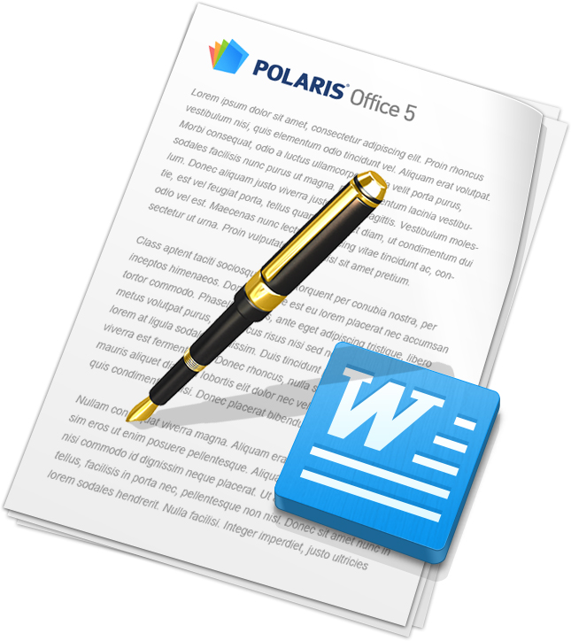

Editing Documents

With POLARIS Office, you can create new documents in .doc and .docx formats or edit your documents with ease. However, the format of new documents is provided as .docx only.

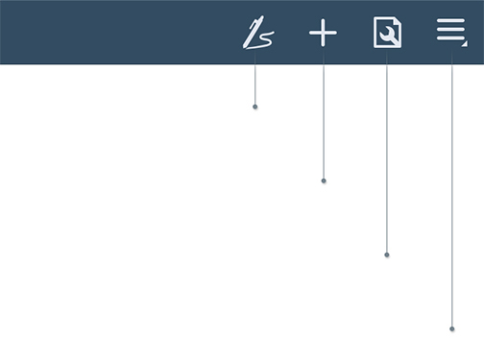

‘Menu’

You can call up the menu.

(This menu icon disappears in the device supporting ‘Hardware menu button’.)

‘Properties’

You can adjust the properties of an object.

‘Insert’

You can insert an object.

‘Free draw’

You can draw a shape/table with a pen.

Selecting Text

To select a word or a paragraph, double tap the screen, and then move left/right points to precisely adjust the area you want to select.

Cut/Copy/Paste

Select a text, and the ‘Cut/Copy/Paste’ menu appears next to the text you selected. Choose ‘Paste’ on the menu after copying the selected text, and you can paste the selected text into the position where the cursor is.

Font Formatting

Click the ‘Properties’ icon in the Title bar after selecting text, and the Properties panel appears at the bottom of the screen. You can change the size, color, effect, font, background color, style, etc., of the text.

Paragraph Formatting

Click the ‘Properties’ icon in the Title bar after selecting text, and the Properties panel appears at the bottom of the screen. You can change the alignment, spacing, indentation, bullet points, etc., of the paragraph.

Insert Object

Tap the Insert icon in the Title bar and select the icon for the type of object you want to insert, such as image, shape, table, or chart. You can insert images, shapes, tables, or charts by selecting them in the Gallery, or insert images by taking a picture using the camera on your device.

Object Format

Select the object for which you want to change the format and then tap the Properties icon in the Title bar to bring up the properties panel for each object. You can set the Brightness, Contrast, Transparency, and Shadow of images, the Color, Border, 3D Rotation, and Alignment of shapes, and the Shape, Layout, and Style of tables and charts.

Insert Header/Footer

Tap the Menu icon in the Title bar and then select Page Layout to insert the header, footer, or page number. You can insert text and images in the header/footer.

Insert Footnote/Endnote

Place the cursor on the position where the footnote/endnote will be inserted, tap the Insert icon in the Title bar, and tap the Footnote or Endnote icon to insert a footnote or endnote. Footnotes are displayed at the bottom of the page and endnotes are displayed at the end of the document.

Select Multiple Objects

Select an object, such as an image, shape, or chart, to display the pop-up menu. Tap the Multi Select icon in the pop-up menu and then tap multiple objects to select multiple objects at once. You can adjust the size or move the selected objects. After selecting the objects, tap the Properties icon in the Title bar to align the selected objects.

Changing Document Layout

To change the document layout, press the ‘Menu’ icon and select ‘Page Layout.’ You can change the margin, page orientation, size, columns, etc., of the document.

Draw Shape/Table with Pen

Tap the My Notes icon in the Title bar and then select the Shape icon to draw a shape with the pen. Select the Table icon to draw a table with the pen. Select the Erase Table icon to delete rows/columns or merge cells in the table.

Multi Select with Pen

Tap the My Notes icon in the Title bar and then tap the Lasso icon to select multiple objects with the Lasso tool.