**Phase 06: Application Walkthrough and Demonstration**

Alex Marroquin (CS)

Andrea Cantu (IT)

Divya Vuppala (IT)

Gabriel Villanueva (CS)

Mark Lagunez (CS)

Santiago Pazmino (CS)

University of Texas Pan-American

Edinburg, TX

CSCI-6333

Spring 2015

**Development**

IDE: IntelliJ IDEA

SDK: jdk v 1.8.0_45

Connector/J: v 5.1.35

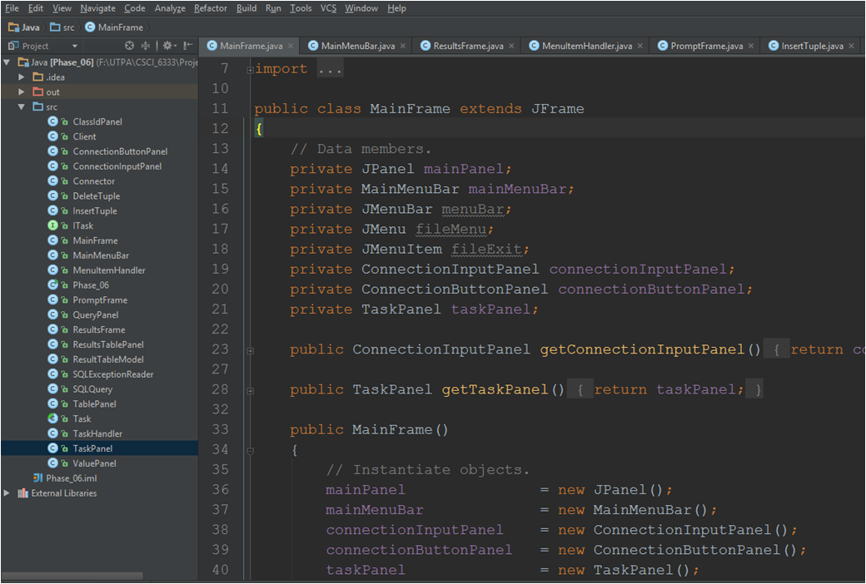

The connector/J file (.jar) was copied into the directory shown below. When building the application you can copy the .jar file into the ../jre/lib/ext directory and it will be available for all applications that execute within the JVM.

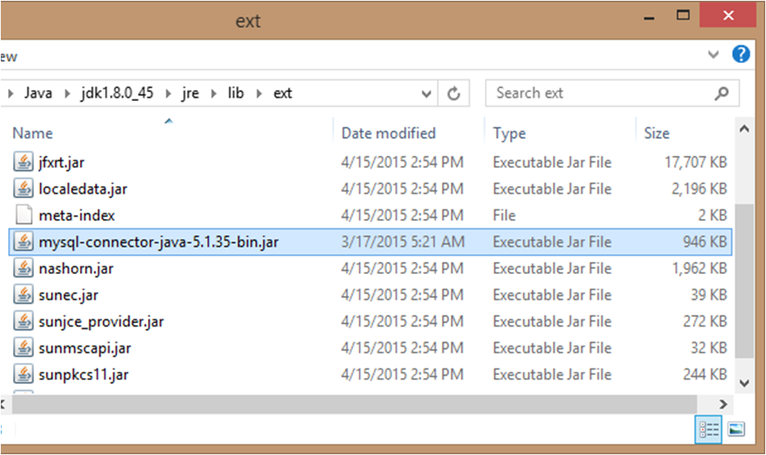

**Demonstration**

When the application is launched, a login window (shown below) is displayed, requesting the user the necessary information to connect to the database.

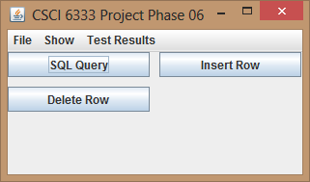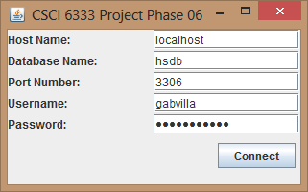

Once the Connect button is pressed (with the correct information in the fields), the main panel is shown with a menu bar containing various options. These options or menu items are explained below.

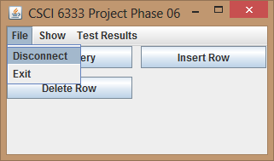

The 'Disconnect' item from the 'File menu takes the user back to the login window. 'Exit' terminates the application (Same as hitting 'x' in the upper right side of the widow). The rest of the menus and menu items display queries in an easy to understand format (See queries below). The buttons in the main panel are for advanced SQL users (e.g. Administrator).

Query 1 (Students Enrolled in Classes)

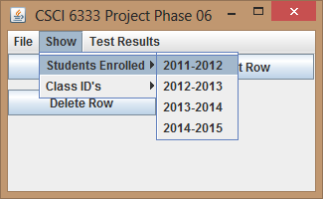

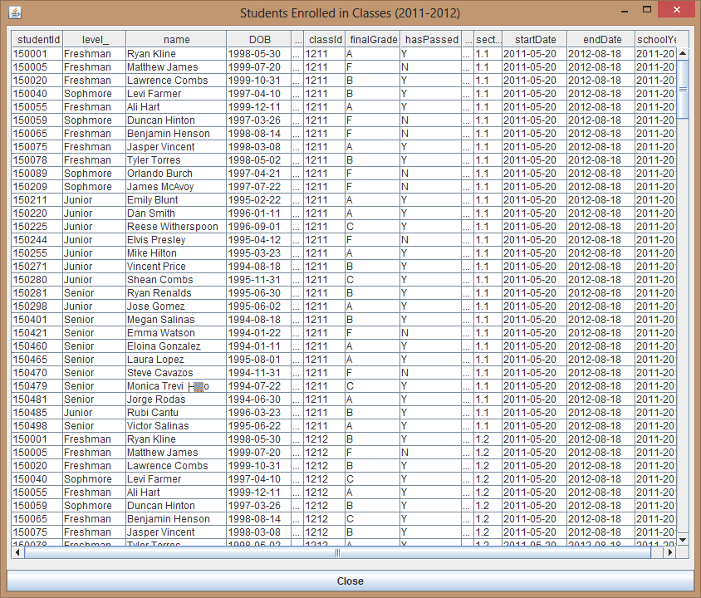Query Results

Query 2 (Class ID's Available for School Year)

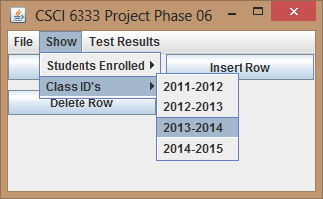

Query Results

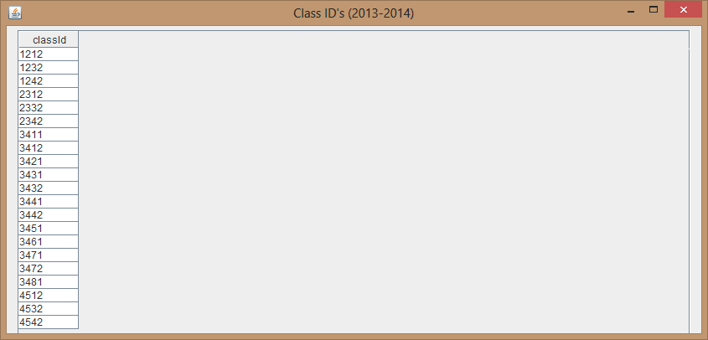

Query 3 (Average Test Score)

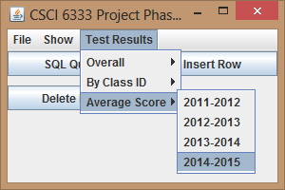

Query Results

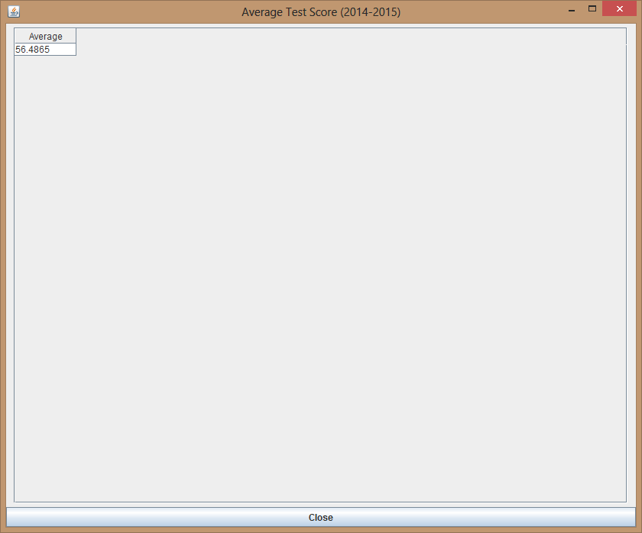

Query 4 (Number of Students that Passed Test, ordered by Subject)

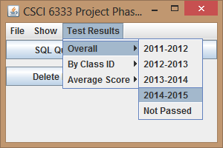

Query Results

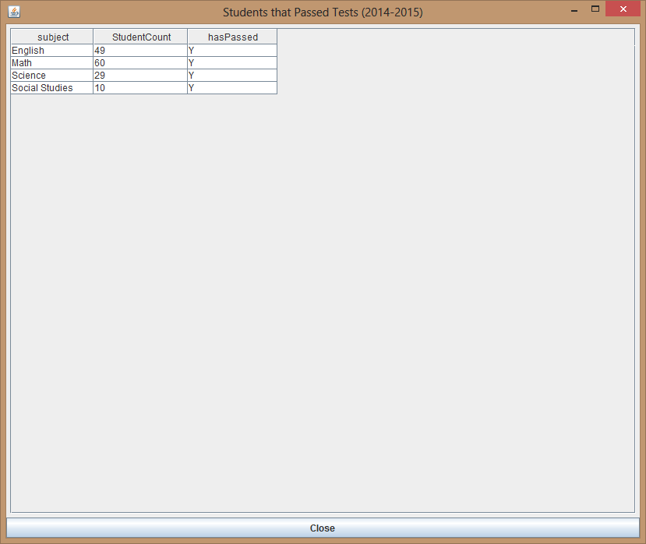

Query 05 (Students that Passed both Class and Test)

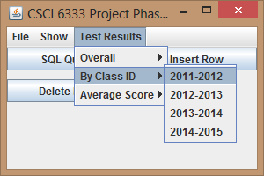

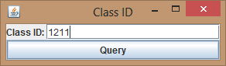

Query Results

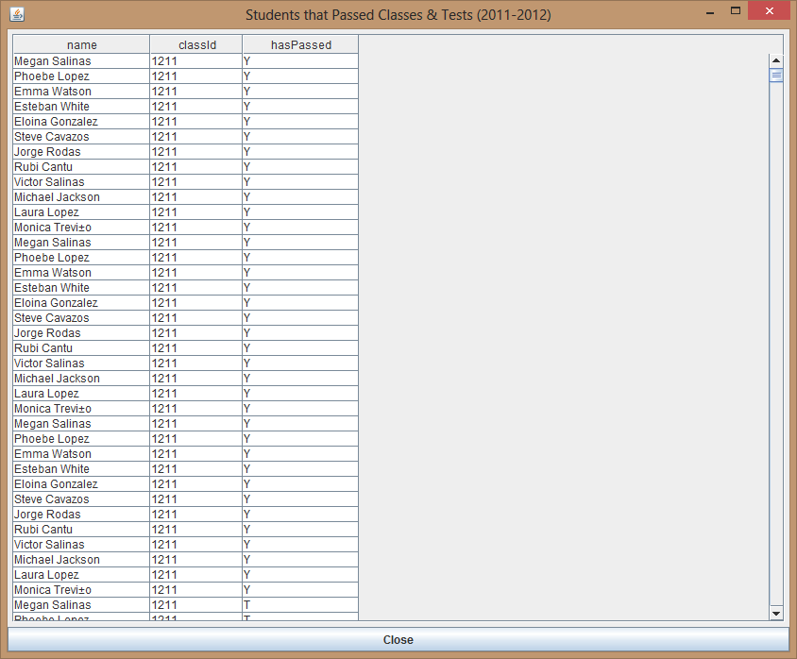

Query 6 (Students that haven't passed any Tests)

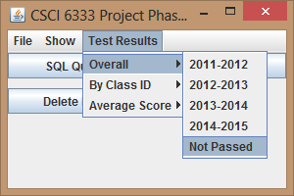

Query Results

